© ASB Software Development Limited

|  |  |
| --- | --- |
|  | Abstract  This document describes the step by step installation of a complete system of IBM Content Foundation 5.5.3 including the set-up of the supporting RHEL 8.0 Linux Operating system and the installation of a DB2 database and configuration of Object Stores for DB2, Oracle and SQLServer using the IBM WebSphere 8.5.5.15 application server.   1. Alan Bluck   Content Foundation 5.5.3 installation on RHEL 8.0 |

Contents

[Installation of the Linux operating system RHEL 8.0 5](#_Toc14094518)

[References 5](#_Toc14094519)

[Red Hat Linux 8.0 Installation on VMWare 5](#_Toc14094520)

[Install VMware Workstation Pro 15.1.0 (minimum version) 5](#_Toc14094521)

[Download RHEL 8.0 iso image 13](#_Toc14094522)

[Install Red Hat Linux 8.0 on VMware 17](#_Toc14094523)

[Check Available Repositories 31](#_Toc14094524)

[Update of libraries and X-Window installs to match IBM Content Foundation 5.5.3 requirements 32](#_Toc14094525)

[**How to install "xorg-x11-apps" package in RHEL8?** 33](#_Toc14094526)

[**Environment** 33](#_Toc14094527)

[**Issue** 33](#_Toc14094528)

[**Resolution** 34](#_Toc14094529)

[Preparation for IBM Security Directory Services 37](#_Toc14094530)

[Download from IBM PartnerWorld Software Value Package or Passport Advantage 37](#_Toc14094531)

[Download IBM Content Foundation 5.5.3 39](#_Toc14094532)

[Korn Shell and User Creation 42](#_Toc14094533)

[IBM Installation Manager Launch 43](#_Toc14094534)

[Download Installation Manager (25th February, 2019) 43](#_Toc14094535)

[Run the install for IBM Installation Manager 48](#_Toc14094536)

[Install WebSphere 8.5.5 Fix Pack 15 58](#_Toc14094537)

[Installation of WebSphere ( I am using WebSphere 8.5.5 Fix Pack 15 ) 58](#_Toc14094538)

[Copy the base 8.5.5 WebSphere: 58](#_Toc14094539)

[Install IBM Security Directory Server 6.4 components 98](#_Toc14094540)

[Installation using the Disk Image file, sds64-linux-x86-64.iso 99](#_Toc14094541)

[Directory server Instance owner 117](#_Toc14094542)

[Resolving the problem 130](#_Toc14094543)

[ESSENTIAL STEP FOR CREATING THE DEFAULT INSTANCE 148](#_Toc14094544)

[Deploying the IDSWeb Application on WebSphere 159](#_Toc14094545)

[First Time Logon to WebSphere – IMPORTANT! 169](#_Toc14094546)

[**Logging on to the console as the server administrator, a member of an administrative group or an LDAP user** 172](#_Toc14094547)

[Add a Domain 174](#_Toc14094548)

[DB2 V10.5 Server Installation 180](#_Toc14094549)

[Before you begin 183](#_Toc14094550)

[Open HTTP ports 11086, 11087 and 11088 connections: 212](#_Toc14094551)

[DB2 Data Studio access 216](#_Toc14094552)

[Applying the DB2 License 221](#_Toc14094553)

[Applying the DB2 License Certificate File 221](#_Toc14094554)

[Before you begin 221](#_Toc14094555)

[Manual License Installation Procedure 221](#_Toc14094556)

[Start or stop DB2 222](#_Toc14094557)

[Procedure 222](#_Toc14094558)

[Create a GCD Database using DB2 223](#_Toc14094559)

[Create a Development Store OS1 database 227](#_Toc14094560)

[Create a Target Object Store OS2 database 229](#_Toc14094561)

[Apply DB10.5 Fix Pack 10 and Interim Fix 231](#_Toc14094562)

[Installation Notes for IBM JDK 232](#_Toc14094563)

[Installation of the Recommended Fix Pack 10 for DB2 10.5 237](#_Toc14094564)

[Procedure 238](#_Toc14094565)

[Recreate the GCD 241](#_Toc14094566)

[Procedure to Drop DB2 GCD DataBase to rebuild the P8 Domain 241](#_Toc14094567)

[Installation of IBM Content Foundation 5.5.3 246](#_Toc14094568)

[Copy using a VMware folder 246](#_Toc14094569)

[Copy using ftp on windows to the Linux VMware 246](#_Toc14094570)

[At this point ensure the following is installed first 248](#_Toc14094571)

[Libraries also required for IBM Content Foundation Installation GUI 249](#_Toc14094572)

[Installation of ICF 5.5.3 251](#_Toc14094573)

[Loading an existing Installation profile 261](#_Toc14094574)

[Database SQL creation 264](#_Toc14094575)

[For DB2 264](#_Toc14094576)

[To create and update the DB2 database: 266](#_Toc14094577)

[DB2 SQL Script for the GCD for Windows Environment 267](#_Toc14094578)

[DB2 SQL Script for the GCD for LINUX Environments 268](#_Toc14094579)

[Oracle SQL Script for the GCD User 270](#_Toc14094580)

[Procedure 270](#_Toc14094581)

[Additional sqlplus command for pluggable Oracle 12c Database 271](#_Toc14094582)

[SQL Server Script for the GCD User 271](#_Toc14094583)

[Procedure 272](#_Toc14094584)

[Procedure 272](#_Toc14094585)

[Procedure 273](#_Toc14094586)

[Websphere Environment For the Database JDBC jar files 274](#_Toc14094587)

[DB2 Environment variables 276](#_Toc14094588)

[Oracle Environment variables 278](#_Toc14094589)

[Copy DB2 jar files 279](#_Toc14094590)

[Copy ORACLE jar files 280](#_Toc14094591)

[Select the Oracle or DB2 JDBC Driver 280](#_Toc14094592)

[Configure for DB2 10.5 Fix Pack 10 Database 282](#_Toc14094593)

[Configure the DB2 OS1 Development Object Store 283](#_Toc14094594)

[Copy the Configure Object Store JDBC task for the OS2 Target Store 284](#_Toc14094595)

[Configure for Oracle GCD Database (example) 294](#_Toc14094596)

[Create and run the Oracle Object Store SQL script (Example) 295](#_Toc14094597)

[Open LDAP and DB2 ports 389, 50000 connections: 303](#_Toc14094598)

[Also added the iiop port, 2809 303](#_Toc14094599)

[Start the FileNet Engine application 307](#_Toc14094600)

[DB2 on RHEL8 Configuration for LDAP using IBM Security Directory Services 6.4 308](#_Toc14094601)

[Section For DB2 322](#_Toc14094602)

[Section For ORACLE 337](#_Toc14094603)

[Installing Google Chrome 342](#_Toc14094604)

[On Centos 7.3 348](#_Toc14094605)

[Starting Oracle 349](#_Toc14094606)

[Open Firewall ports for the Windows Host server Chrome Browser 349](#_Toc14094607)

[Appendix A – Installation of VMware tools on the RHEL 8.0 System 350](#_Toc14094608)

[Appendix B – Network configuration changes for a Static IP Address 354](#_Toc14094609)

[Appendix H – Clear-down of Oracle Object Store tables to re-apply 359](#_Toc14094610)

[Appendix M - DB10.5 Universal Fix pack 10 Update log 360](#_Toc14094611)

[Appendix N - Disabling WebSphere 8.5.5.15 security for LDAP config 366](#_Toc14094612)

[Configuration of WebSphere 8.5.5 for JAAS User Authentication 366](#_Toc14094613)

[Unlocking WebSphere if the security requires re-configuration 366](#_Toc14094614)

[Appendix O- yum -y install redhat-lsb libXScrnSaver 380](#_Toc14094615)

[Appendix C – Full output of the library installs 395](#_Toc14094616)

[Appendix B – DB2 Check Log output 402](#_Toc14094617)

# Installation of the Linux operating system RHEL 8.0

## References

<https://linuxconfig.org/redhat>

<https://linuxconfig.org/how-to-install-red-hat-linux-8-on-vmware-workstation>

<https://linuxconfig.org/rhel-8-configure-static-ip-address>

<https://www.golinuxhub.com/2014/07/how-to-detect-new-nicethernet-card.html>

## Red Hat Linux 8.0 Installation on VMWare

### Install VMware Workstation Pro 15.1.0 (minimum version)

The VMware Workstation support for RHEL 8.0 only starts with **VMware Workstation Pro**

version **15.1.0**, so this needs to be installed as an upgrade (or a new installation) first!

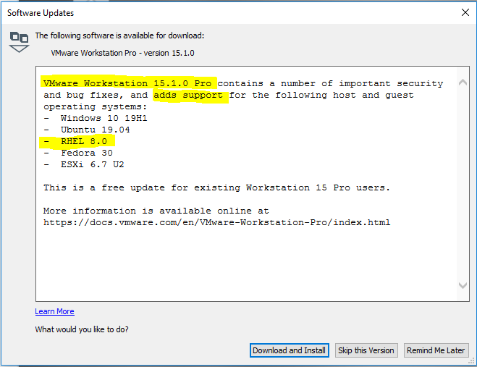

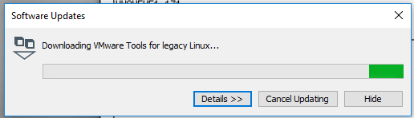

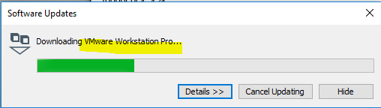

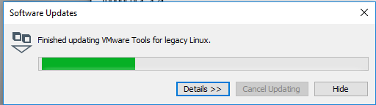

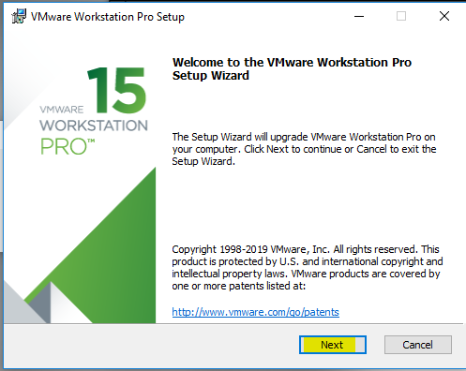

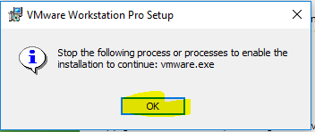

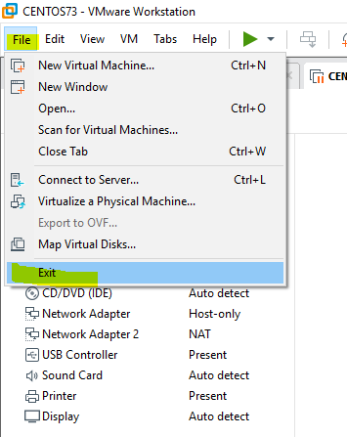

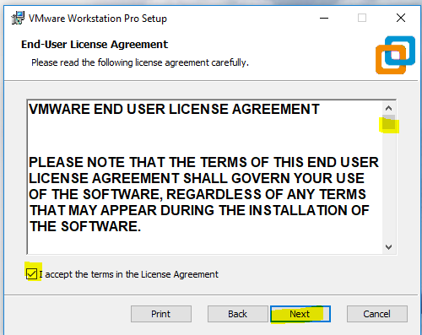

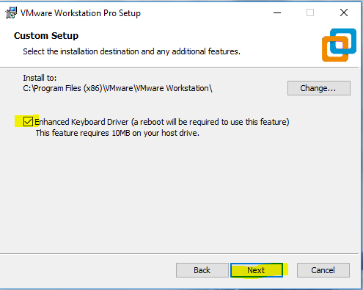

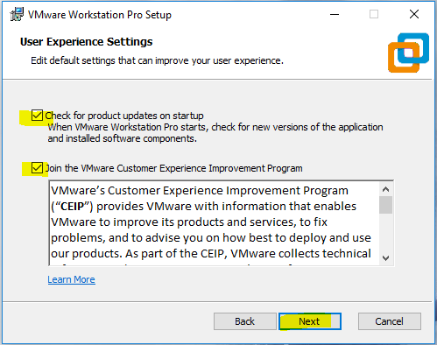

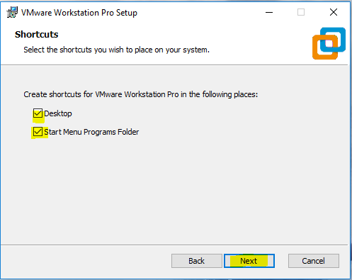

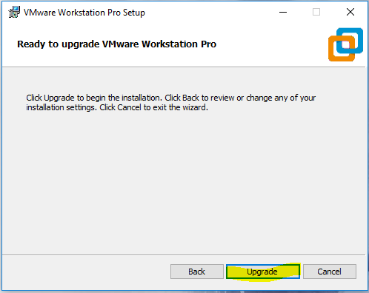

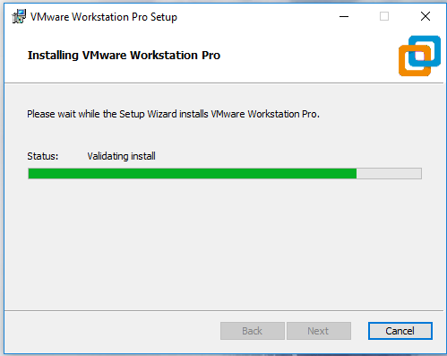

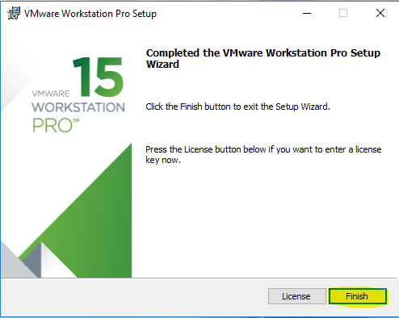

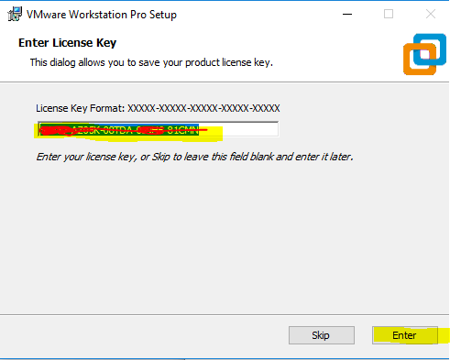

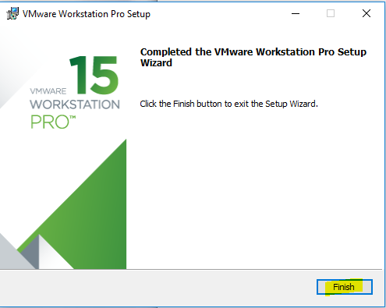

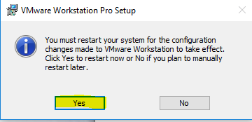

After reboot

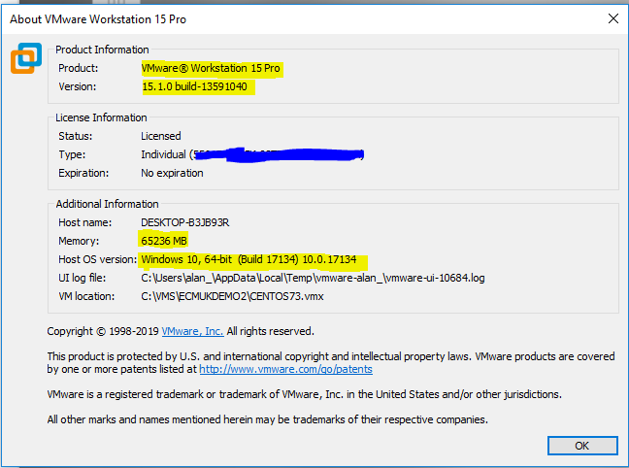

### Download RHEL 8.0 iso image

<https://developers.redhat.com/products/rhel/download/> and then

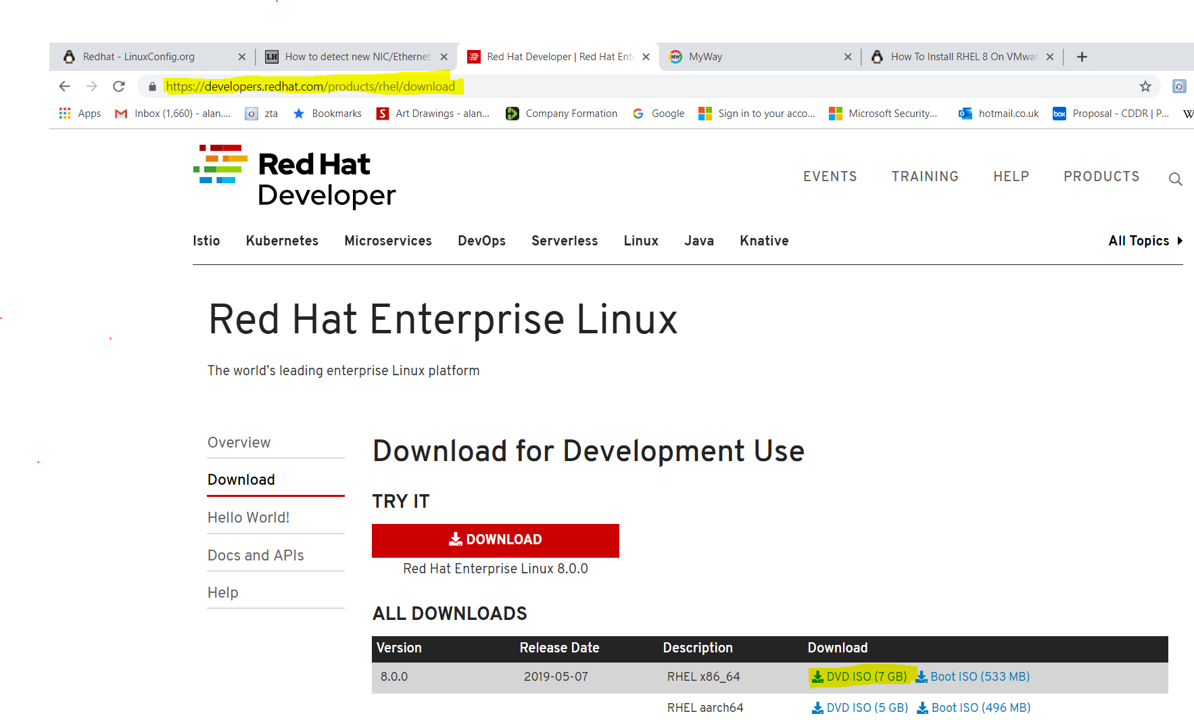

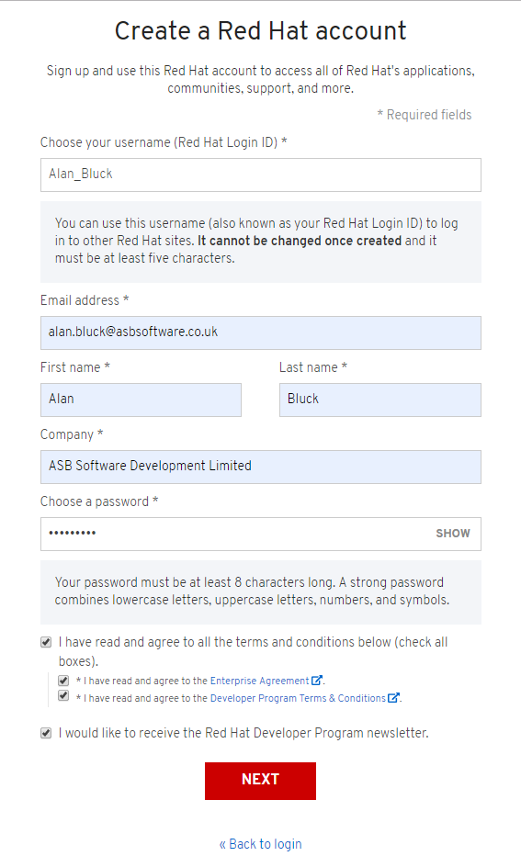

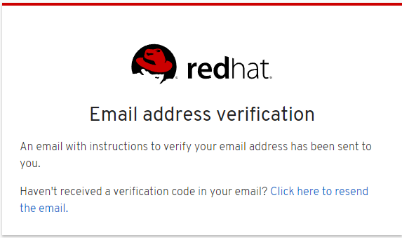

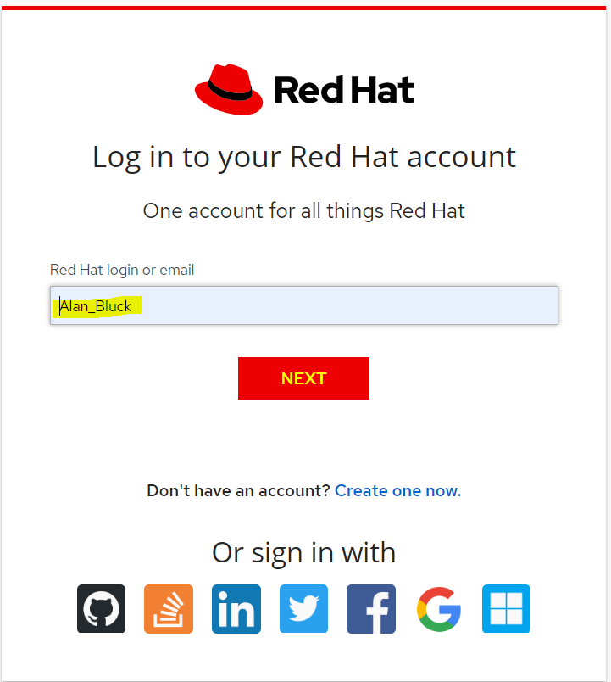

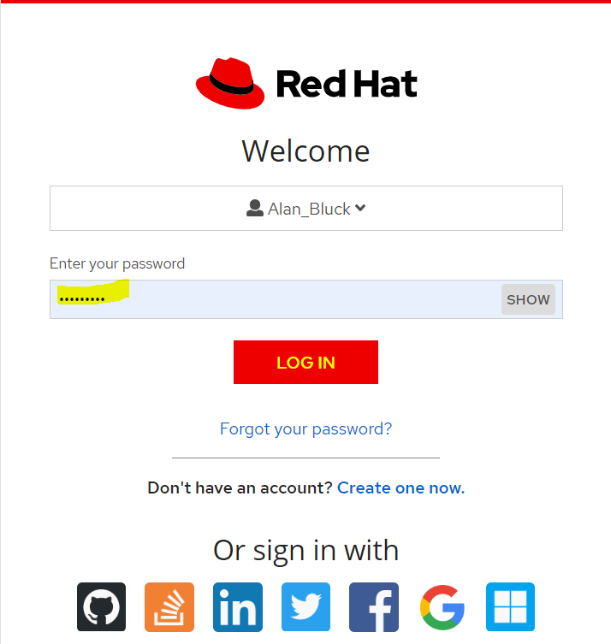

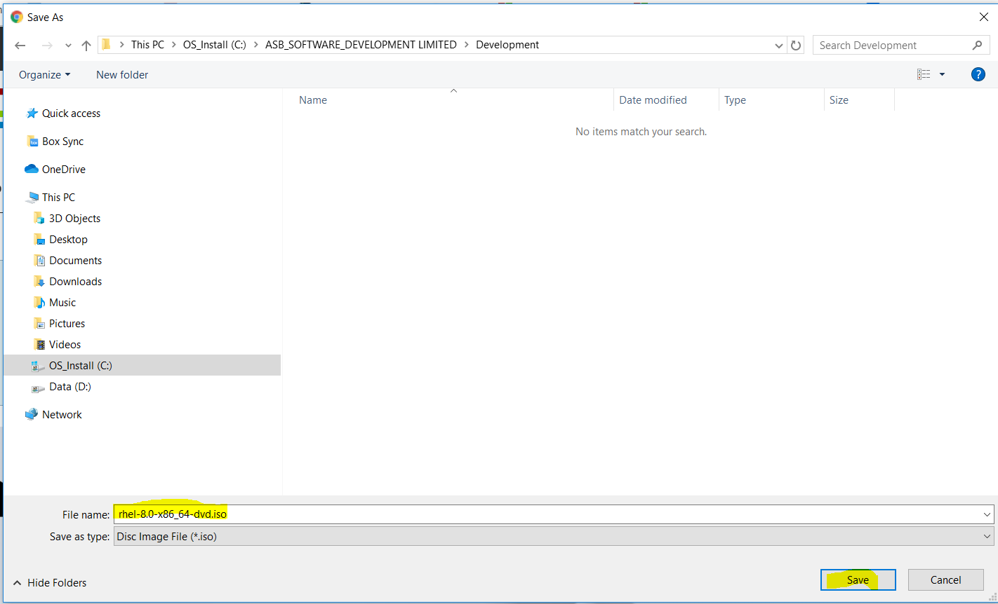

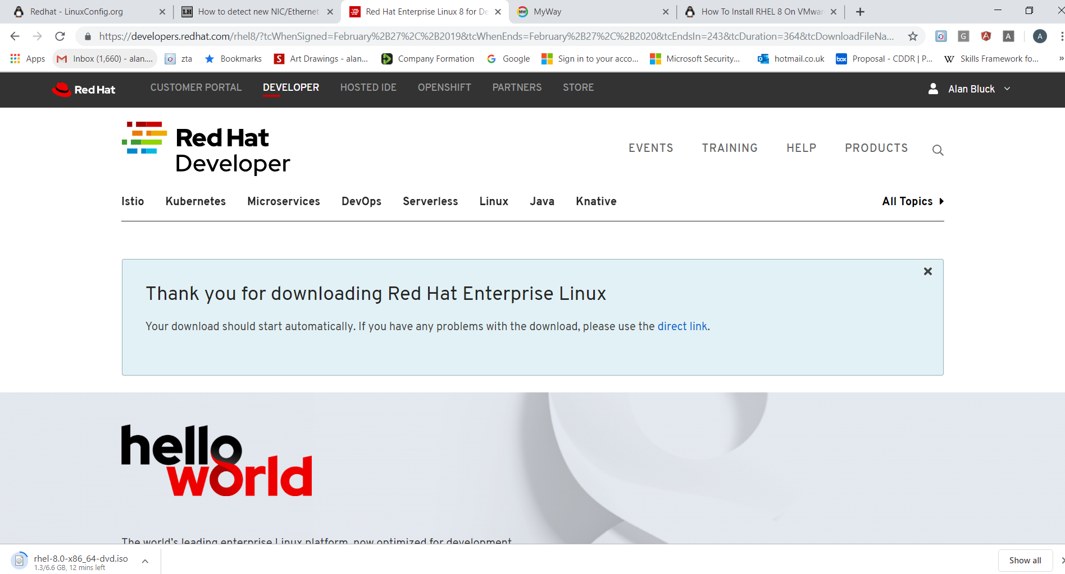

Scroll down to see

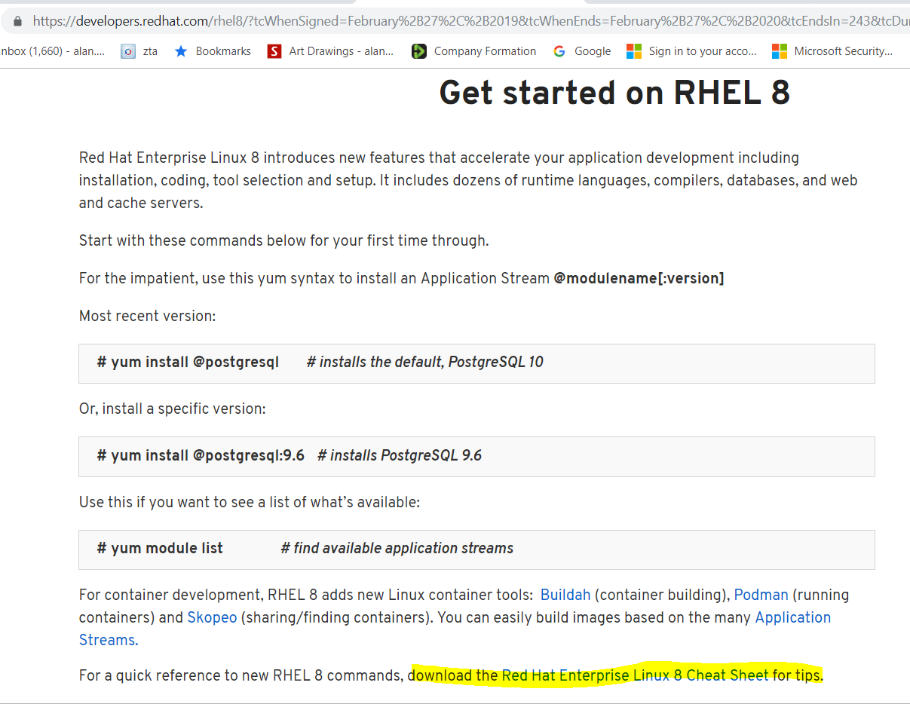

### Install Red Hat Linux 8.0 on VMware

Ref:

<https://linuxconfig.org/redhat> (general networking information)

<https://linuxconfig.org/how-to-install-red-hat-linux-8-on-vmware-workstation> (Installation steps)

Select the menu item **File > New Virtual Machine**

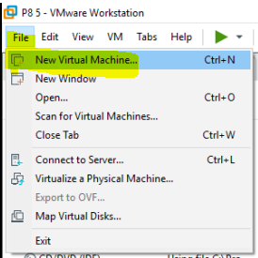

and in the first window select the second option ° **Custom**.

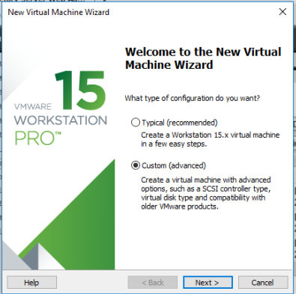

Click Next

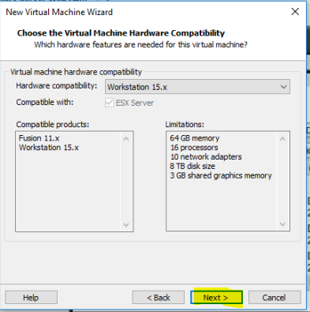

Click Next to accept the latest compatible Workstation version

Note the location of the downloaded RHEL 8.0 iso file:

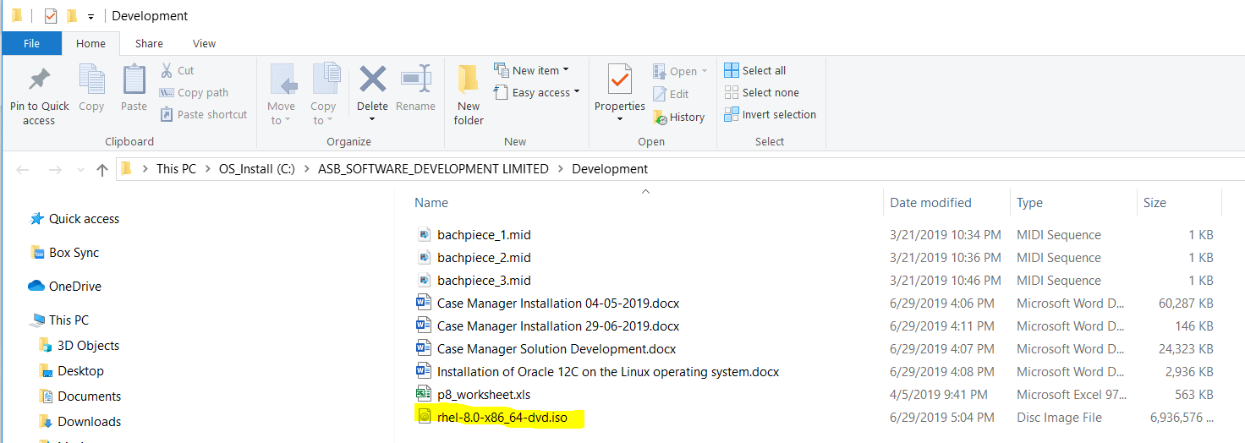

Browse to the iso using the VMware

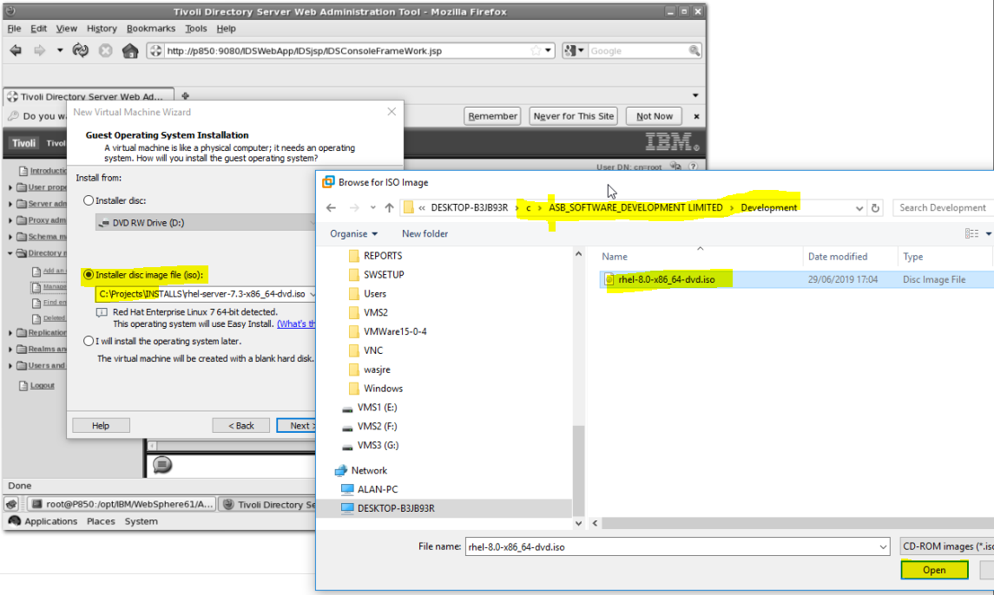

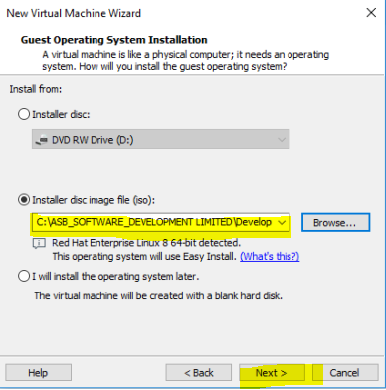

Click Next

**NB IBM Content Foundation 5.5.3 is not yet supported using RHEL 8.0 (and higher)**

**(See** IBM Case Manager 5.5.3 Software Compatibility report **section)**

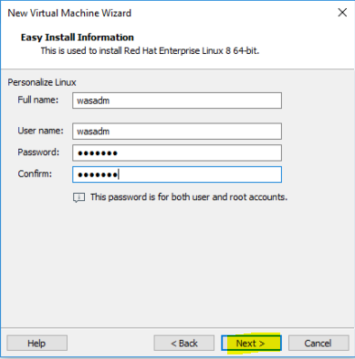

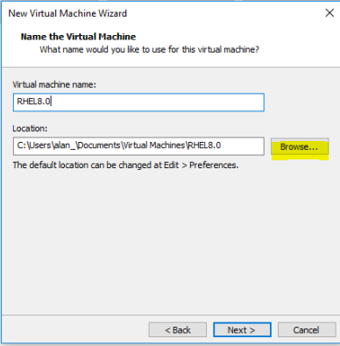

Browse for the location of the VMWare

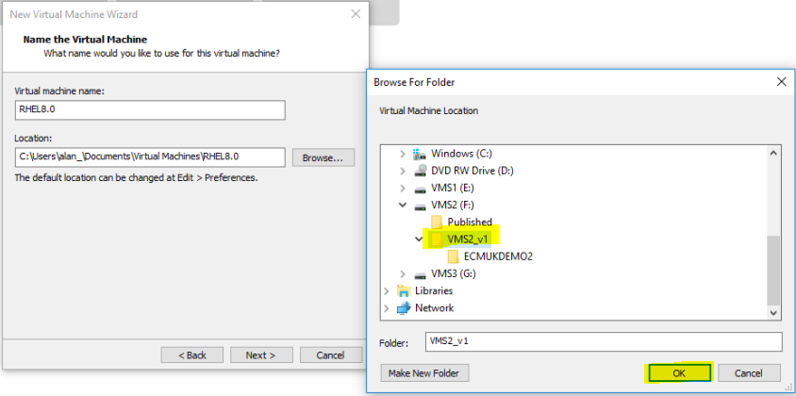

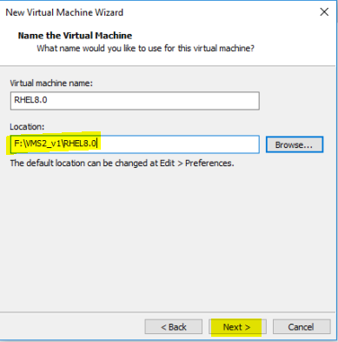

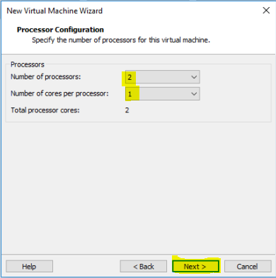

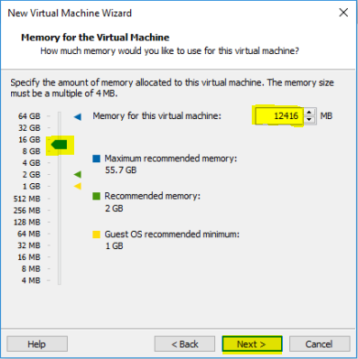

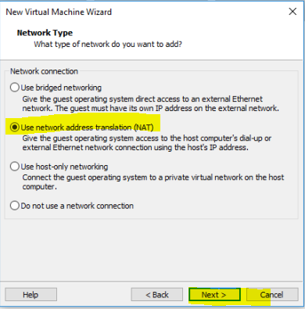

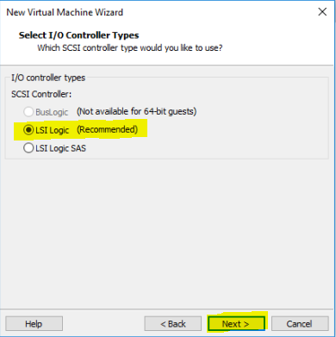

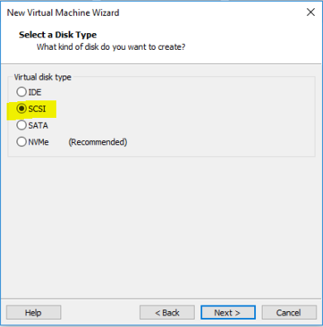

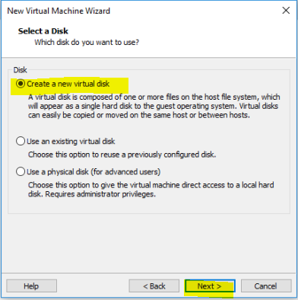

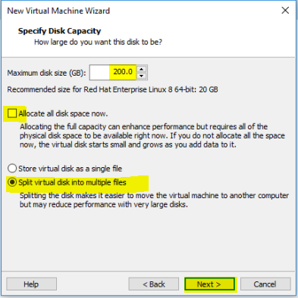

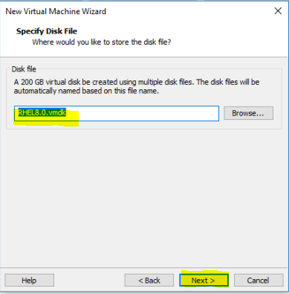

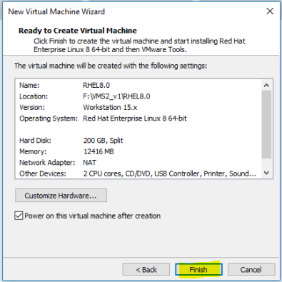

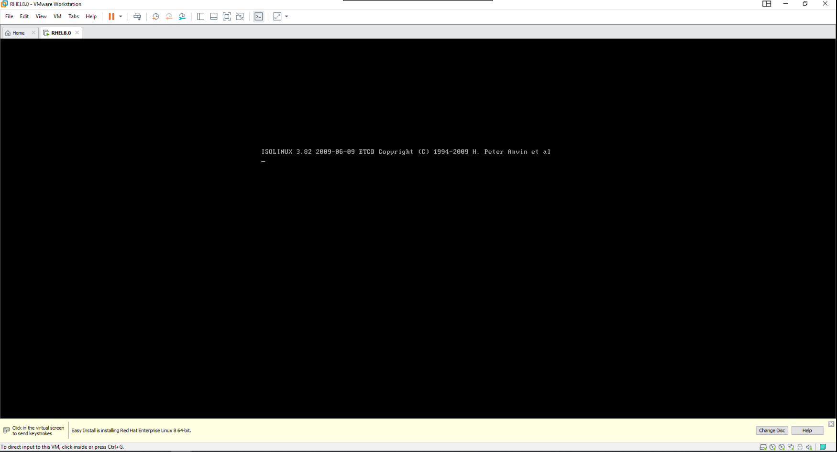

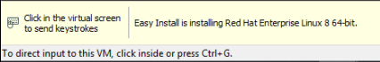

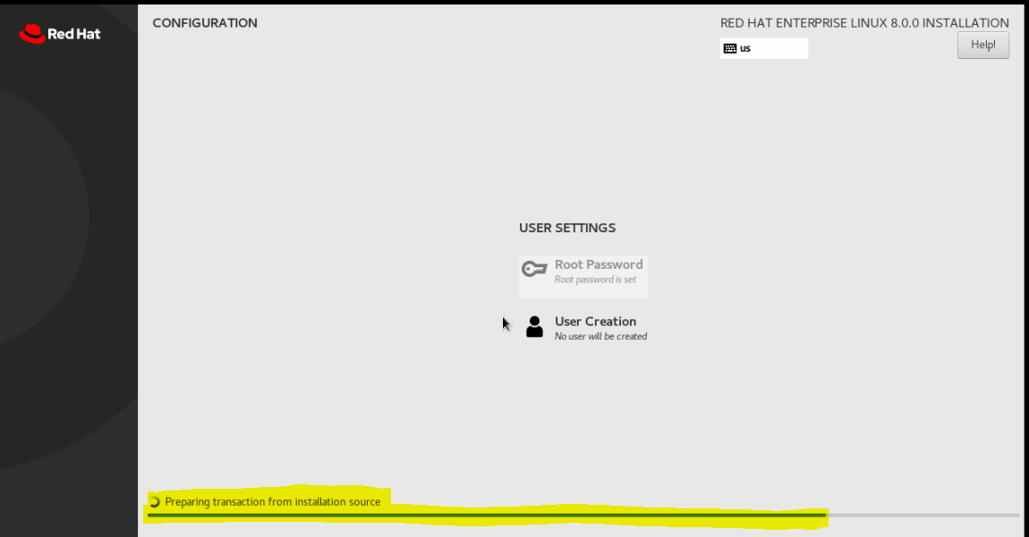

Install status shows each package being installed eg

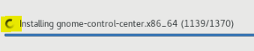

etc

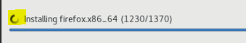

etc

System restarts after installation in the VMware (on my system around 15 minutes)

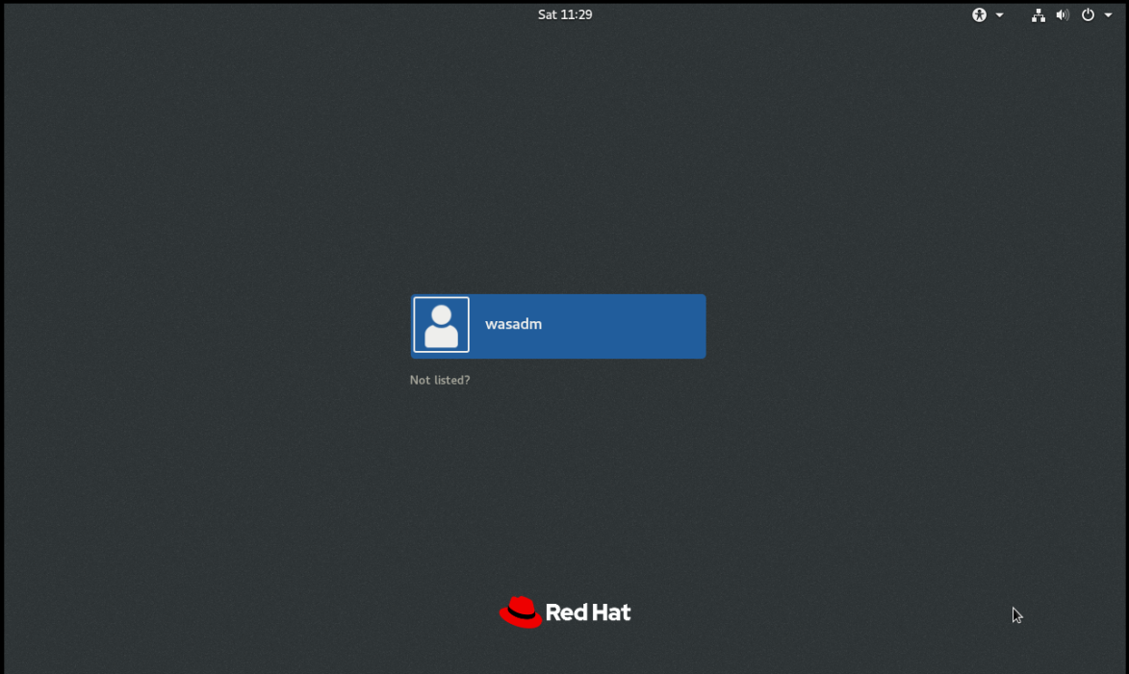

Login as wasadm

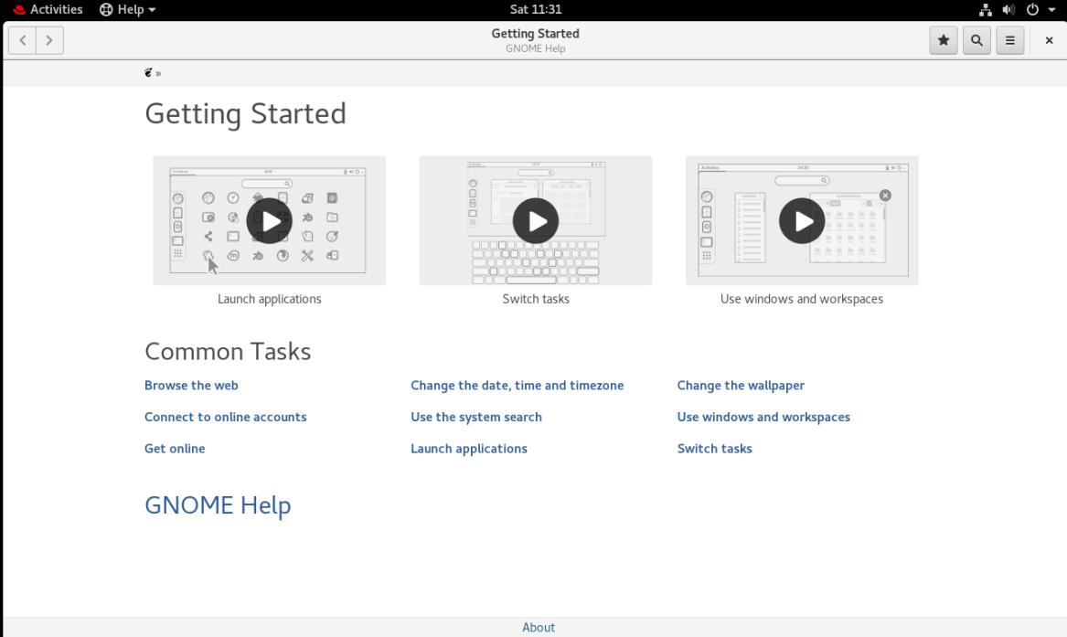

Review the Getting Started videos

Enabling Subscribe to the RHEL system

REF

<https://www.tecmint.com/enable-rhel-subscription-in-rhel-8/>

If you have not registered your system during the [RHEL 8 installation](https://www.tecmint.com/installation-of-rhel-8/), you can do it now by applying the following command as root user.

You can complete the whole process in one step by using the following command.

# subscription-manager register --username **<username>** --password **<password>** --auto-attach

*Register RHEL 8 to Redhat Subscription*

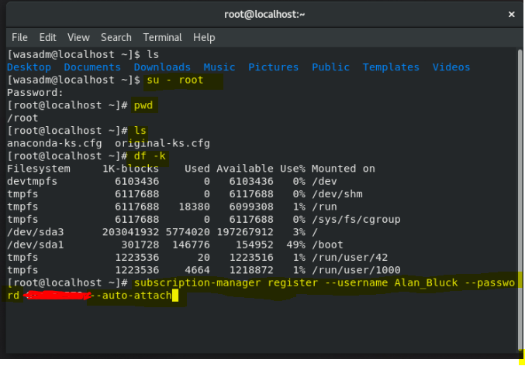

Where you should change **<username>** and **<password>** with the username and password used for your RHEL customer portal.

This gave the following on my system

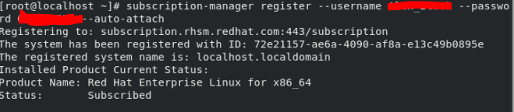

### Check Available Repositories

Once you have completed your subscription, you can review the enabled repositories by using the following command:

# yum repolist

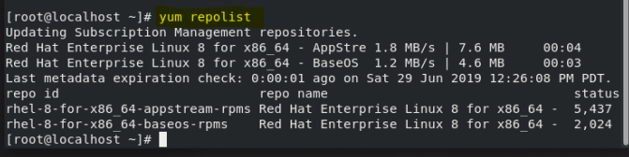

If you want to enable more repositories for your RHEL installation, you can edit the following file:

# vi /etc/yum.repos.d/redhat.repo

Within that file, you will see a long list of available repos. To enable certain repo, changed **0** to **1** next to enabled:

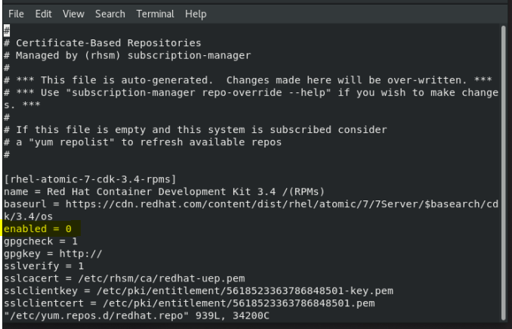

### Update of libraries and X-Window installs to match IBM Content Foundation 5.5.3 requirements

#### X-Windows Terminal installation

yum install xterm

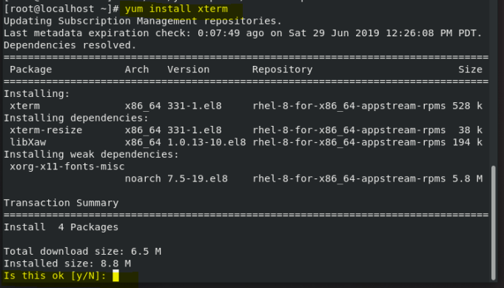

Enter y

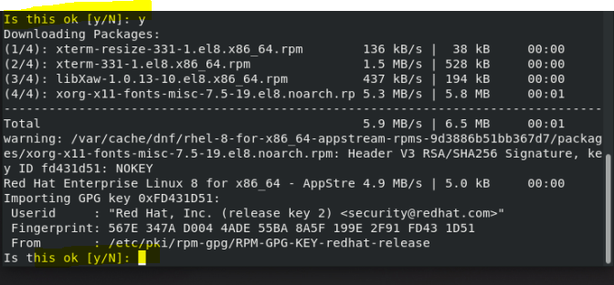

Enter y

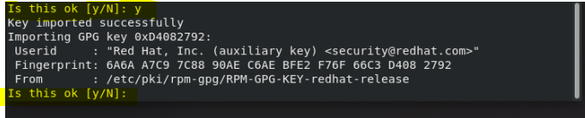

Enter y

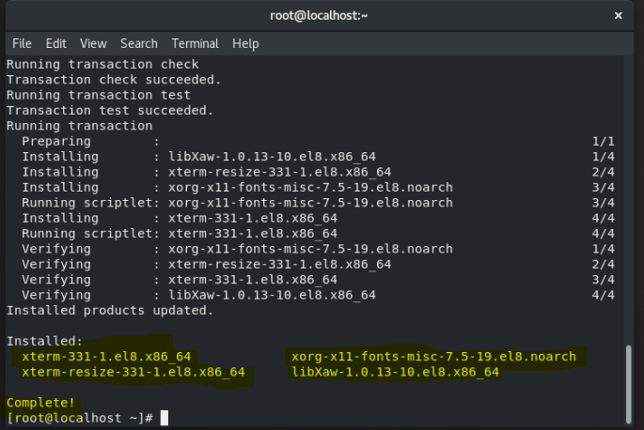

REF <https://access.redhat.com/solutions/3887371>

**NOTE: Installation of X-Windows xclock is no longer available**

# **How to install "xorg-x11-apps" package in RHEL8?**

 SOLUTION VERIFIED - Updated April 18 2019 at 11:54 AM -

[English](https://access.redhat.com/solutions/3887371)

## **Environment**

* Red Hat Enterprise Linux 8
* xorg-x11-apps

## **Issue**

* **How to install the xorg-x11-apps package to get xclock in RHEL8?**
* Which package provides xclock in RHEL8?
* Which applications can be used to test ssh X11Forwarding in RHEL8?

## **Resolution**

xorg-x11-apps package is no longer available in RHEL8. Use xterm or any other GUI application to test SSH X11Forwarding.

This solution is part of Red Hat’s fast-track publication program, providing a huge library of solutions that Red Hat engineers have created while supporting our customers. To give you the knowledge you need the instant it becomes available, these articles may be presented in a raw and unedited form.

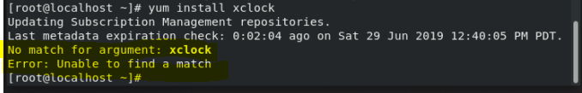

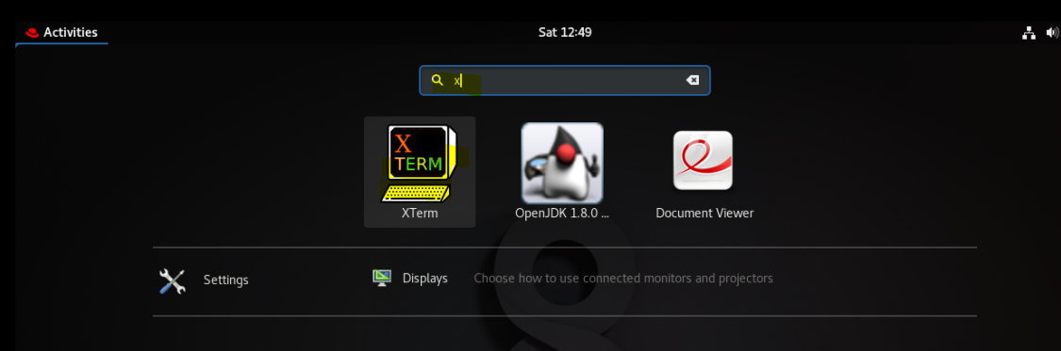

**yum install gtk2 libXtst xorg-x11-fonts-Type1**

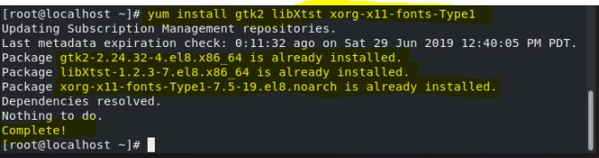

**ARCH32=$(uname -m | sed -e 's/s390x/s390/g' -e 's/x86\_64/i686/g')**

**yum install glibc.$ARCH32 gtk2.$ARCH32 gtk3.$ARCH32 libXtst.$ARCH32 libXft.$ARCH32 libXtst.$ARCH32 adwaita\*theme.$ARCH32 compat-libstdc++-33.$ARCH32**

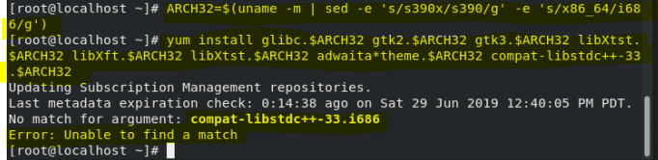

**Splitting up and running the installs as follows worked much better!!**

**yum install gtk3.$ARCH32**

**See Appendix A for the output**

**yum install libXtst.$ARCH32**

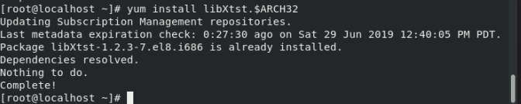

**yum install libXft.$ARCH32**

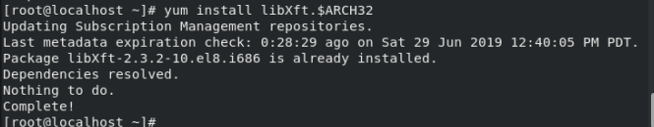

**yum install libXtst.$ARCH32**

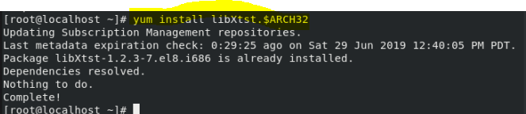

**yum install adwaita\*theme.$ARCH32**

**[root@localhost ~]# yum install adwaita\*theme.$ARCH32**

Updating Subscription Management repositories.

Last metadata expiration check: 0:30:13 ago on Sat 29 Jun 2019 12:40:05 PM PDT.

Dependencies resolved.

================================================================================

Package Arch Version Repository Size

================================================================================

Installing:

adwaita-gtk2-theme i686 3.22.3-4.el8 rhel-8-for-x86\_64-appstream-rpms 132 k

Installing dependencies:

gtk2 i686 2.24.32-4.el8 rhel-8-for-x86\_64-appstream-rpms 3.6 M

Transaction Summary

================================================================================

Install 2 Packages

Total download size: 3.8 M

Installed size: 14 M

Is this ok [y/N]: y

Downloading Packages:

(1/2): adwaita-gtk2-theme-3.22.3-4.el8.i686.rpm 366 kB/s | 132 kB 00:00

(2/2): gtk2-2.24.32-4.el8.i686.rpm 4.7 MB/s | 3.6 MB 00:00

--------------------------------------------------------------------------------

Total 4.8 MB/s | 3.8 MB 00:00

Running transaction check

Transaction check succeeded.

Running transaction test

Transaction test succeeded.

Running transaction

Preparing : 1/1

Installing : gtk2-2.24.32-4.el8.i686 1/2

Running scriptlet: gtk2-2.24.32-4.el8.i686 1/2

Installing : adwaita-gtk2-theme-3.22.3-4.el8.i686 2/2

Running scriptlet: adwaita-gtk2-theme-3.22.3-4.el8.i686 2/2

Verifying : gtk2-2.24.32-4.el8.i686 1/2

Verifying : adwaita-gtk2-theme-3.22.3-4.el8.i686 2/2

Installed products updated.

Installed:

**adwaita-gtk2-theme-3.22.3-4.el8.i686 gtk2-2.24.32-4.el8.i686**

**Complete**!

[root@localhost ~]#

**yum install compat-libstdc++-33.$ARCH32**

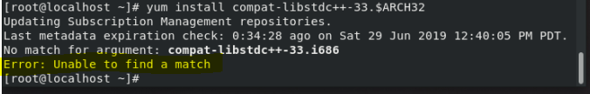

**REF**

<https://access.redhat.com/documentation/en-us/red_hat_enterprise_linux/8/html-single/considerations_in_adopting_rhel_8/index>

## Preparation for IBM Security Directory Services

Ref:

<https://www.youtube.com/watch?v=0T2piH-Azxc>

**(NB But, note that there are differences from this, required to run on RHEL 8.0)**

### Download from IBM PartnerWorld Software Value Package or Passport Advantage

Ref <https://www-03.ibm.com/isc/esd/dswdown/searchDescription.wss>



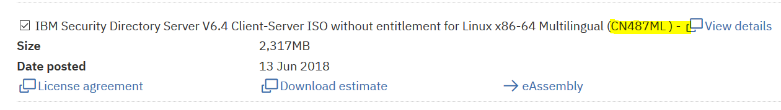

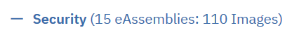

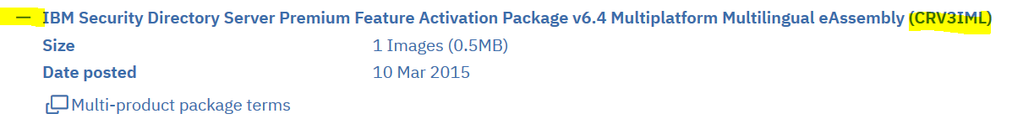

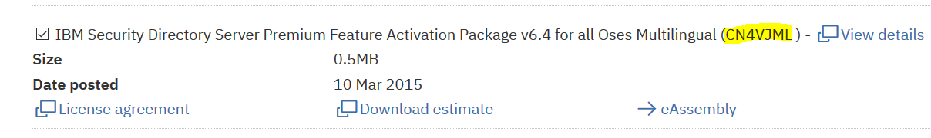

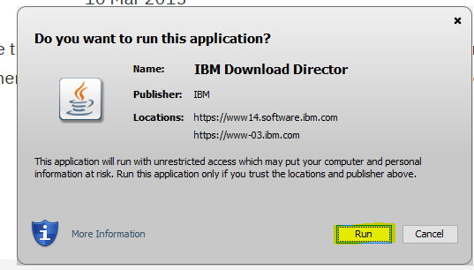

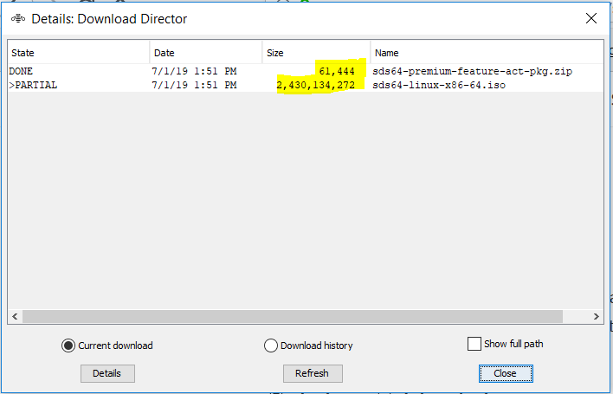

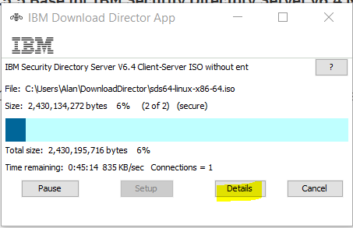

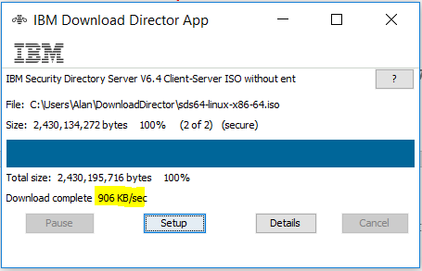

### Download IBM Content Foundation 5.5.3

REFs

<https://www-01.ibm.com/support/docview.wss?uid=ibm10881660>

<https://www.ibm.com/support/knowledgecenter/en/SSNW2F_5.5.0/com.ibm.p8toc.doc/welcome_p8.htm>

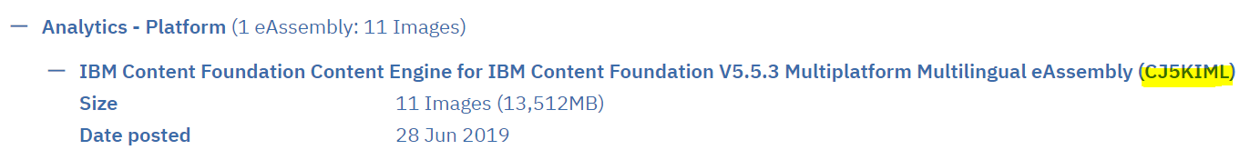

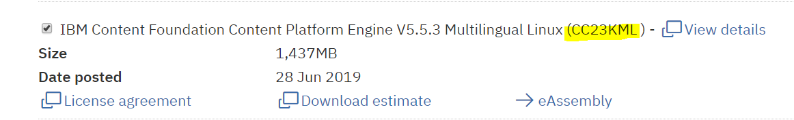

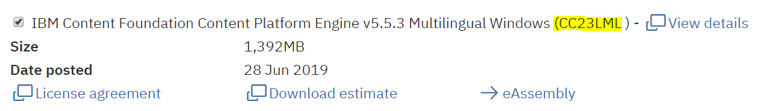

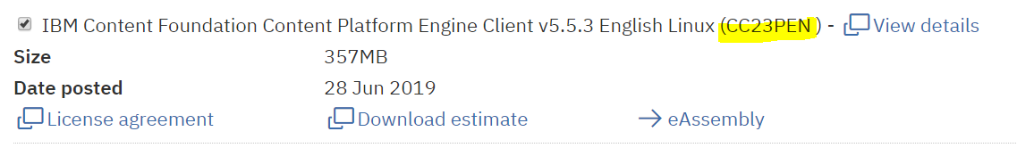

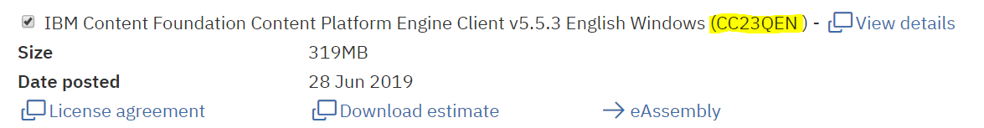

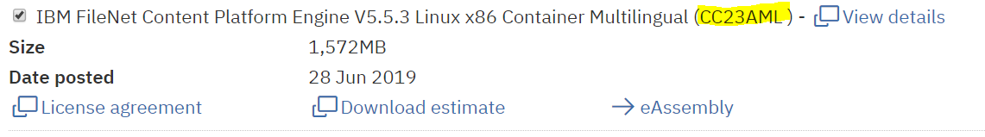

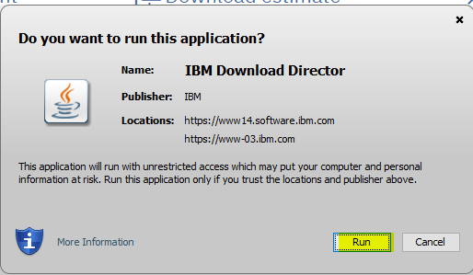

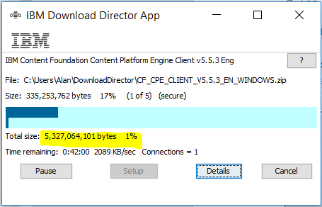

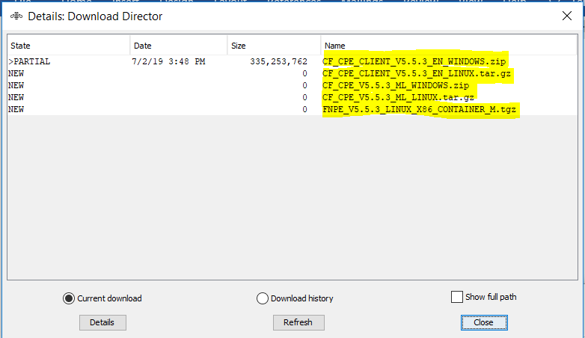

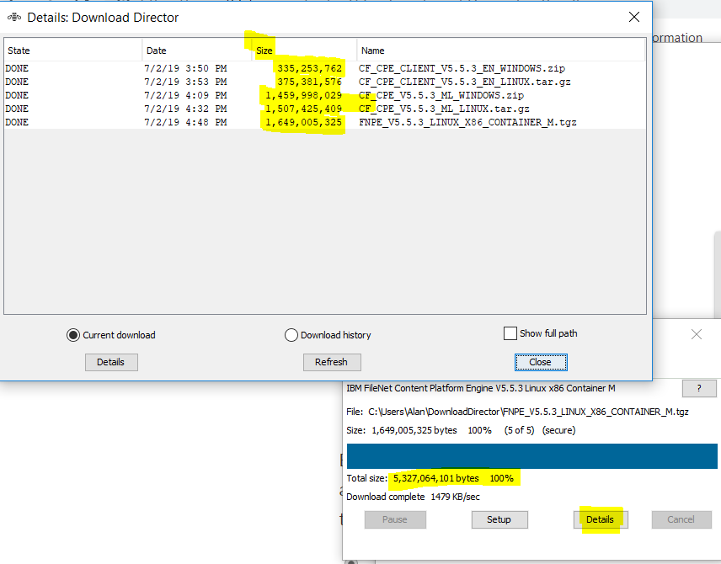

### Korn Shell and User Creation

#### To install the Korn shell

yum install -y ksh

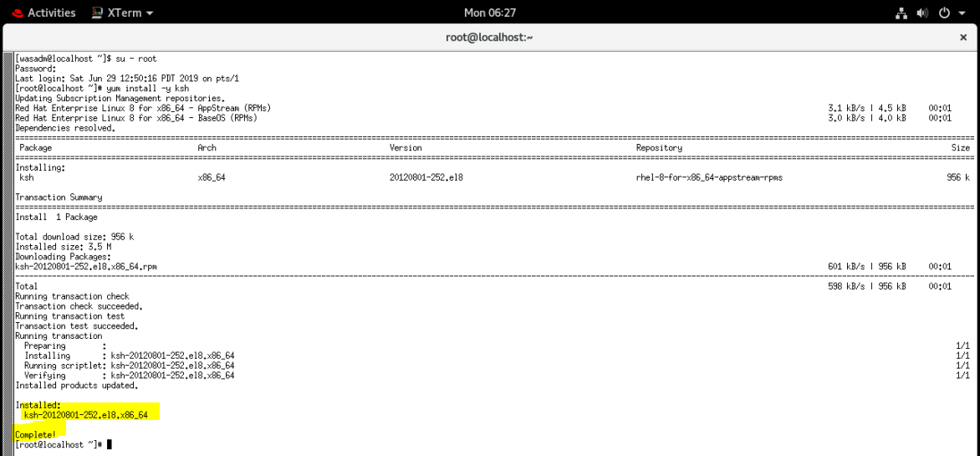

#### To create the LDAP User and Group

groupadd idsldap

useradd -g idsldap -d /home/idsldap -m -s /bin/ksh idsldap

passwd idsldap

usermod -a -G idsldap root

groups root

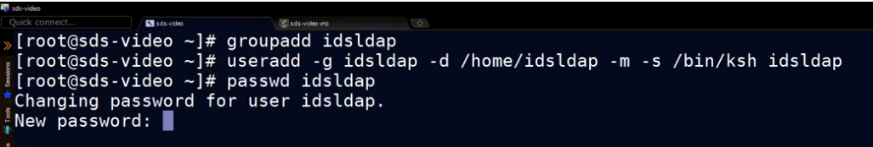

filenet123

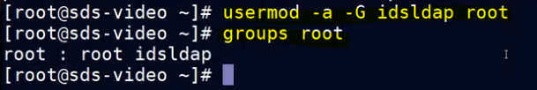

**NB Log out and log back into the root account at this point to pick up the user and group memberships!**

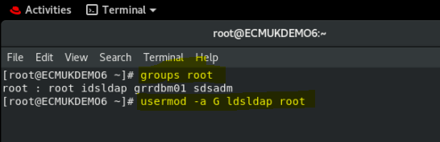

## IBM Installation Manager Launch

## Download Installation Manager (25th February, 2019)

REF

<https://www-03.ibm.com/isc/esd/dswdown/searchPartNumber.wss?ls=true&tt=DD&pn=CND0ZML>

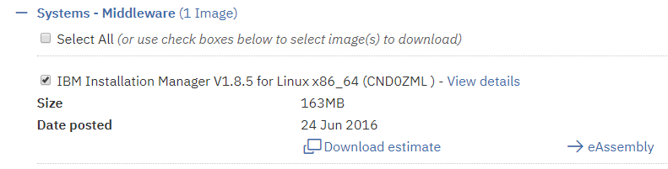

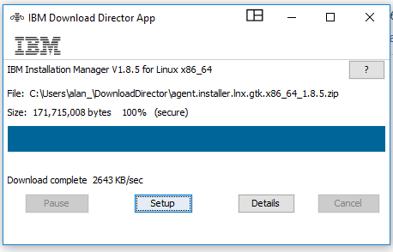

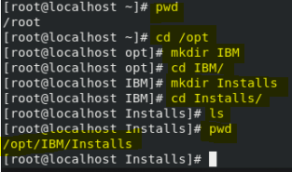

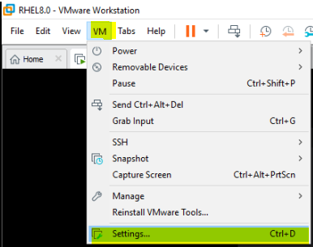

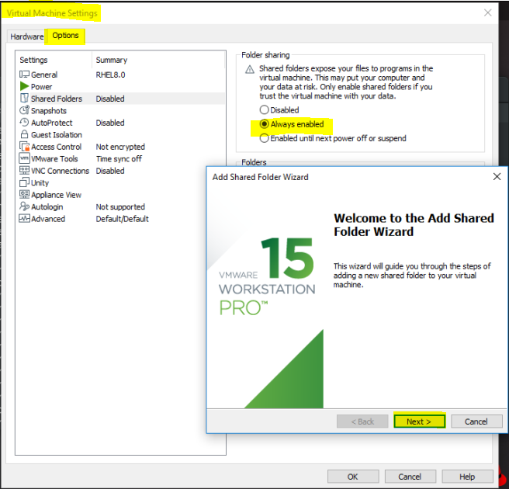

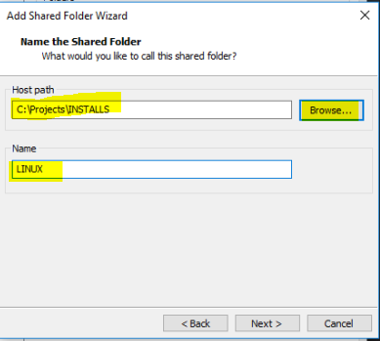

Add a VMware shared folder, reference as LINUX

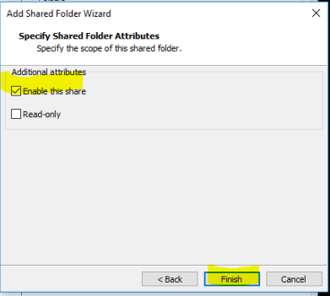

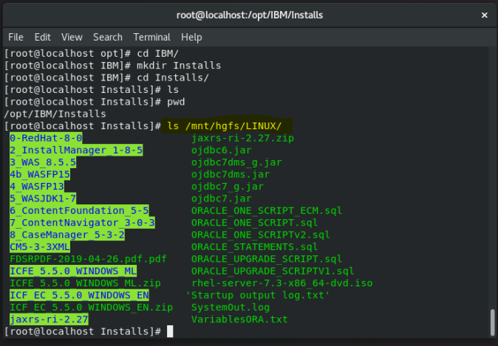

from

[root@localhost Installs]#

Use the Linux copy command to copy the downloaded IBM Installation Manager 1.8.5 zip file to the server installation folder, Installs

cp /mnt/hgfs/LINUX/2\_InstallManager\_1-8-5/agent.installer.lnx.gtk.x86\_64\_1.8.5.zip .

unzip agent.installer.lnx.gtk.x86\_64\_1.8.5.zip

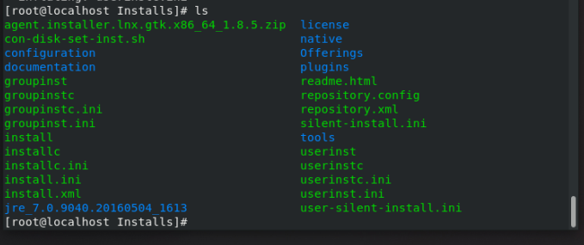

## Run the install for IBM Installation Manager

<https://www.itzgeek.com/how-tos/linux/centos-how-tos/how-to-install-gnome-gui-on-rhel-8.html>

[root@localhost Installs]# **xauth info**

Authority file: /root/.Xauthority

File new: no

File locked: no

Number of entries: 1

Changes honored: yes

Changes made: no

Current input: (argv):1

[root@localhost Installs]#

usermod -aG wheel idsldap

**logout and then log back into the GUI**

**id**

**to list groups**

[**https://developers.redhat.com/blog/2018/08/15/how-to-enable-sudo-on-rhel/**](https://developers.redhat.com/blog/2018/08/15/how-to-enable-sudo-on-rhel/)

yum group list

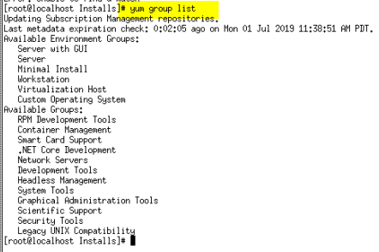

Install Gnome GUI using the [YUM command](https://www.itzgeek.com/how-tos/linux/centos-how-tos/linux-basics-30-yum-command-examples-for-linux-package-manager.html).

**yum groupinstall "Server with GUI"**

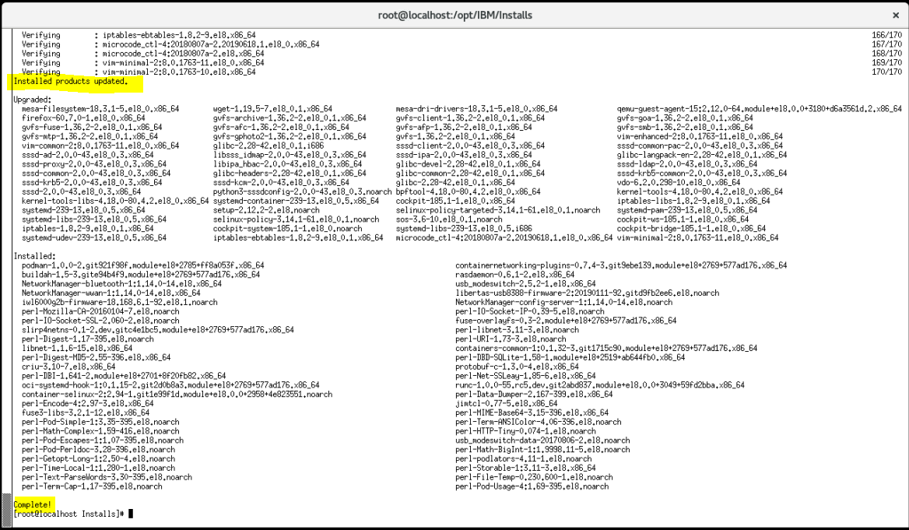

systemctl set-default graphical

reboot

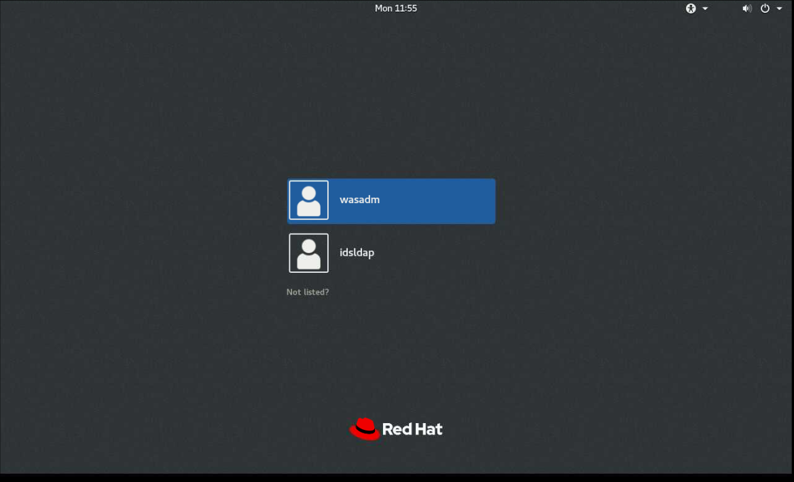

[root@localhost Installs]# **systemctl set-default graphical**

[root@localhost Installs]# **reboot**

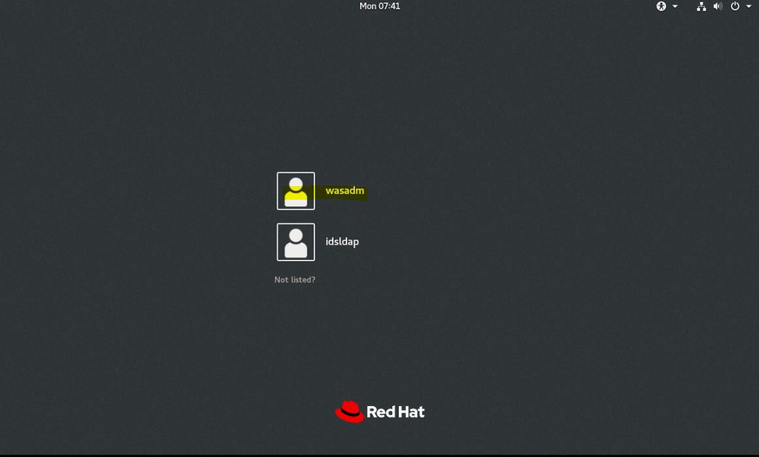

**[root@localhost Installs]# xhost +**

**No protocol specified**

**xhost: unable to open display ":0.0"**

**REF:** [**https://www-01.ibm.com/support/docview.wss?uid=swg21163846**](https://www-01.ibm.com/support/docview.wss?uid=swg21163846)

Make sure the X11 window server is running, and use the following command to note the port number:

ps -ef | egrep X11



export DISPLAY=localhost:0.0 export DISPLAY

**xhost +SI:localuser:root**

# visudo

and add

idsldap  ALL=(ALL) ALL

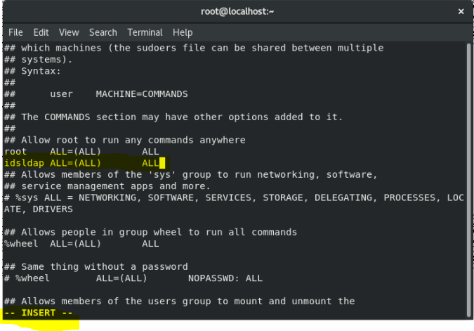

so this user can do all administrative jobs(same as root) by simply prefixing sudo and entering his own password ( or use "idsldap ALL=(ALL)  NOPASSWD: ALL" if you dont want to enter passwd).

**Best solution found as follows!**

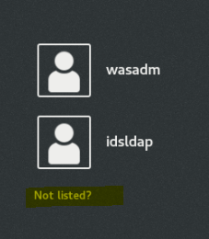

Select Not listed? As shown above

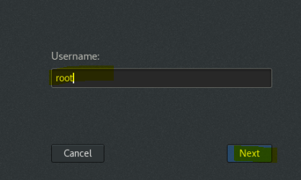

Log in as root

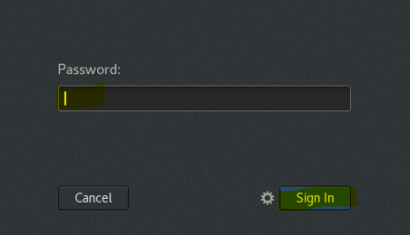

Enter the Password and click Sign In

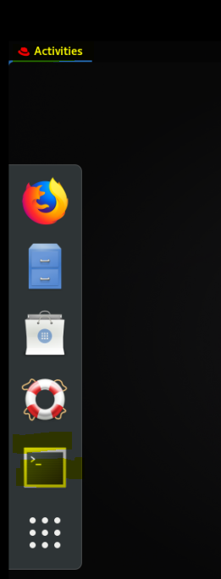

Select Terminal

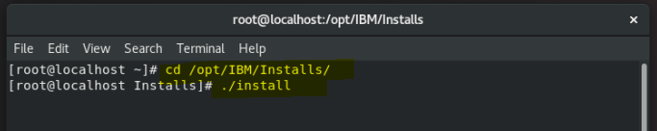

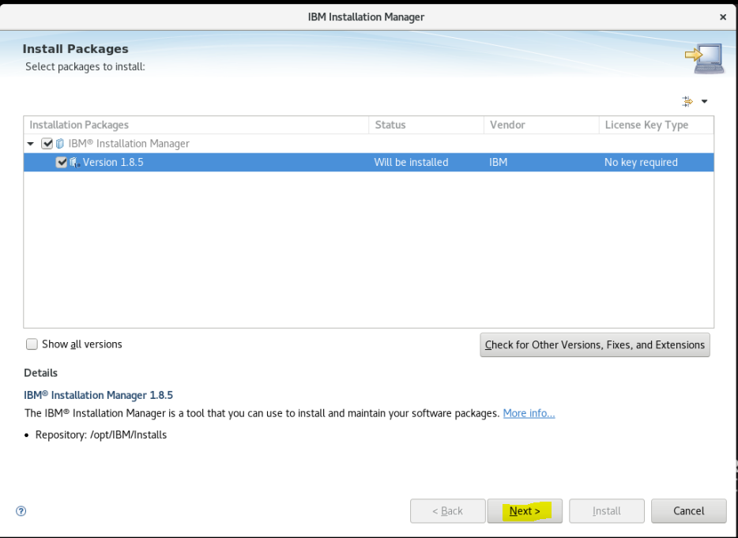

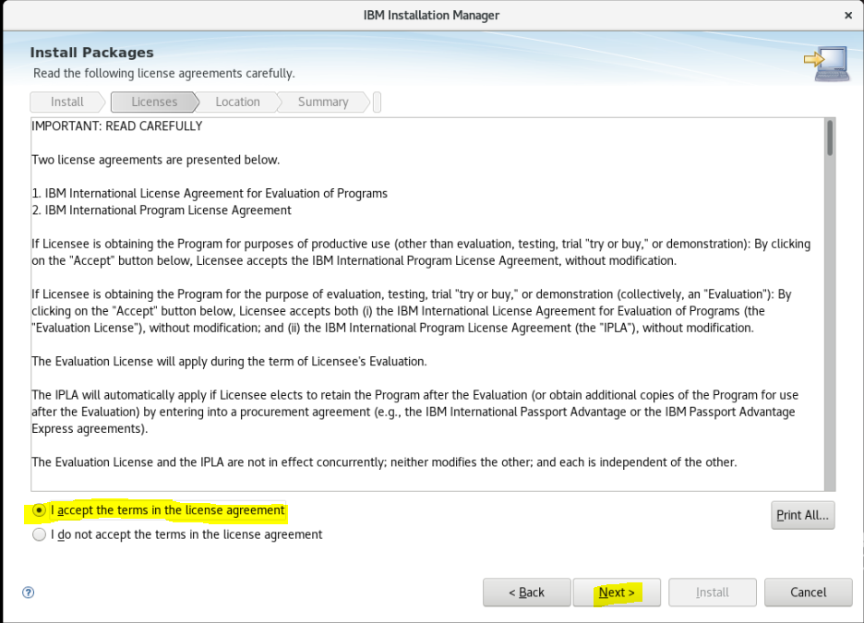

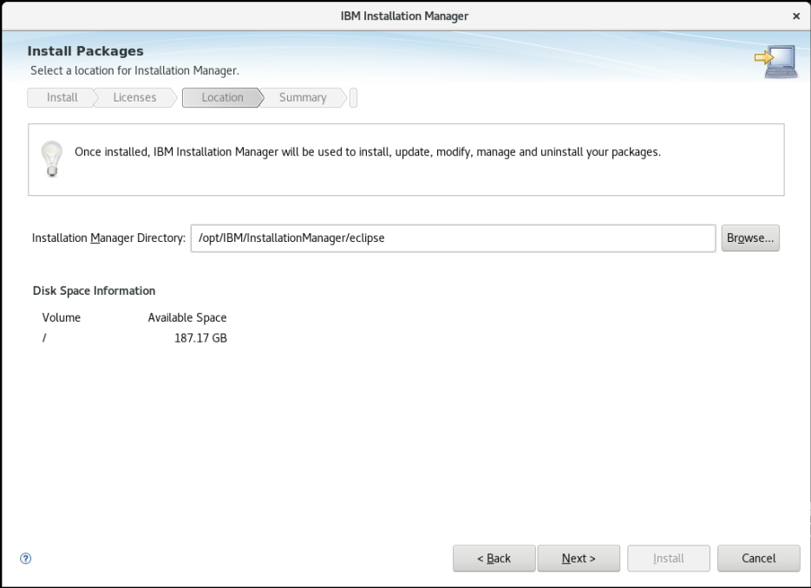

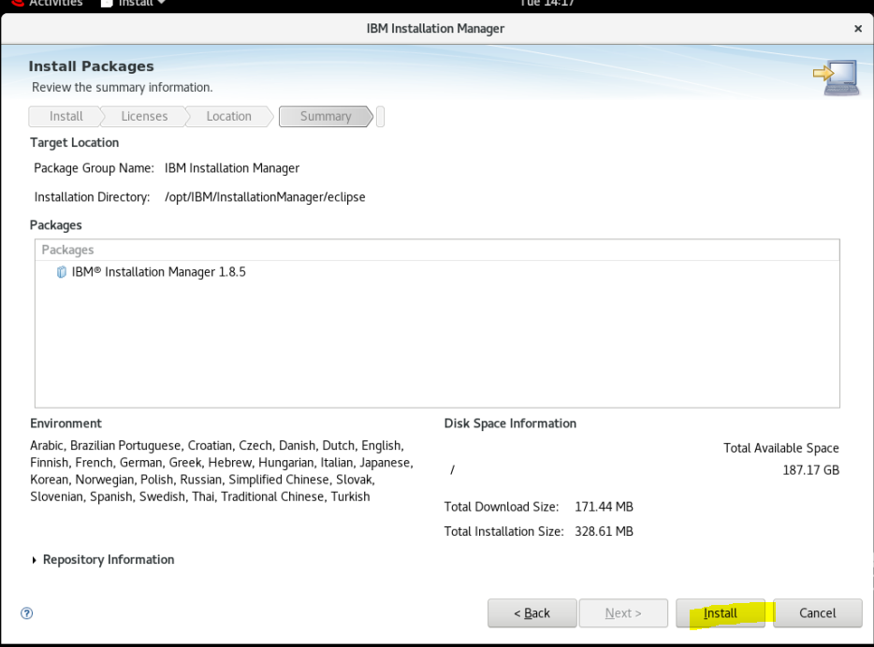

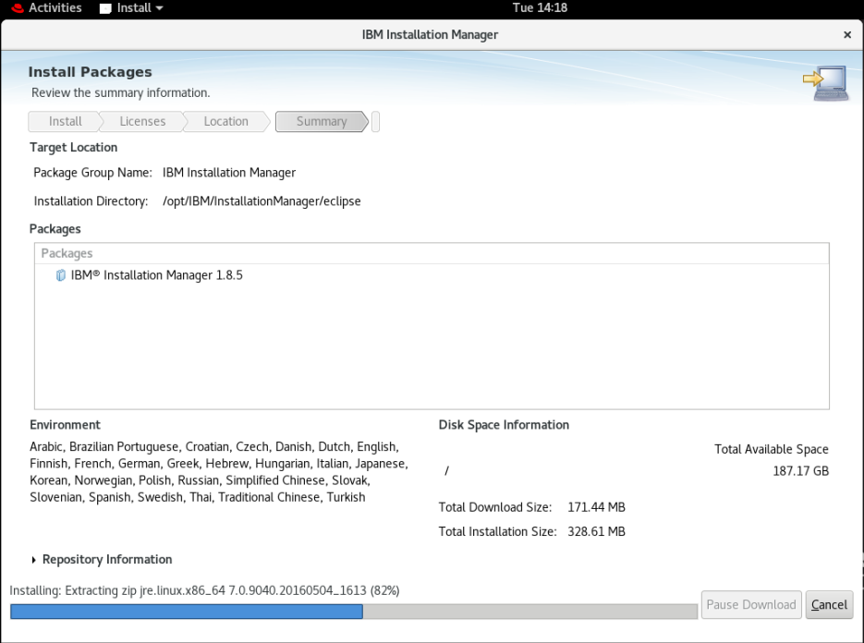

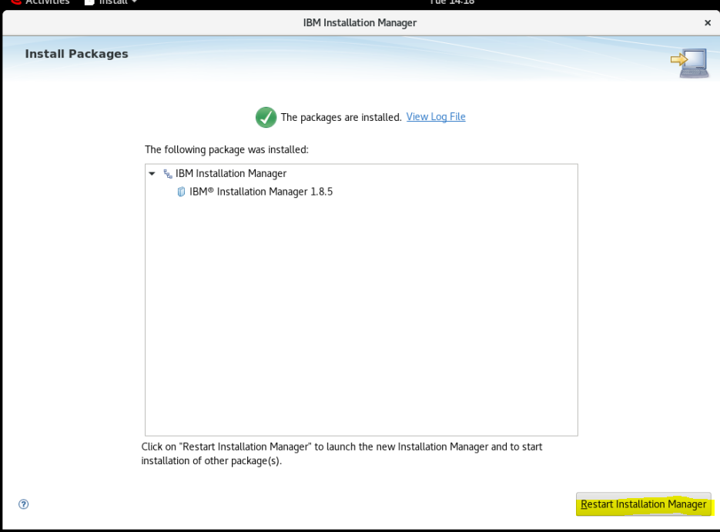

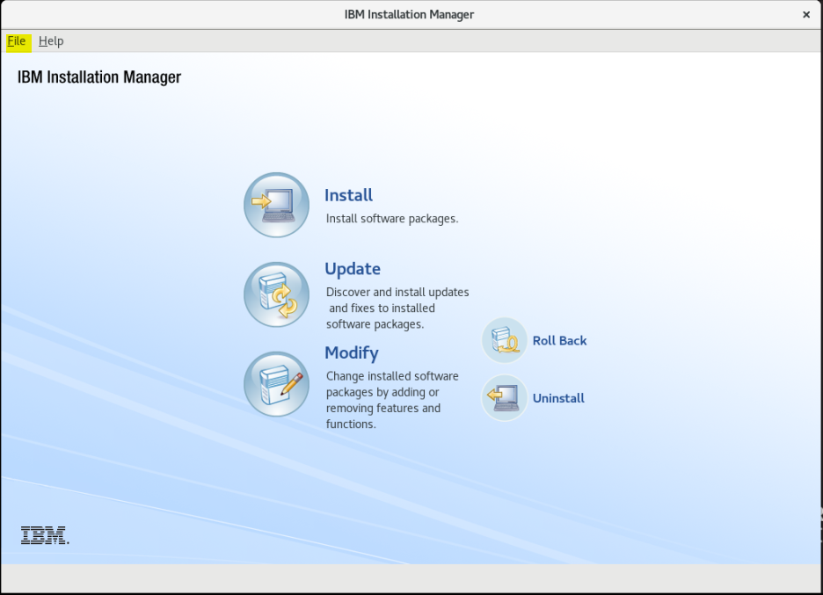

Can be started from the Desktop now:

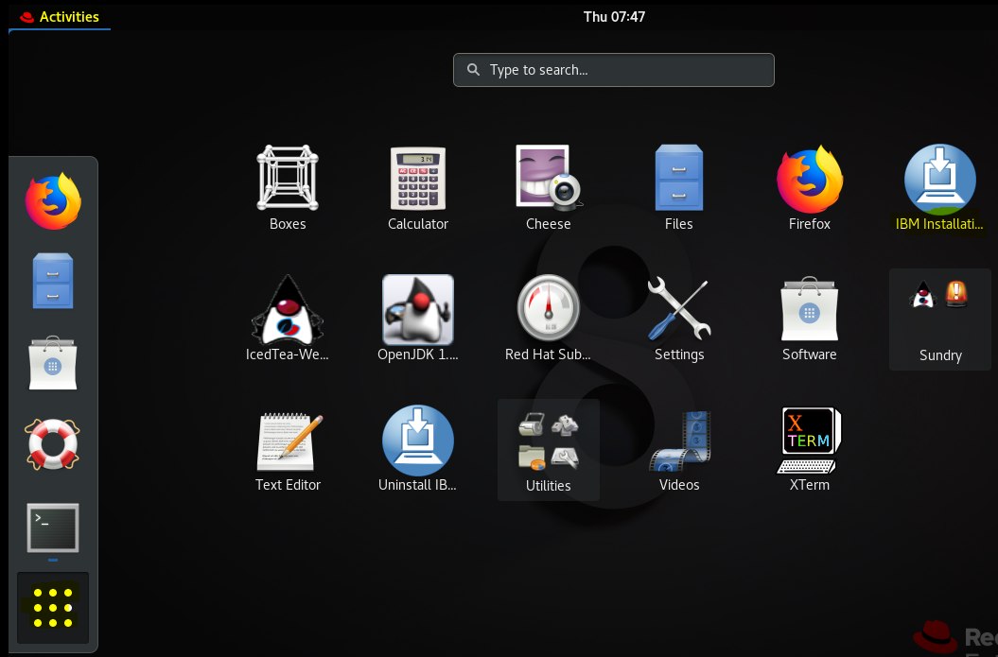

Double click on the IBM Installer Icon highlighted above

### Install WebSphere 8.5.5 Fix Pack 15

#### Download WebSphere 8.5.5

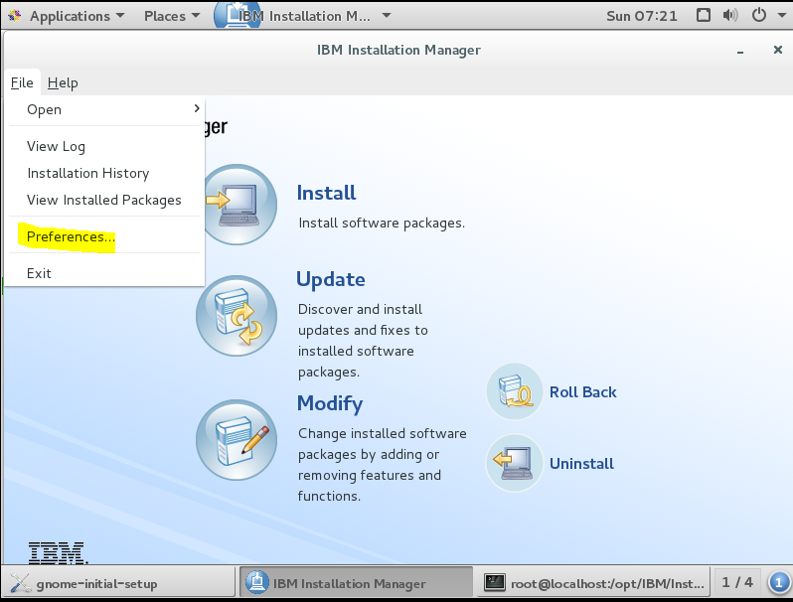

## Installation of WebSphere ( I am using WebSphere 8.5.5 Fix Pack 15 )

## Copy the base 8.5.5 WebSphere:

[root@localhost InstallManager18]# **pwd**

**/opt/IBM/Installs/**

[root@localhost Installs]# **mkdir WebSphere855**

[root@localhost Installs]# **cd WebSphere855/**

#### Using FTP server –Procedure for Installation of FTP

Signed in as root use:

dnf install vsftpd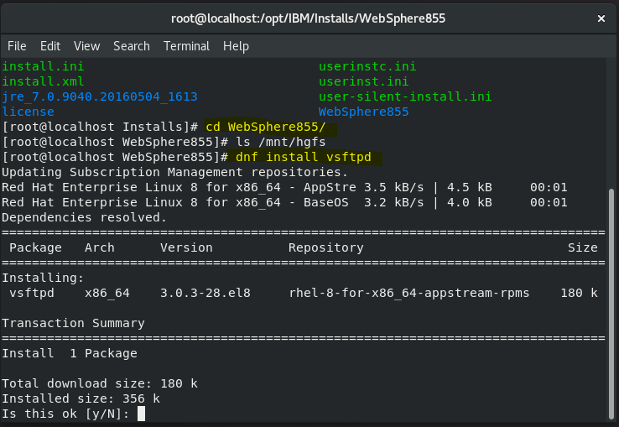

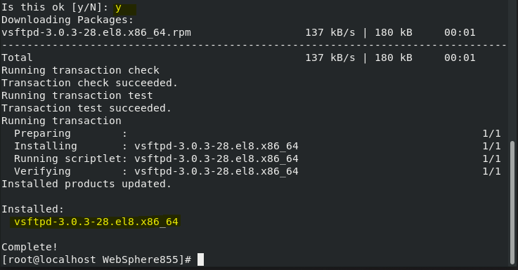

Make a backup copy of the FTP configuration file

mv /etc/vsftpd/vsftpd.conf /etc/vsftpd/vsftpd.conf\_orig



Start with a clean configuration file

grep -v ^# /etc/vsftpd/vsftpd.conf\_orig > /etc/vsftpd/vsftpd.conf



View the initial configuration file and start the system

cat /etc/vsftpd/vsftpd.conf

systemctl start vsftpd

systemctl enable vsftpd

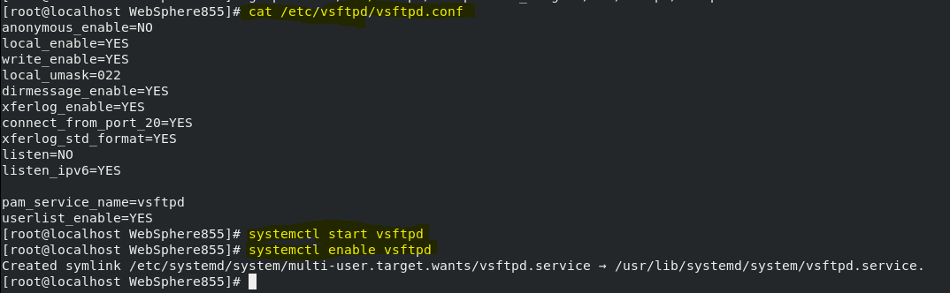

Open firewall FTP port 21 incoming connections:

firewall-cmd --zone=public --permanent --add-service=ftp

firewall-cmd --reload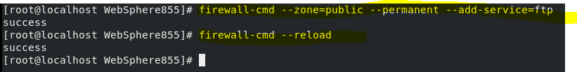

Test FTP connection from the remote host using the ftp command. Use your regular user credentials to login. For example, create an FTP connection to host ip

:

chown root:wasadm -R /opt

Using binary mode to transfer files.

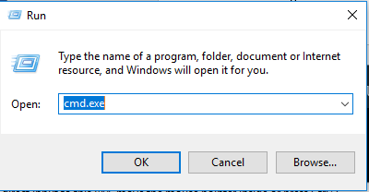

Enter ftp from the windows command line:

ftp>open 192.168.50.128

(Or whatever the host ip or DNS Host RHEL 8.0 server name is set to)

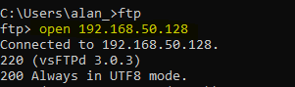

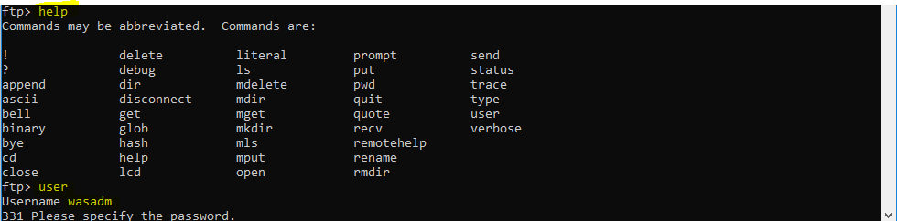



Move to the local binary installation directory using lcd

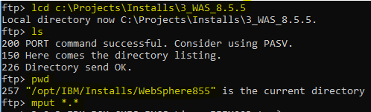

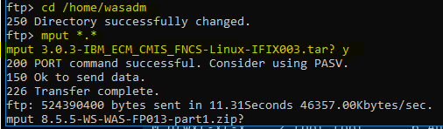

(NB use the lcd ftp command to select the local windows installation binary holding directory)

Now copy the ftp’d Base WebSphere 8.5.5 installation zip files to the WebSphere Installs sub-directory

cp /home/wasadm/WASND\*.zip /opt/IBM/Installs/WebSphere855/

#### Using VMware

[root@localhost WebSphere855]# **cp /mnt/hgfs/LINUX/WAS\_8.5.5/WASND\_v8.5.5\_\*.zip .**

(NB Takes awhile!)

#### Installing the Base WebSphere 8.5.5 application server

[root@localhost WebSphere855]# ls

WASND\_v8.5.5\_1of3.zip WASND\_v8.5.5\_2of3.zip WASND\_v8.5.5\_3of3.zip

[root@localhost WebSphere855]#

unzip WASND\_v8.5.5\_1of3.zip

unzip WASND\_v8.5.5\_2of3.zip

unzip WASND\_v8.5.5\_3of3.zip

[root@localhost WebSphere855]# ls -lsa

total 2909896

0 drwxr-xr-x. 9 root root 270 Mar 10 07:51 .

0 drwxrwxr-x. 4 wasadm wasadm 50 Mar 10 07:25 ..

4 -rw-r--r--. 1 root root 380 May 14 2013 Copyright.txt

0 drwxr-xr-x. 5 root root 56 May 14 2013 disk1

0 drwxr-xr-x. 3 root root 35 May 14 2013 disk2

0 drwxr-xr-x. 3 root root 35 May 14 2013 disk3

4 drwxr-xr-x. 2 root root 4096 May 14 2013 lafiles

0 drwxr-xr-x. 10 root root 156 May 14 2013 readme

0 drwxr-xr-x. 3 root root 43 May 14 2013 Remote\_Installation\_Tool\_for\_IBM\_i

4 -rw-r--r--. 1 root root 81 May 14 2013 repository.config

0 drwxr-xr-x. 3 root root 21 May 14 2013 responsefiles

1030000 -rwxr-xr-x. 1 root root 1054717615 Mar 10 07:34 WASND\_v8.5.5\_1of3.zip

998588 -rwxr-xr-x. 1 root root 1022550691 Mar 10 07:39 WASND\_v8.5.5\_2of3.zip

881296 -rwxr-xr-x. 1 root root 902443241 Mar 10 07:43 WASND\_v8.5.5\_3of3.zip

[root@localhost WebSphere855]# **rm -rf \*.zip**

(Above to save space as we no longer need the WAS .zip files)

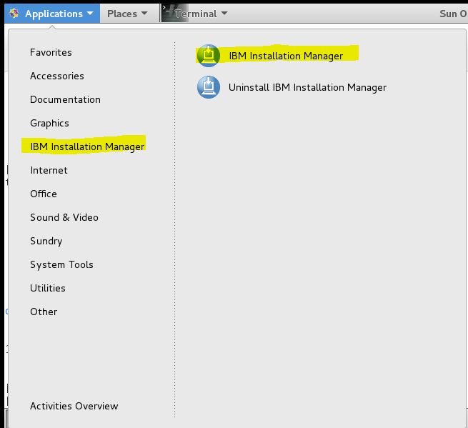



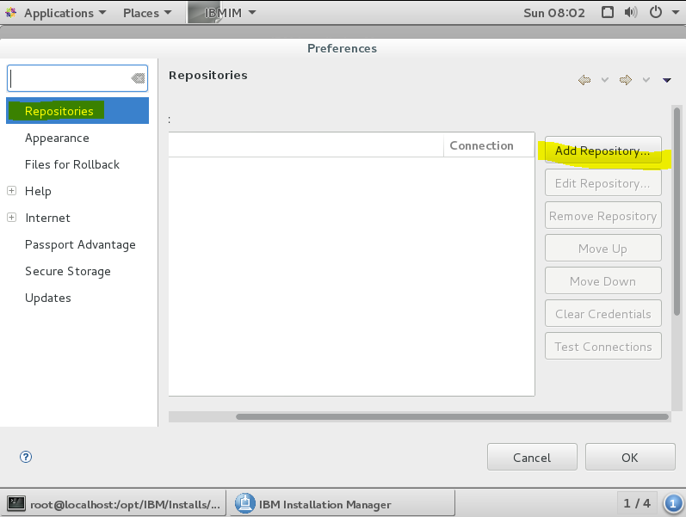

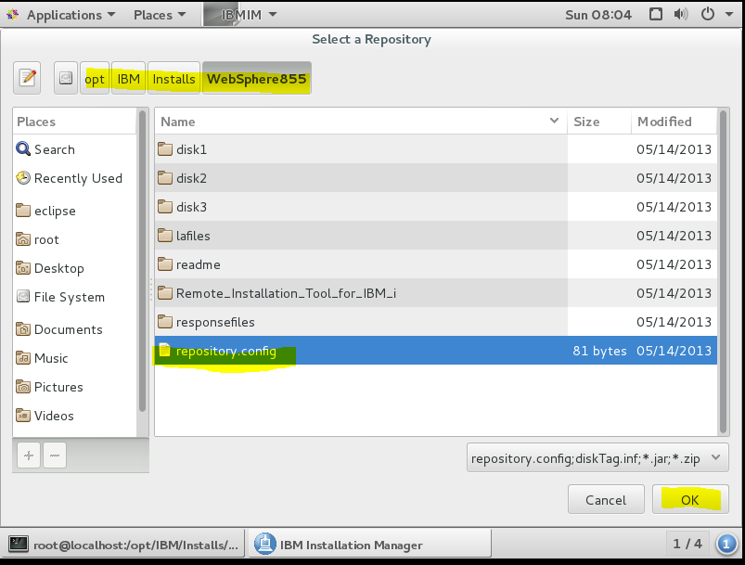

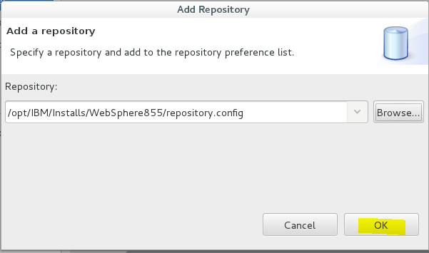

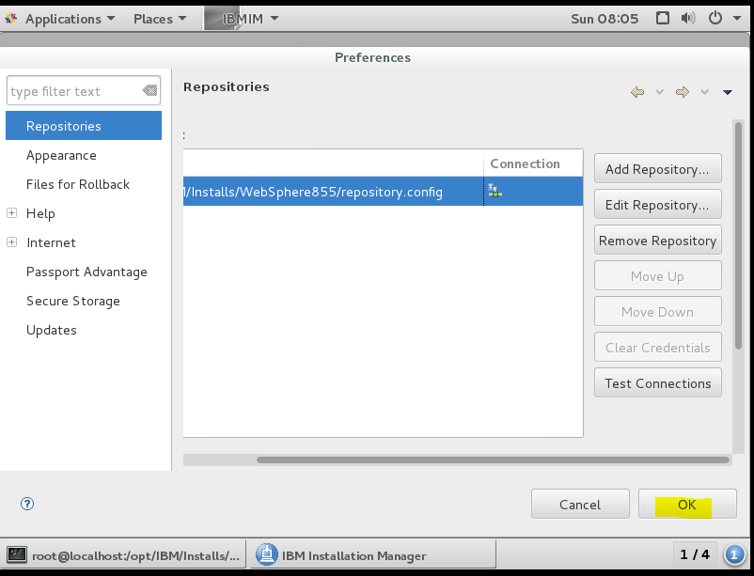

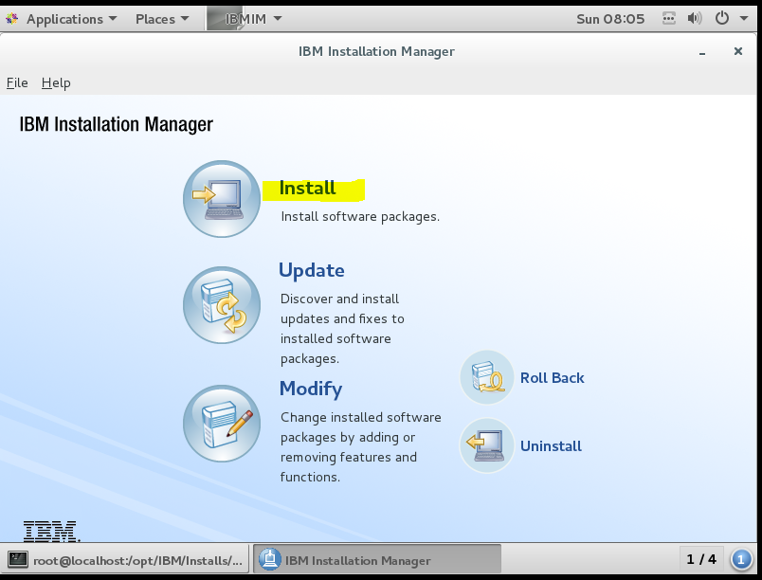

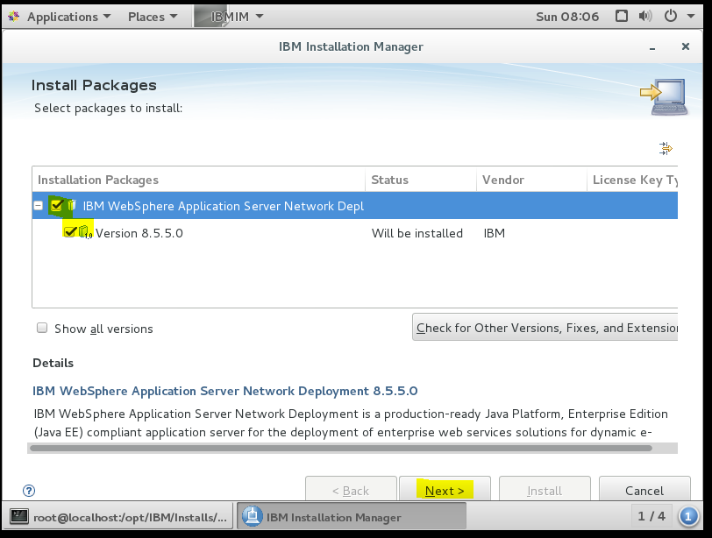

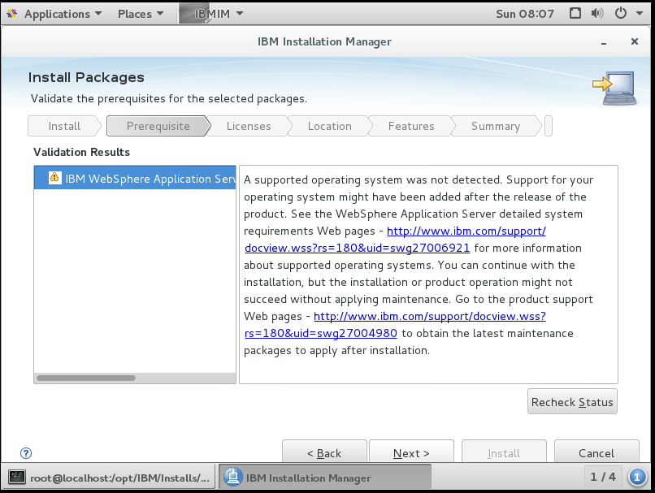

Click Next anyway!!

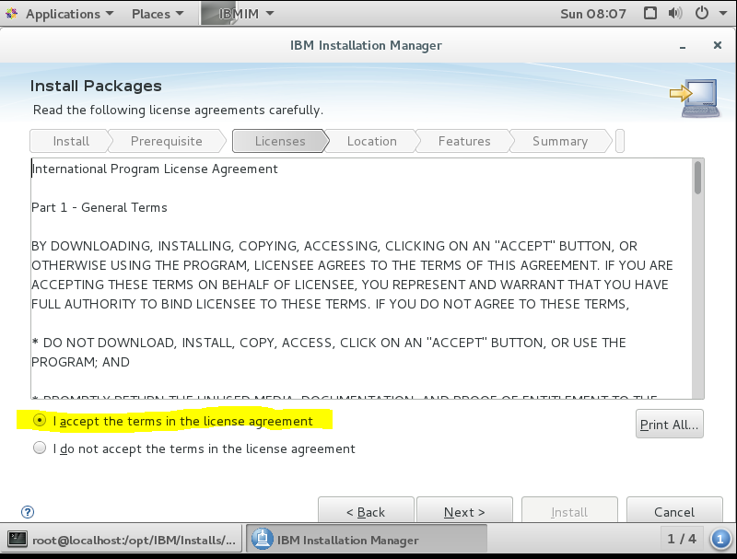

Select I accept… and click Next

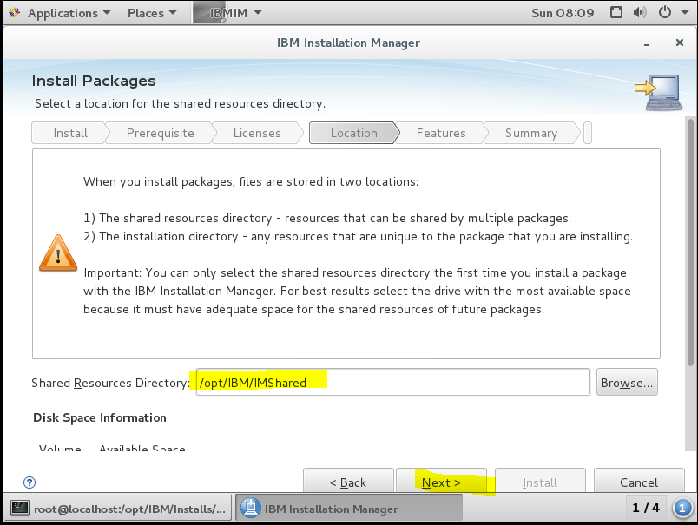

Select Next

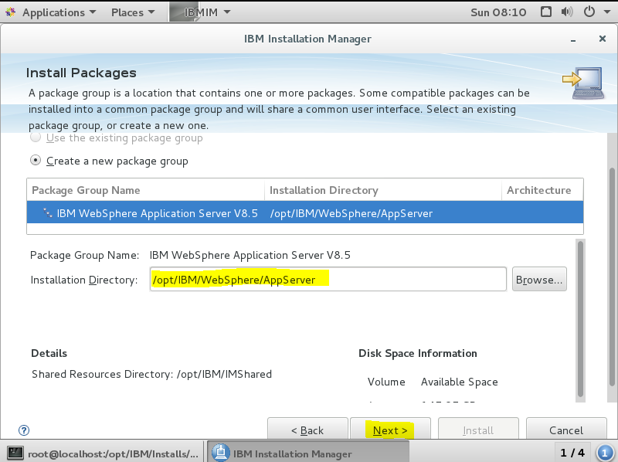

Select Next… (NB note the path generated by the Installer)

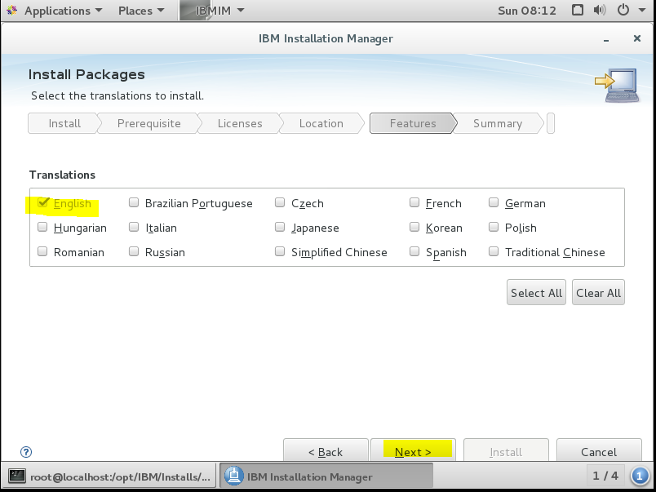

Select any additional language packs required and click Next

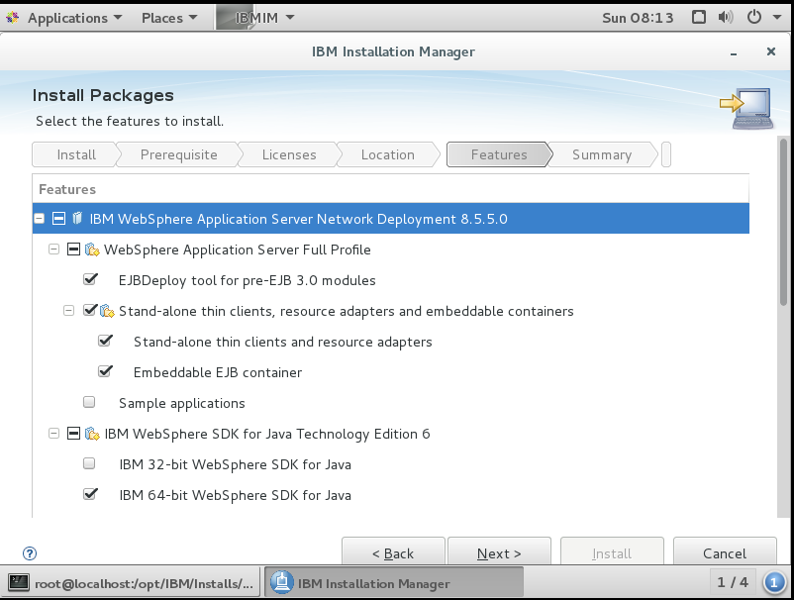

Scroll down to see installation settings made

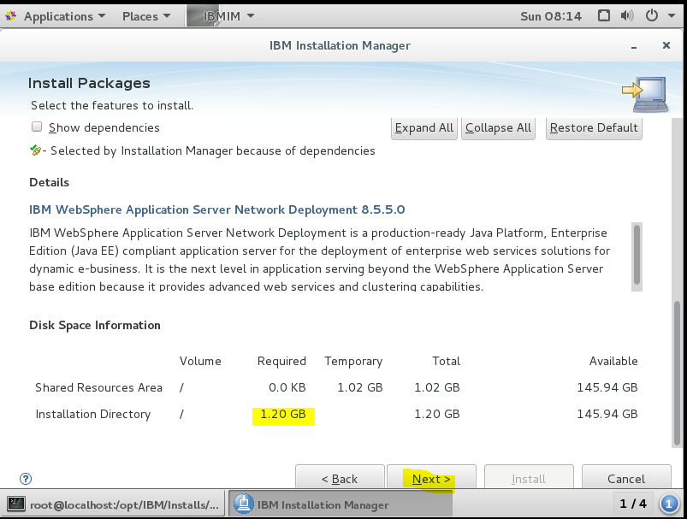

Click Next to install

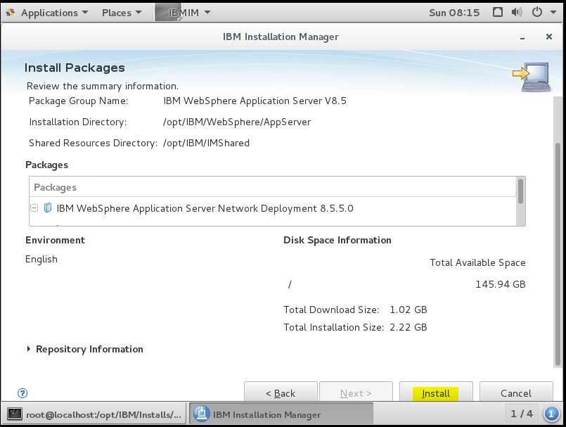

Click Install

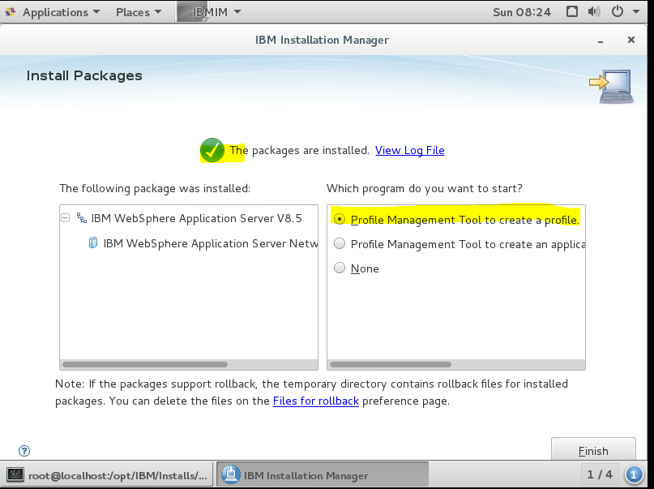

Click Finish and launch create a profile

**NOTE: On RHEL 8.0 with the Base WebSphere 8.5.5 I get an error (see screen shot )so need to run Fix Pack upgrade first**

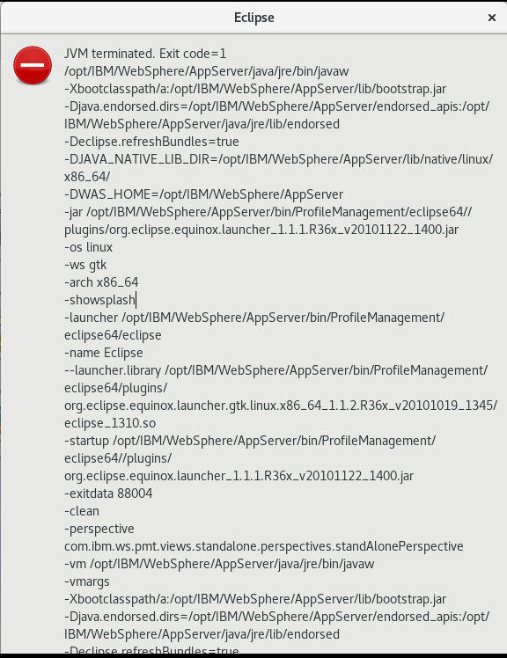

#### Upgrade WebSphere 8.5.5 Base

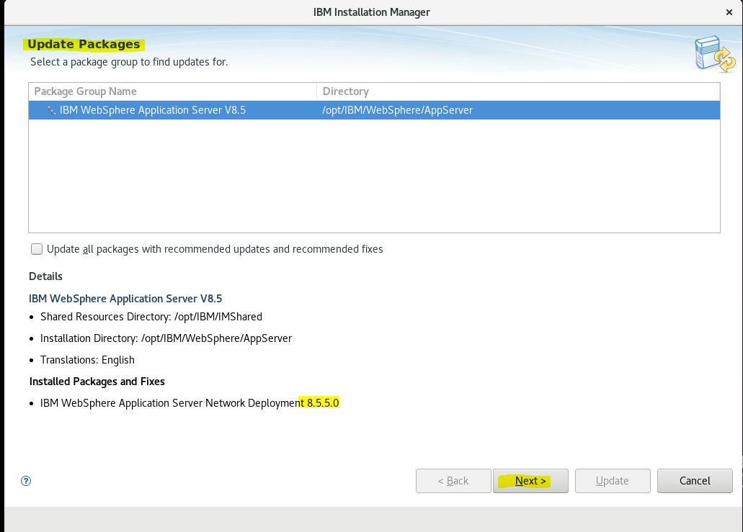

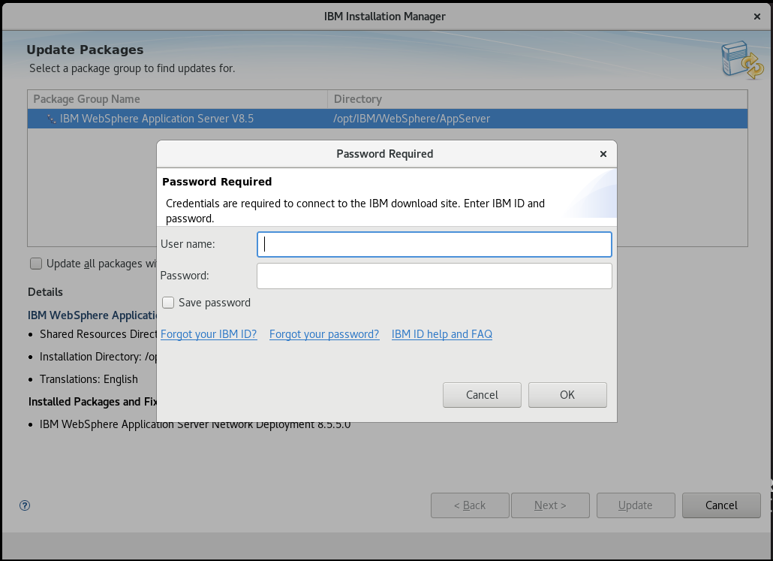

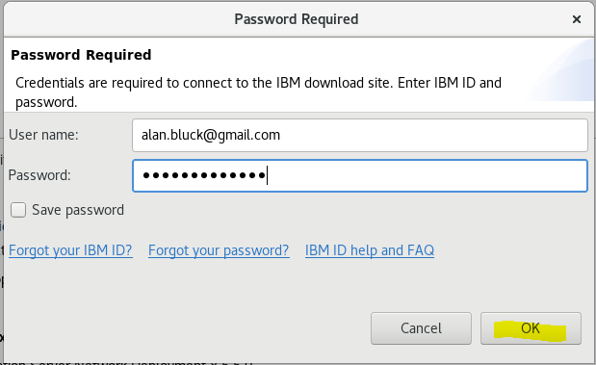

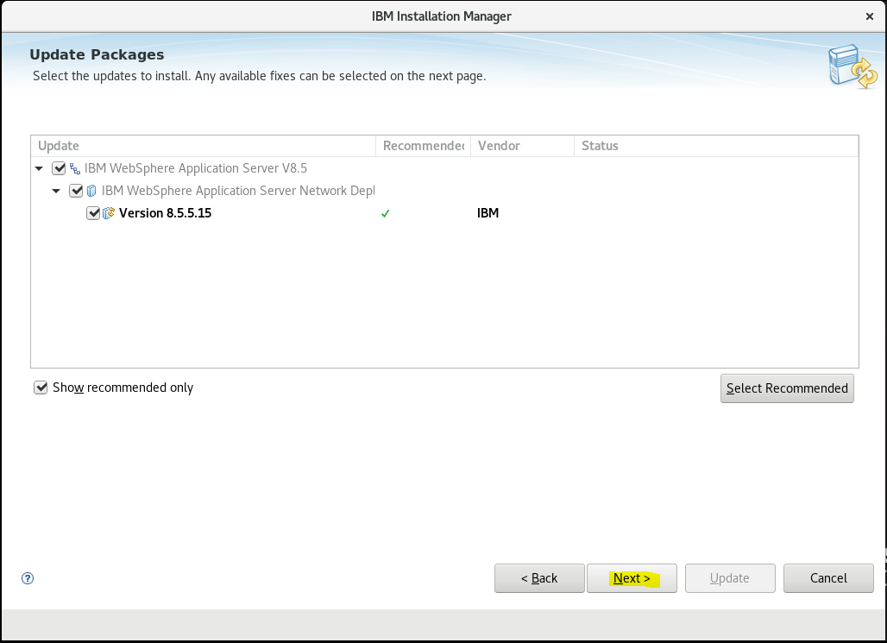

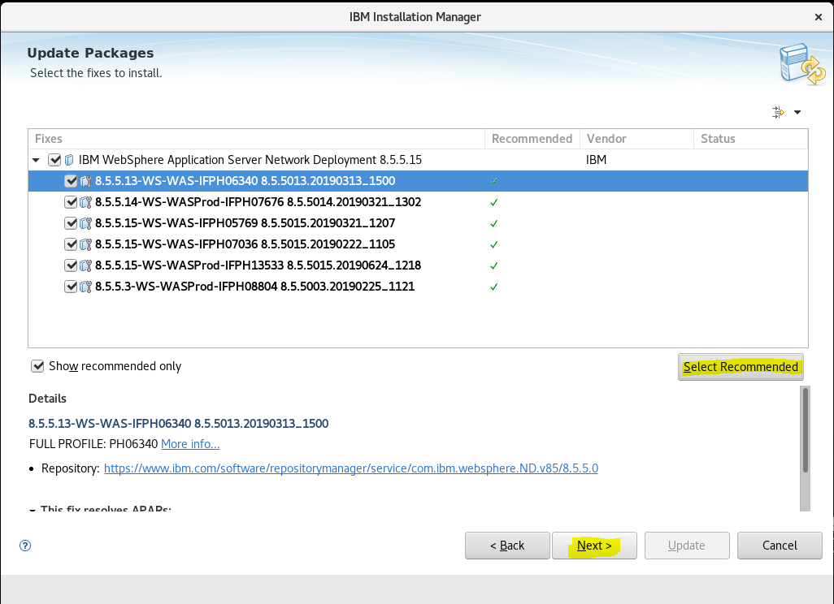

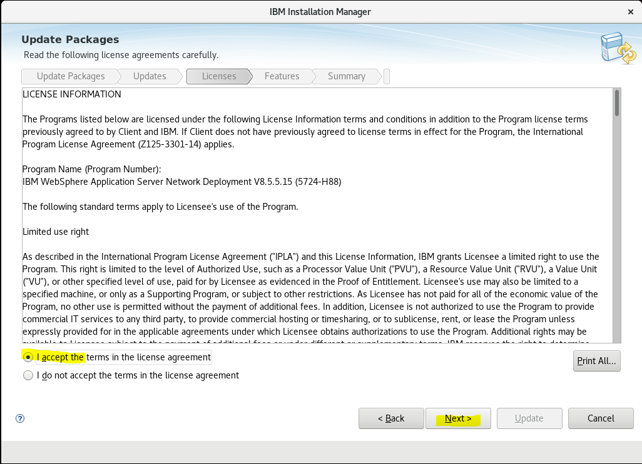

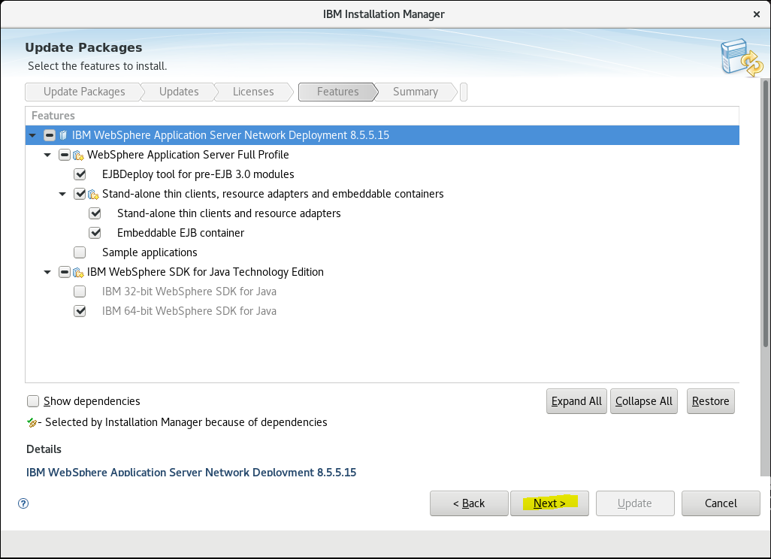

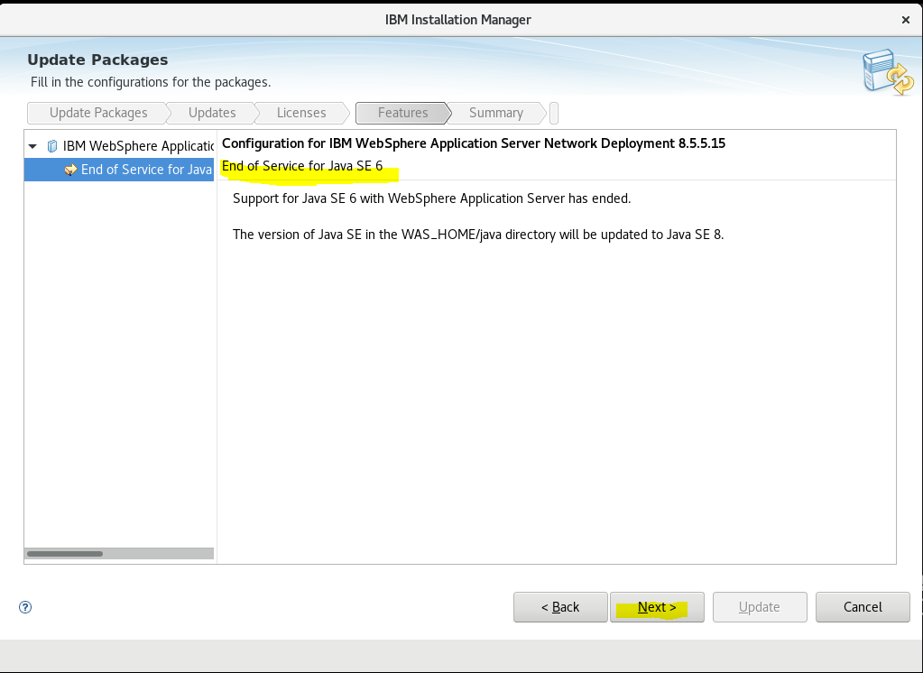

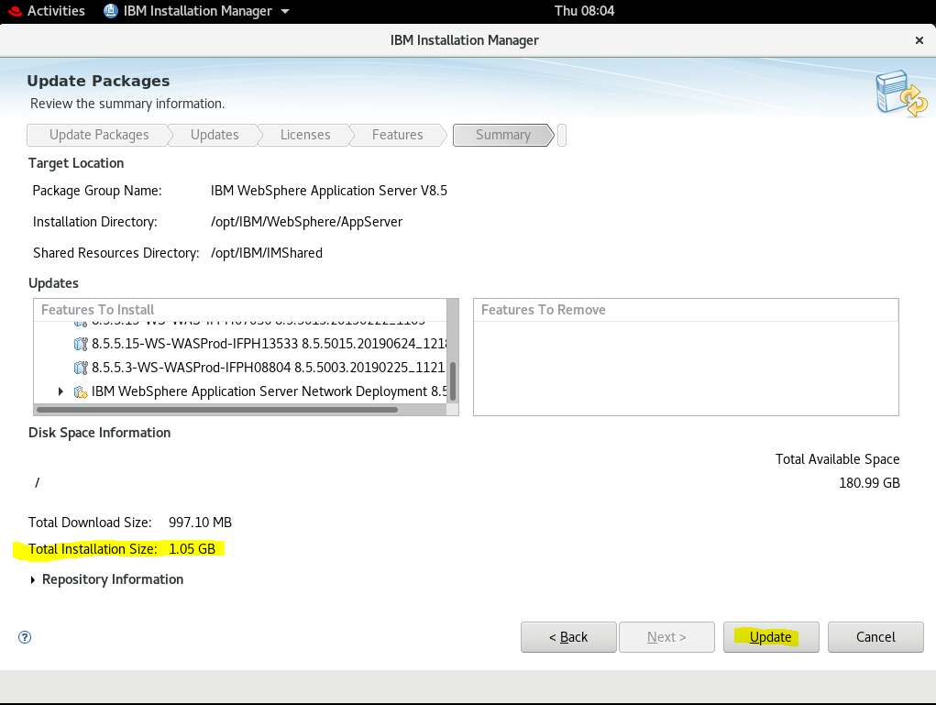

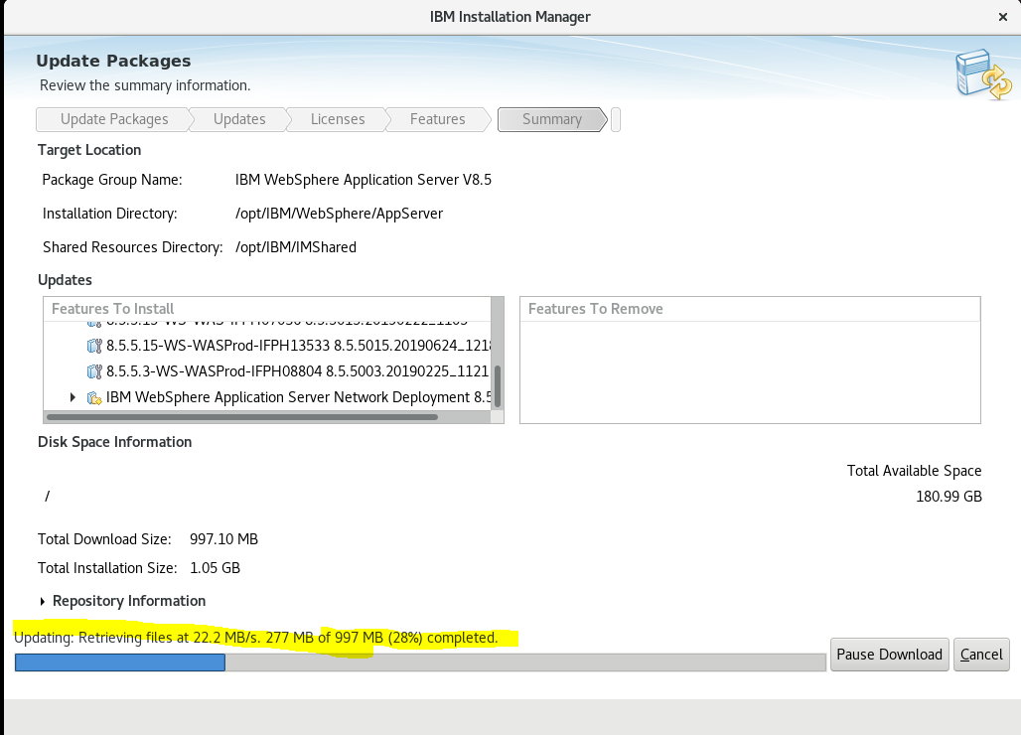

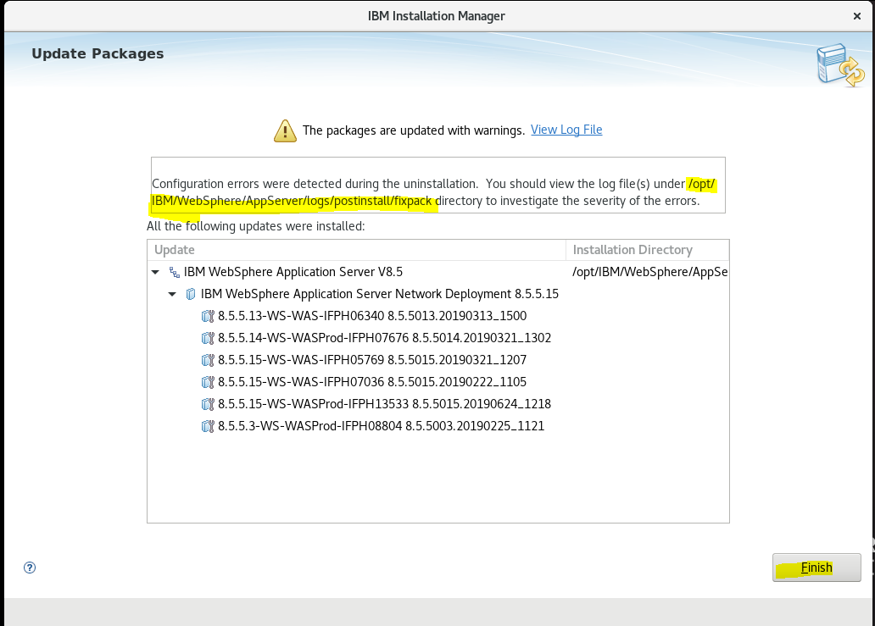

Repeat Update Install procedure

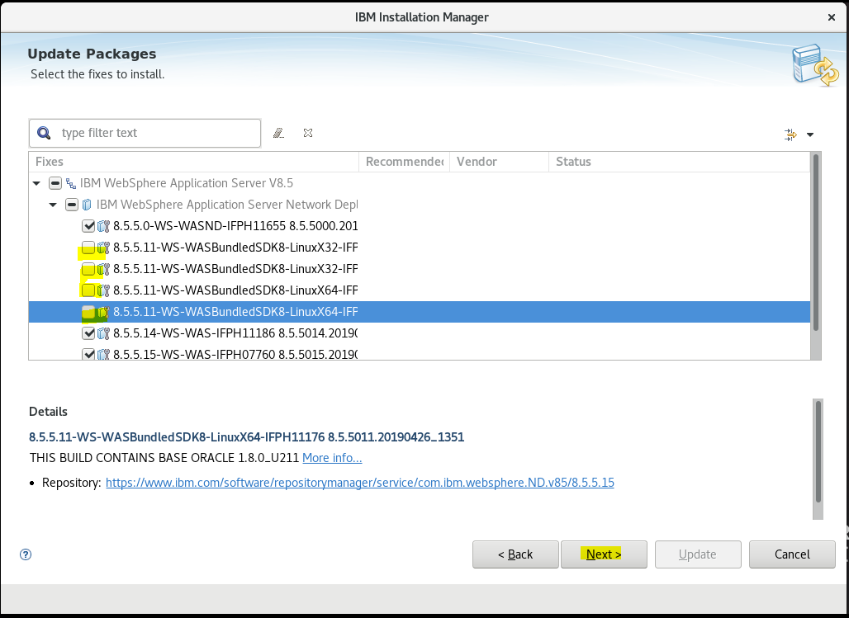

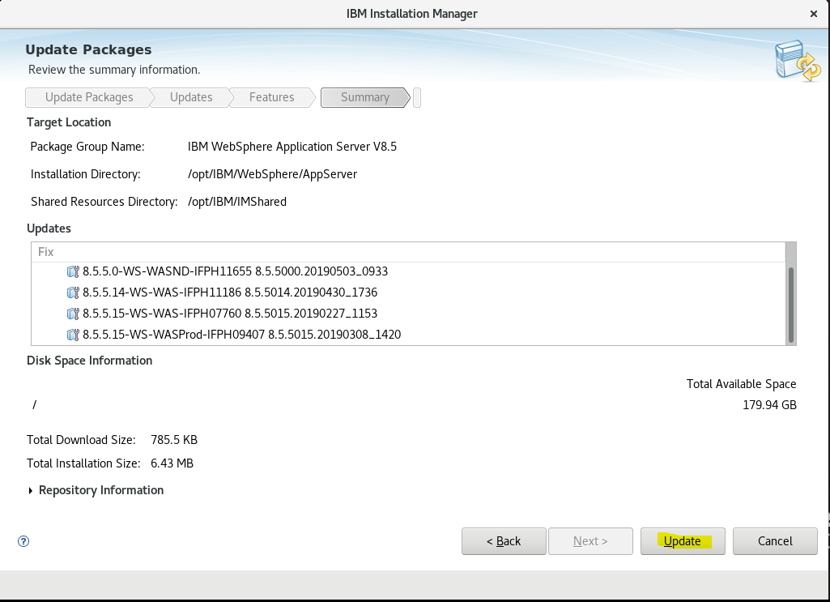

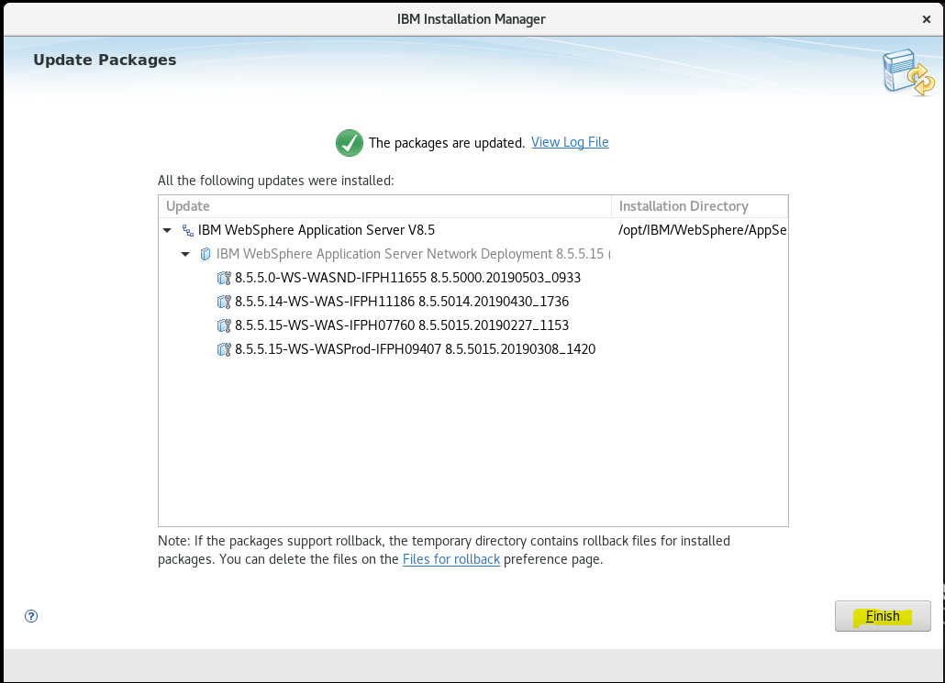

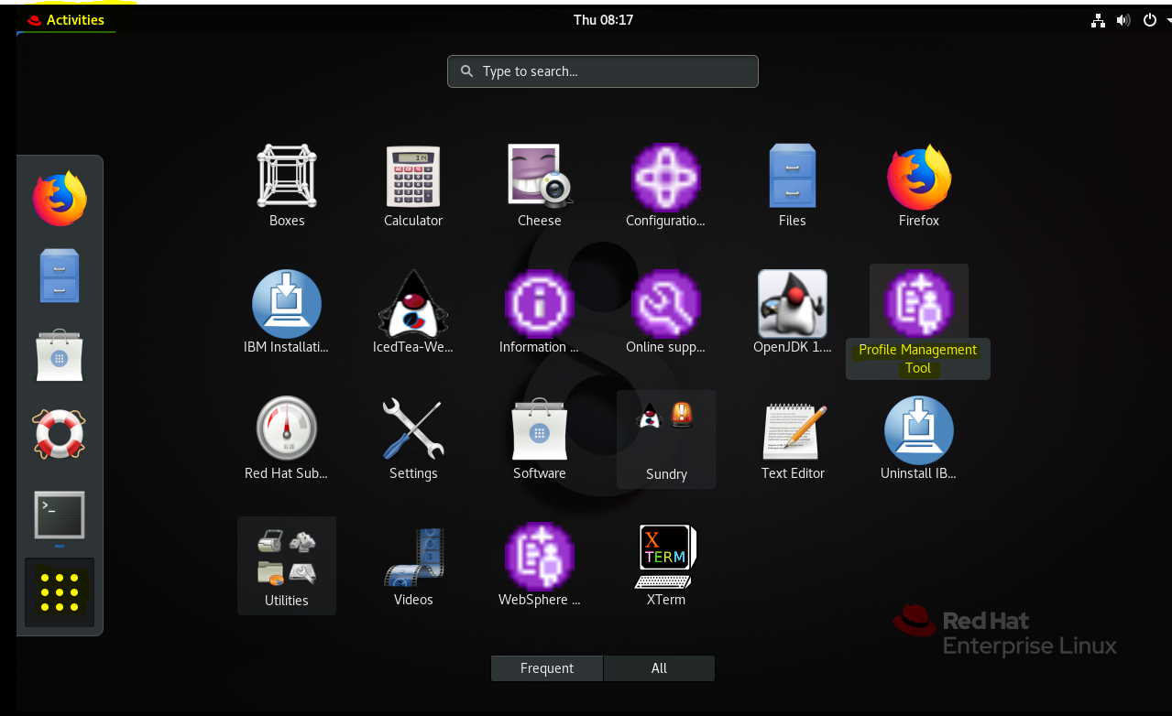

Double-Click on the Profile Management Tool

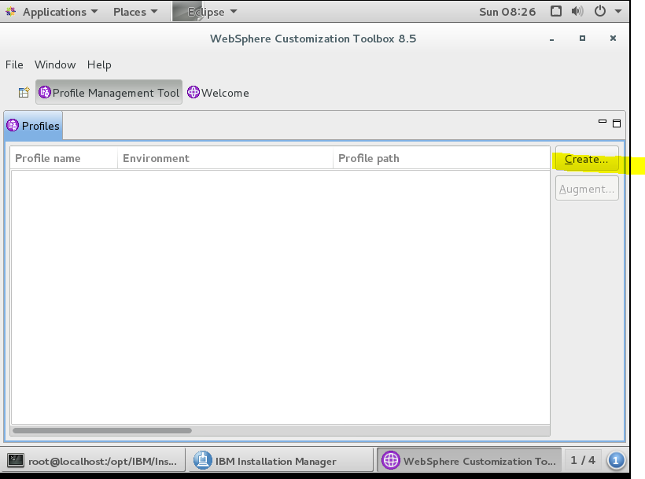

Select Create

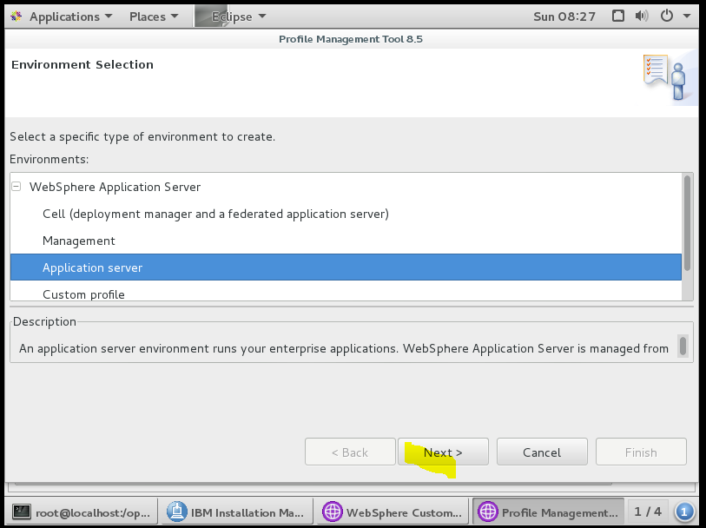

Click Next

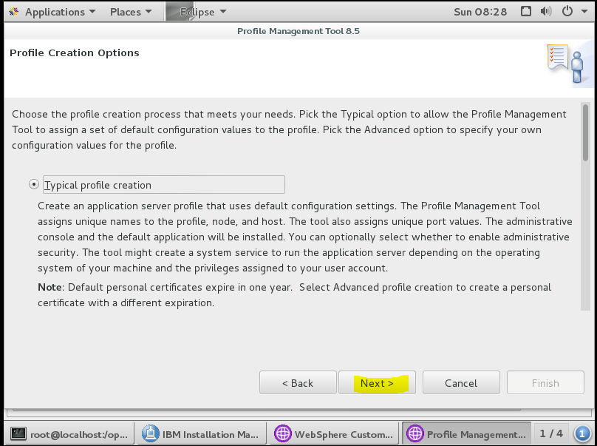

Click Next

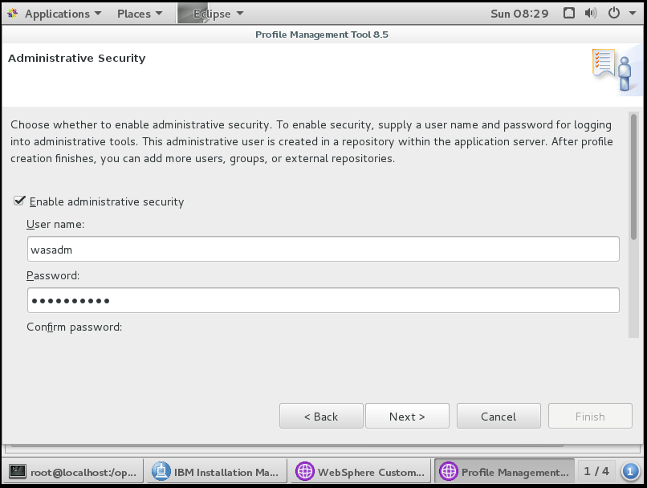

Scroll down to confirm password and click Next

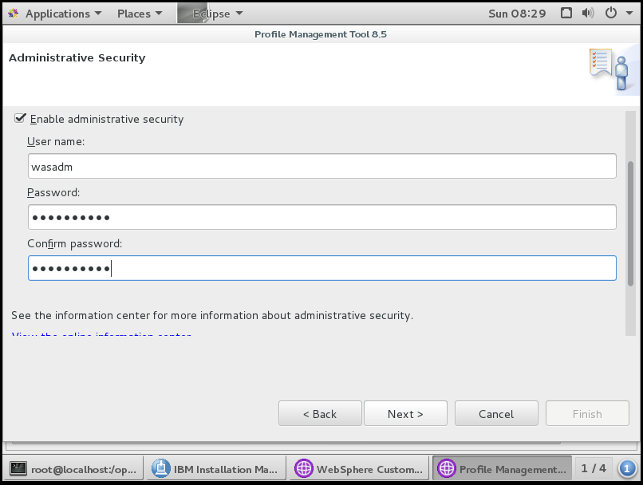

Click Next

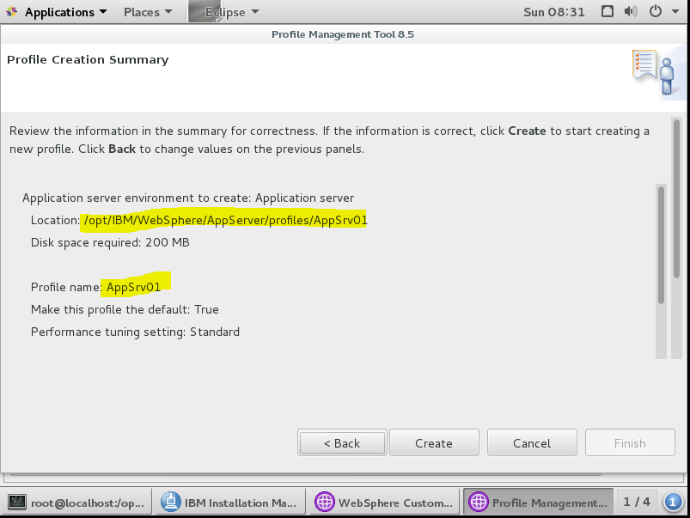

Note the profile name and path and ports (see scroll-down below) and click Create

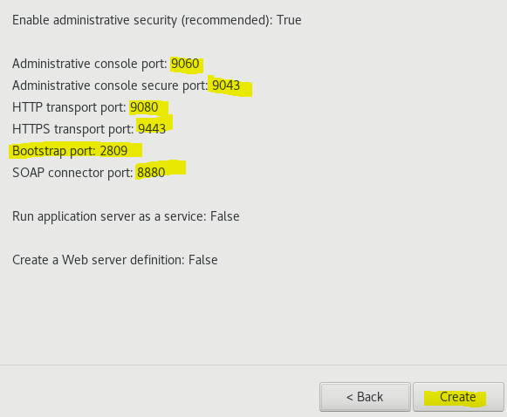

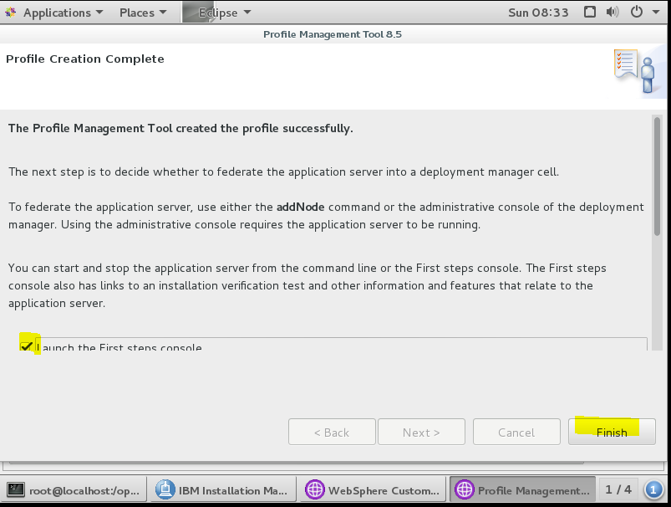

Click Finish and launch the First Steps console to test the deployment

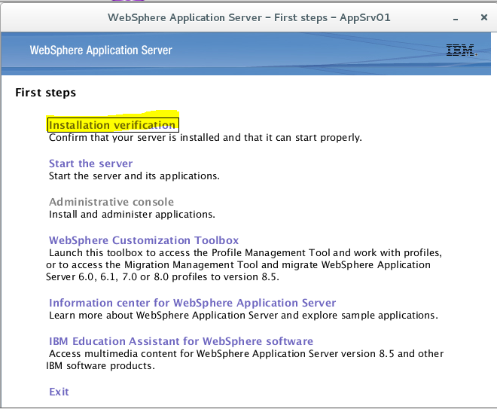

Select and click on Installation verification

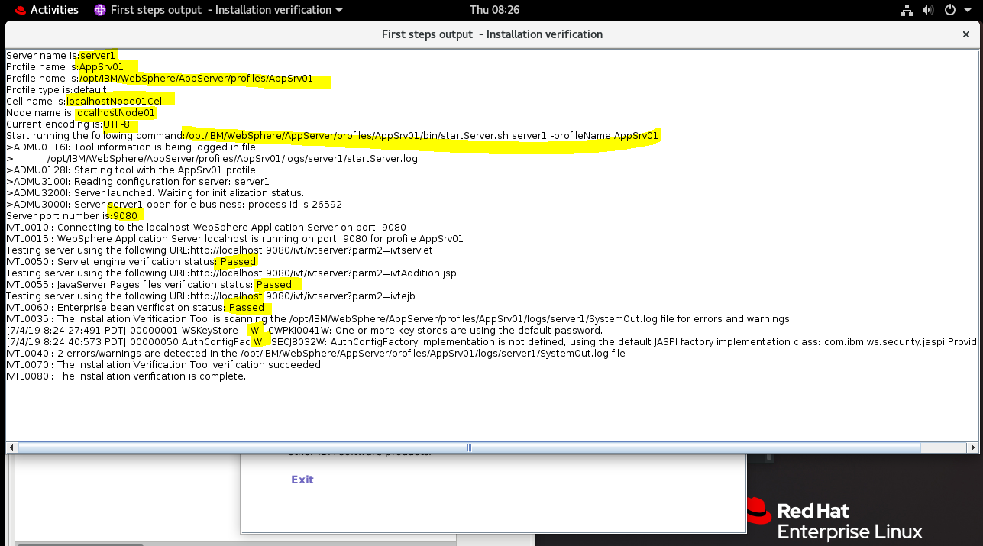

Window shows the startup passed OK

Full Log below

Server name is:server1

Profile name is:AppSrv01

Profile home is:/opt/IBM/WebSphere/AppServer/profiles/AppSrv01

Profile type is:default

Cell name is:localhostNode01Cell

Node name is:localhostNode01

Current encoding is:UTF-8

Start running the following command:/opt/IBM/WebSphere/AppServer/profiles/AppSrv01/bin/startServer.sh server1 -profileName AppSrv01

>ADMU0116I: Tool information is being logged in file

> /opt/IBM/WebSphere/AppServer/profiles/AppSrv01/logs/server1/startServer.log

>ADMU0128I: Starting tool with the AppSrv01 profile

>ADMU3100I: Reading configuration for server: server1

>ADMU3200I: Server launched. Waiting for initialization status.

>ADMU3000I: Server server1 open for e-business; process id is 26592

Server port number is:9080

IVTL0010I: Connecting to the localhost WebSphere Application Server on port: 9080

IVTL0015I: WebSphere Application Server localhost is running on port: 9080 for profile AppSrv01

Testing server using the following URL:http://localhost:9080/ivt/ivtserver?parm2=ivtservlet

IVTL0050I: Servlet engine verification status: Passed

Testing server using the following URL:http://localhost:9080/ivt/ivtserver?parm2=ivtAddition.jsp

IVTL0055I: JavaServer Pages files verification status: Passed

Testing server using the following URL:http://localhost:9080/ivt/ivtserver?parm2=ivtejb

IVTL0060I: Enterprise bean verification status: Passed

IVTL0035I: The Installation Verification Tool is scanning the /opt/IBM/WebSphere/AppServer/profiles/AppSrv01/logs/server1/SystemOut.log file for errors and warnings.

[7/4/19 8:24:27:491 PDT] 00000001 WSKeyStore W CWPKI0041W: One or more key stores are using the default password.

[7/4/19 8:24:40:573 PDT] 00000050 AuthConfigFac W SECJ8032W: AuthConfigFactory implementation is not defined, using the default JASPI factory implementation class: com.ibm.ws.security.jaspi.ProviderRegistry.

IVTL0040I: 2 errors/warnings are detected in the /opt/IBM/WebSphere/AppServer/profiles/AppSrv01/logs/server1/SystemOut.log file

IVTL0070I: The Installation Verification Tool verification succeeded.

IVTL0080I: The installation verification is complete.

Select Stop Server from the First Steps links

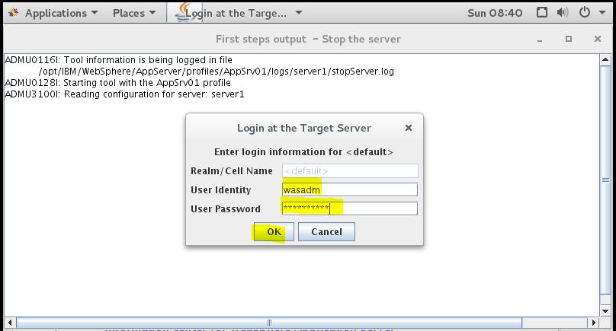

ADMU0116I: Tool information is being logged in file

/opt/IBM/WebSphere/AppServer/profiles/AppSrv01/logs/server1/stopServer.log

ADMU0128I: Starting tool with the AppSrv01 profile

ADMU3100I: Reading configuration for server: server1

ADMU3201I: Server stop request issued. Waiting for stop status.

ADMU4000I: Server server1 stop completed.

**Repeat above steps to create a second profile AppSrv02**

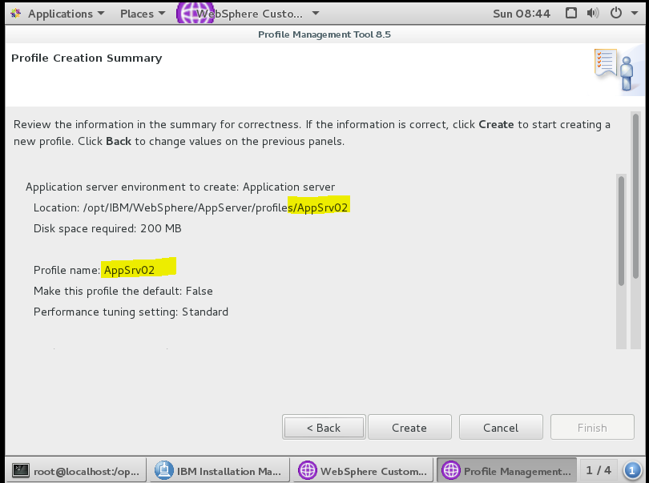

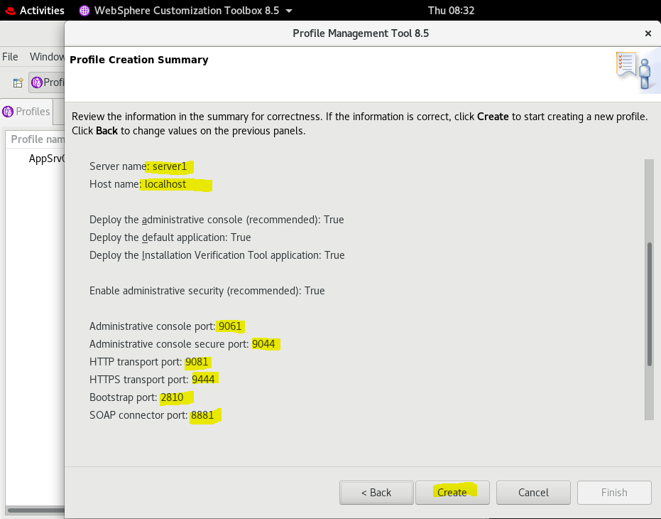

Click Create

Repeat the Installation verification steps for the second profile

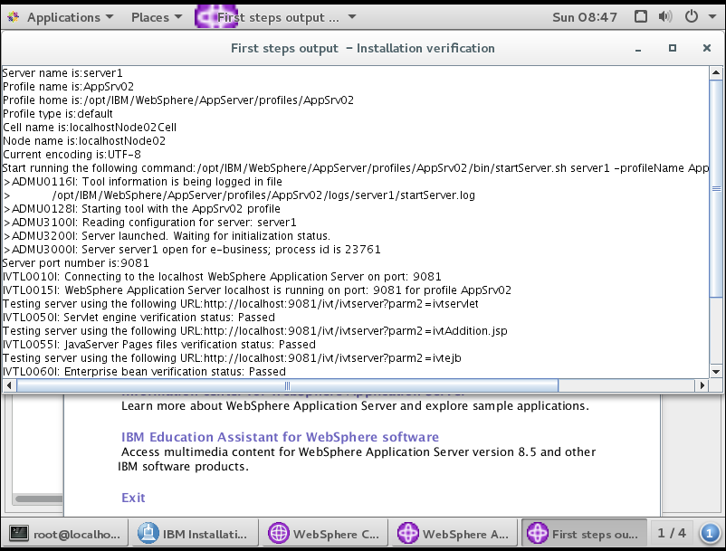

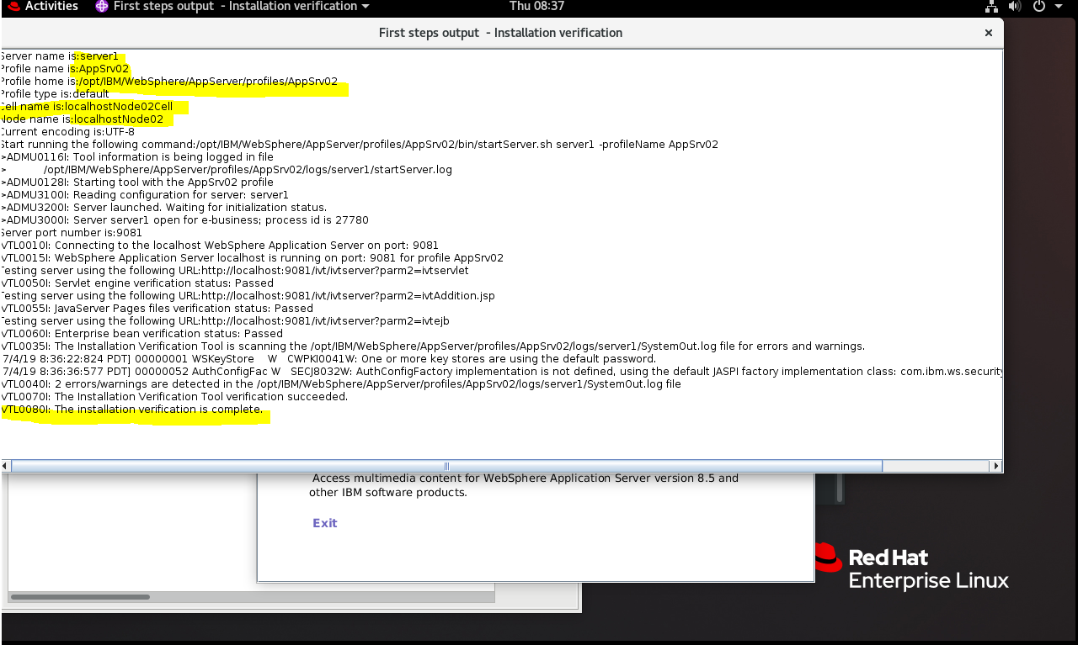

Full log Below

Server name is:server1

Profile name is:**AppSrv02**

Profile home is:/opt/IBM/WebSphere/AppServer/profiles/AppSrv02

Profile type is:default

Cell name is:**localhostNode02Cell**

Node name is:**localhostNode02**

Current encoding is**:UTF-8**

Start running the following command:/opt/IBM/WebSphere/AppServer/profiles/AppSrv02/bin/startServer.sh server1 -profileName AppSrv02

>ADMU0116I: Tool information is being logged in file

> /opt/IBM/WebSphere/AppServer/profiles/AppSrv02/logs/server1/startServer.log

>ADMU0128I: Starting tool with the AppSrv02 profile

>ADMU3100I: Reading configuration for server: server1

>ADMU3200I: Server launched. Waiting for initialization status.

>ADMU3000I: Server server1 open for e-business; process id is 27780

Server port number is:**9081**

IVTL0010I: Connecting to the localhost WebSphere Application Server on port: 9081

IVTL0015I: WebSphere Application Server localhost is running on port: 9081 for profile AppSrv02

Testing server using the following URL:http://localhost:9081/ivt/ivtserver?parm2=ivtservlet

IVTL0050I: Servlet engine verification status: Passed

Testing server using the following URL:http://localhost:9081/ivt/ivtserver?parm2=ivtAddition.jsp

IVTL0055I: JavaServer Pages files verification status: Passed

Testing server using the following URL:http://localhost:9081/ivt/ivtserver?parm2=ivtejb

IVTL0060I: Enterprise bean verification status: Passed

IVTL0035I: The Installation Verification Tool is scanning the /opt/IBM/WebSphere/AppServer/profiles/AppSrv02/logs/server1/SystemOut.log file for errors and warnings.

[7/4/19 8:36:22:824 PDT] 00000001 WSKeyStore W CWPKI0041W: One or more key stores are using the default password.

[7/4/19 8:36:36:577 PDT] 00000052 AuthConfigFac W SECJ8032W: AuthConfigFactory implementation is not defined, using the default JASPI factory implementation class: com.ibm.ws.security.jaspi.ProviderRegistry.

IVTL0040I: 2 errors/warnings are detected in the /opt/IBM/WebSphere/AppServer/profiles/AppSrv02/logs/server1/SystemOut.log file

IVTL0070I: The Installation Verification Tool verification succeeded.

IVTL0080I: The installation verification is complete.

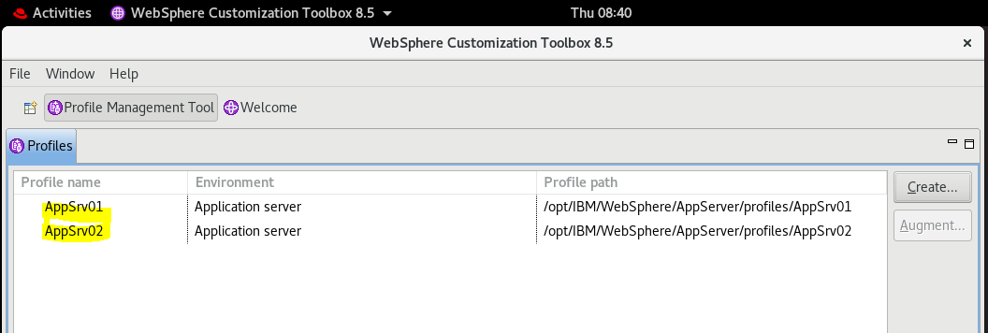

Two profiles now set up and tested.

Used FireFox browser to log into the IBM WebSphere 8.5.5.15 console

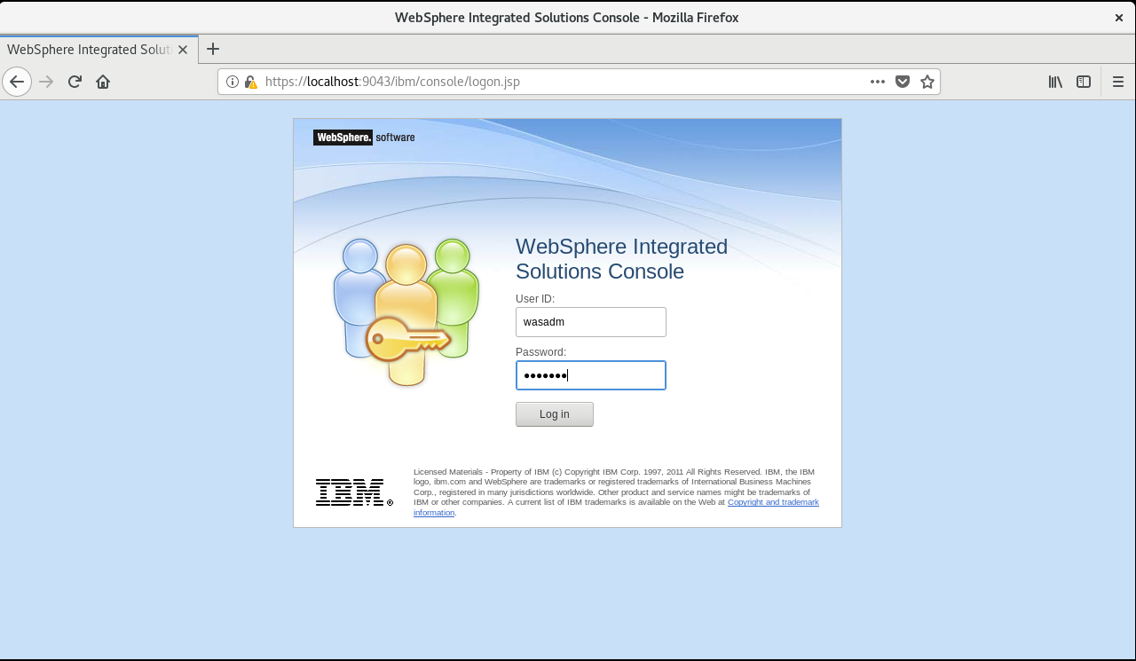

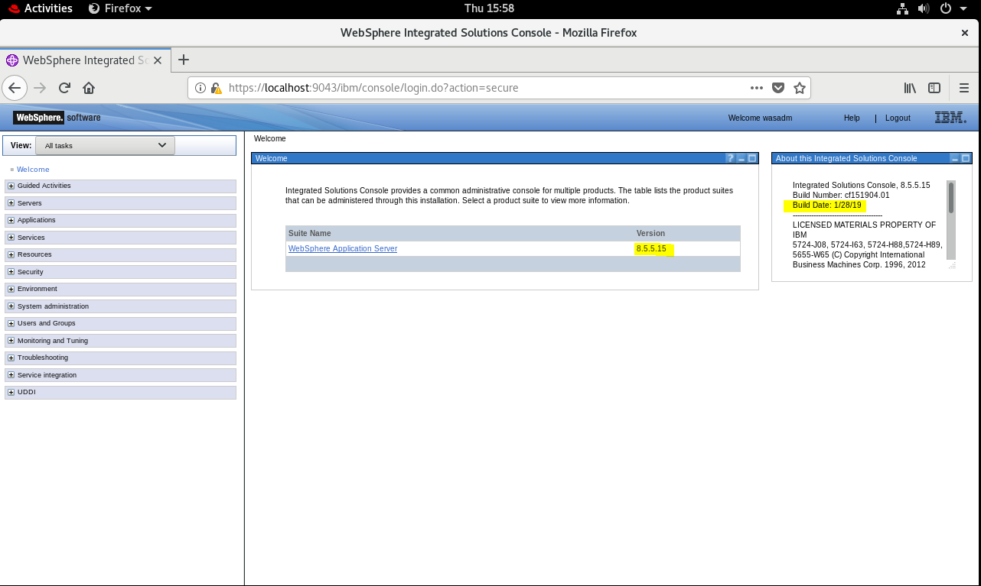

## Install IBM Security Directory Server 6.4 components

REF

<https://www-01.ibm.com/support/docview.wss?uid=swg22007592>

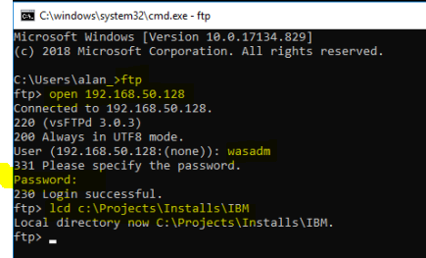

Used ftp to upload the Installation binaries for IBM Security Directory services

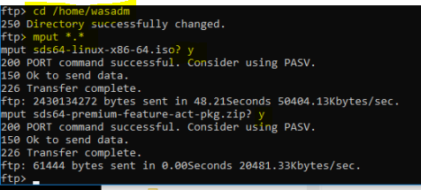

Copied **sds64-linux-x86-64.iso** , the Disk Image for the Security Directory Service installations and **sds64-premium-feature-act-pkg.zip** for the premium features of the SDS

mkdir /opt/IBM/Installs/SDS64

copy from /home/wasadm to /opt/IBM/Installs/SDS64

cd /opt/IBM/Installs/SDS64

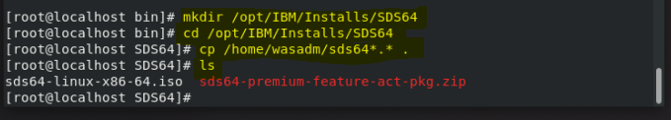

Default Installation locations

|  |  |  |  |
| --- | --- | --- | --- |
| **Operating System** | **IBM Security Directory Server 6.4** | **DB2** | **IBM SDK Java** |
| RHEL 8.0 Linux | /opt/ibm/ldap/V6.4 | /opt/ibm/sdsV6.4db2 | /opt/ibm/ldap/V6.4/java |

### Installation using the Disk Image file, sds64-linux-x86-64.iso

mount -o loop sds64-linux-x86-64.iso /mnt



cd /mnt

ll

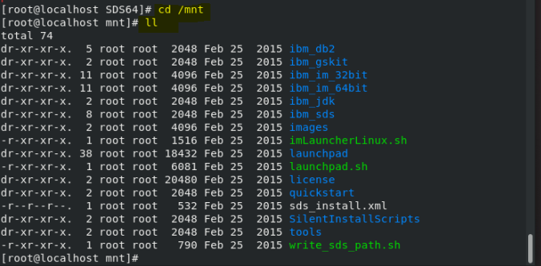

./imlauncher.sh

**Gives the following error so we have to use the Installation Manager 1.8.5 installed for WebSphere 8.5.5.15 used earlier**

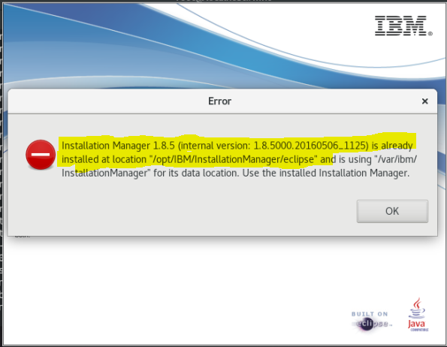

So we can use the Installation Manager downloaded for WebSphere Installation:

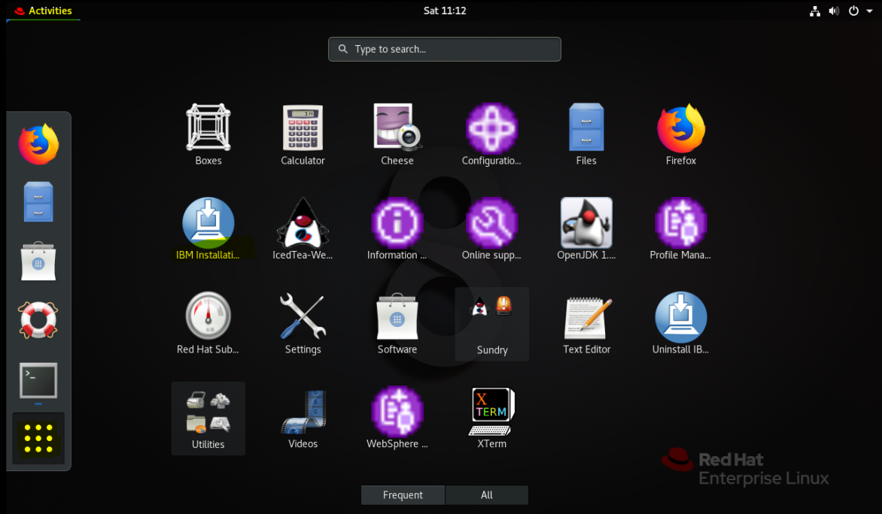

NB we need the Korn shell to install the Directory Service if you get this message:

In IBM Installation Manager

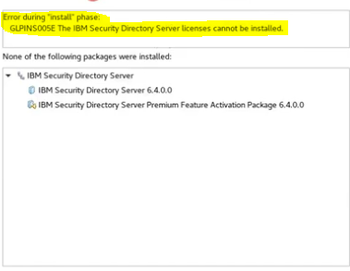

**So ensure the Korn Shell is installed first**

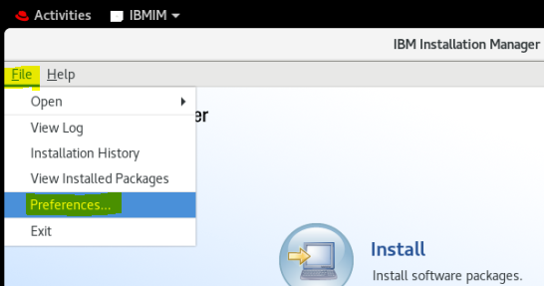

**Select Preferences above**

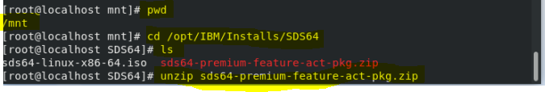

**Add 2 repository config files NB unzip the premium feature zip file first!**

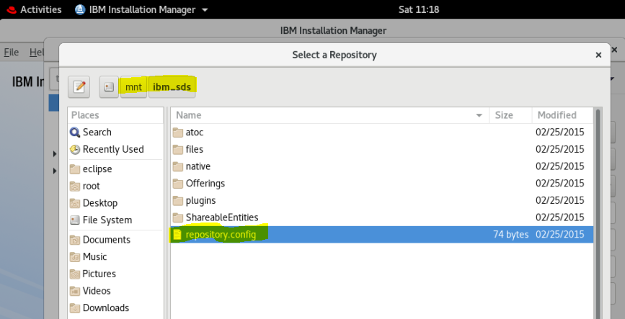

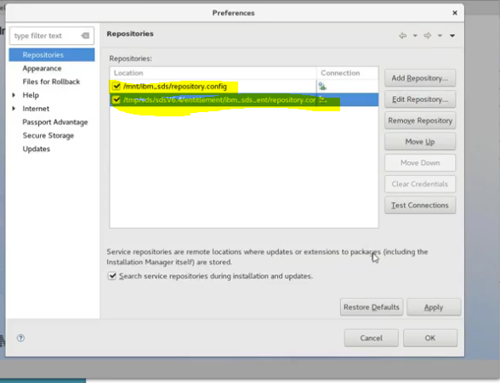

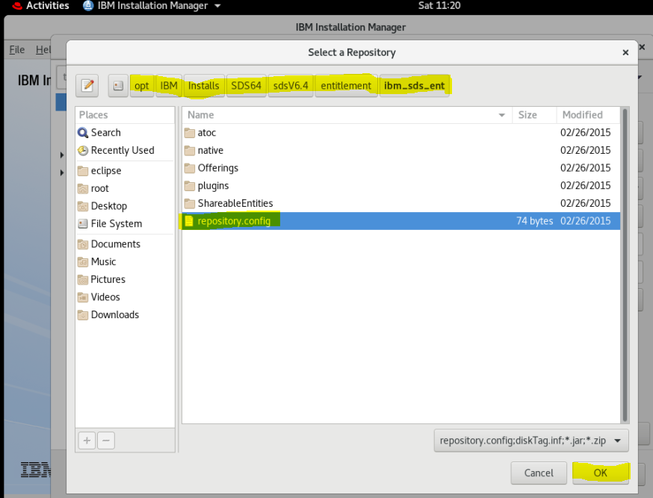

Click OK and Install

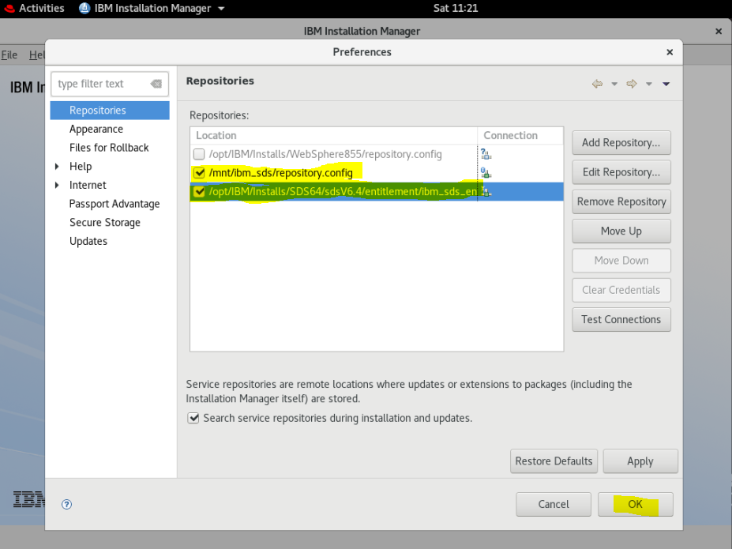

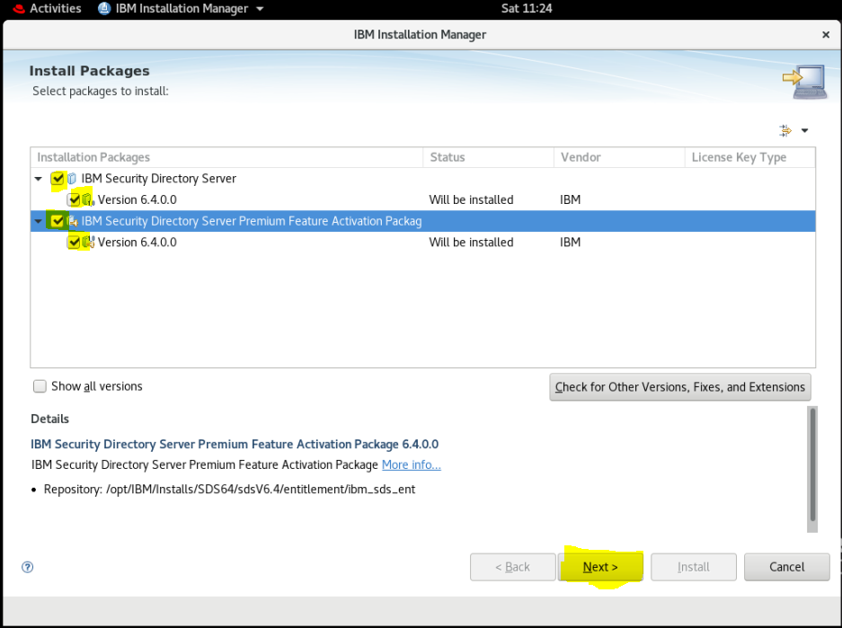

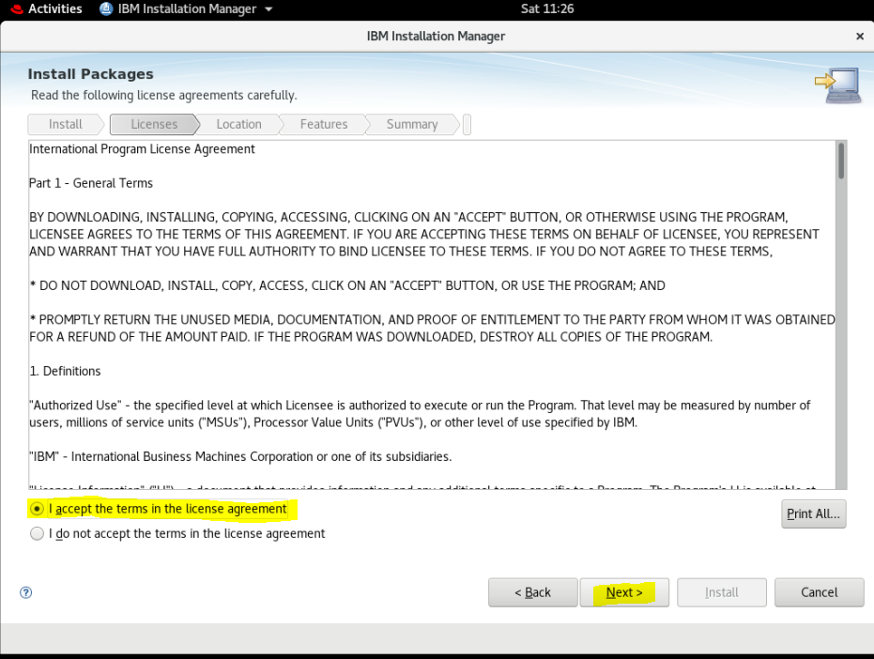

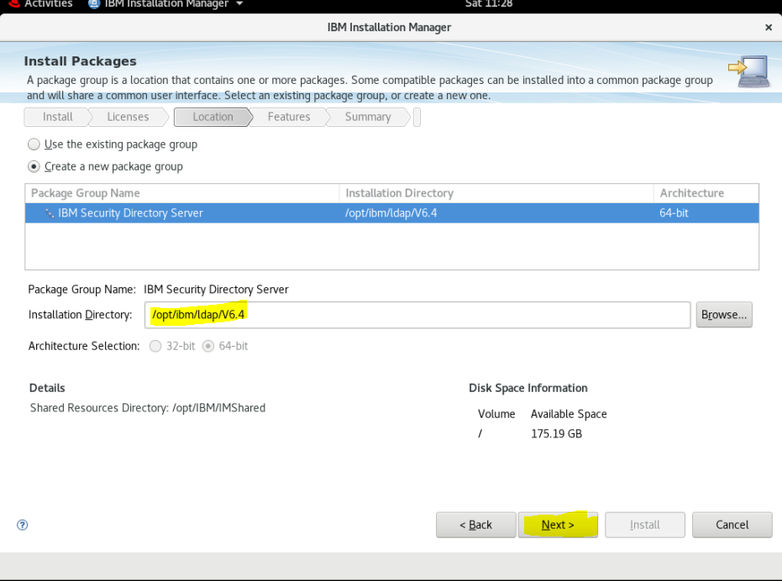

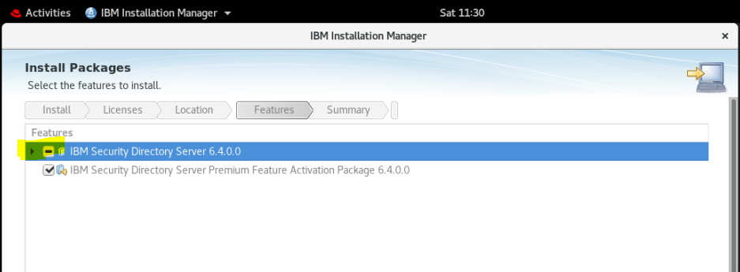

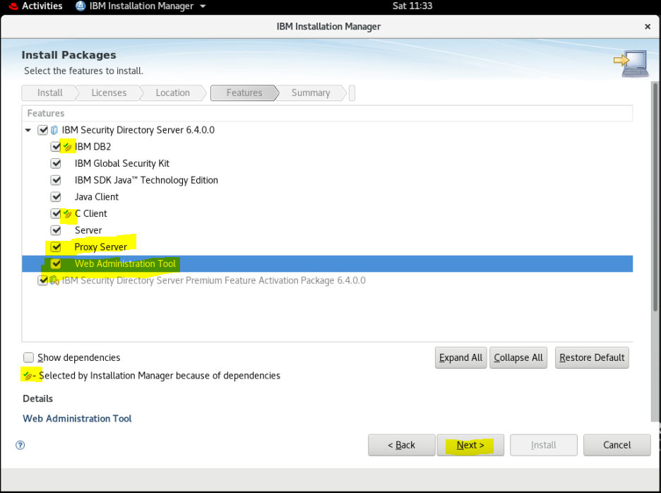

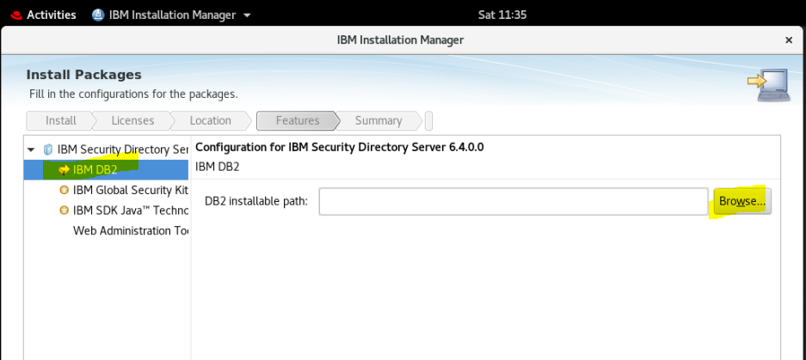

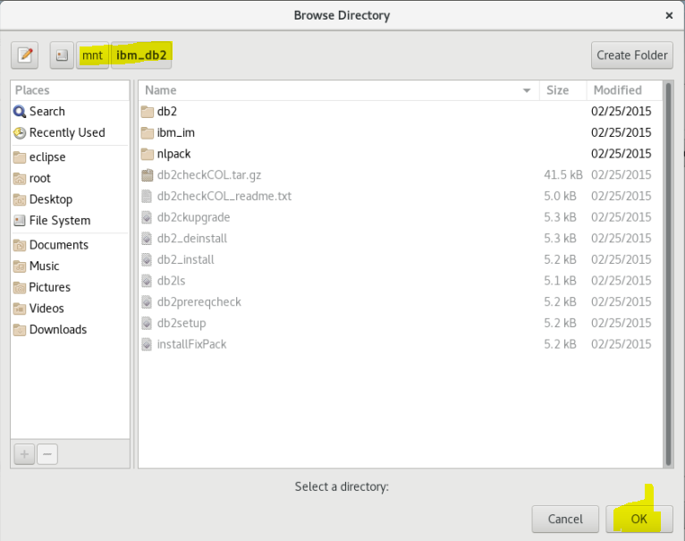

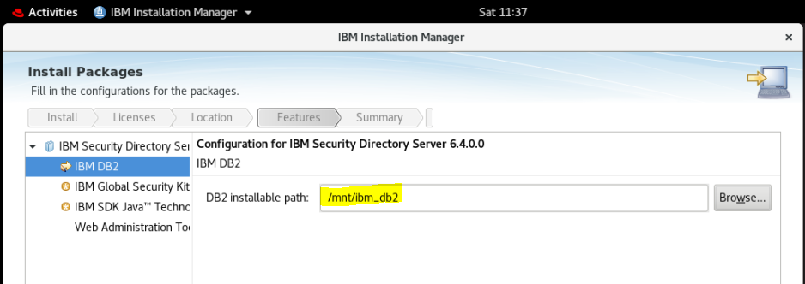

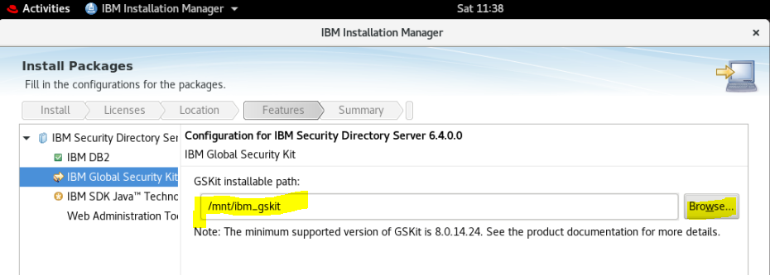

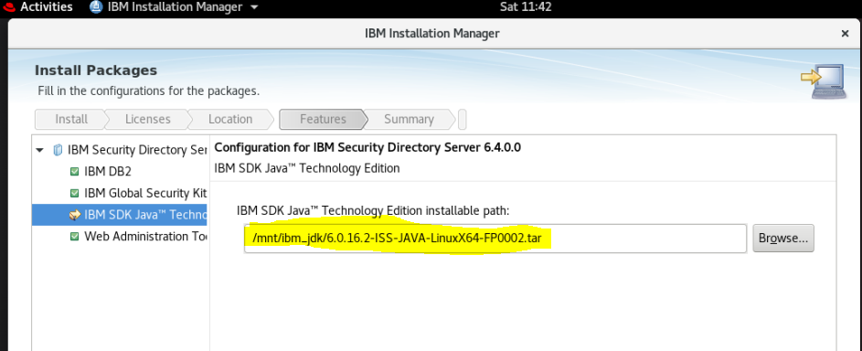

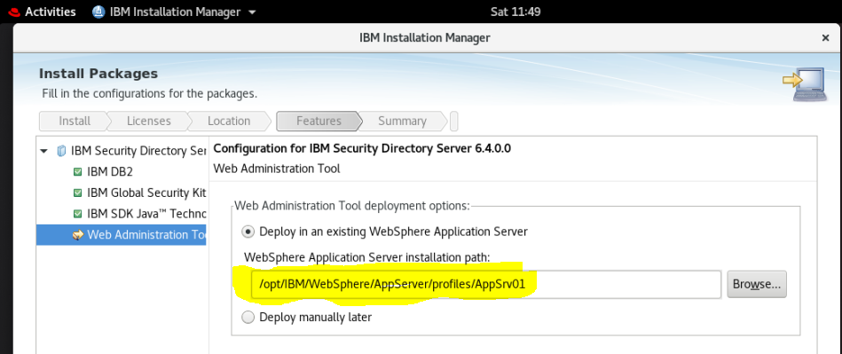

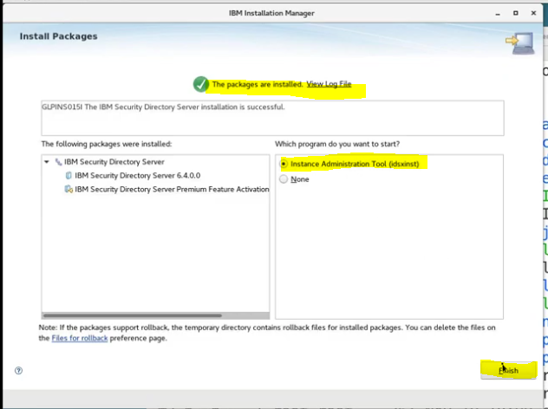

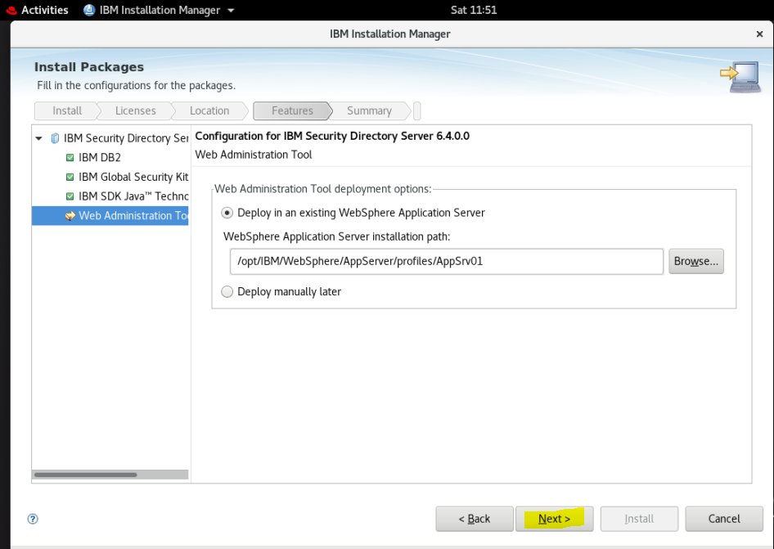

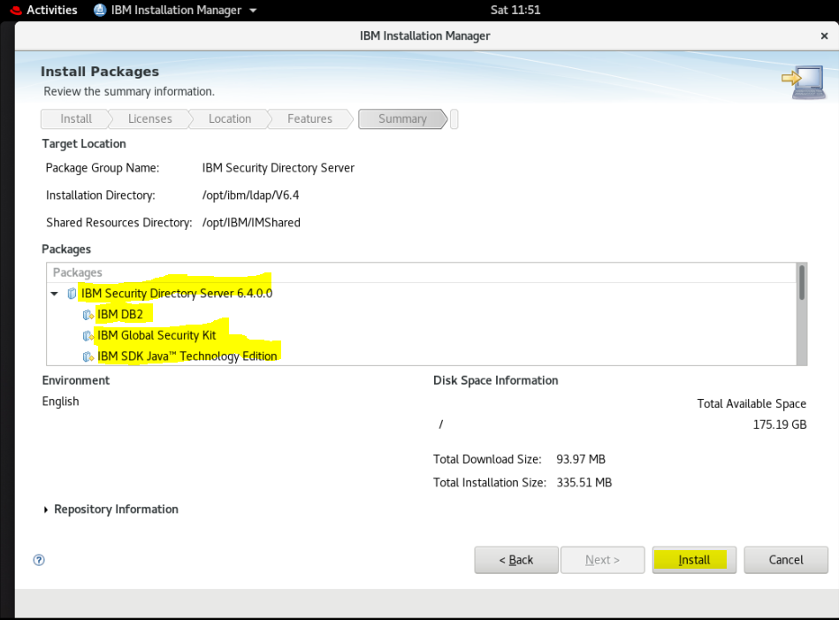

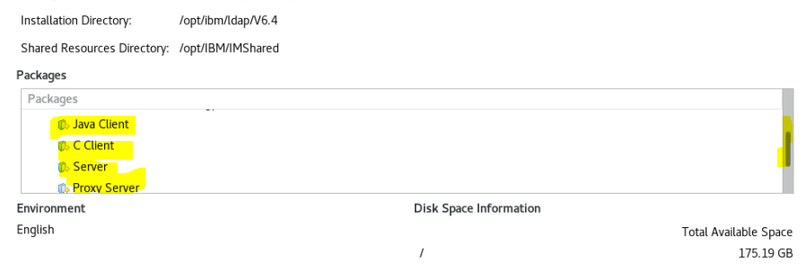

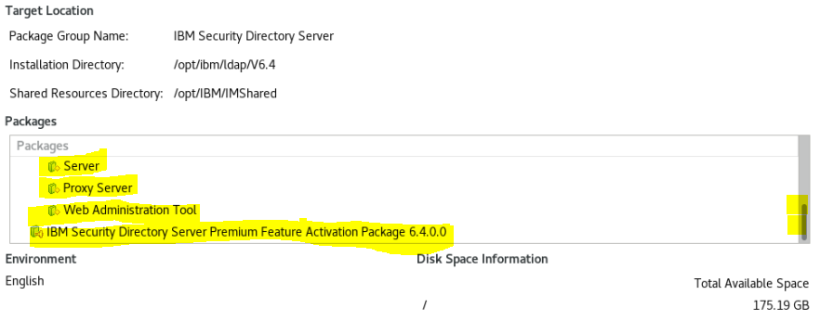

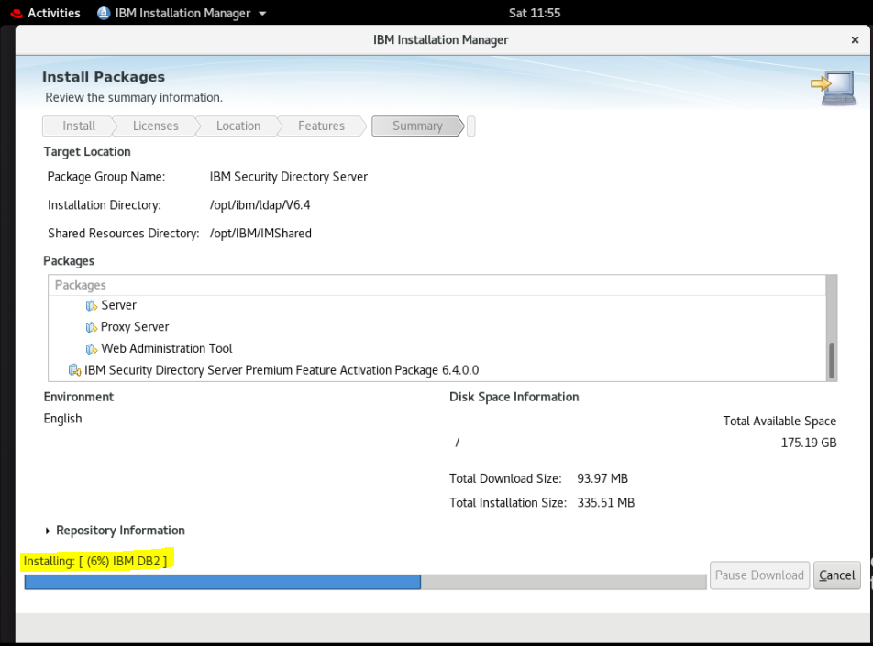

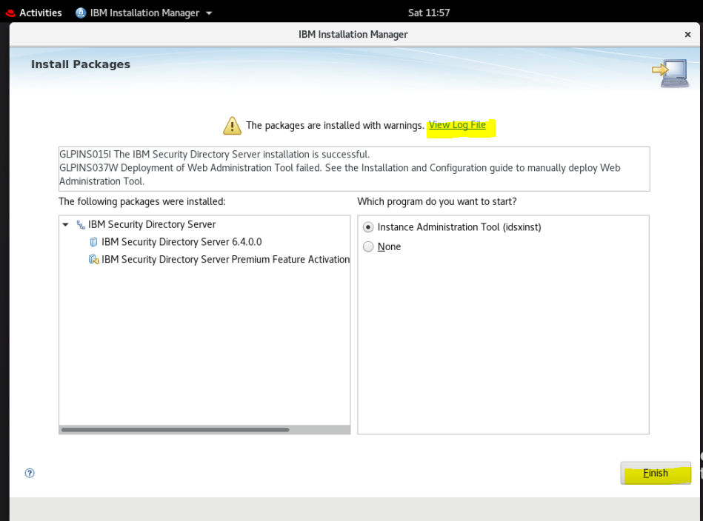

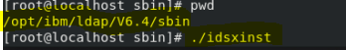

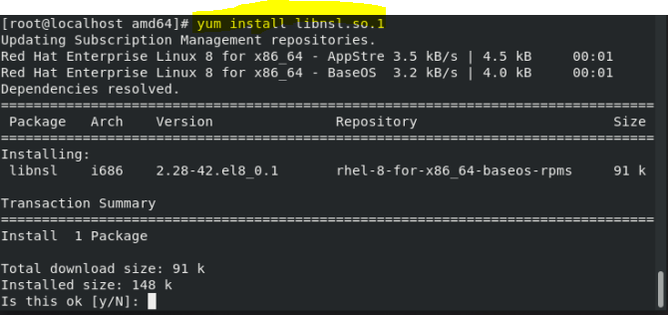

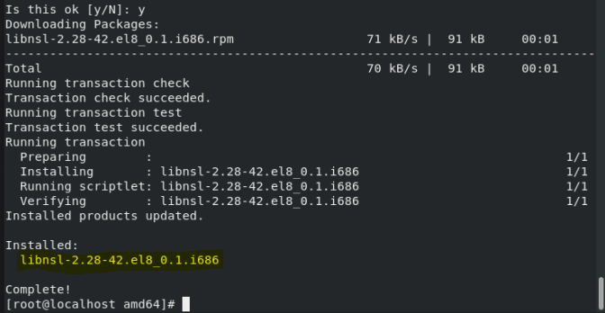

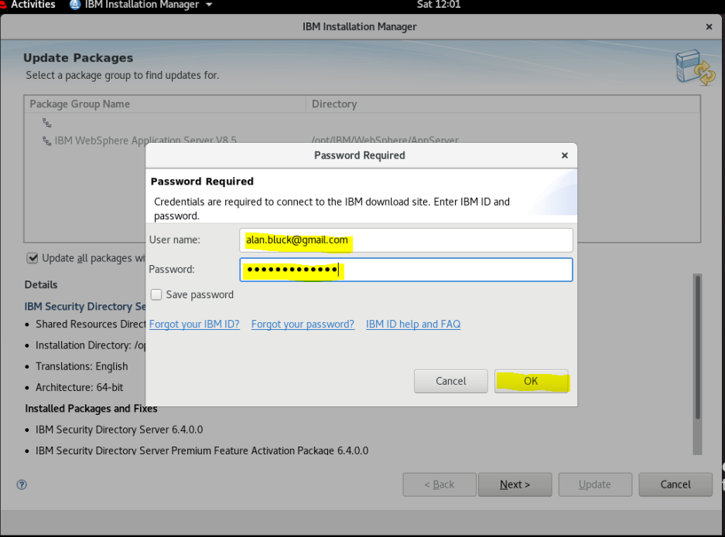

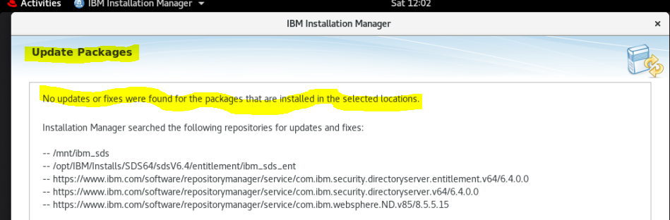

On trying

**./idxinst**

**I first got the error:-**

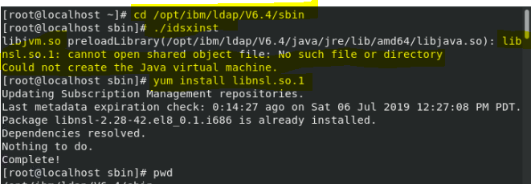

Then (see above) installed library package

**yum install libnsl.so.1**

I tried

**cp libnsl.so.1 /opt/ibm/ldap/V6.4/java/jre/lib/amd64**

[root@localhost sbin]# ./idsxinst

libjvm.so preloadLibrary(/opt/ibm/ldap/V6.4/java/jre/lib/amd64/libjava.so): libnsl.so.1: wrong ELF class: ELFCLASS32

Could not create the Java virtual machine.

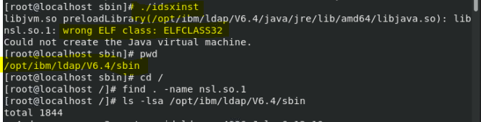

I then found the name of the 32 bit shared object package

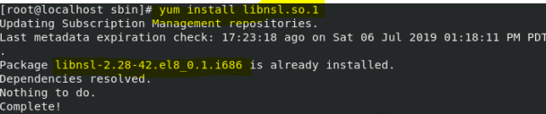

and tried the 64 bit version:

**yum install libnsl-2.28-42.el8\_0.1.x86\_64**

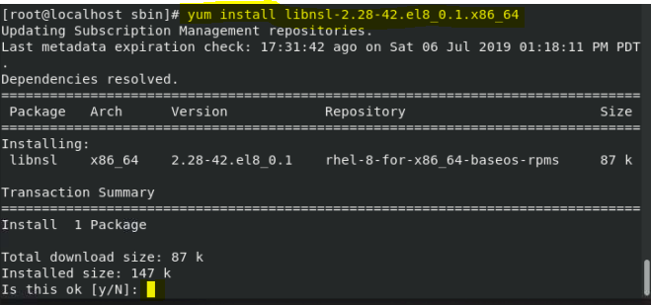

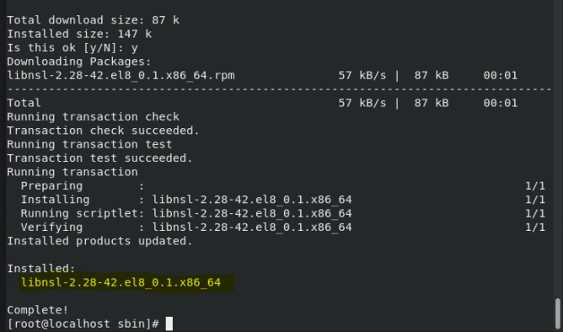

**This fixed the error message!**

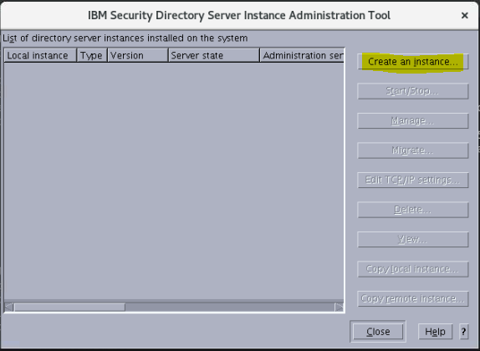

You can also launch the admin tool from the Workstation Gnome GUI icon (search “Inst”)

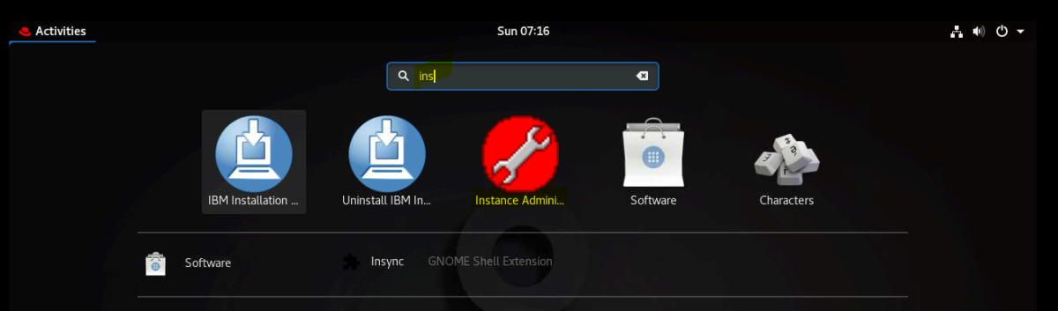

Double click on **Instance Administration** Icon (spanner with a red background)

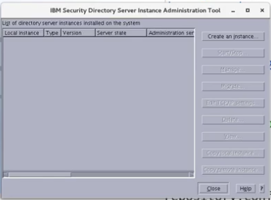

### Directory server Instance owner

This is a system user ID that is the directory server instance owner

(See Korn Shell and User Creation)

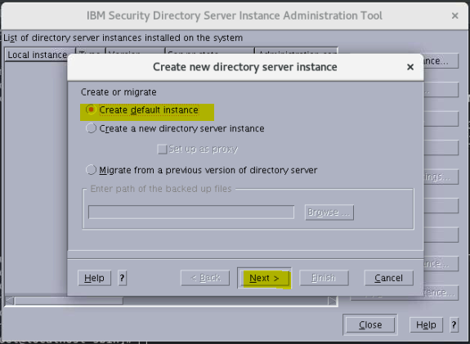

If you need to Add the proxy (for Open LDAP)

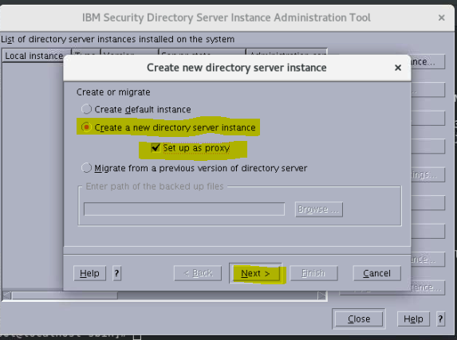

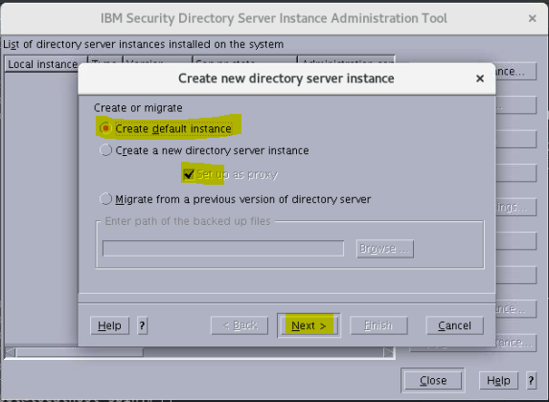

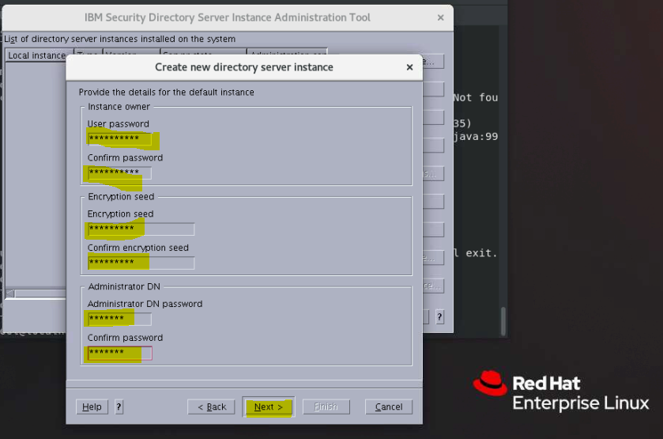

Default created

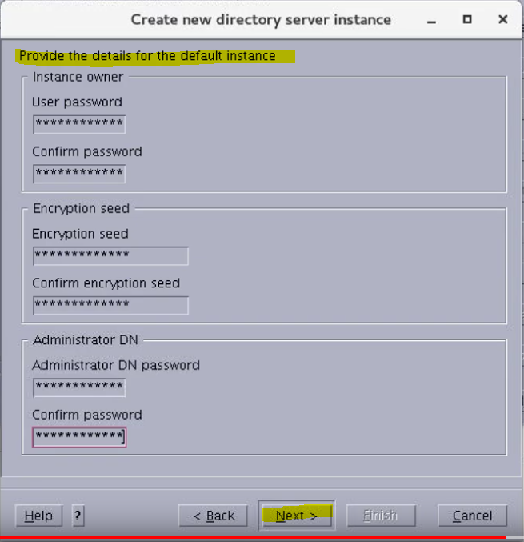

Got

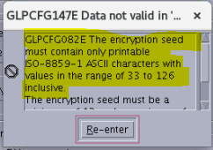

Scrolled down :

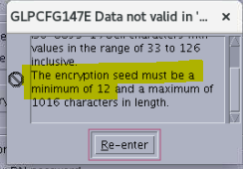

**(I only had a seed with 9 Characters!)**

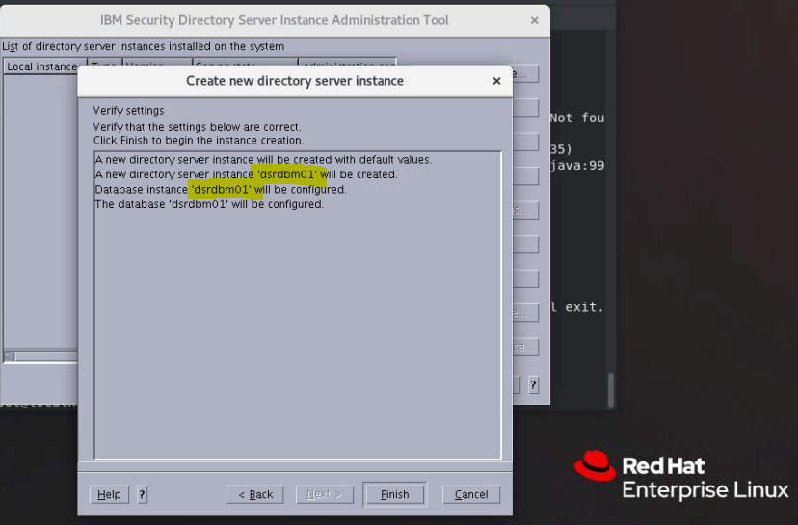

Click Finish

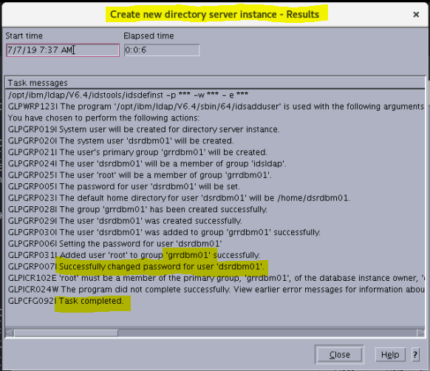

NOTE above has one error which we need to fix :

#### Add grrdbm01 primary group to root user

**GLPICR102E ‘root’ must be a member of the primary group ‘grrdbm01’ and of the database**

usermod -a -G grrdbm01 root

groups root

**NB The above steps do not work on their own!!**

**(at least at RHEL 8.0)**

**See my section:**

**ESSENTIAL STEP FOR CREATING THE DEFAULT INSTANCE**

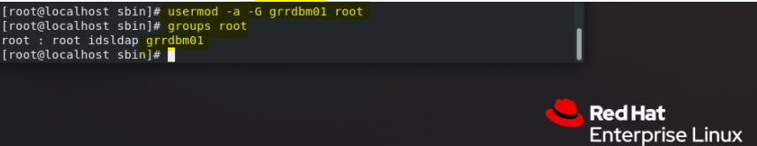

**NB Then you must logout and log back in as root before the above can be seen by the process!**

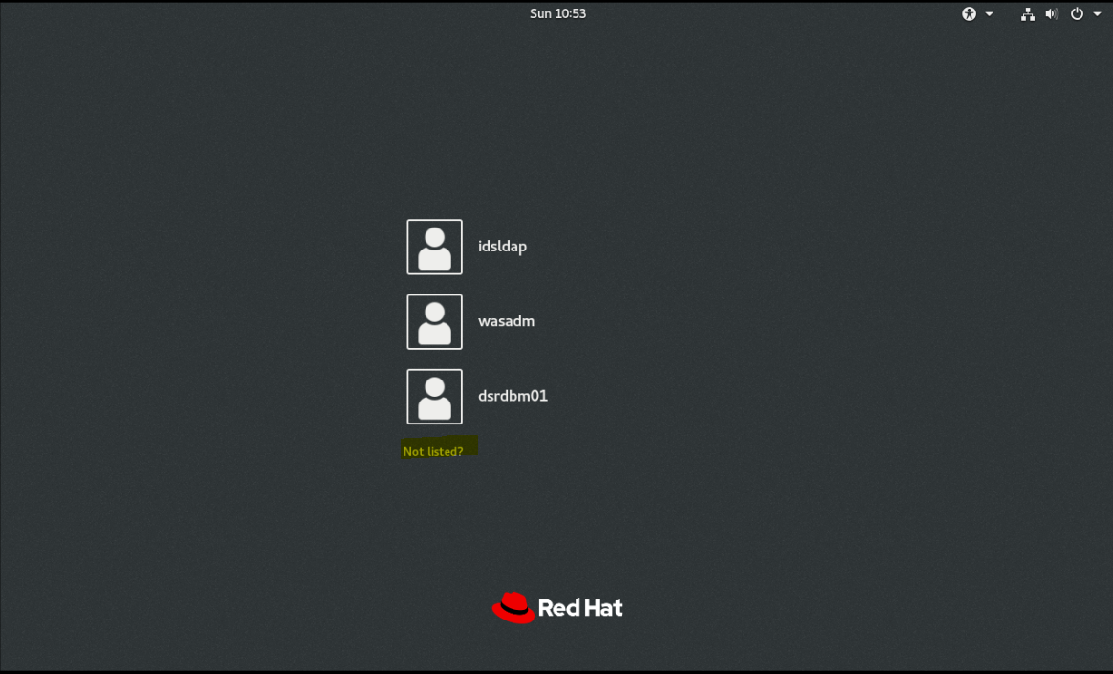

**Log in as root by clicking on the Not listed? Option as shown above**

**REF Technote**

<https://www-01.ibm.com/support/docview.wss?uid=swg21585068>

Fixed default instance settings for IBM Security Directory Services 6.4

|  |  |
| --- | --- |
| Settings | Linux |
| Name | dsrdbm01 |
| Instance location | /home/dsrdbm01 |
| Group name | grrdbm01 |
| Administrator DN | cn=root |
| Database name | dsrdbm01 |

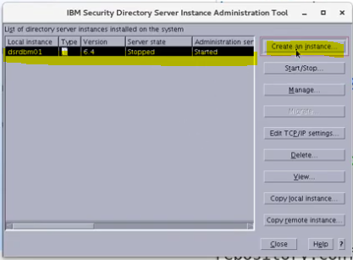

Create a proxy

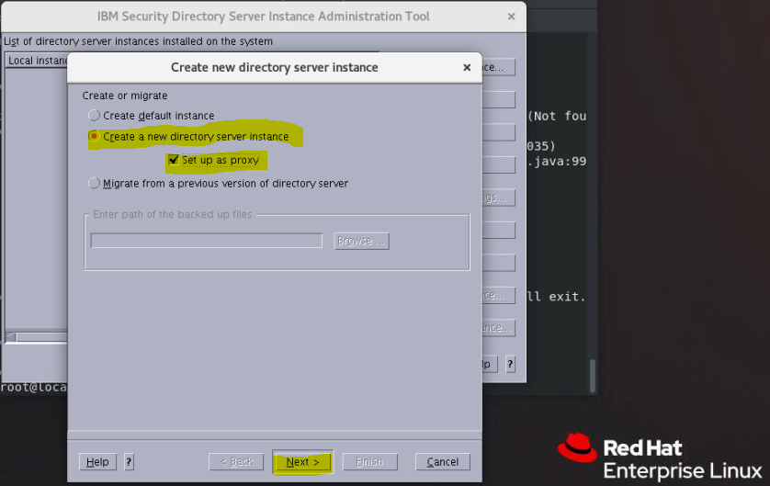

cd /opt/ibm/ldap/V6.4/sbin

./idsadduser -u dsproxy -g sdsadm -l /home/dsproxy -w filenet

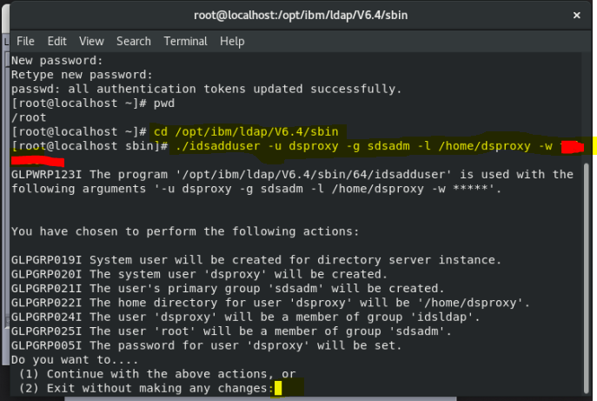

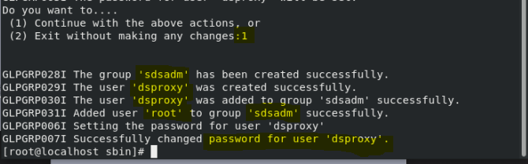

Log out and log back in again to see the user account created above

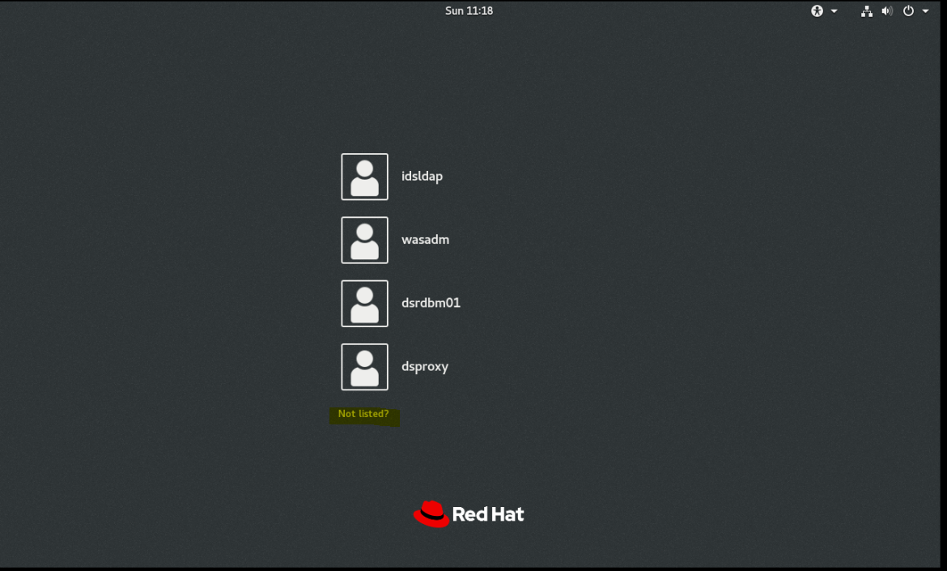

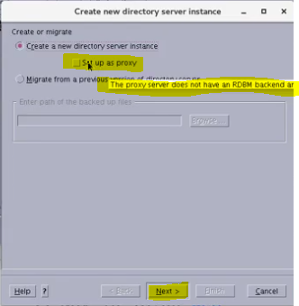

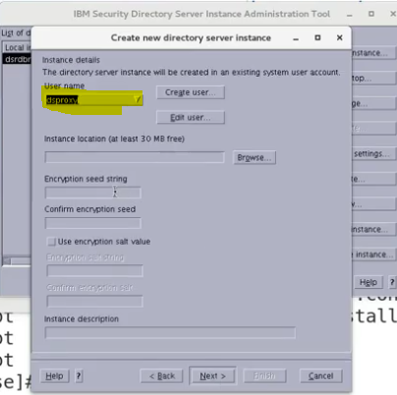

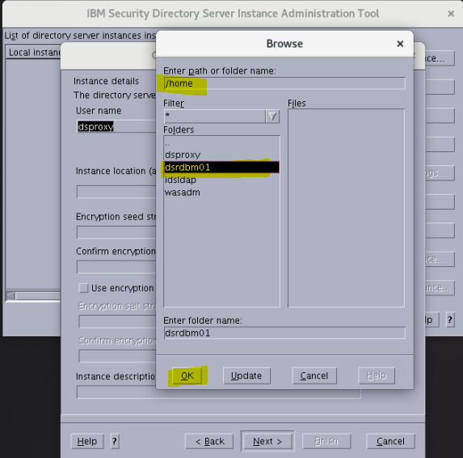

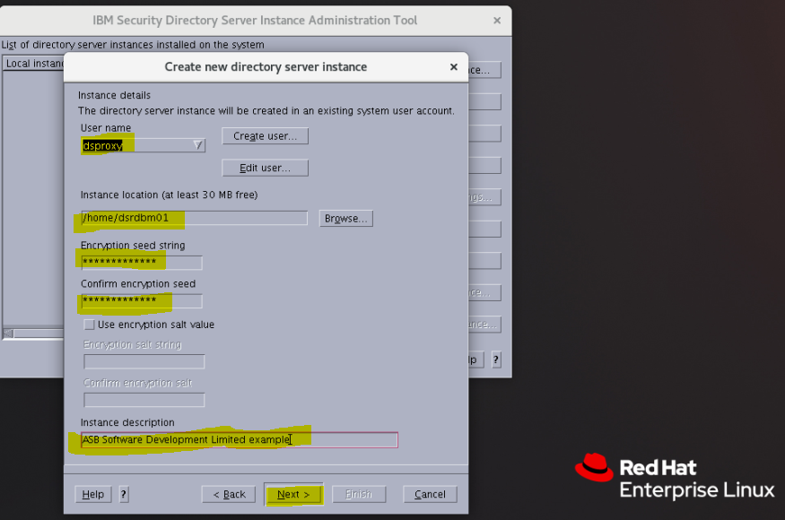

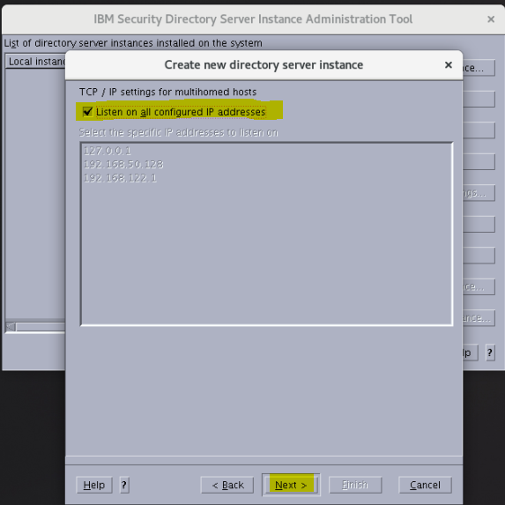

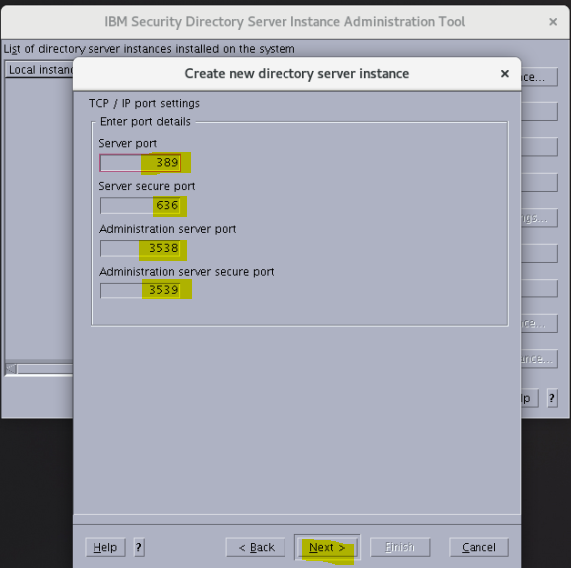

**Defaults set, these port numbers need to be changed to use the proxy server instance!**

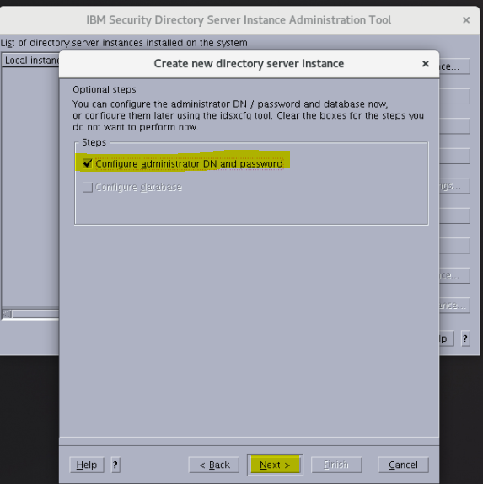

Using cn=root

Password: IBMFileNetP8

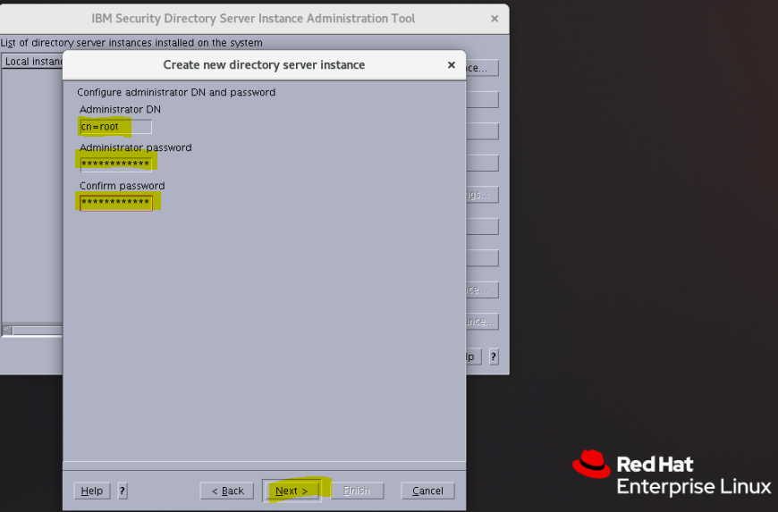

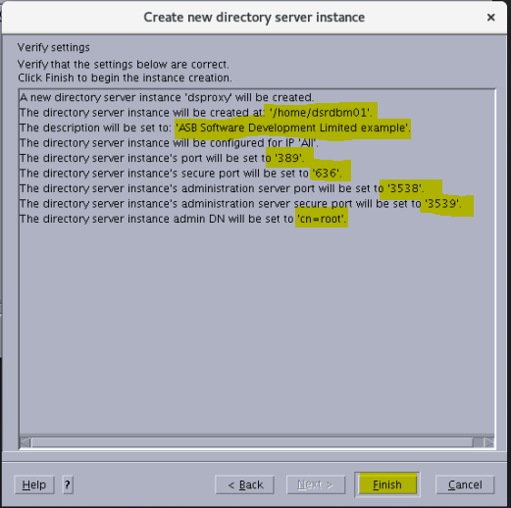

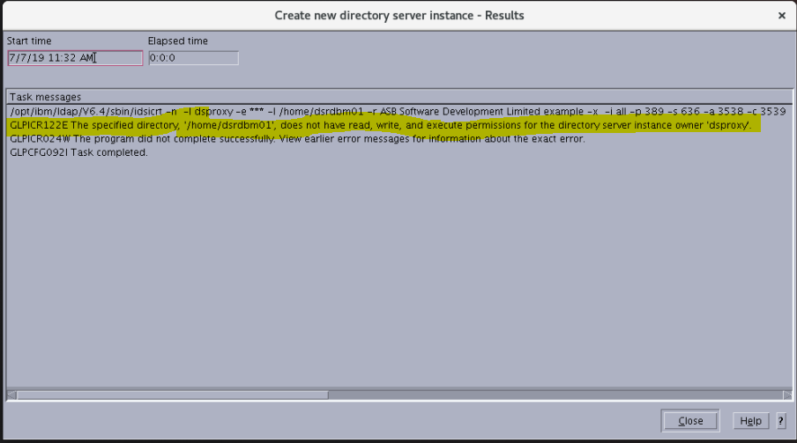

## Resolving the problem

These are four possible solutions to addressing the error:

1. Confirm that the root user is a member of the instance owner's primary group.   
   For example, if dsproxy is the instance owner, and idsldap is the primary group of the instance owner, root also must be a member of the idsldap group. Output should be similar to this:   
     
   /home/dsproxy: # grep -i dsproxy /etc/passwd   
   dsproxy:x:1003:1003::/home/dsproxy:/bin/ksh

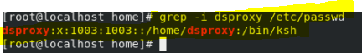  
  
/home/dsproxy: # grep -i 1003 /etc/group   
sdsadm:x:1003:dsproxy,root

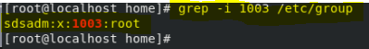

FIX USED

usermod -a -G idsldap root

groups root

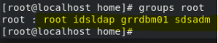

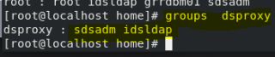

usermod -a -G grrdbm01 dsproxy

groups dsproxy

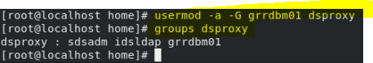

2. Confirm that the instance owner's .profile has read, write and execute permission.  
For example, if the instance owner is called dsproxy and it is a member of the idsldap group, then the ls -la output from instance's home folder the permissions and ownership on .profile should look like this:  
  
-rwxr----- 1 dsproxy dsproxy 183 Feb 16 13:50 .profile

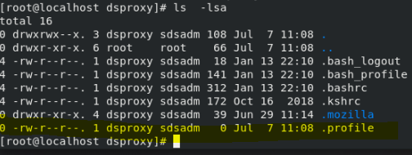

FIX USED

**chmod 766 .profile**

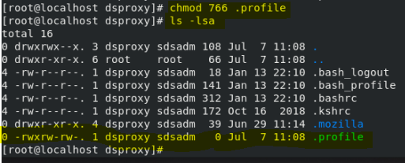  
  
3. Confirm that the previous instance is properly cleaned up before re-attempting idsicrt.  
The error can be caused if a previous instance was not completely cleaned up.  
  
If the db2 instance is still listed in db2ilist, drop the db2 instance using db2idrop:  
<db2\_install\_location>/instance/db2ilist  
<db2\_install\_location>/instance/db2idrop ldapdb2  
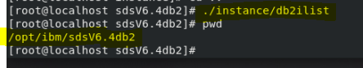  
Check the /home/dsproxy directory. If any of these directories still exist, manually rename/remove them:   
ldap32kcont\_ldapdb2   
sqllib  
ldapdb2   
idsslapd-ldapdb2   
  
4. Confirm that the /etc/hosts file contains the correct server name and ip address and the server can be pinged.

#### Add a second network adapter card

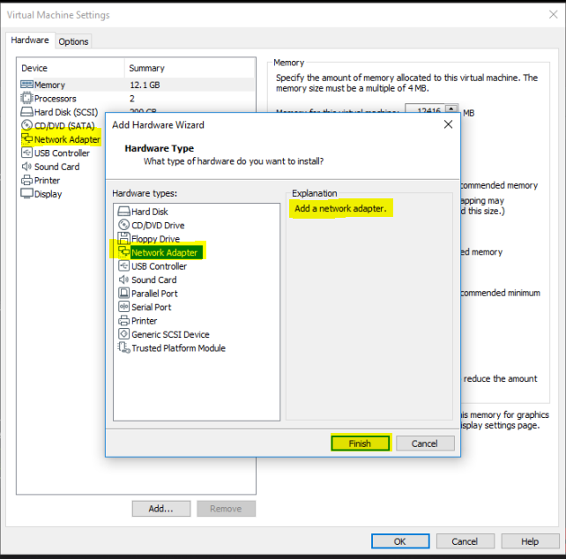

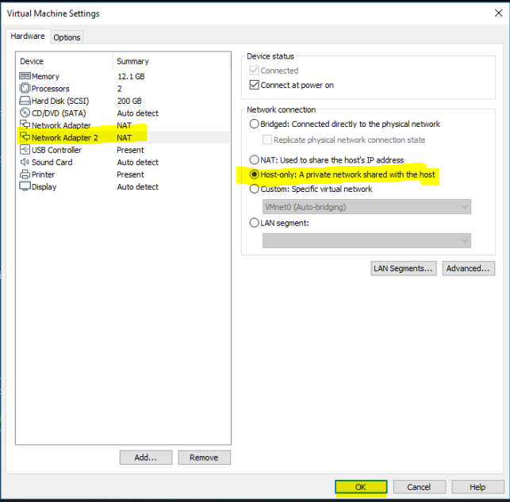

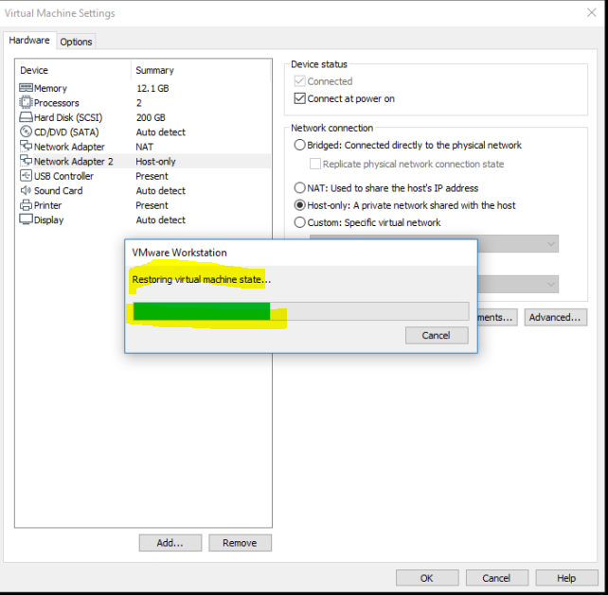

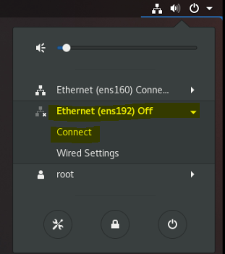

**nmcli con show**

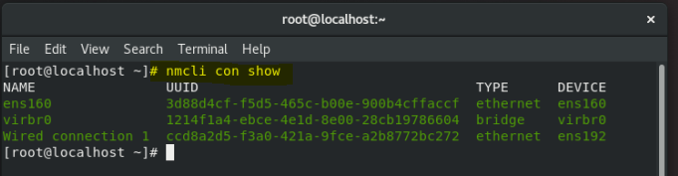

**nmcli dev status**

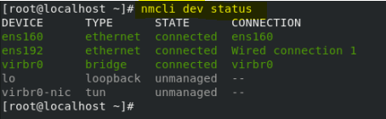

To see the current Server Hostname, type

**hostnamectl**

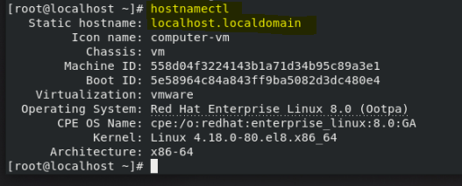

#### Change the Host name to ECMUKDEMO6

**hostnamectl set-hostname ECMUKDEMO6**

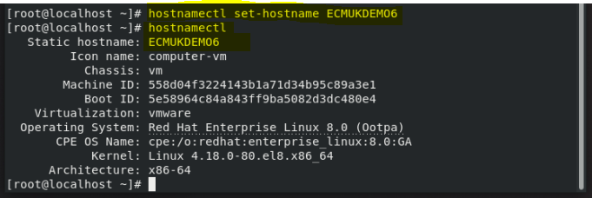

*For example, if the server name is ldaptest.example.com, the /etc/hosts file would contain an entry similar to this:   
  
192.168.245.178 ldaptest.example.com ldaptest  
  
==> ping ldaptest  
PING ldaptest.example.com: (9.12.345.678): 56 data bytes  
64 bytes from 192.168.245.178: icmp\_seq=0 ttl=255 time=0 ms  
64 bytes from 192.168.245.178: icmp\_seq=1 ttl=255 time=0 ms*

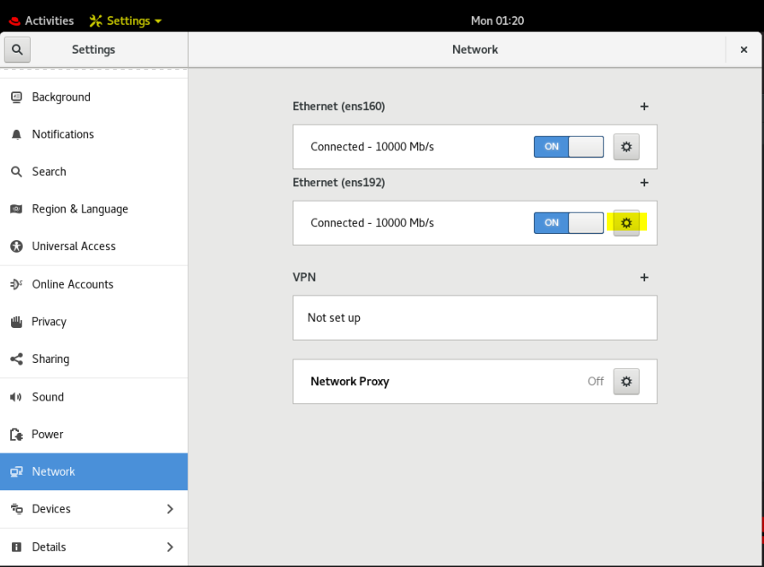

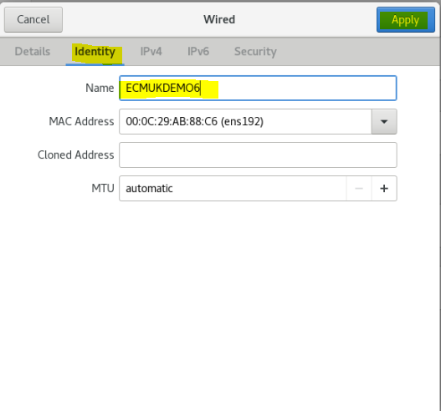

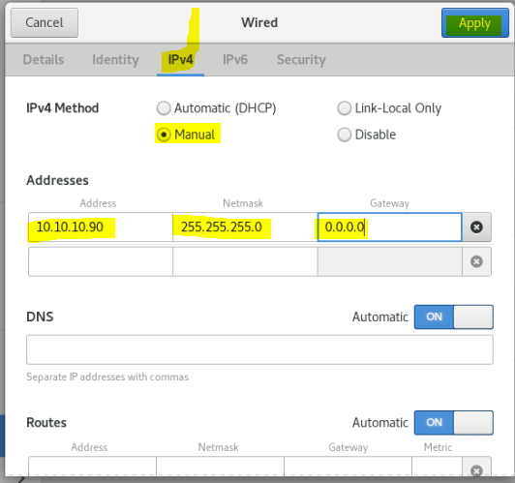

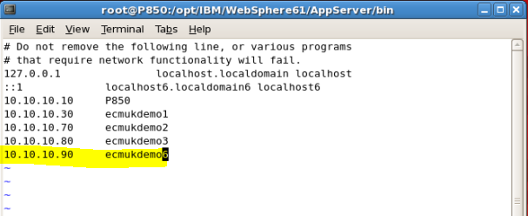

nmcli con show

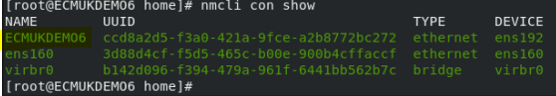

nmcli dev status

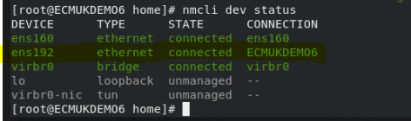

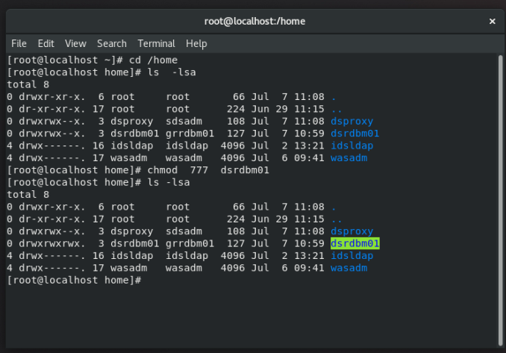

vi /etc/hosts

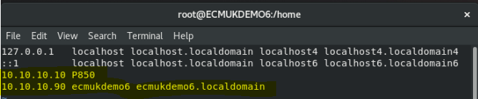

reboot

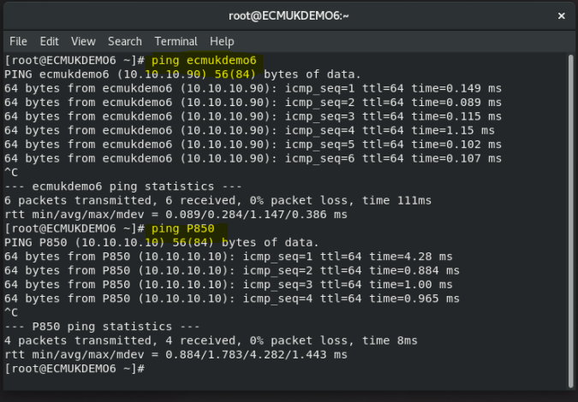

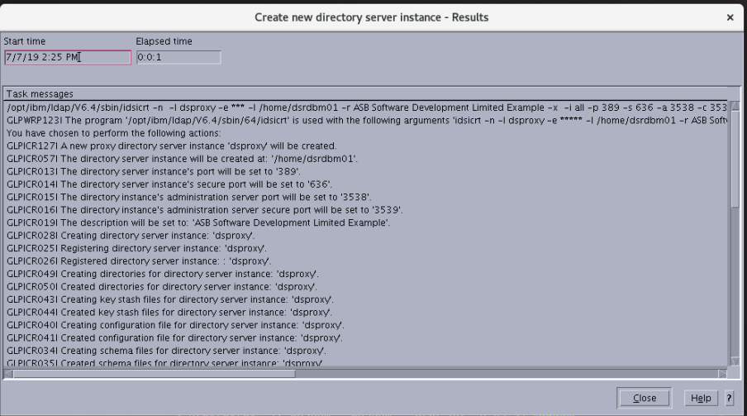

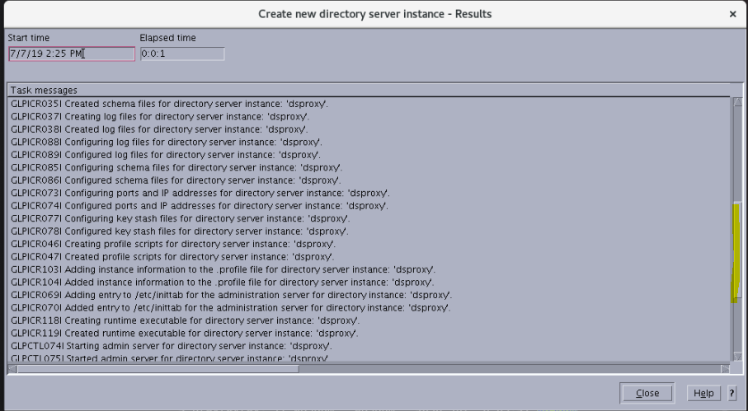

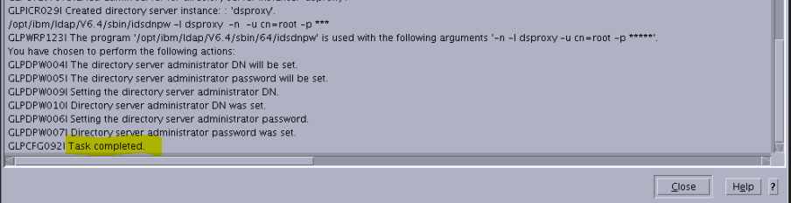

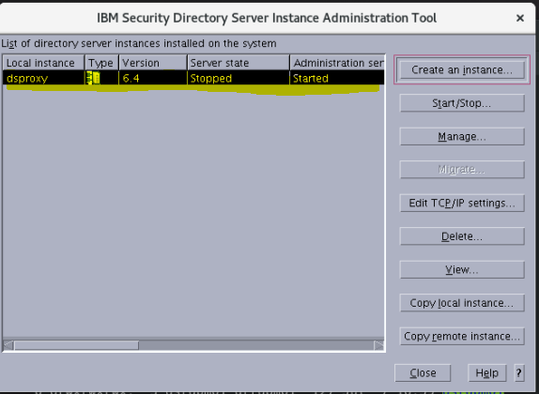

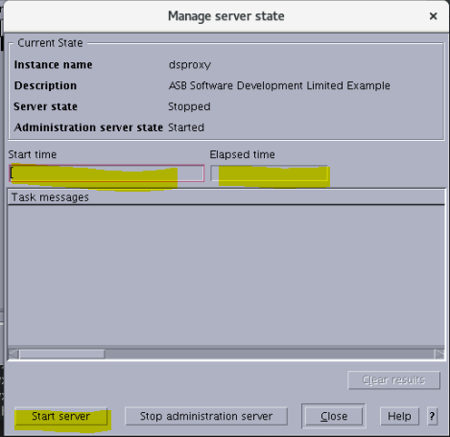

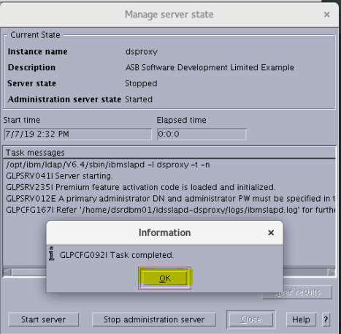

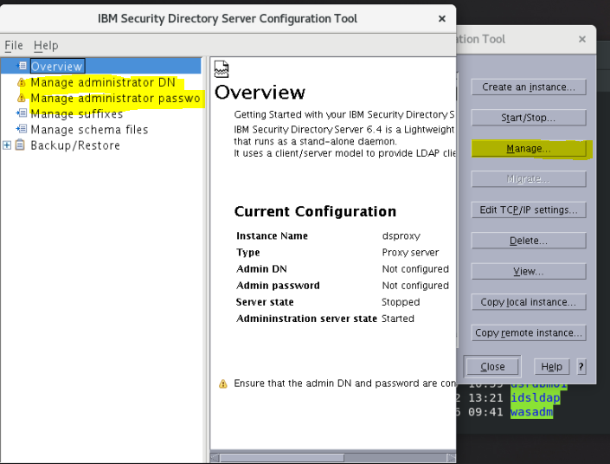

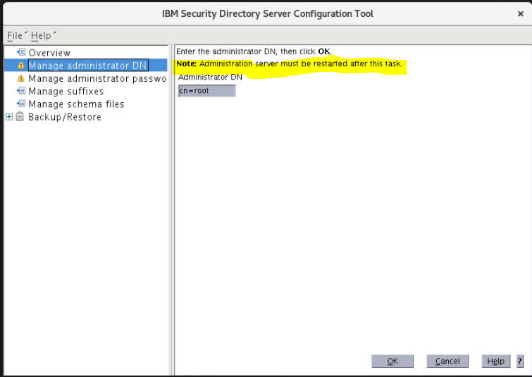

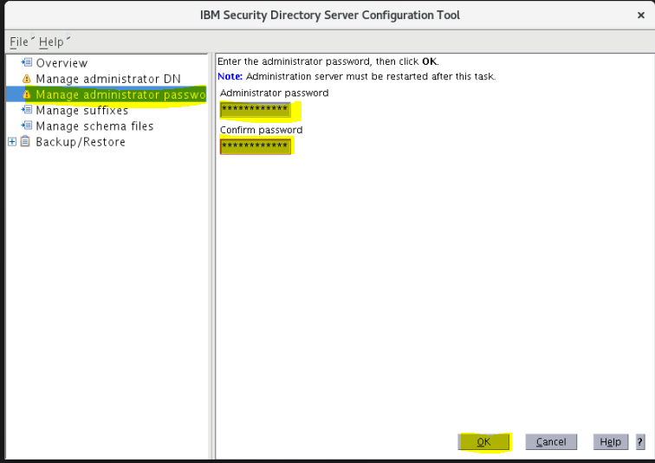

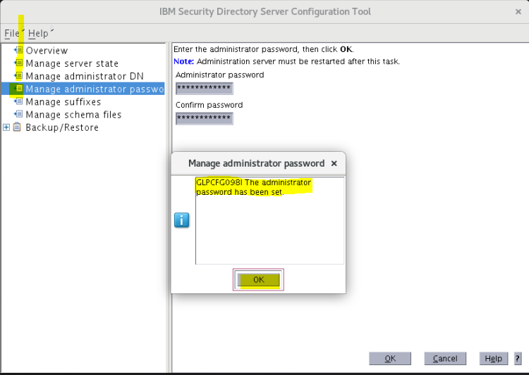

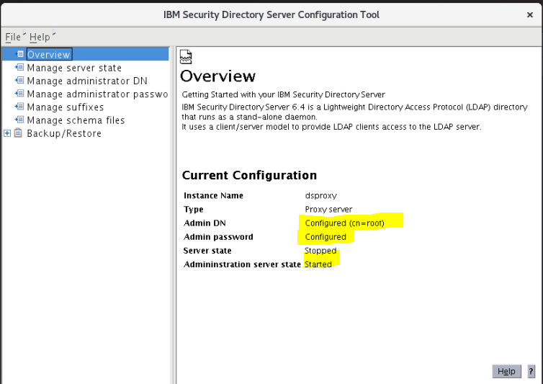

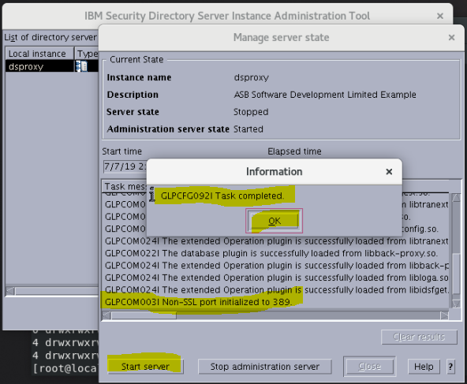

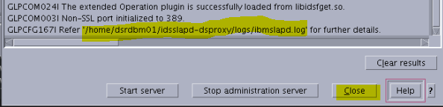

2019-07-07T14:40:33.239789-7:00 GLPPXY010E The configuration file does not contain any entries for back-end servers. No data will be available.

REF:

<https://www.ibm.com/support/knowledgecenter/en/SSVJJU_6.4.0/com.ibm.IBMDS.doc_6.4/GLPPXY010E.html>

##### Explanation

No servers were defined in the configuration file for the proxy server to use. Without valid server definitions, the proxy server cannot be used.

##### Action

Define your distributed topology correctly in the configuration file so that the proxy server can function properly. See the IBM Security Directory Server Administration Guide for more information.

**Parent topic:** [Messages](https://www.ibm.com/support/knowledgecenter/SSVJJU_6.4.0/com.ibm.IBMDS.doc_6.4/c_mg_messages.html?view=kc)

**Rebooted the server from root**

shutdown -r now

### ESSENTIAL STEP FOR CREATING THE DEFAULT INSTANCE

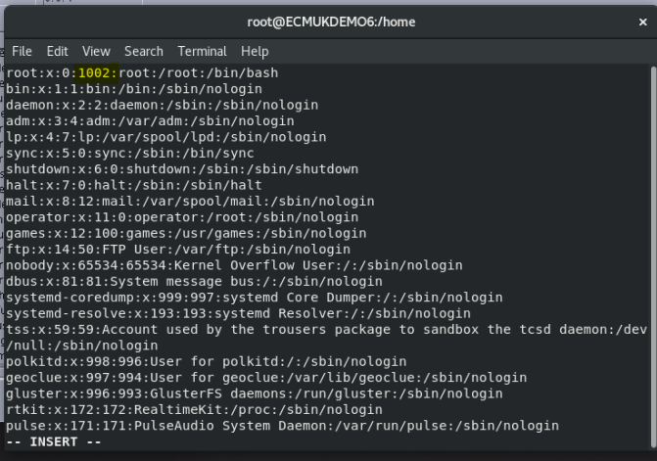

Must take the above GroupID (1002) replacing ID 0 from the actual Group ID held in /etc/passwd for dsrdbm01

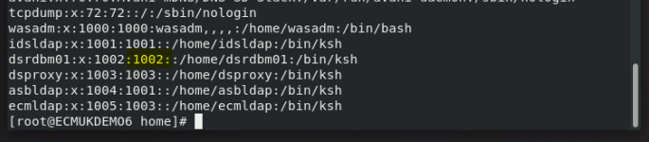

**Above is the ESSENTIAL step to allow the creation of the default instance (or any other instance required, since the Group Id of root (usually 0) must match the Group Id in the /etc/passwd file for the default instance user!**

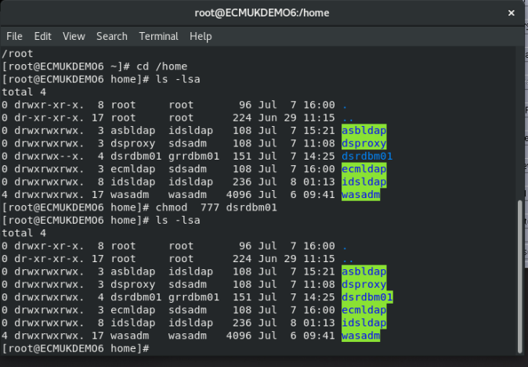

**Also made the dsrdm01 /home subdirectory permissions as above**

**(will be changed back by the installer!)**

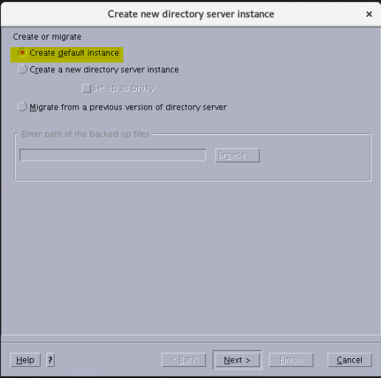



Default created





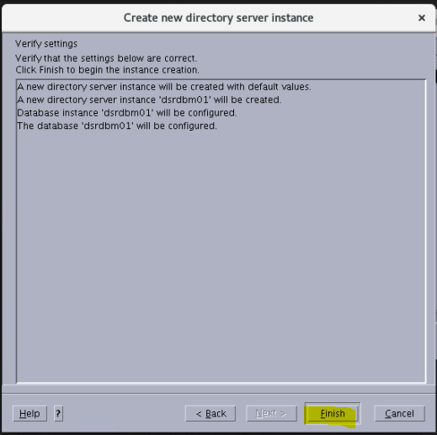

Click Finish to launch the default Instance

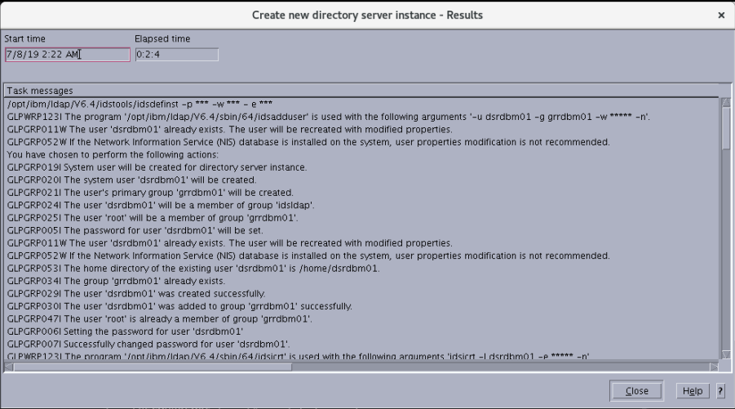

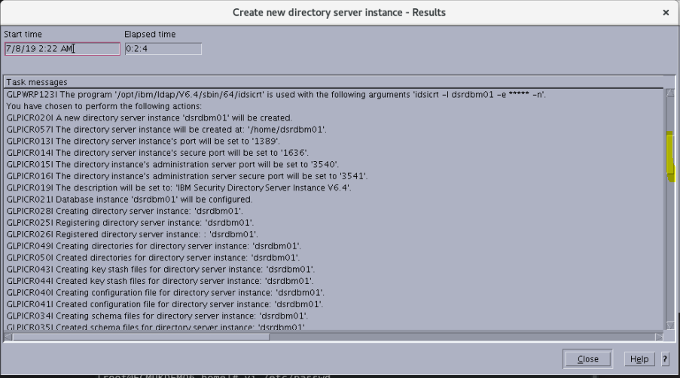

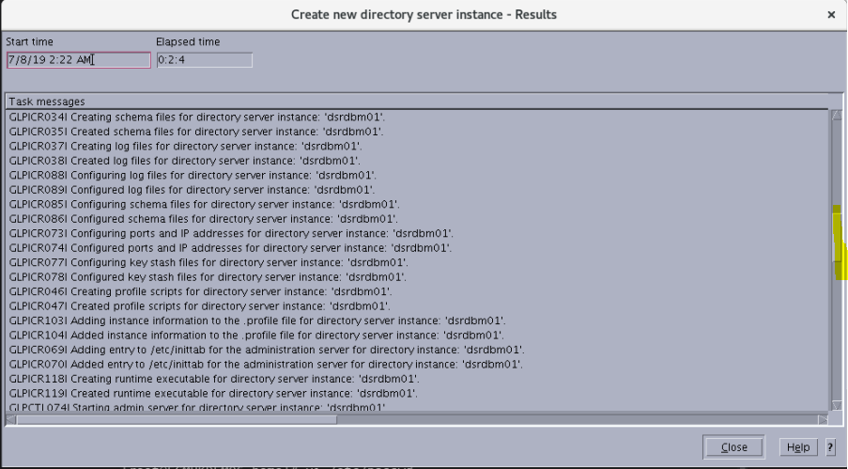

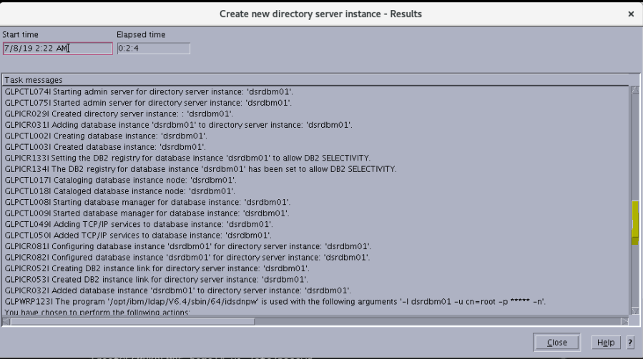

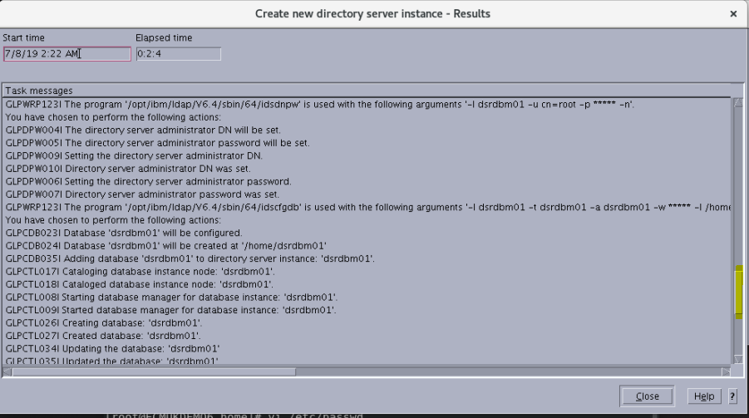

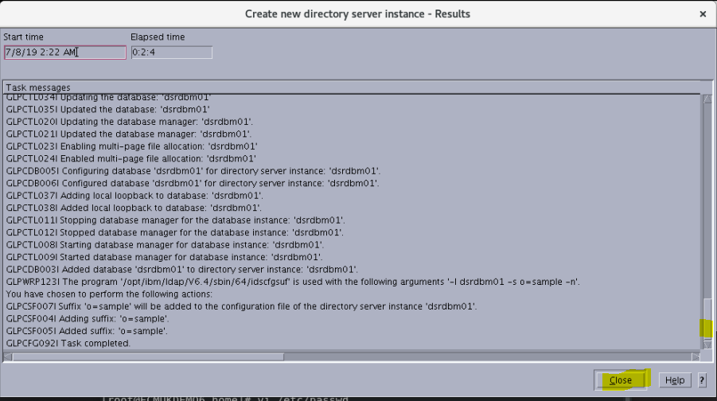

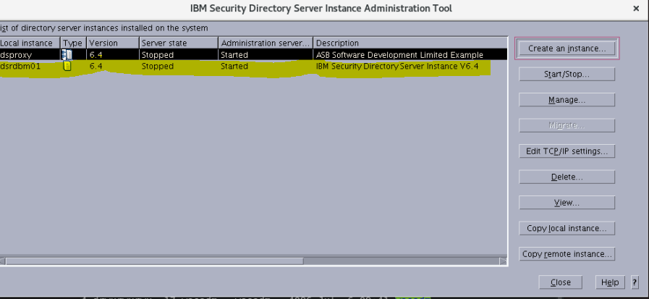

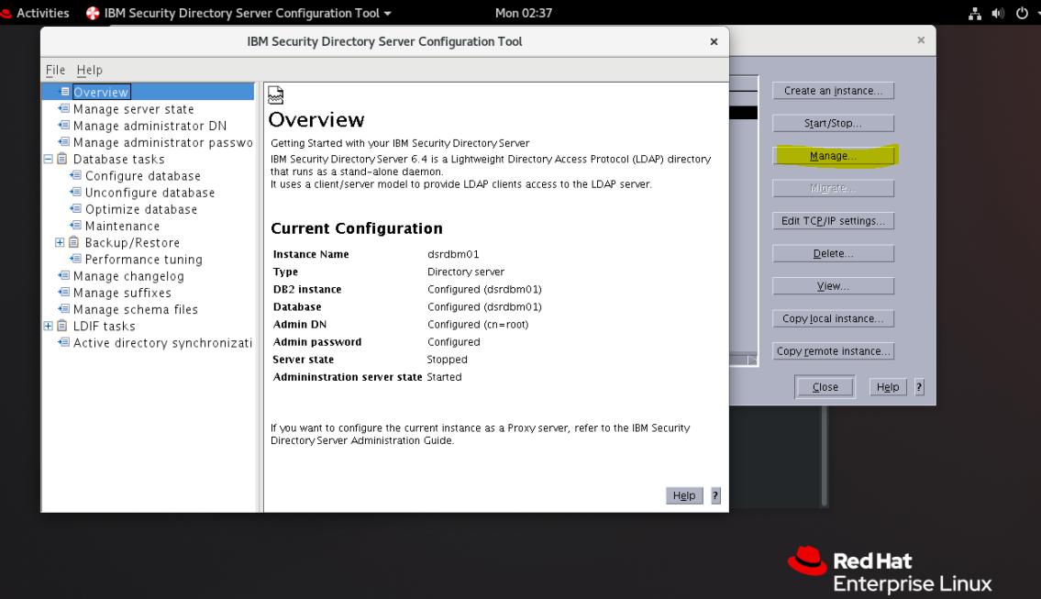

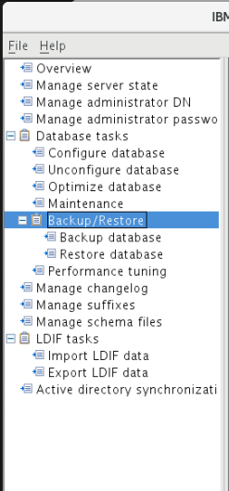

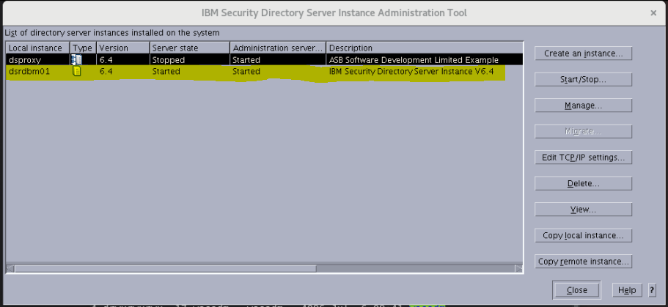

REF:

<https://www.ibm.com/support/knowledgecenter/en/SSVJJU_6.2.0/com.ibm.IBMDS.doc/messages24.htm>

### Deploying the IDSWeb Application on WebSphere

The IBM Security Directory Services Web Application is held in

/opt/ibm/ldap/V6.4/idstools/IDSWebApp.war

REF: <https://www.ibm.com/support/knowledgecenter/en/SSVJJU_6.3.0/com.ibm.IBMDS.doc/install227.htm>

Use the following instructions to install and deploy IBM Web Administration Tool into WebSphere.

1. Install WebSphere using the installation information provided with it, and make sure that it is running properly.

REF: Install WebSphere 8.5.5 Fix Pack 15

1. Install the Web Administration Tool using either the InstallShield GUI or the installation utility for your operating system. The file containing the Web Administration Tool is named IDSWebApp.war, and it is in the idstools subdirectory of the installation directory you specified during installation of Security Directory Server.

( In **/opt/ibm/ldap/V6.4/idstools/IDSWebApp.war** )

1. Login to the WebSphere Admin console, the URL is:

<http://ecmukdemo6:9060/ibm/console>

start the server

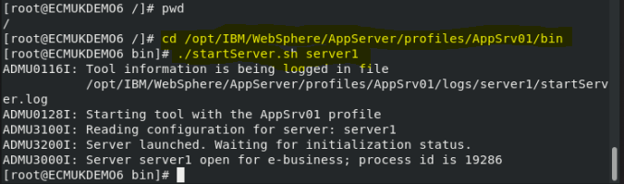

1. Enter the user ID and password of the user. This user should have sufficient permission to perform operations on WebSphere Application Server.

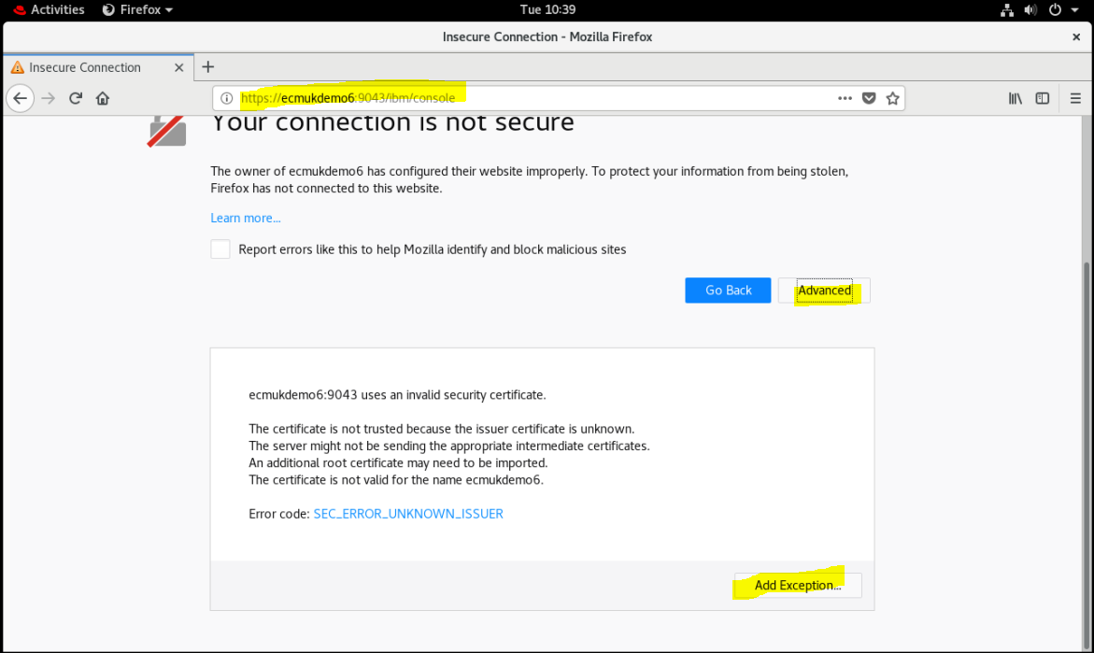

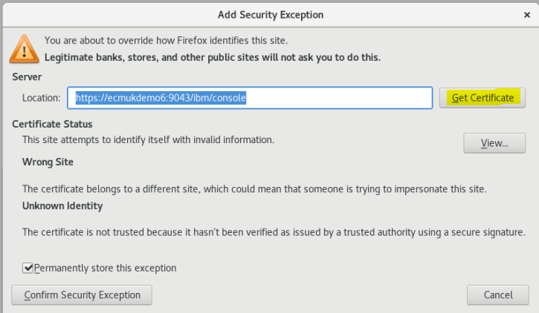

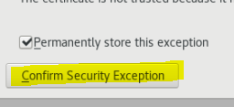

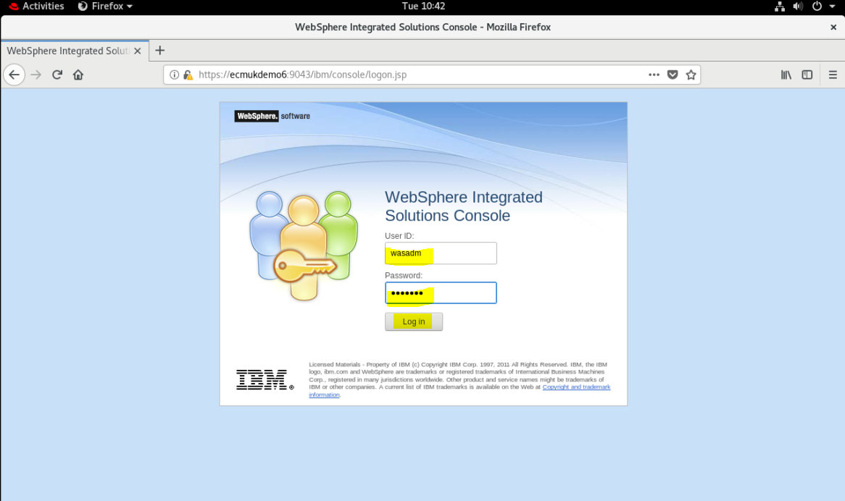

1. On the left navigational pane, expand Application and then click New Application.
2. From the New Application panel, click New Enterprise Application.

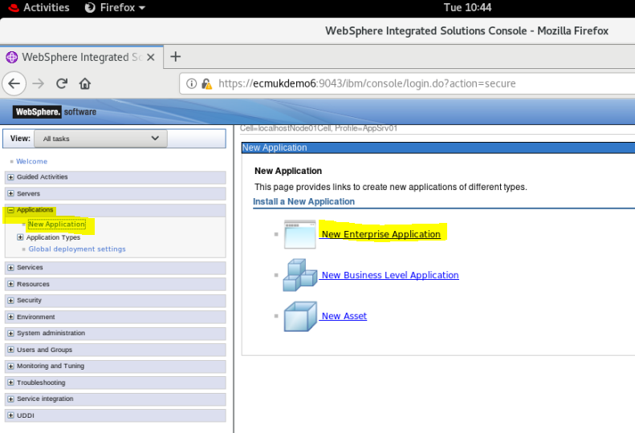

1. On the Path to the new application panel, do one of the following depending from where the WebSphere Admin console is launched:
   * If from the local system, select Local file system and then enter the path of the IDSWebApp.war file in the Full path field. You can also click Browse to specify the path.

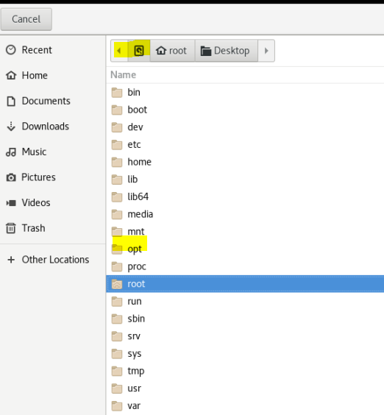

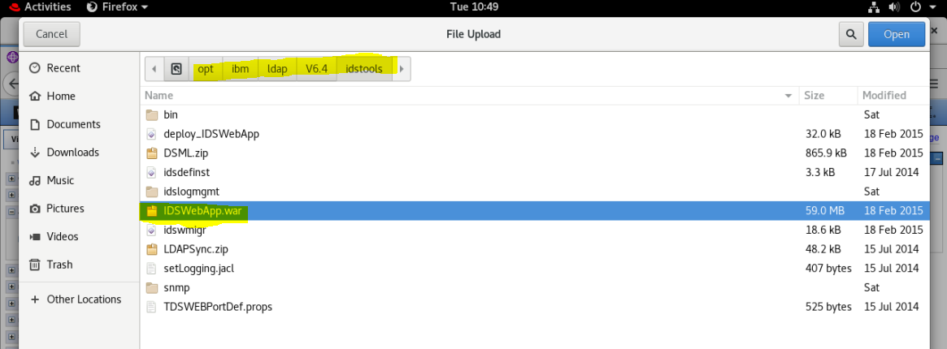

* + If from a remote system, select Remote file system and then enter the path of the IDSWebApp.war file in the Full path field. You can also click Browse to specify the path.

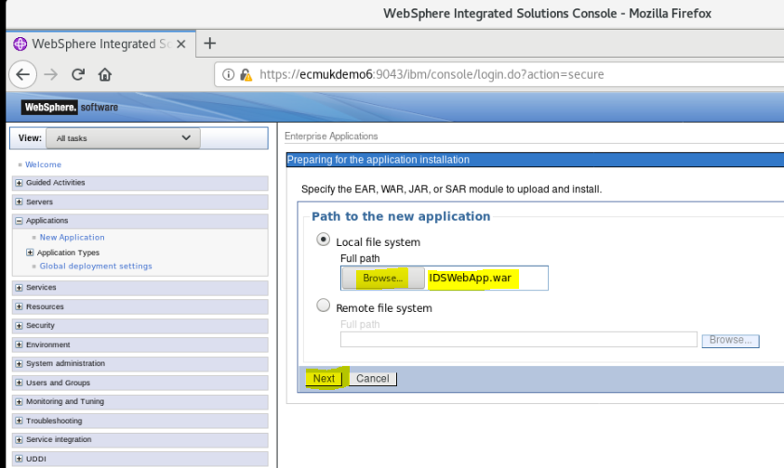

1. On the How do you want to install the application panel, select the option you want and click Next. In this example, the Fast Path option is selected.

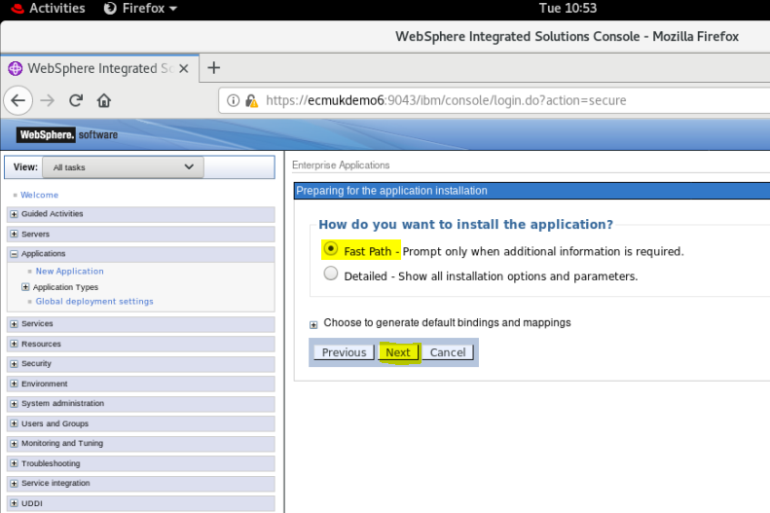

1. On the Select installation options panel, the default options are selected. Click Next.

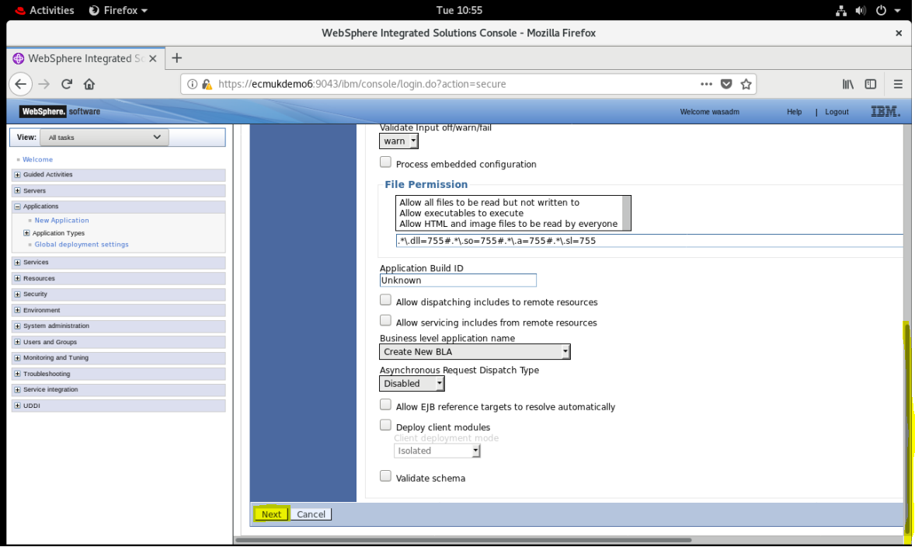

1. On the Map modules to server panel, user can map modules to the servers specified in the Clusters and servers field. Select the check box for the required module and then click Apply.

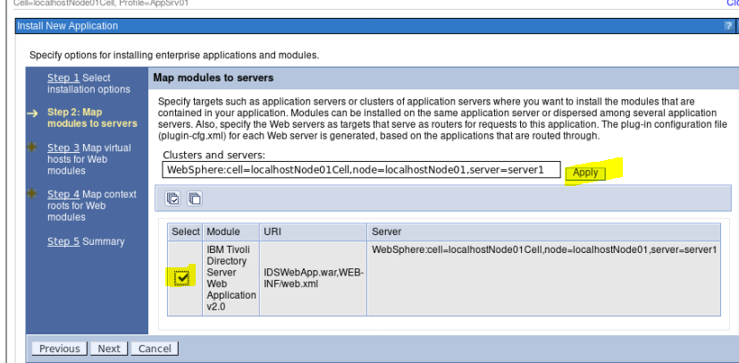

After the mapping is done, click Next.

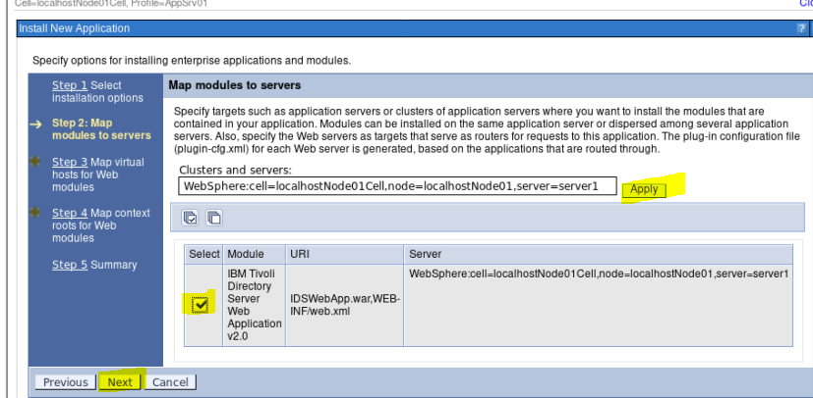

1. On the Map virtual hosts for Web modules panel, user can map the Web application to the specific virtual servers. If there are more virtual hosts, it requires knowledge of the WebSphere environment to select the right module. In this example, there is only one default\_host option is available for selection. Click Next.

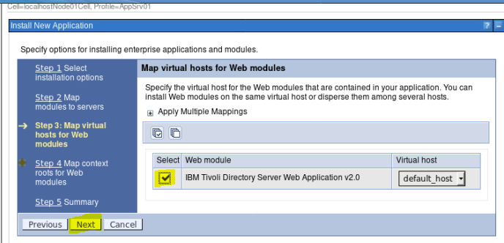

1. On the Map context roots for Web modules, enter a context root in the field. For example, /IDSWebApp.

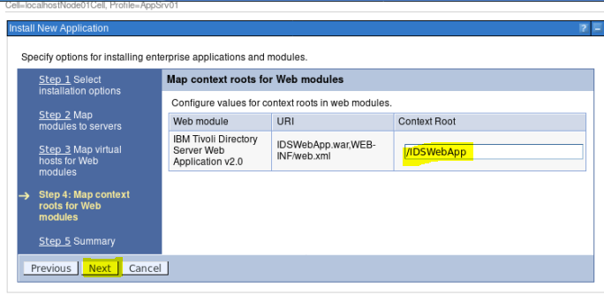

1. A summary of options you selected is displayed. Click Finish.

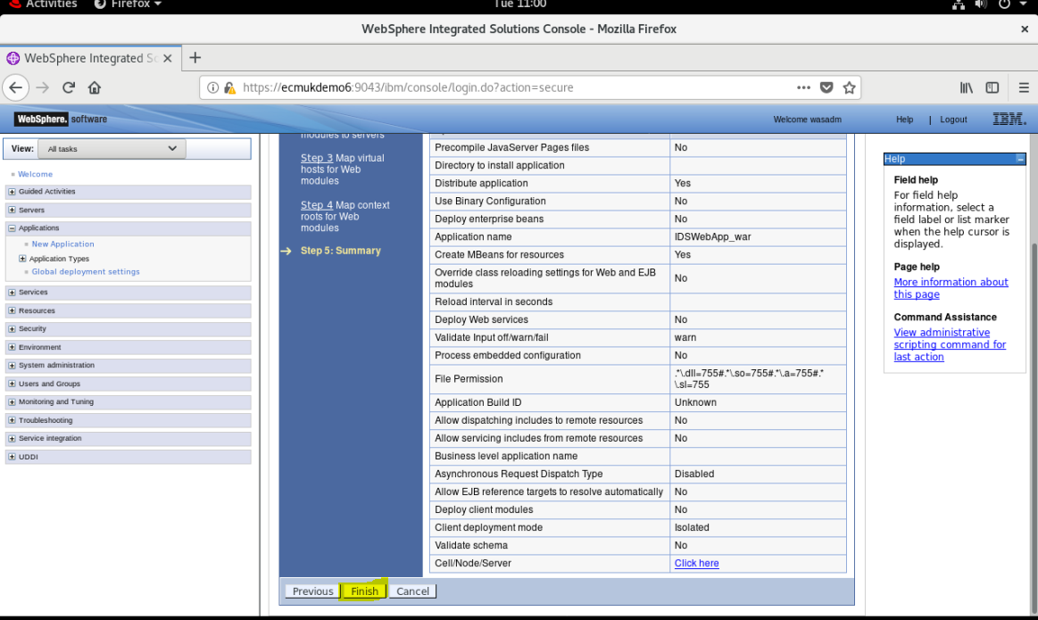

1. This initiates the installation of your application. A summary of installation is displayed.
2. To start the application, you must first save the changes to the master configuration. Click Save.

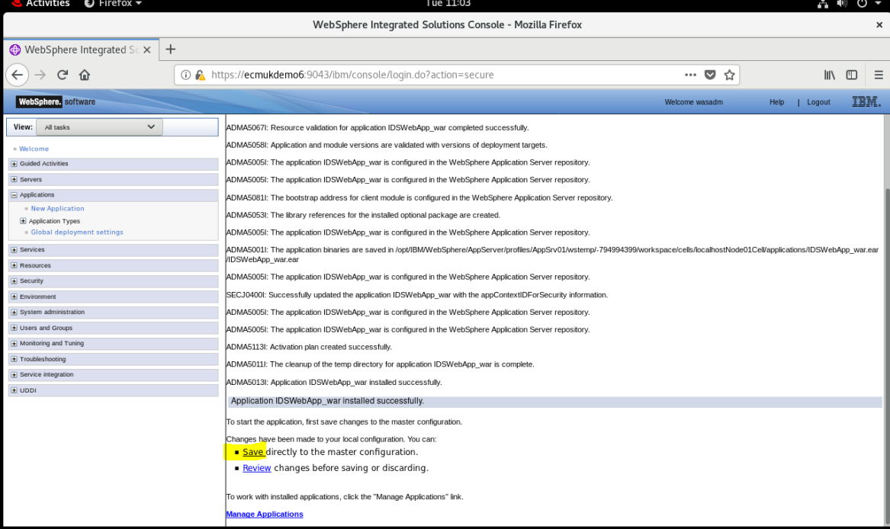

1. On the left navigational pane, expand Applications and then click WebSphere enterprise applications under Application Types.
2. To start the application, from the Enterprise Applications panel select the check box adjacent to IDSWebApp\_war and click Start.

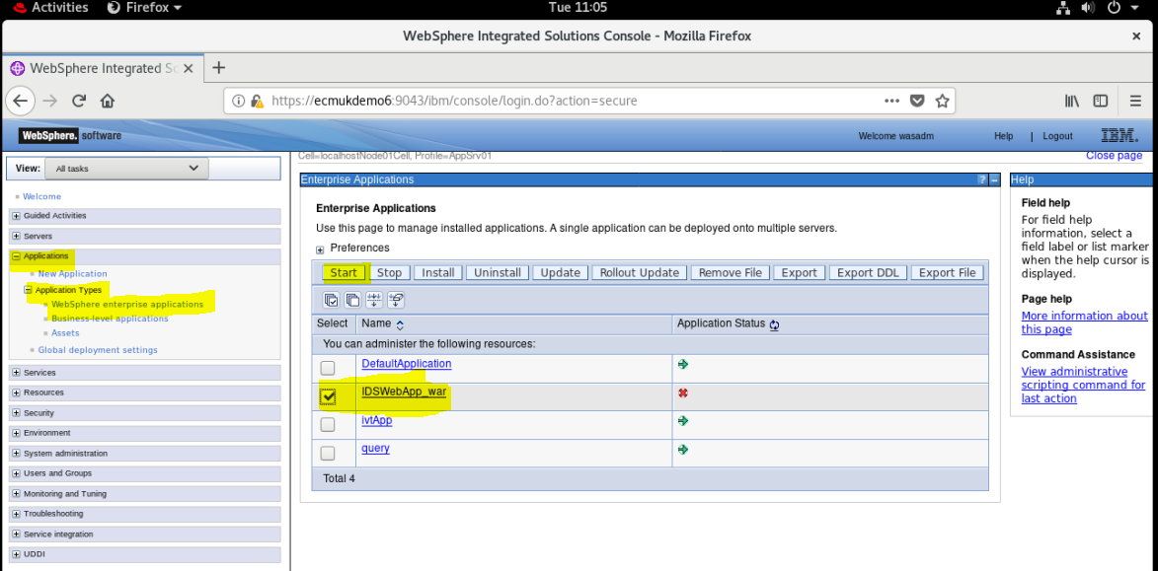

1. Start the Web Administration Tool (for example, through the Administrative Console).

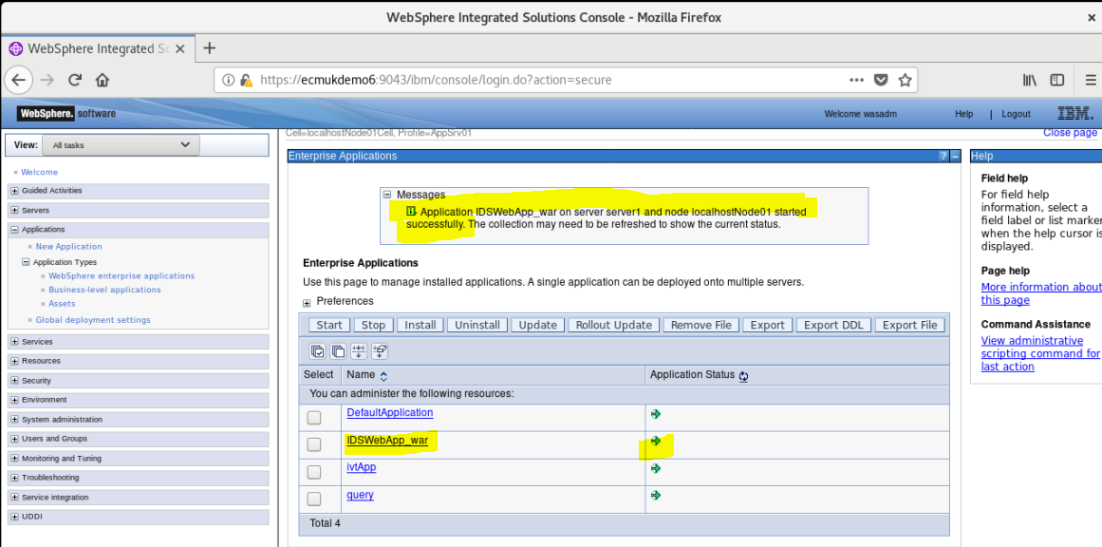

1. Now to launch the Web Administration Tool from a Web browser, type the following address:
   * For HTTP, type:

http://<localhost>:*WAS\_http\_port*/IDSWebApp

<http://ecmukdemo6:9080/IDSWebApp>

* + For HTTPS, type:

https://<localhost>:*WAS\_https\_port*/IDSWebApp

1. By default, the HTTP port is 9080, and the HTTPS port is 9443.
2. The Security Directory Server Web Administration login page window is displayed.

### First Time Logon to WebSphere – IMPORTANT!

REF

<https://www.ibm.com/support/knowledgecenter/en/SSVJJU_6.2.0/com.ibm.IBMDS.doc_6.2/admin_gd11.htm>

use

1. Log in to the console as the console administrator, using the following instructions:
   1. **In the User ID field, type superadmin.**
   2. **In the Password field, type secret.**
   3. Click **Login**.

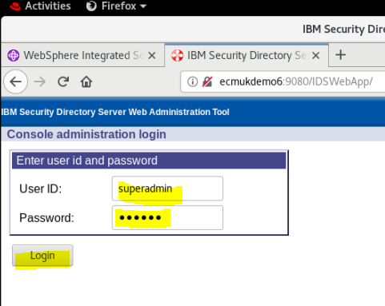

The IBM Security Directory Server Web Administration Tool console is displayed.

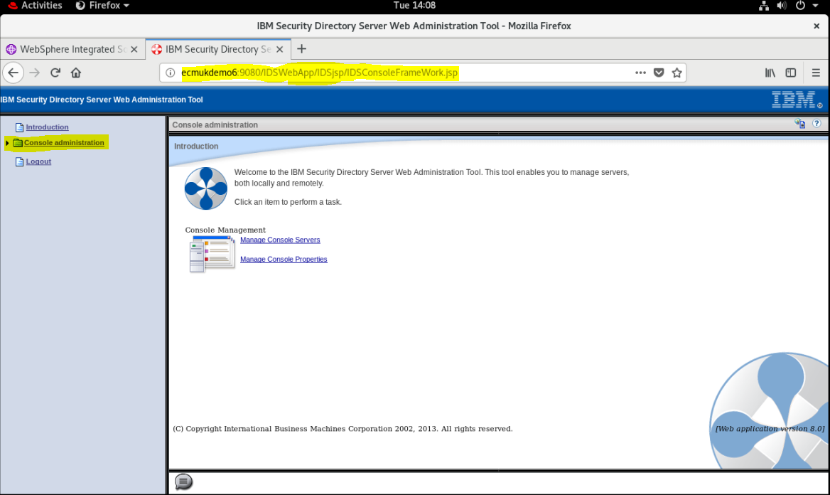

1. Add a server to the console, using the following instructions:
   1. Do one of the following:
      * Click **Manage console servers** in the right side of the window.
      * Expand **Console administration** in the navigation area, and then click **Manage console servers**.

A table of server host names and port numbers is displayed.

* 1. Click **Add**.

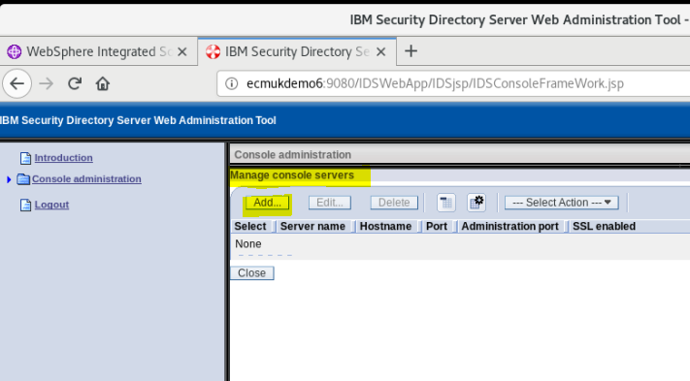

* 1. Enter a unique name in the **Server name** field to identify a registered IBM Security Directory Server (TDS) server instance running on a specific host name or IP address and server port.

From the installation log ports are as highlighted below:

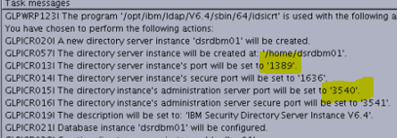

* 1. Type the hostname or the IP address of the server in the **Hostname** field.
  2. Specify the server port number in the **Port** field.

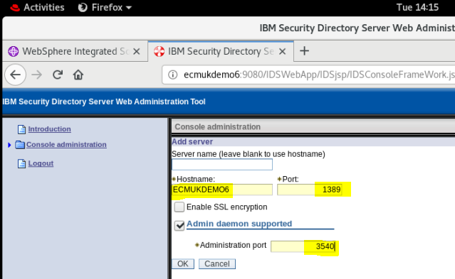

* 1. Specify whether the console will be communicating with the server using Secure Sockets Layer (SSL). The **Enable SSL encryption** check box will display only if you installed an SSL-enabled version of IBM(R) Security Directory Server Web Administration Tool.
  2. Select the **Administration server supported** check box to enable the Administration port control.
  3. Specify the Administration server port number in the **Administration port** field.
  4. Click **OK** to apply the changes or click **Cancel** to exit the panel without making any changes.

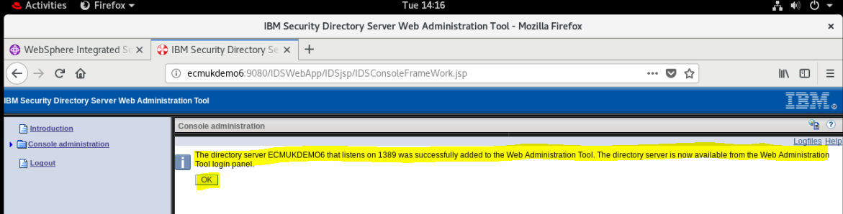

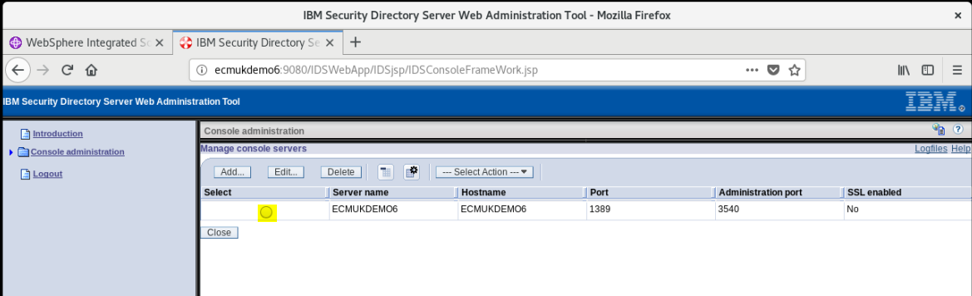

1. Click **Logout** in the navigation area.

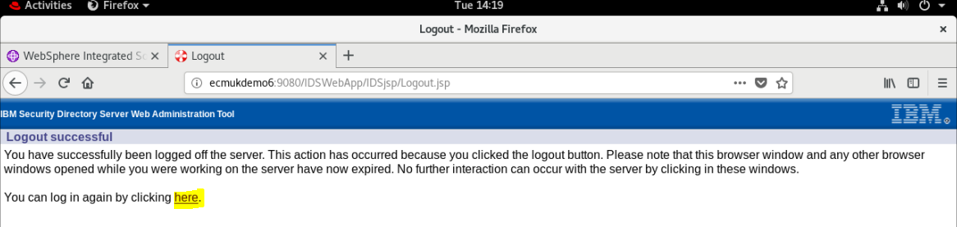

### **[Logging on to the console as the server administrator, a member of an administrative group or an LDAP user](https://www.ibm.com/support/knowledgecenter/SSVJJU_6.2.0/com.ibm.IBMDS.doc_6.2/admin_gd02.htm?view=kc" \l "ToC_42)**

To log on as the server administrator, a member of the administrative group (see [Creating the administrative group](https://www.ibm.com/support/knowledgecenter/SSVJJU_6.2.0/com.ibm.IBMDS.doc_6.2/admin_gd17.htm?view=kc#admingroup)) or an LDAP user:

* At the IBM Security Directory Server login page select the LDAP Server Name or IP address and port for your machine from the drop-down menu.

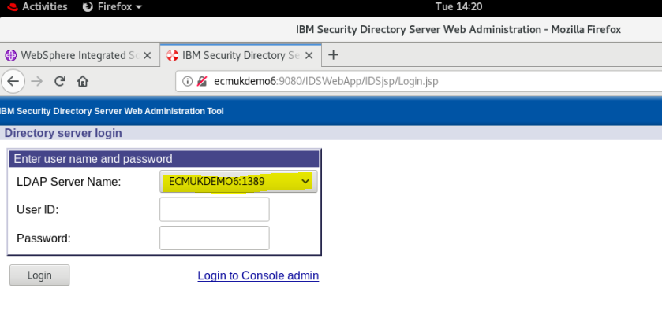

**NB We change the port later to 389 which can be done by using the administrator tool and the default superadmin user.**

* Enter the administrator DN and the corresponding password for that administrator DN (you set these up during the server configuration process). For example, if the administrator DN which was created during the server configuration process was cn=root, then enter the full administrator DN. Do not just use root (although for my test system I did!). Similarly, to login as an admin group member or as a normal DIT user, enter the DN of the user and the corresponding password. For example, if the DIT user is cn=Tom Brown, o=sample then you need to enter the login name as cn=Tom Brown, o=sample.

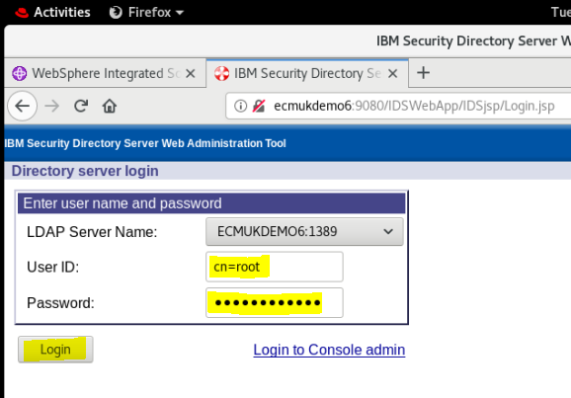

* Click **Login**.

The IBM Security Directory Server Web Administration Tool console is displayed with various server management tasks. The server management tasks vary depending upon the capabilities of the server and the type of user that you have logged on as.

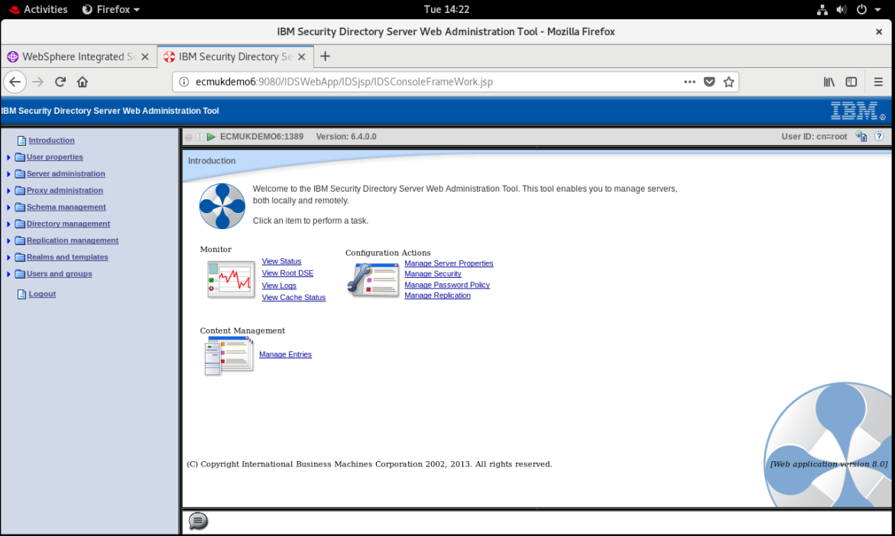

### Add a Domain

<https://www.ibm.com/support/knowledgecenter/en/SSVJJU_6.4.0/com.ibm.IBMDS.doc_6.4/ds_ag_user_rel_add_realm_wat.html>

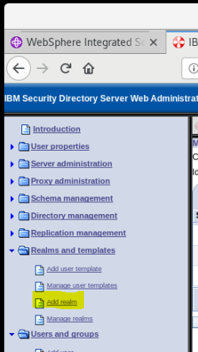

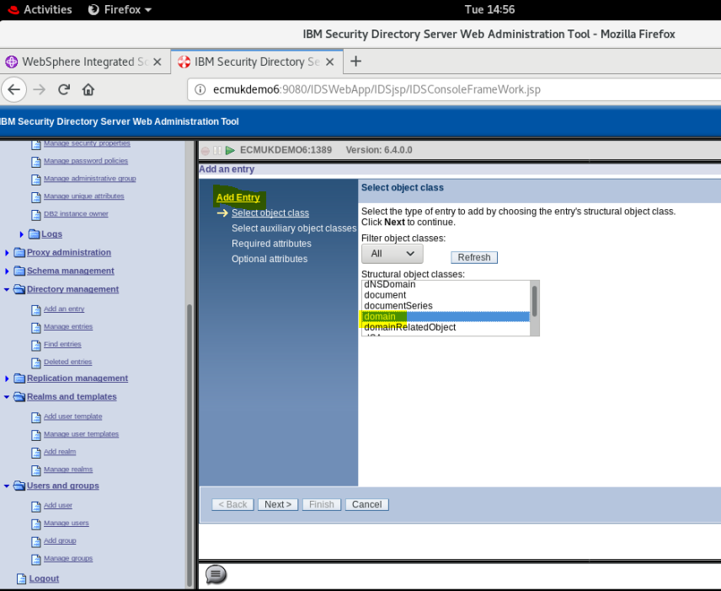

Add a Domain

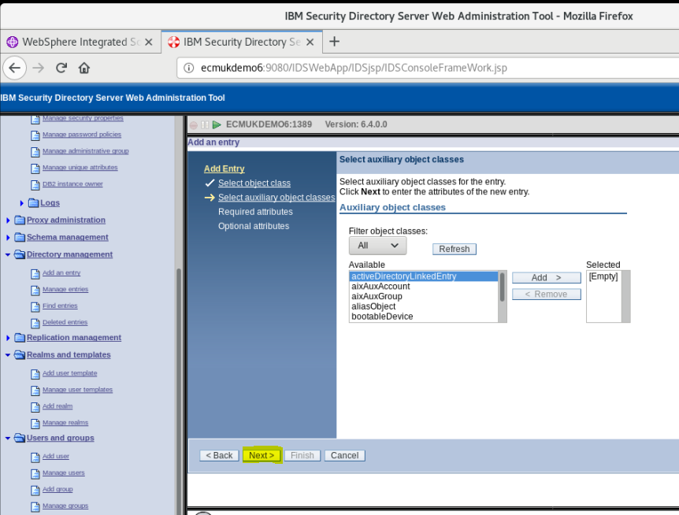

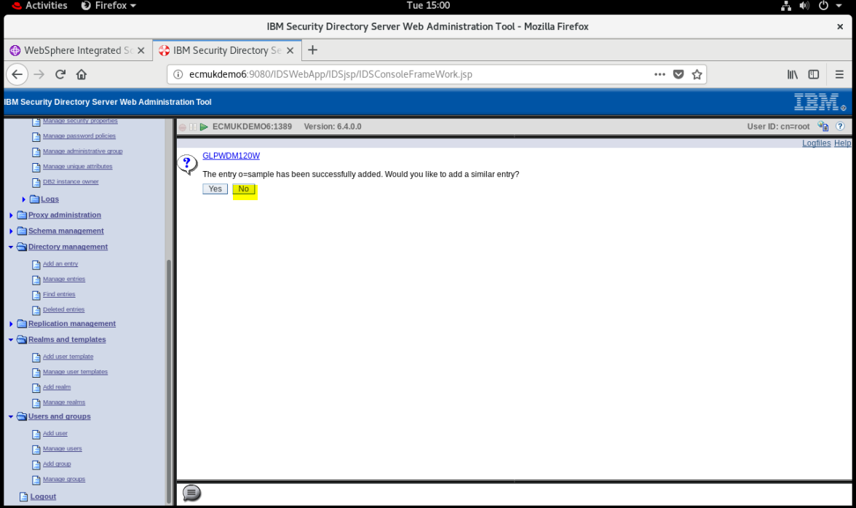

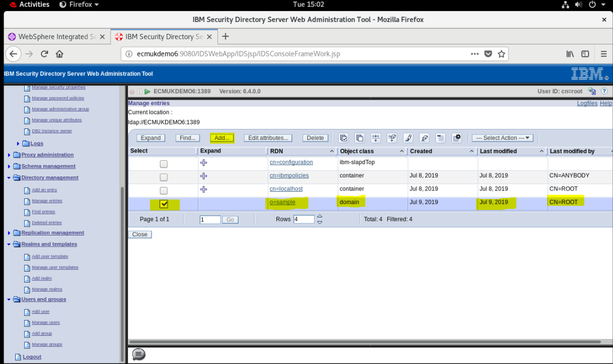

Add inetOrgPerson p8admin

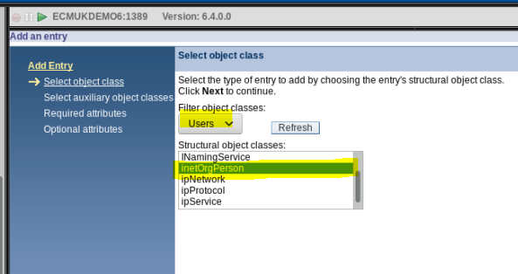

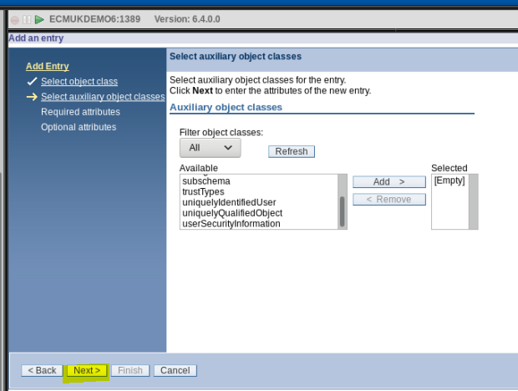

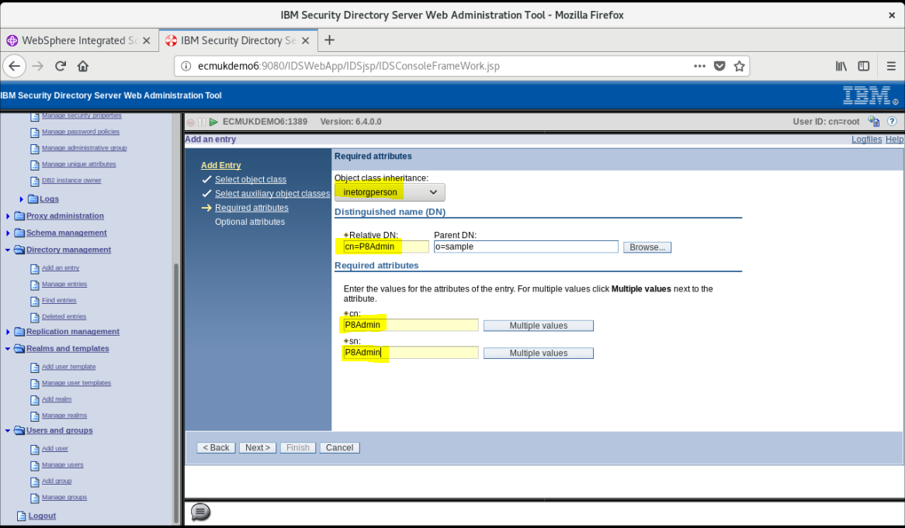

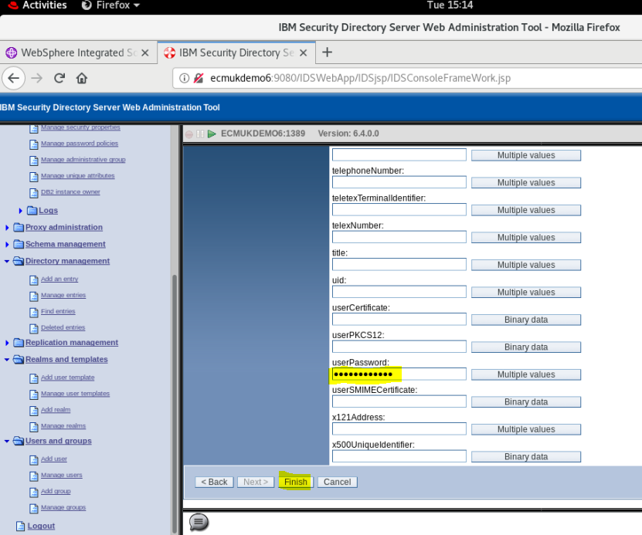

Click Finish

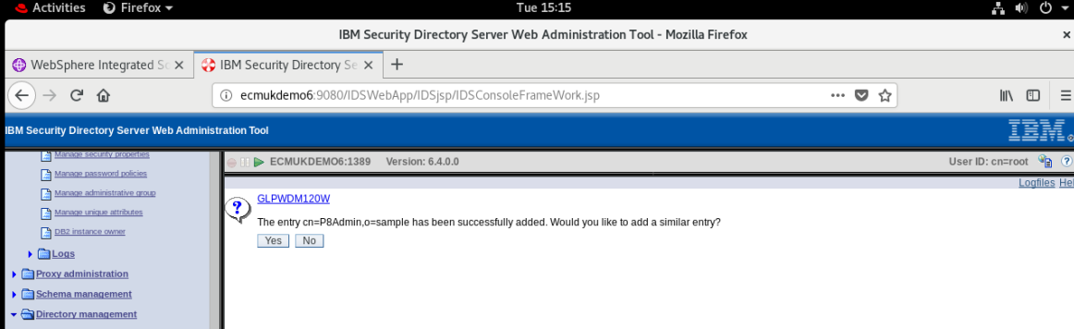

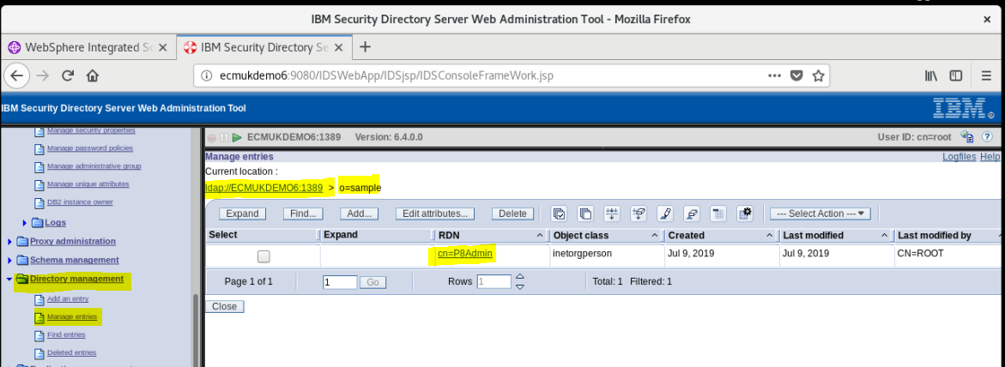

1. **Note:**
2. The localhost address works only if you are running the browser on the computer on which the Web Administration Tool is installed. If the Web Administration Tool is installed on a different computer, replace localhost with the hostname (eg ecmukdemo6 as shown above) or IP address of the computer where the Web Administration Tool is installed.
3. If Global or Administrative security is turned on for Websphere Application Server and SSL must be enabled for the Web Administration Tool when deploying the Web Administration Tool into Websphere Application Server, user can use one of the following approaches:
   * Deploy the Web Administration Tool into a new profile.
   * If it is not possible to deploy the Web Administration Tool into a new profile, user must add the directory server's certificate to the profile's trust store. Additionally, for server-client authentication user must add the Websphere Application Server profile certificate to the directory server's trust store.

Installation

# DB2 V10.5 Server Installation

Download DB2 Server V10.5 to use with the Object Stores of the IBM Content Platform Engine 5.5

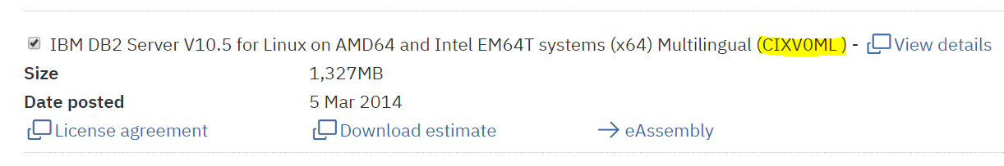

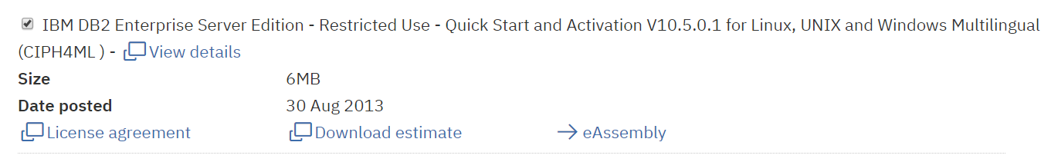

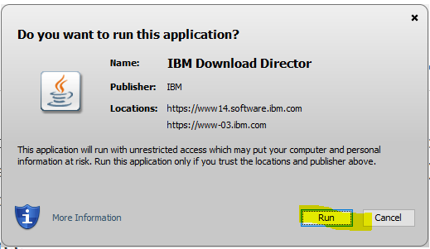

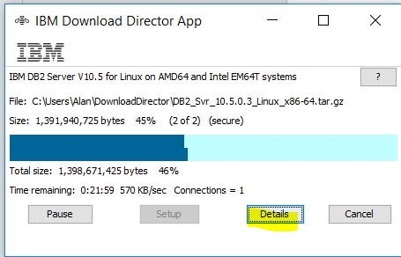

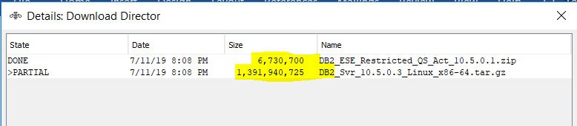

**REF:**

[**https://www.ibm.com/support/knowledgecenter/en/SSEPGG\_10.5.0/com.ibm.db2.luw.qb.server.doc/doc/c0024080.html**](https://www.ibm.com/support/knowledgecenter/en/SSEPGG_10.5.0/com.ibm.db2.luw.qb.server.doc/doc/c0024080.html)

**ftp the Install files downloaded to /home/wasadm user:**

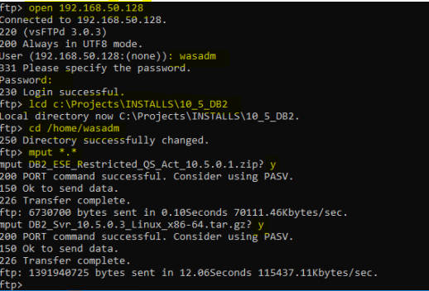

**Copy and unpack the installation and license files**

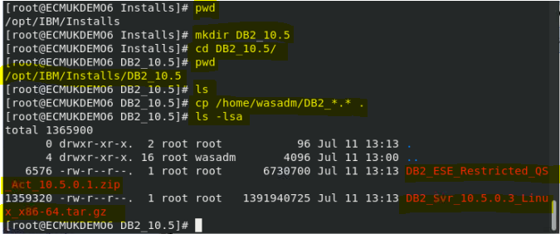

tar -zxvf DB2\_Svr\_10.5.0.3\_Linux\_x86-64.tar.gz

unzip DB2\_ESE\_Restricted\_QS\_Act\_10.5.0.1.zip

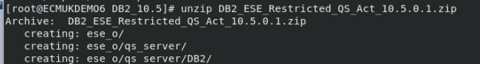

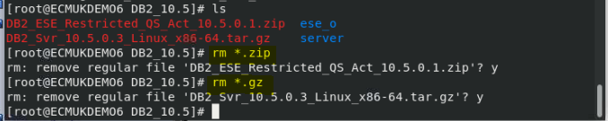

**Delete the zip and gz files to release disk space**

## Before you begin

Before starting the DB2 Setup wizard, check the installation prerequisites by using the db2prereqcheck command.

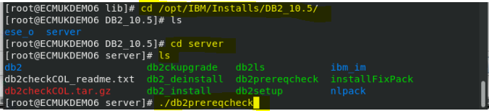

If you are installing a non-pureScale DB2 product then use a summarized command below:

1. db2prereqcheck -s -i



See Appendix B Appendix B – DB2 Check Log output

(This has the full check list **and some yum install fixes**)

• Enter the ./db2setup command from the directory where the database product image resides to start the DB2 Setup wizard.

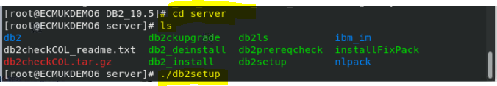

• The IBM DB2 Setup Launchpad opens. From this window, you can view installation prerequisites and the release notes, or you can proceed directly to the installation. You can also review the installation prerequisites and release notes for late-breaking information.

./db2setup -l /tmp/db2setup.log -t /tmp/db2setup.trc[](javascript:void(0);)

The -l and -t parameters enable DB2 logging and tracing. The IBM DB2 Setup Launchpad opens. From this window, you can view the DB2 pureScale® Feature release information, upgrade options, architectural overview, and pre-installation planning, or you can proceed directly to the installation.

**NB I just used :**

**./db2setup**

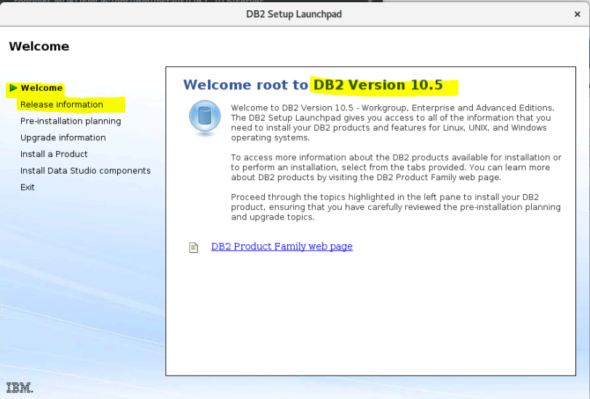

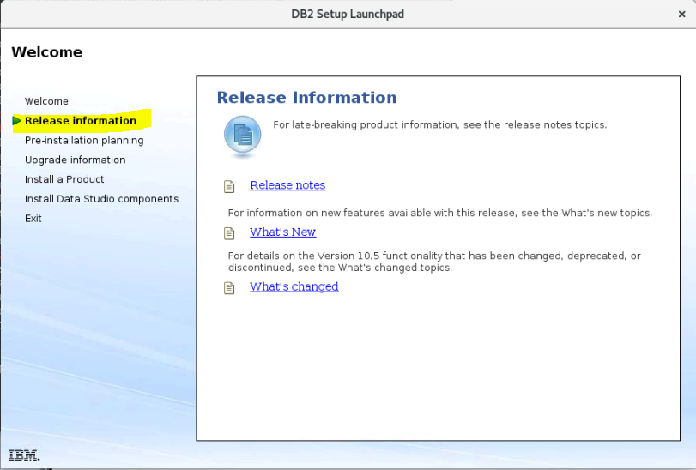

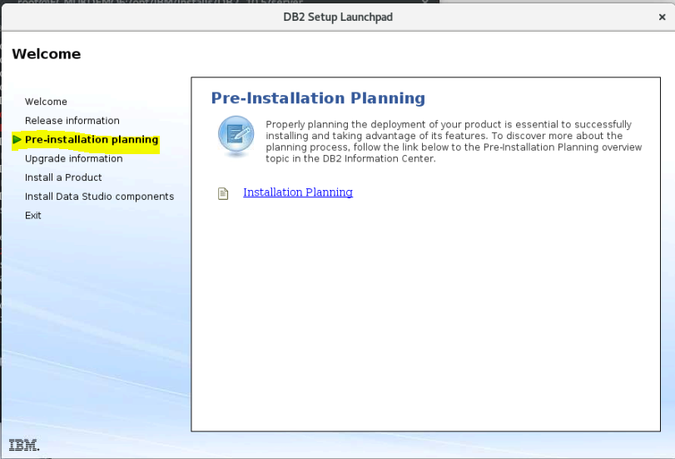

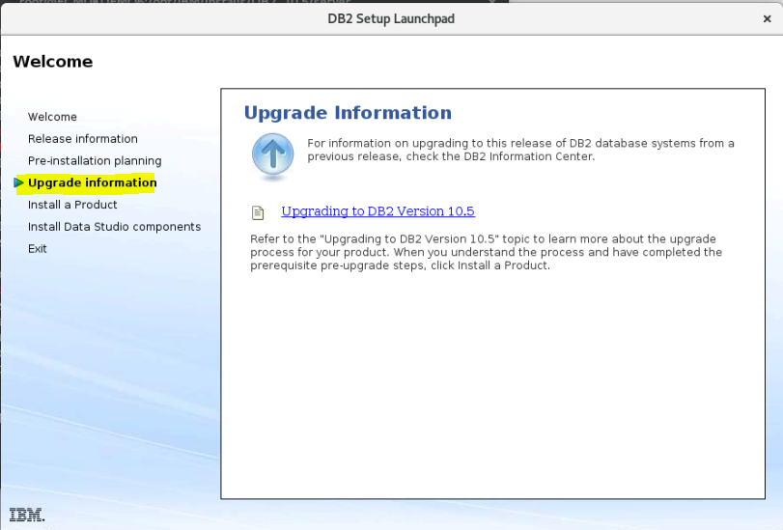

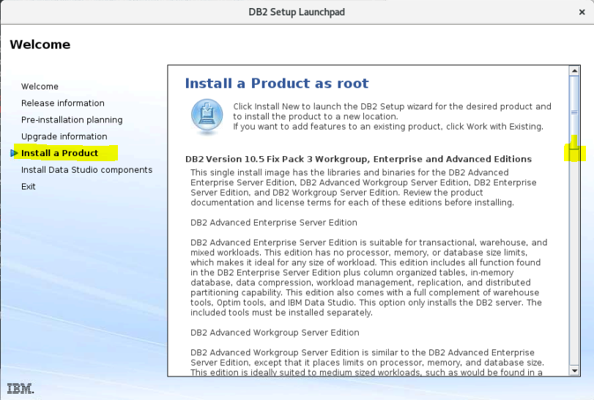

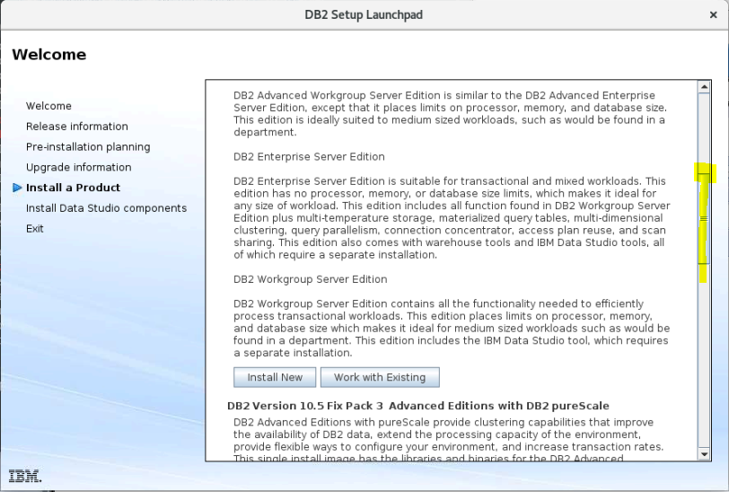

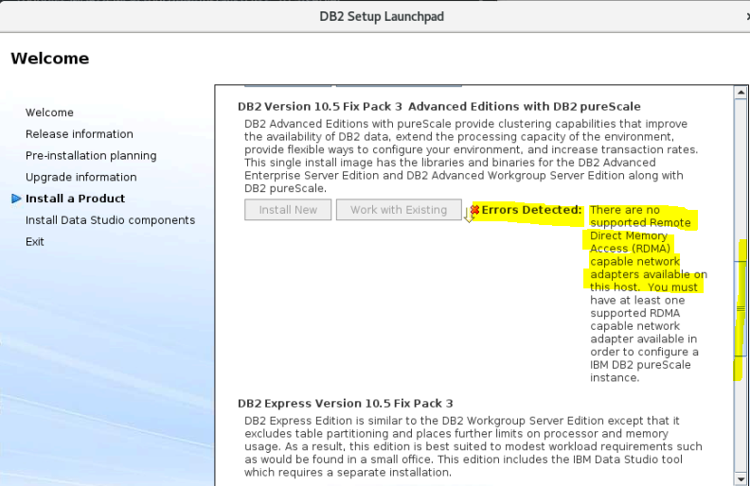

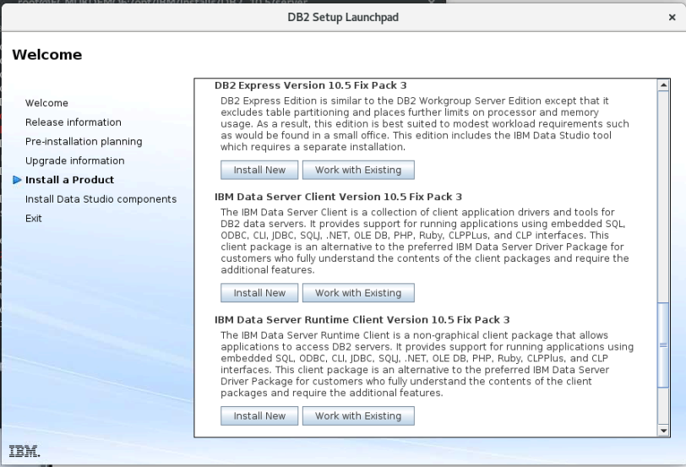

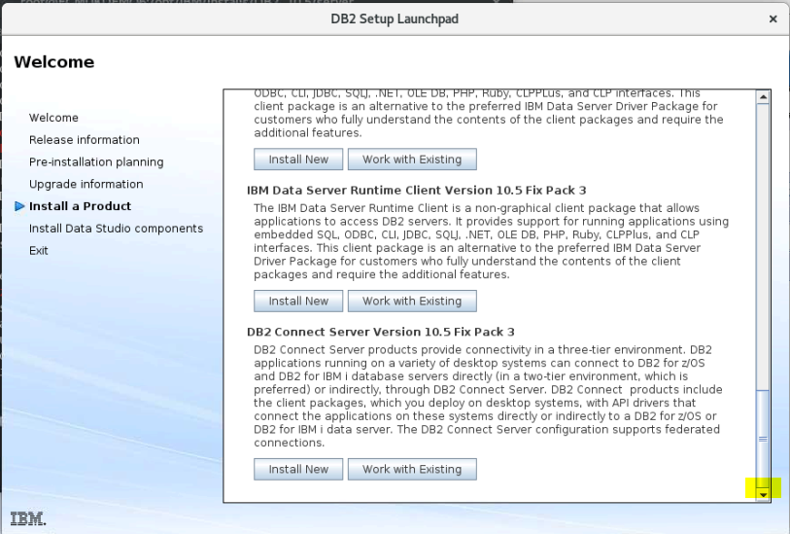

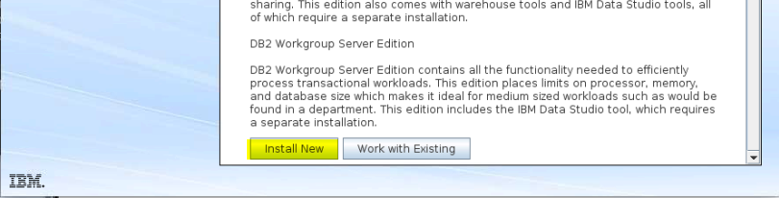

• Click Install a Product and the Install a Product window will display the products available for installation.

Launch the installation by clicking Install New. Proceed through the installation following the DB2 Setup wizard's prompts.

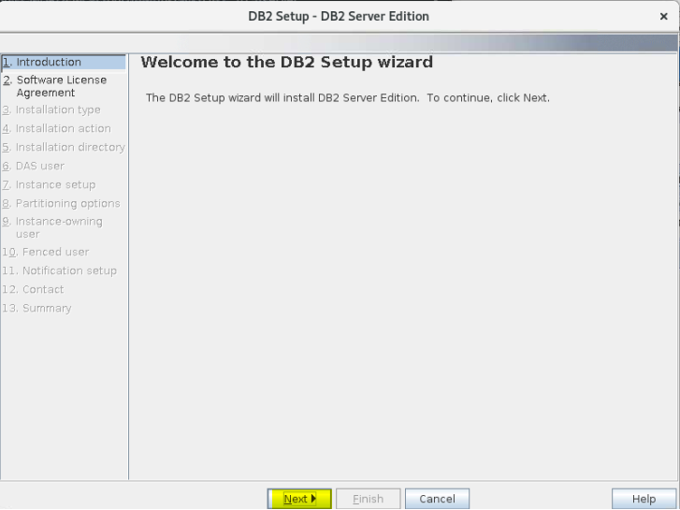

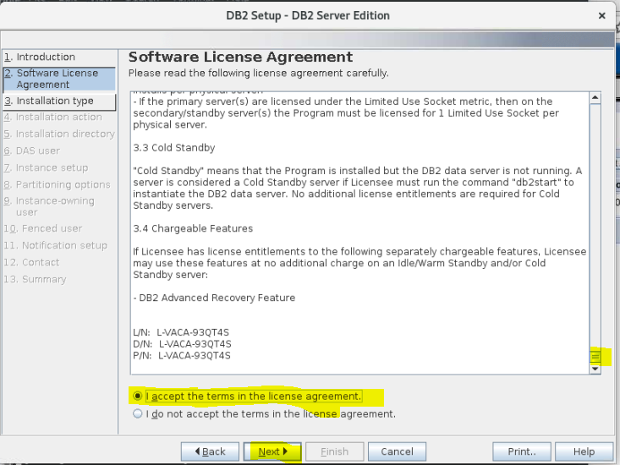

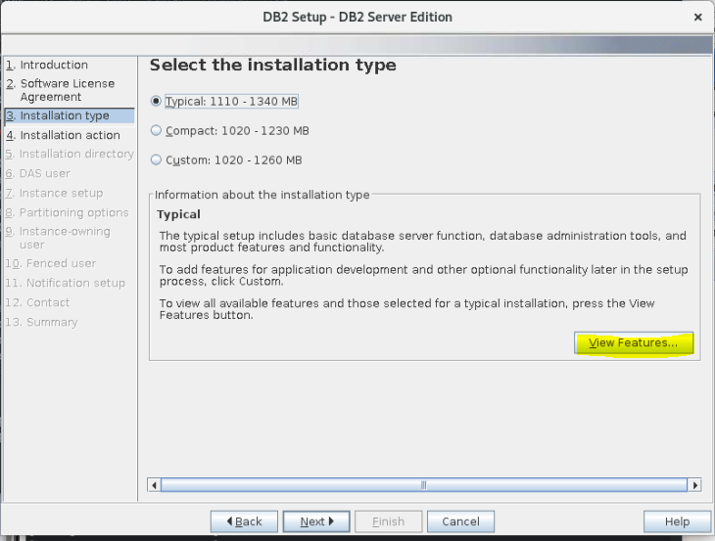

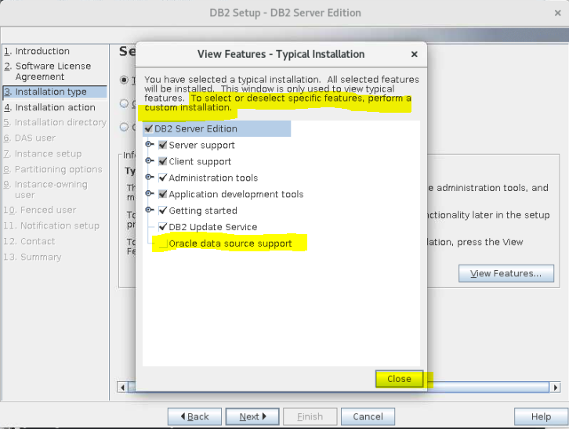

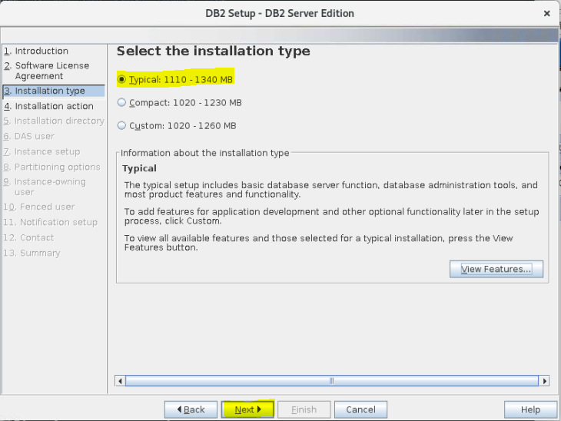

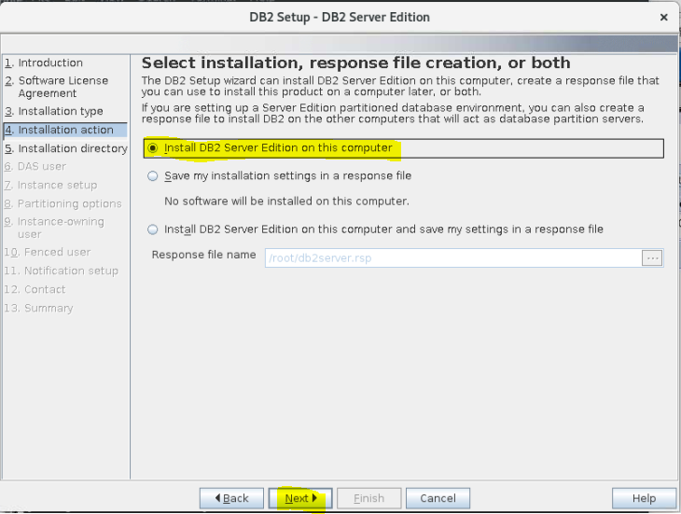

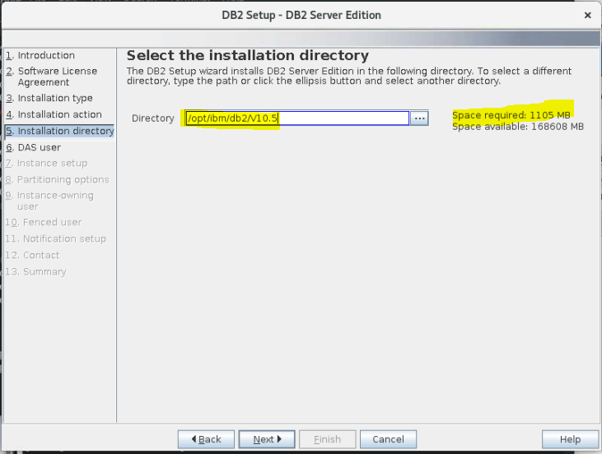

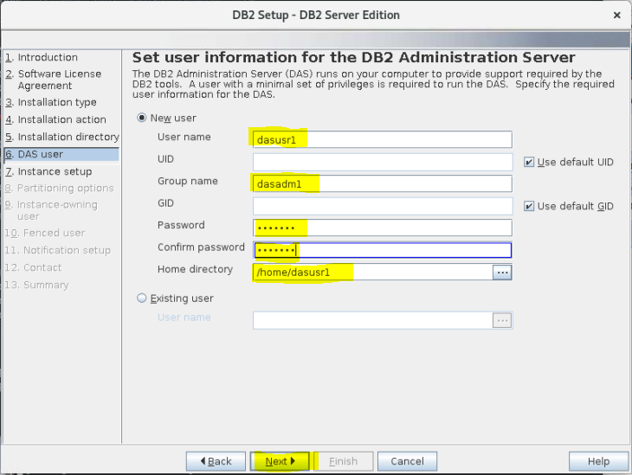

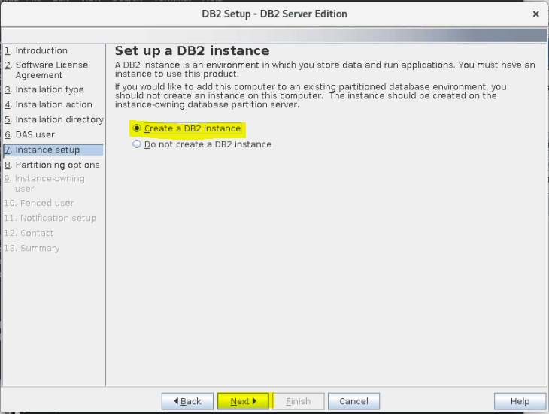

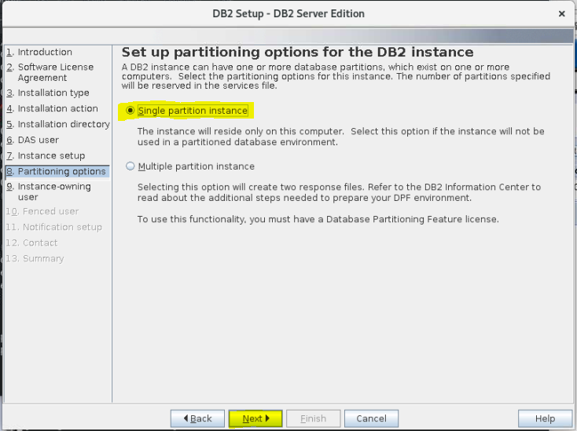

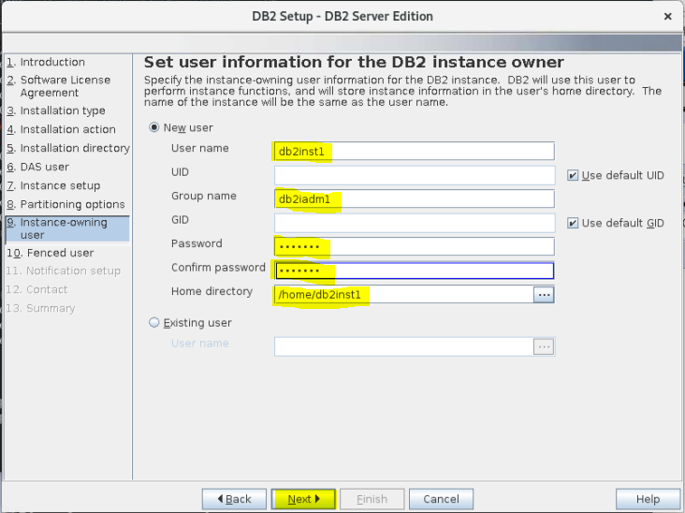

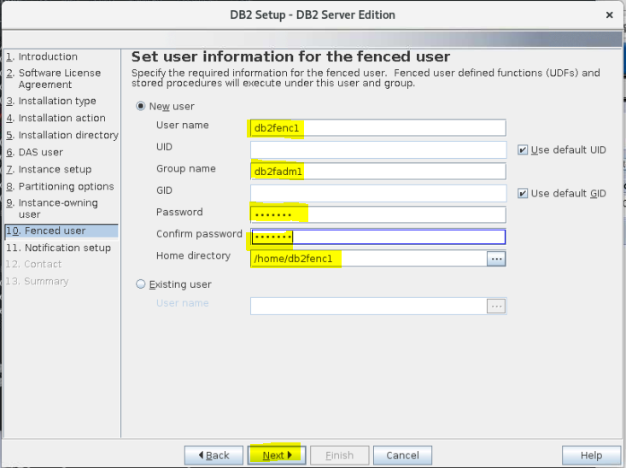

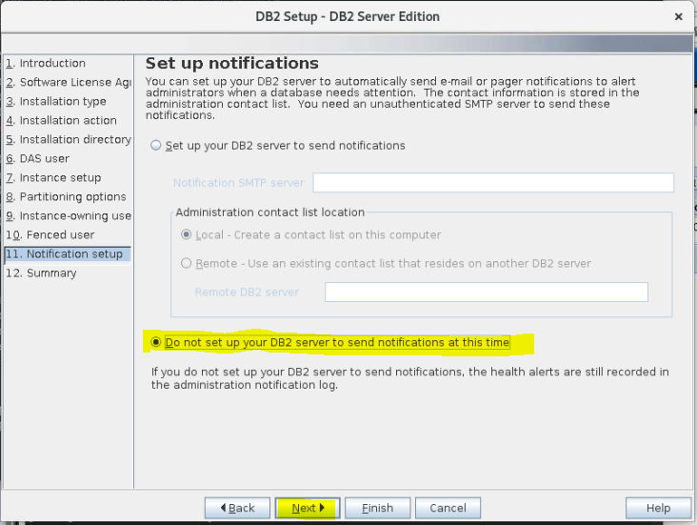

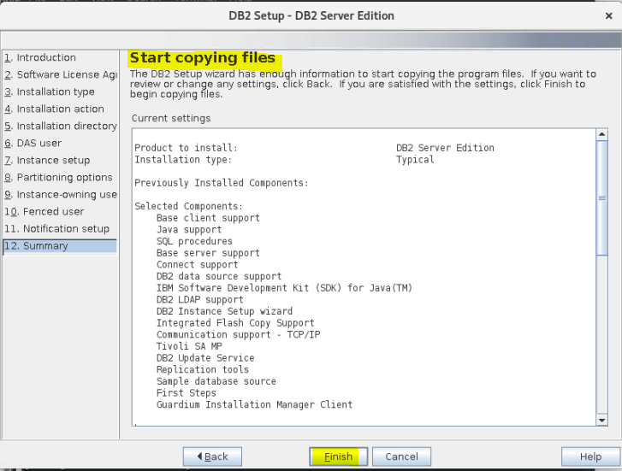

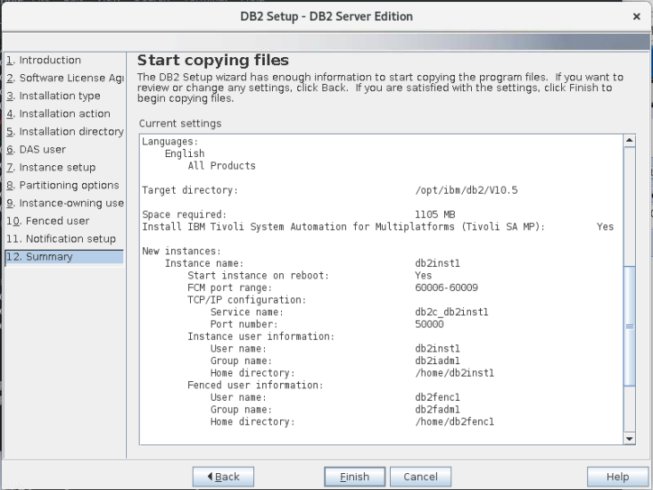

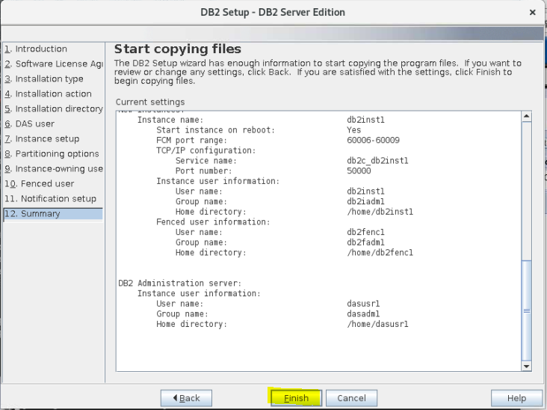

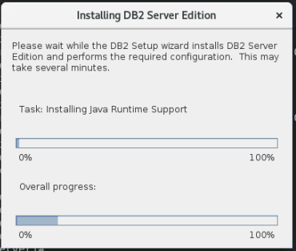

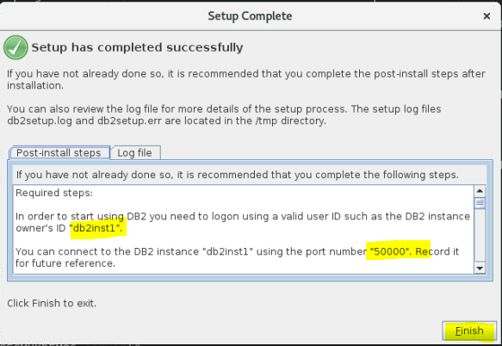

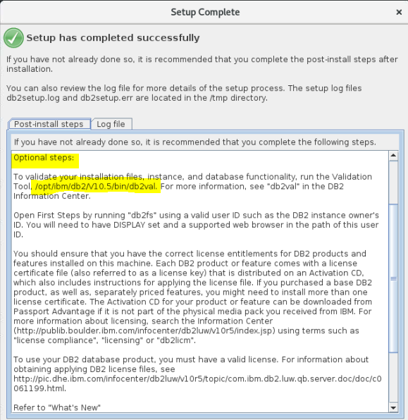

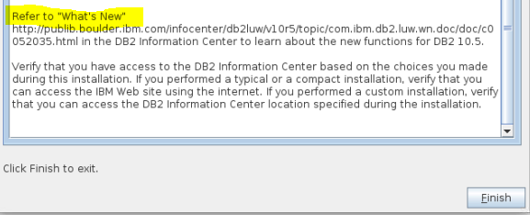

REF <http://publib.boulder.ibm.com/infocenter/db2luw/v10r5/topic/com.ibm.db2.luw.wn.doc/doc/c0052035.html>

/opt/ibm/db2/V10.5/bin/db2val

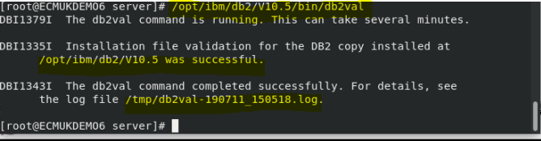

• Sample panels when using the DB2 setup wizard will lead you to the installation process.

<https://www.ibm.com/support/knowledgecenter/en/SSEPGG_10.5.0/com.ibm.db2.luw.qb.server.doc/doc/c0024080.html>

To install the Data Studio components, restart the IBM® DB2 Setup Launchpad by running the db2setup command. Click Install Data Studio components. The Install Data Studio components panel displays the products available for installation.

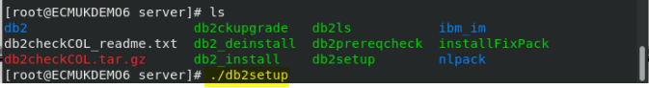

./db2setup

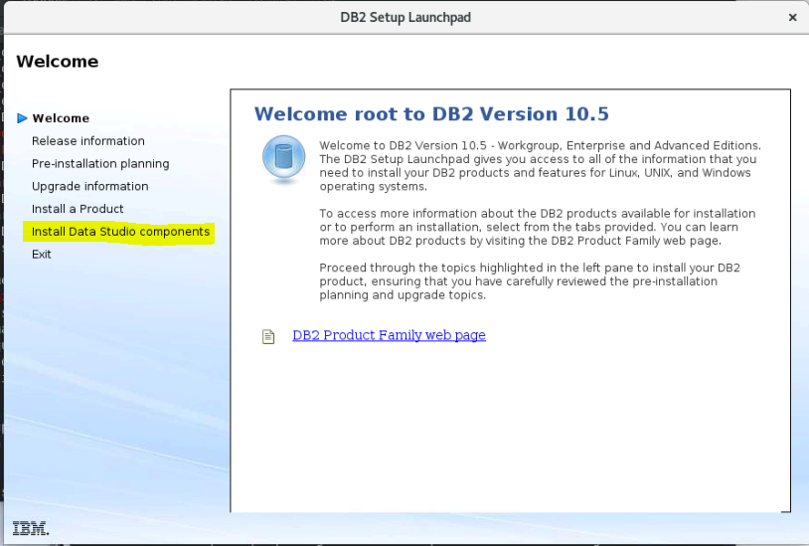

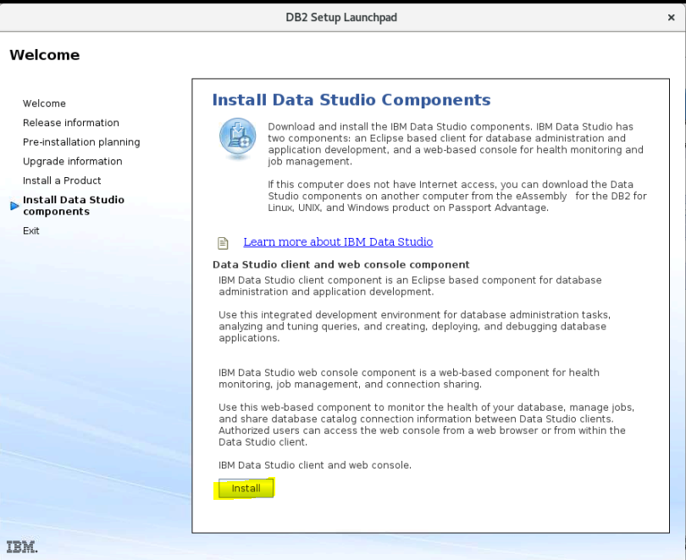

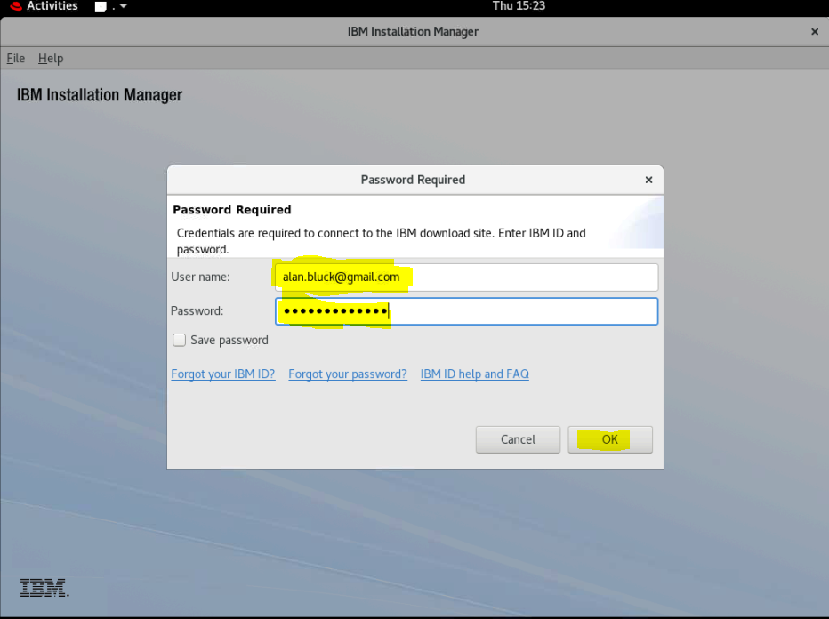

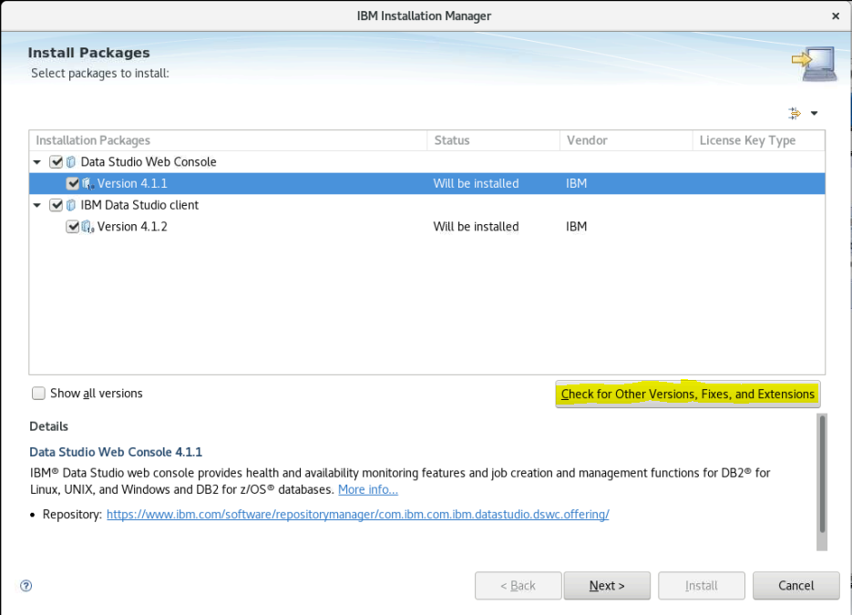

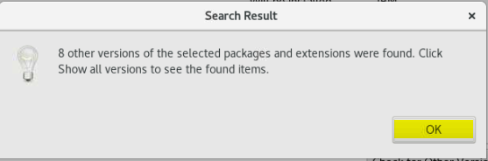

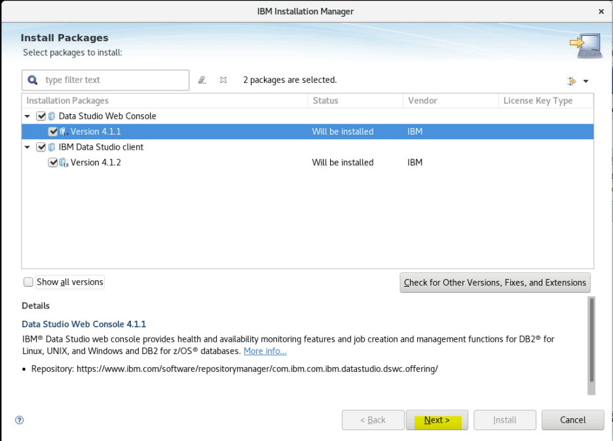

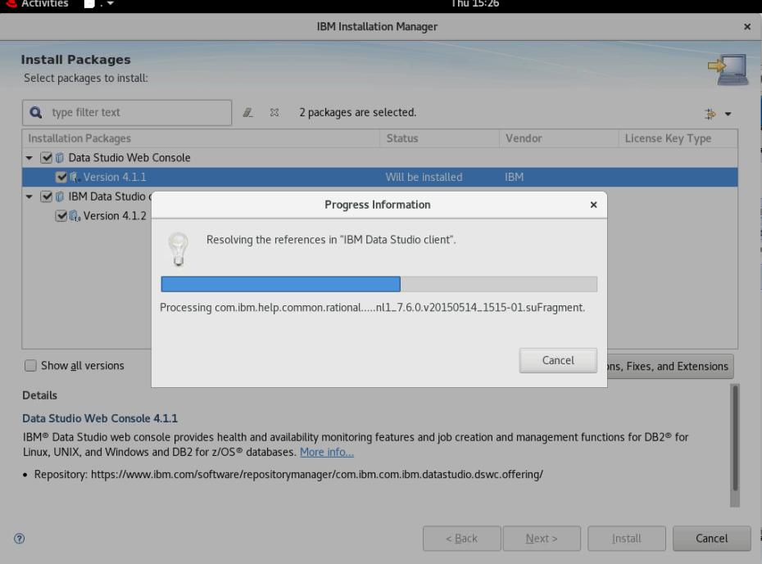

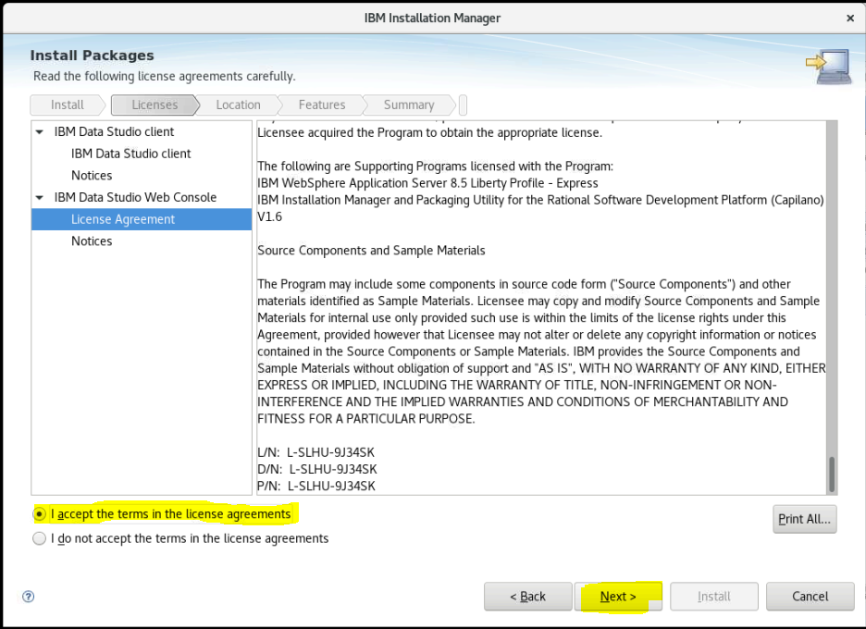

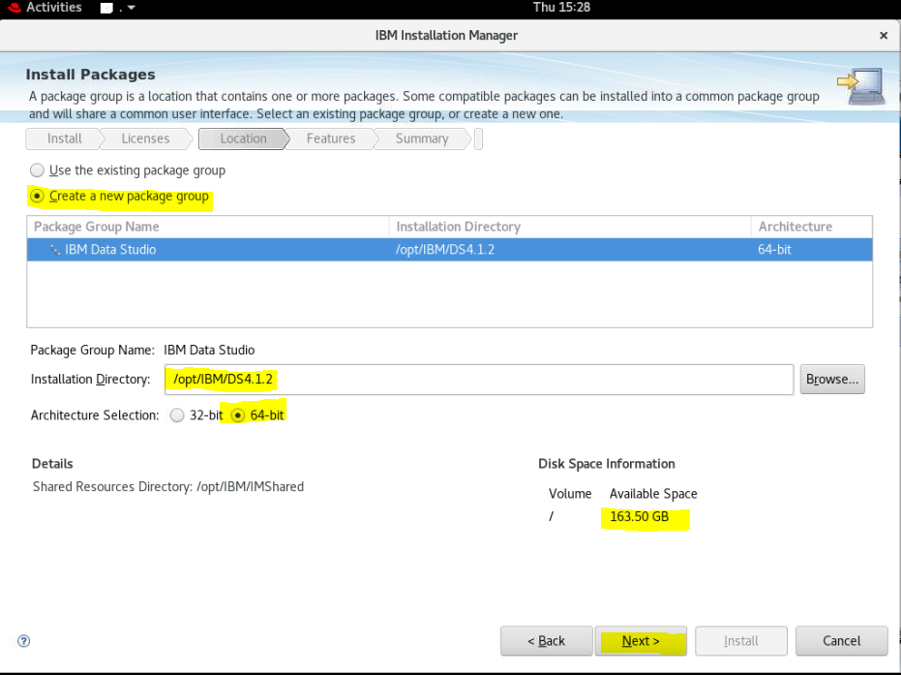

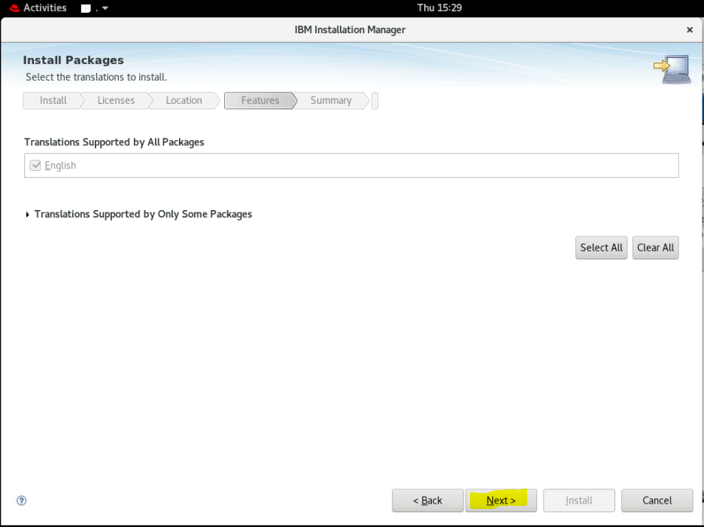

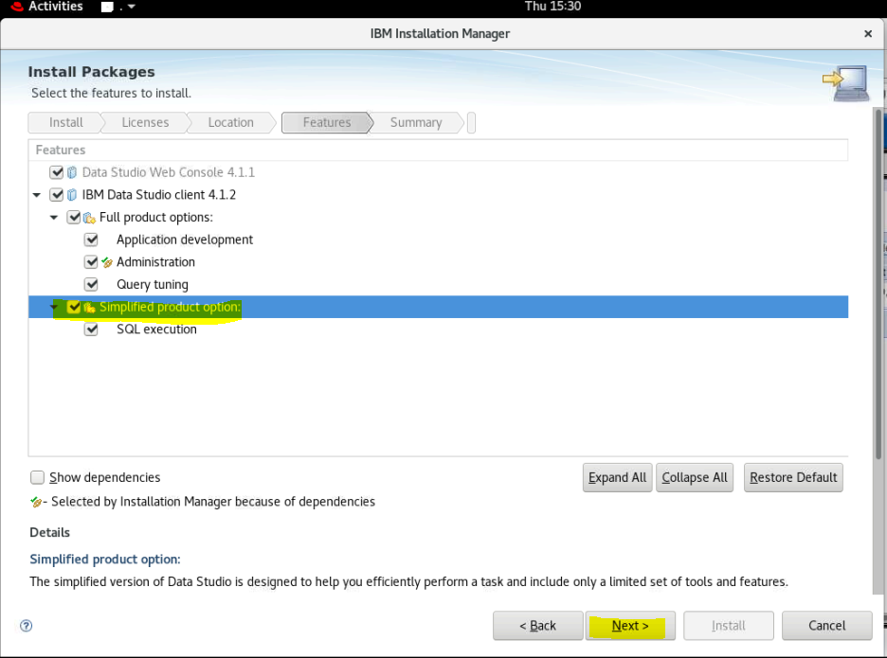

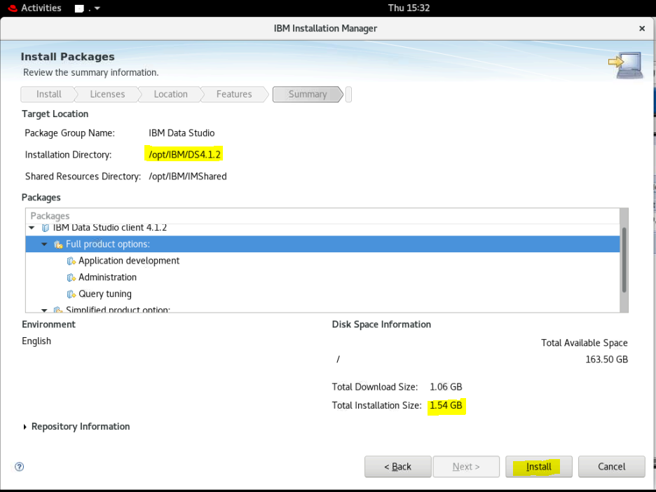

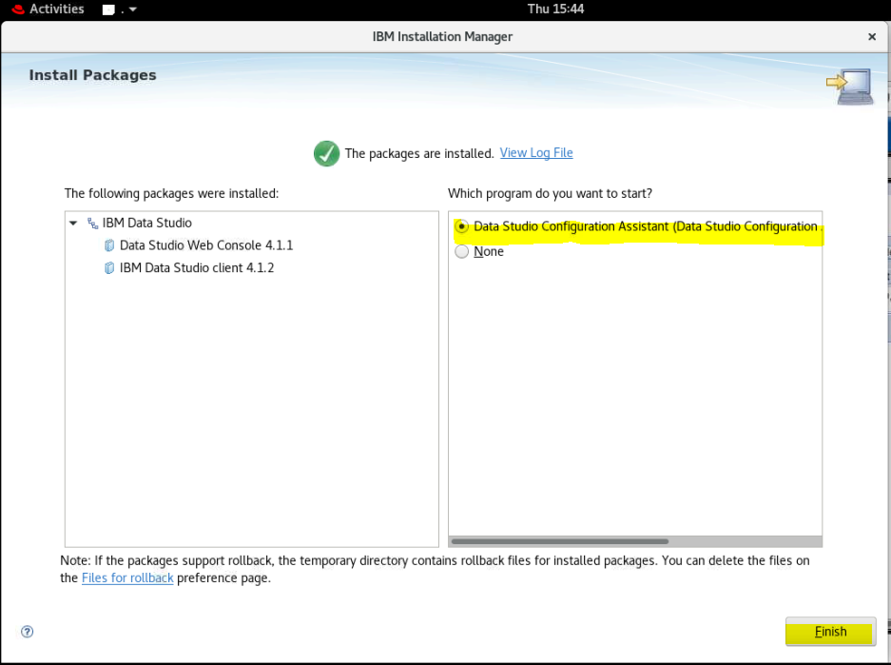

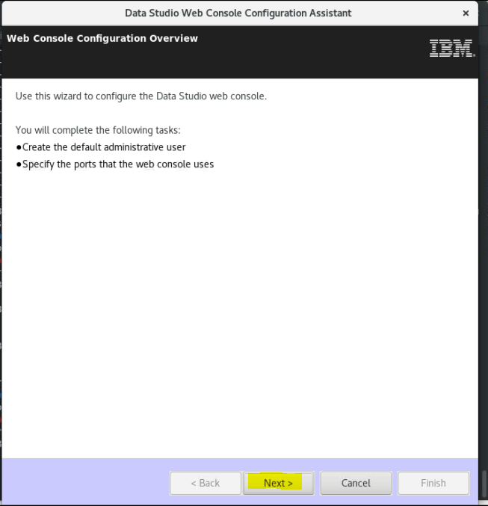

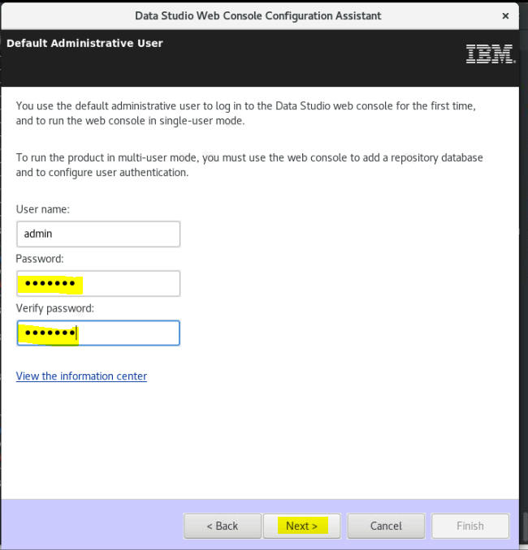

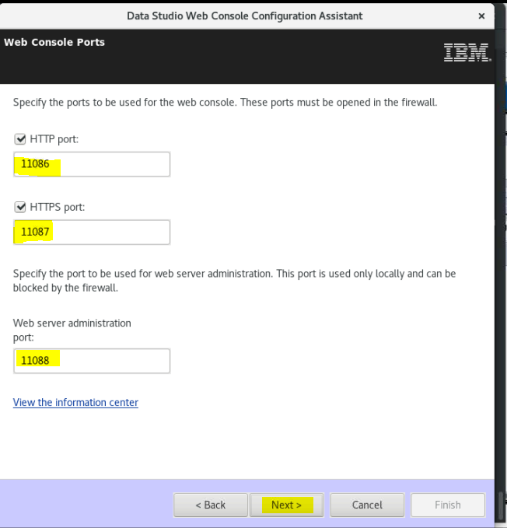

### Open HTTP ports 11086, 11087 and 11088 connections:

firewall-cmd --zone=public --permanent --add-port=11086/tcp

firewall-cmd --zone=public --permanent --add-port=11087/tcp

firewall-cmd --zone=public --permanent --add-port=11088/tcp

firewall-cmd –reload

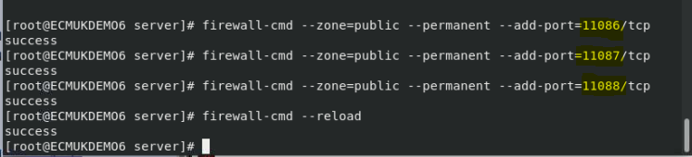

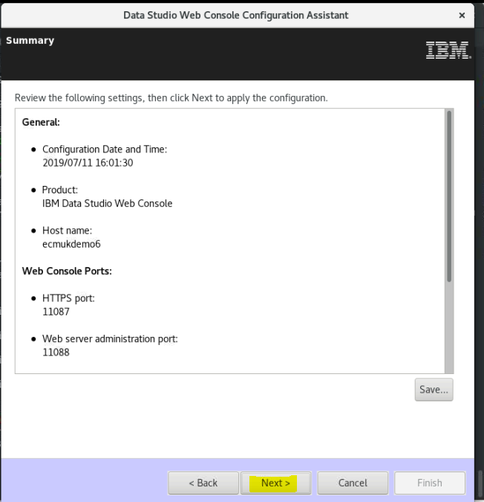

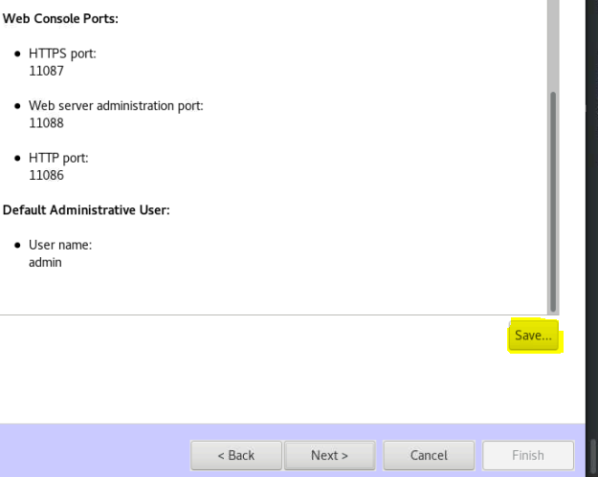

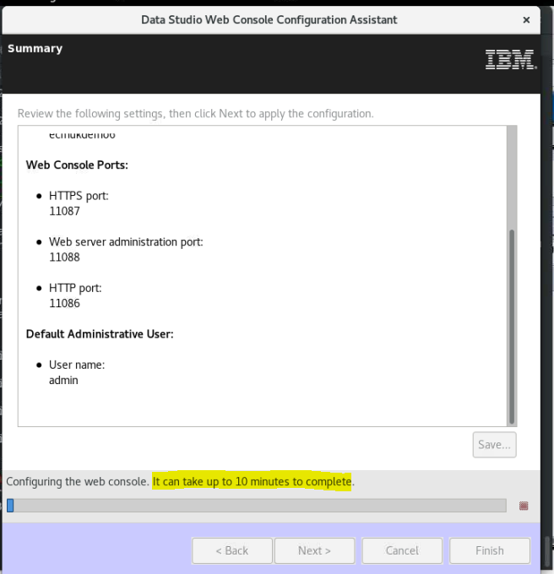

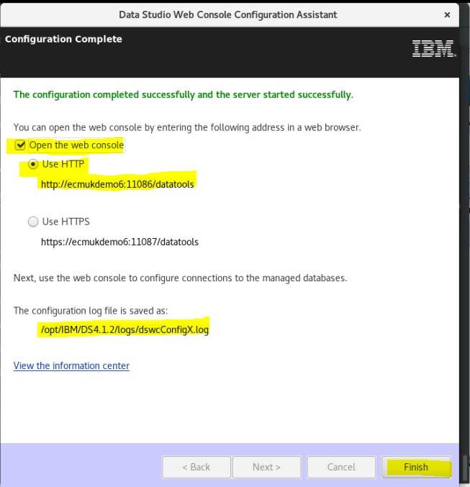

### DB2 Data Studio access

Use the web URL <http://ecmukdemo6:11086/datatools> to access the Data Studio

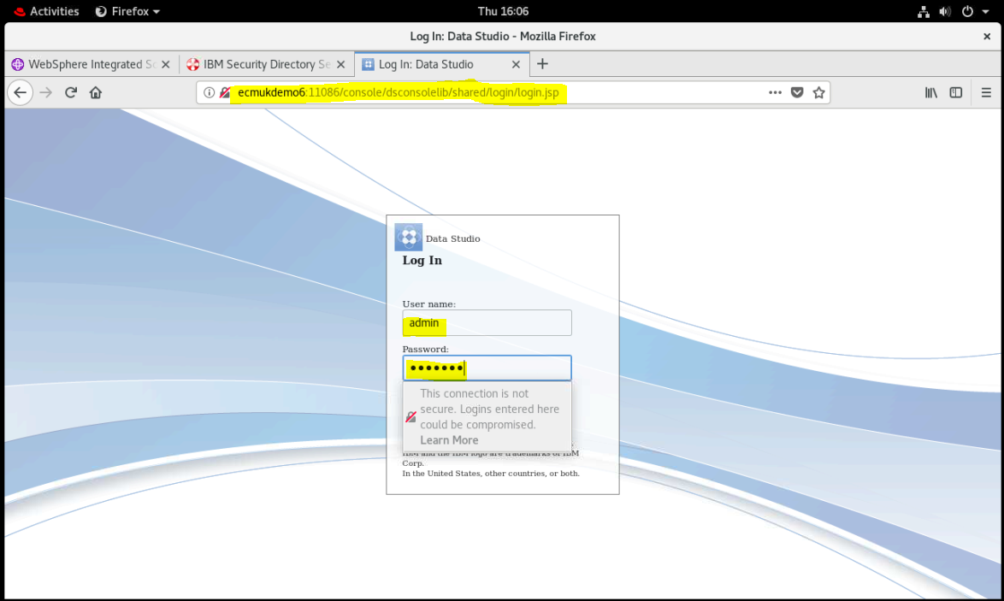

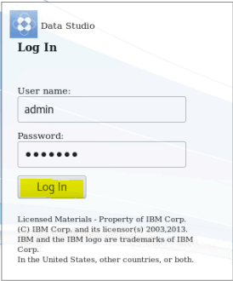

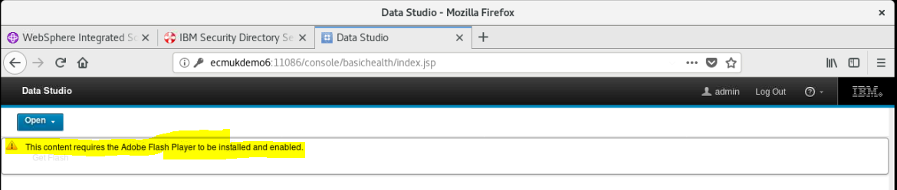

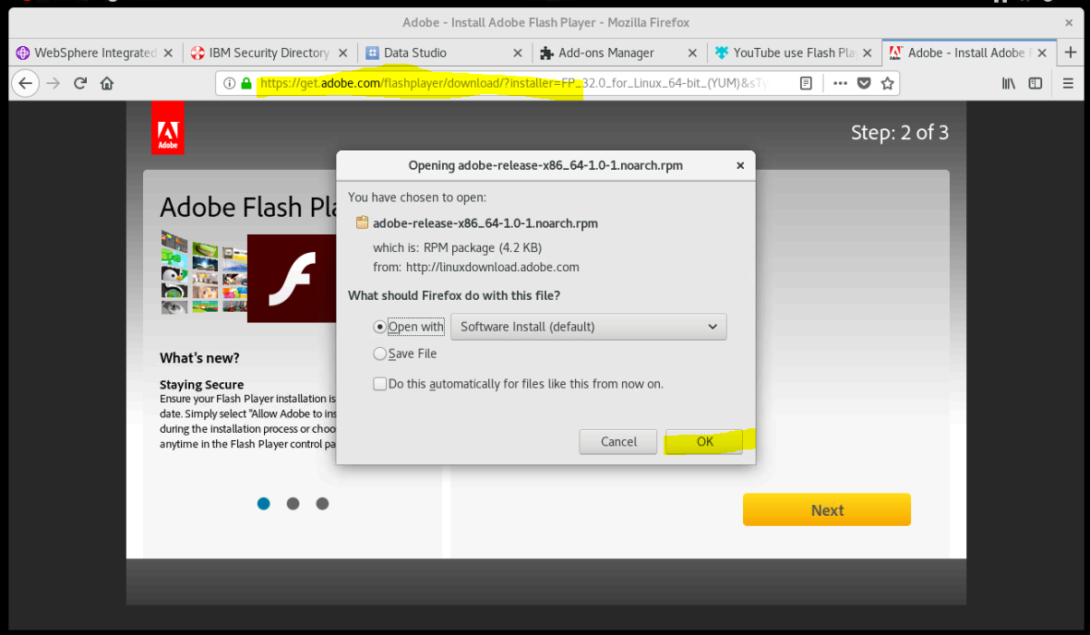

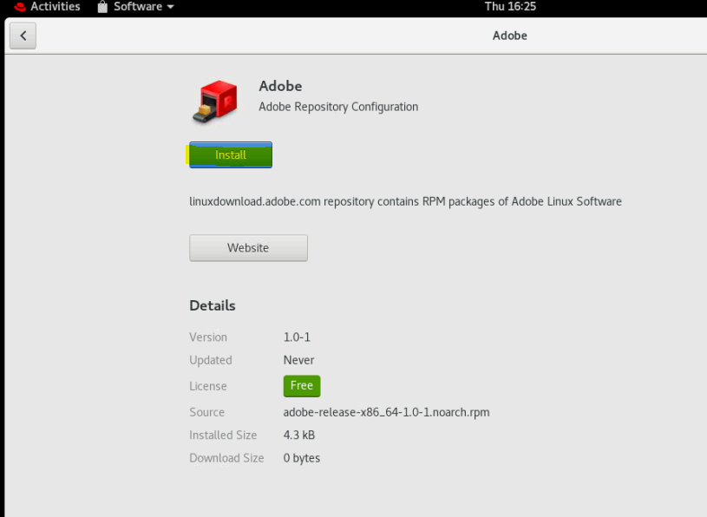

**NB I couldn’t install this correctly on FireFox on the Linux box so need to run from my Windows host server!**

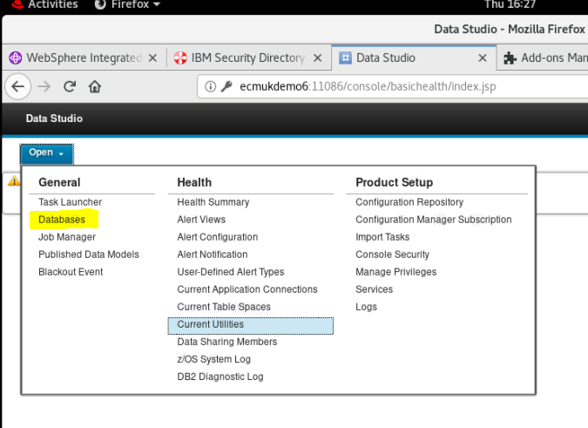

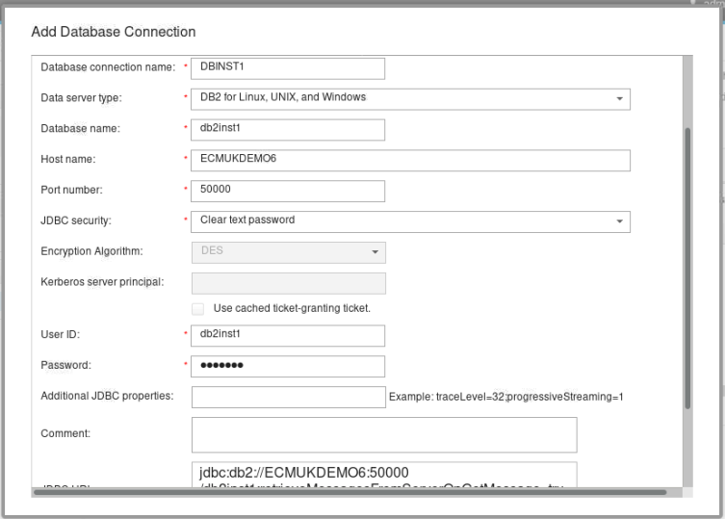

jdbc:db2://ECMUKDEMO6:50000/db2inst1:retrieveMessagesFromServerOnGetMessage=true;securityMechanism=3;

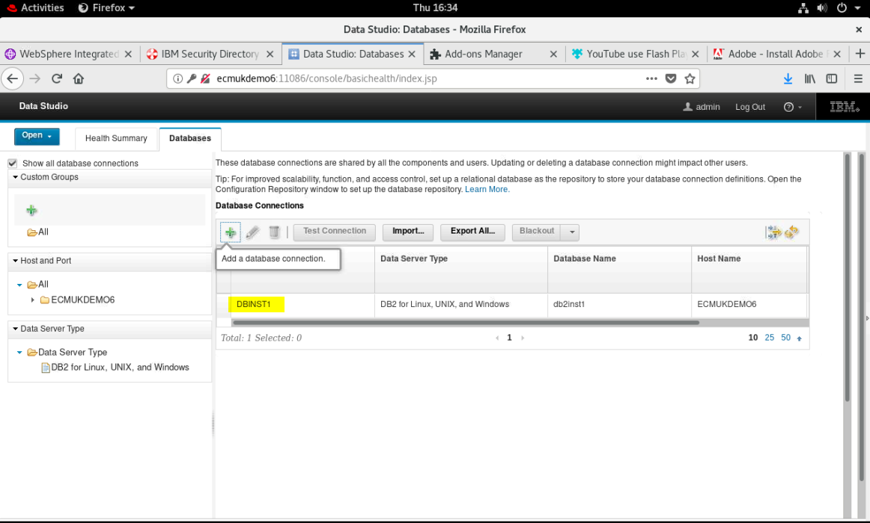

1. You can view the DB2 product that is installed on your system as follows:

On Linux and UNIX systems, run the db2ls command.

./db2ls -q -p -b /opt/ibm/db2/V10.5[](javascript:void(0);)

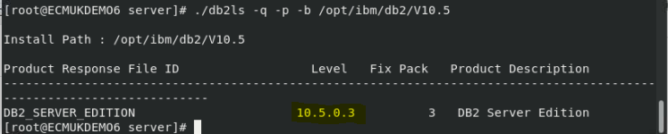

The command output displays as follows:

Install Path : /opt/ibm/db2/V10.5

Product Response File ID Level Fix Pack Product Description

------------------------------------------------------------------------------------------------------

DB2\_SERVER\_EDITION 10.5.0.3 3 DB2 Server Edition

1. You can view the product license certificate file that is automatically applied during the DB2 product installation by running the db2licm -l command.

The command output displays as follows:

Product name: "DB2 Enterprise Server Edition"

License type: "License not registered"

Expiry date: "License not registered"

Product identifier: "db2ese"

Version information: "10.5"[](javascript:void(0);)

### Applying the DB2 License

After you complete the installation procedure, you must apply the DB2 product license certificate file, and complete the necessary post-installation tasks.

## Applying the DB2 License Certificate File

REF

<https://www.ibm.com/support/knowledgecenter/en/SSEPGG_10.5.0/com.ibm.db2.luw.qb.server.doc/doc/t0023608.html>

To be in compliance with your current product entitlement, after installation, you must manually apply the licenses.

## Before you begin

Ensure that the base license certificate file is available at the /db2/license directory of the installation image.

The following base licenses are available at the /db2/license directory of the server image and the product-specific base license is automatically applied during DB2® product installation.

* db2ese.lic
* db2exp.lic
* db2consv.lic

.

## Manual License Installation Procedure

To apply any of the DB2 Enterprise Server Edition, DB2 Advanced Enterprise Server Edition, DB2 Workgroup Server Edition, or DB2 Advanced Workgroup Server Edition licenses:

1. To verify the DB2 product license information, run the db2licm -l command.

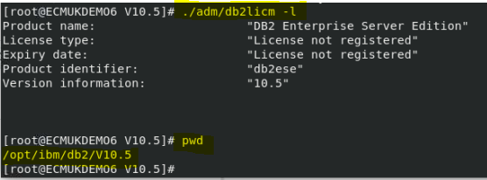

/opt/ibm/db2/V10.5/adm/db2licm -a /opt/IBM/Installs/DB2\_10.5/ese\_o/db2/license/db2ese\_o.lic

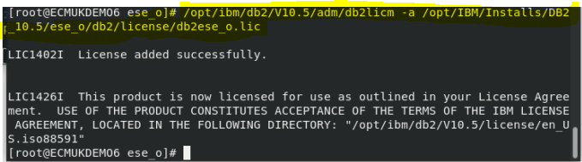

/opt/ibm/db2/V10.5/adm/db2licm -l

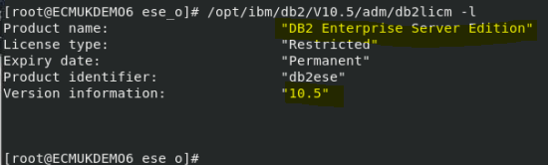

# Start or stop DB2

<https://www.ibm.com/support/knowledgecenter/en/SSEPGG_10.5.0/com.ibm.db2.luw.admin.dbobj.doc/doc/t0004676.html>

Before you start an instance on your Linux or UNIX operating system:

1. Log in with a user ID or name that has SYSADM, SYSCTRL, or SYSMAINT authority on the instance; or log in as the instance owner (**db2inst1**)
2. Run the startup script as follows, where INSTHOME is the home directory of the instance you want to use:
3. . INSTHOME/sqllib/db2profile (for Bourne or Korn shell)

source INSTHOME/sqllib/db2cshrc (for C shell)[](javascript:void(0);)

/home/db2inst1/sqllib/db2profile

## Procedure

To start the instance:

* From the command line, enter the **db2start** command. The DB2 database manager applies the command to the current instance.
* From IBM® Data Studio, open the task assistant for starting the instance.

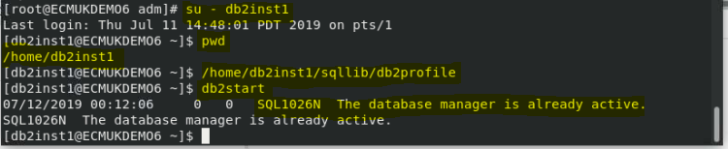

## Create a GCD Database using DB2

[root@ECMUKDEMO6 ese\_o]# cd /opt/IBM

[root@ECMUKDEMO6 IBM]# mkdir GCDDB

[root@ECMUKDEMO6 IBM]# chown db2inst1:db2iadm1 GCDDB

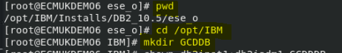

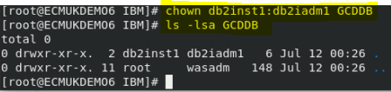

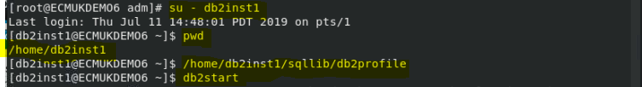

db2 CREATE DATABASE GCD AUTOMATIC STORAGE YES ON /opt/IBM/GCDDB USING CODESET UTF-8 TERRITORY US COLLATE USING SYSTEM PAGESIZE 32768



db2 CONNECT TO ***GCD***

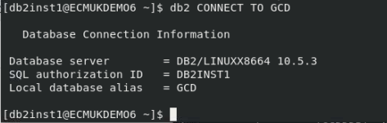

db2 CREATE REGULAR TABLESPACE CEDATA\_TS PAGESIZE 32 K MANAGED BY AUTOMATIC STORAGE EXTENTSIZE 16 OVERHEAD 10.5 PREFETCHSIZE 16 TRANSFERRATE 0.14 BUFFERPOOL IBMDEFAULTBP DROPPED TABLE RECOVERY ON

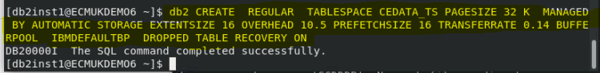

db2 CREATE USER TEMPORARY TABLESPACE USRTEMP\_TS PAGESIZE 32 K MANAGED BY AUTOMATIC STORAGE EXTENTSIZE 16 OVERHEAD 10.5 PREFETCHSIZE 16 TRANSFERRATE 0.14 BUFFERPOOL IBMDEFAULTBP

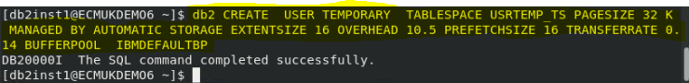

db2 GRANT CREATETAB,CONNECT ON DATABASE TO USER ***gcduser***



db2 GRANT USE OF TABLESPACE CEDATA\_TS TO USER ***gcduser***



db2 GRANT USE OF TABLESPACE USRTEMP\_TS TO USER ***gcduser***



db2 UPDATE DATABASE CONFIGURATION USING APPLHEAPSZ 2560 IMMEDIATE



db2 GRANT SELECT on SYSIBM.SYSVERSIONS TO gcduser

db2 GRANT SELECT on SYSCAT.DATATYPES TO gcduser

db2 GRANT SELECT on SYSCAT.INDEXES TO gcduser

db2 GRANT SELECT on SYSIBM.SYSDUMMY1 TO gcduser

db2 GRANT USAGE on workload SYSDEFAULTUSERWORKLOAD TO gcduser

db2 GRANT IMPLICIT\_SCHEMA on DATABASE TO gcduser

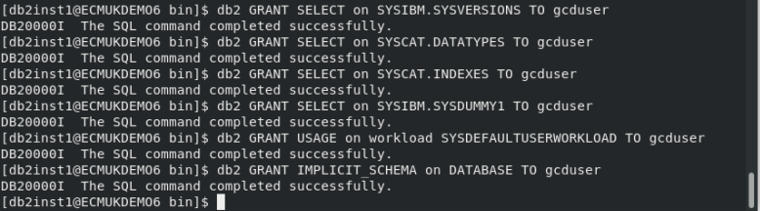

db2 CONNECT RESET

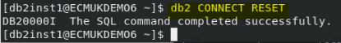

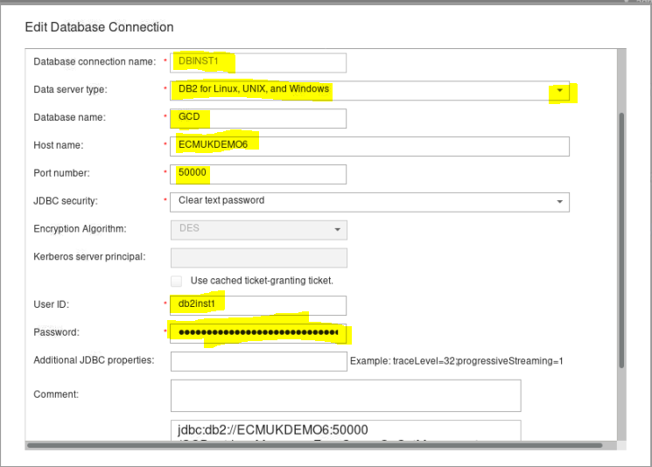

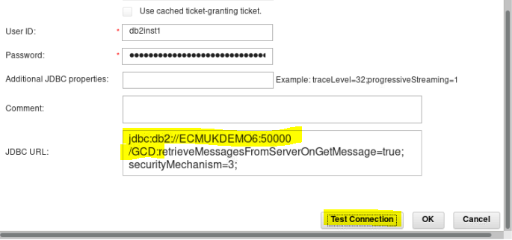

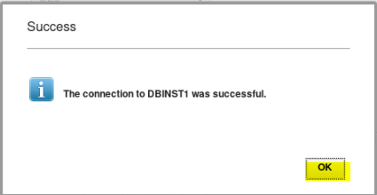

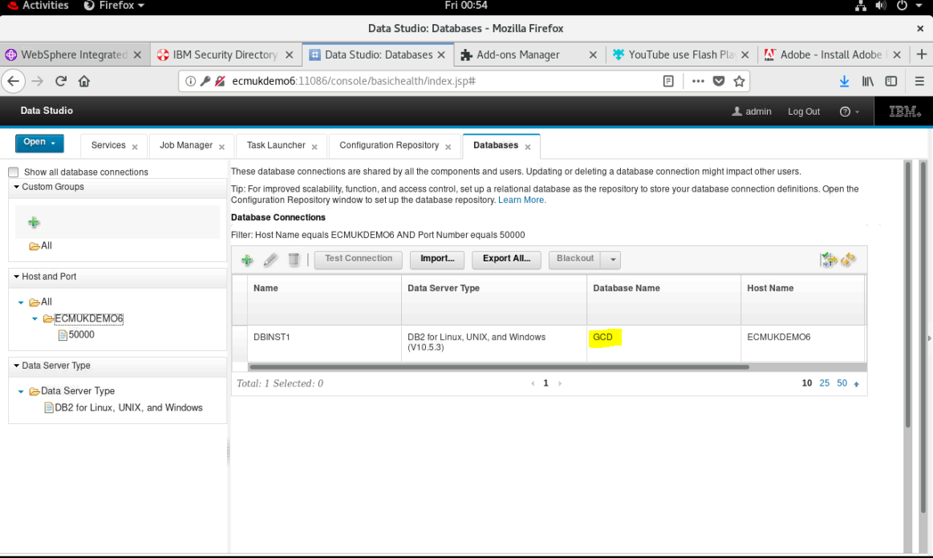

## Create a Development Store OS1 database

Repeat the above DB2 SQL to create the Development Object Store Database

Create an OS1 Database

[root@ECMUKDEMO6 ese\_o]# **cd /opt/IBM**

[root@ECMUKDEMO6 IBM]# **mkdir OS1DB**

[root@ECMUKDEMO6 IBM]# chown db2inst1:db2iadm1 OS1DB

db2 CONNECT RESET

db2 CREATE DATABASE OS1 AUTOMATIC STORAGE YES ON /opt/IBM/OS1DB USING CODESET UTF-8 TERRITORY US COLLATE USING SYSTEM PAGESIZE 32768

db2 CONNECT TO OS1

db2 CREATE REGULAR TABLESPACE CEDATA\_TS PAGESIZE 32 K MANAGED BY AUTOMATIC STORAGE EXTENTSIZE 16 OVERHEAD 10.5 PREFETCHSIZE 16 TRANSFERRATE 0.14 BUFFERPOOL IBMDEFAULTBP DROPPED TABLE RECOVERY ON

db2 CREATE USER TEMPORARY TABLESPACE USRTEMP\_TS PAGESIZE 32 K MANAGED BY AUTOMATIC STORAGE EXTENTSIZE 16 OVERHEAD 10.5 PREFETCHSIZE 16 TRANSFERRATE 0.14 BUFFERPOOL IBMDEFAULTBP

db2 GRANT CREATETAB,CONNECT ON DATABASE TO USER OS1user

db2 GRANT USE OF TABLESPACE CEDATA\_TS TO USER OS1user

db2 GRANT USE OF TABLESPACE USRTEMP\_TS TO USER OS1user

db2 UPDATE DATABASE CONFIGURATION USING APPLHEAPSZ 2560 IMMEDIATE

db2 CONNECT RESET

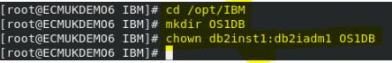

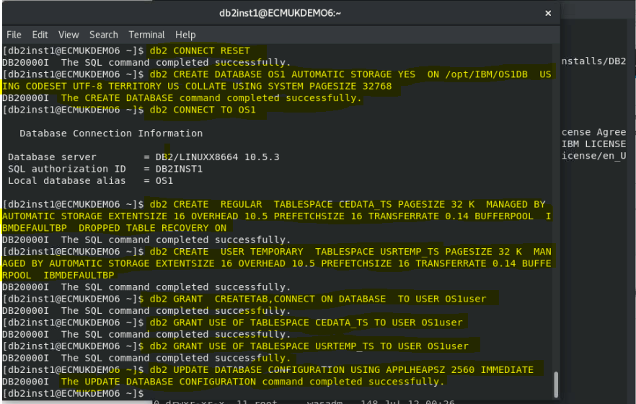

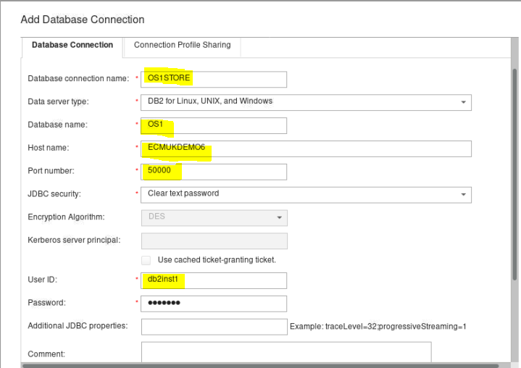

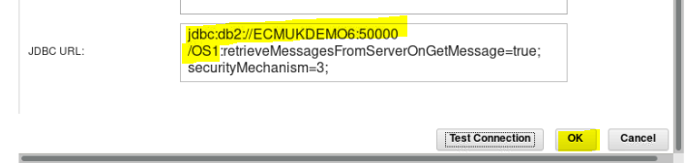

## Create a Target Object Store OS2 database

Repeat the above DB2 SQL to create the Target Object Store Database

Create an OS2 Database

[root@ECMUKDEMO6 ese\_o]# **cd /opt/IBM**

[root@ECMUKDEMO6 IBM]# **mkdir OS2DB**

[root@ECMUKDEMO6 IBM]# **chown db2inst1:db2iadm1 OS2DB**

db2 CONNECT RESET

db2 CREATE DATABASE OS2 AUTOMATIC STORAGE YES ON /opt/IBM/OS2DB USING CODESET UTF-8 TERRITORY US COLLATE USING SYSTEM PAGESIZE 32768

db2 CONNECT TO OS2

db2 CREATE REGULAR TABLESPACE CEDATA\_TS PAGESIZE 32 K MANAGED BY AUTOMATIC STORAGE EXTENTSIZE 16 OVERHEAD 10.5 PREFETCHSIZE 16 TRANSFERRATE 0.14 BUFFERPOOL IBMDEFAULTBP DROPPED TABLE RECOVERY ON

db2 CREATE USER TEMPORARY TABLESPACE USRTEMP\_TS PAGESIZE 32 K MANAGED BY AUTOMATIC STORAGE EXTENTSIZE 16 OVERHEAD 10.5 PREFETCHSIZE 16 TRANSFERRATE 0.14 BUFFERPOOL IBMDEFAULTBP

db2 GRANT CREATETAB,CONNECT ON DATABASE TO USER OS2user

db2 GRANT USE OF TABLESPACE CEDATA\_TS TO USER OS2user

db2 GRANT USE OF TABLESPACE USRTEMP\_TS TO USER OS2user

db2 UPDATE DATABASE CONFIGURATION USING APPLHEAPSZ 2560 IMMEDIATE

db2 CONNECT RESET

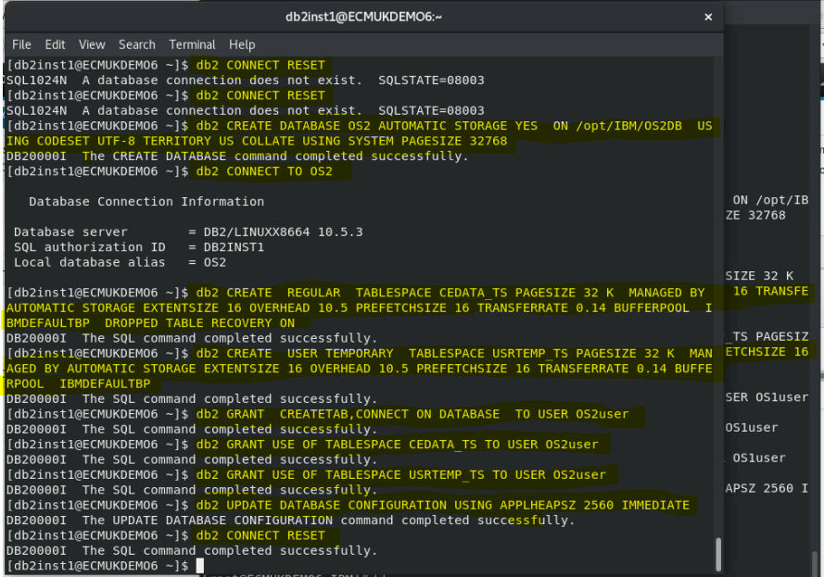

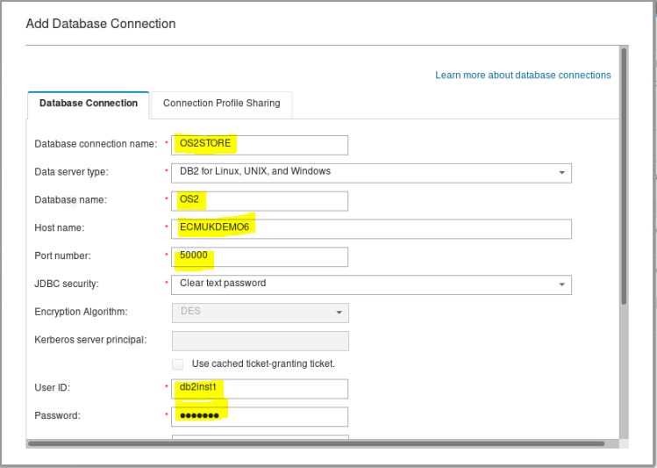

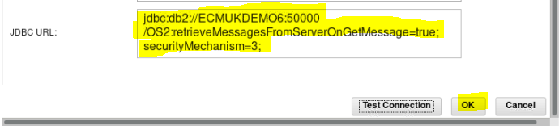

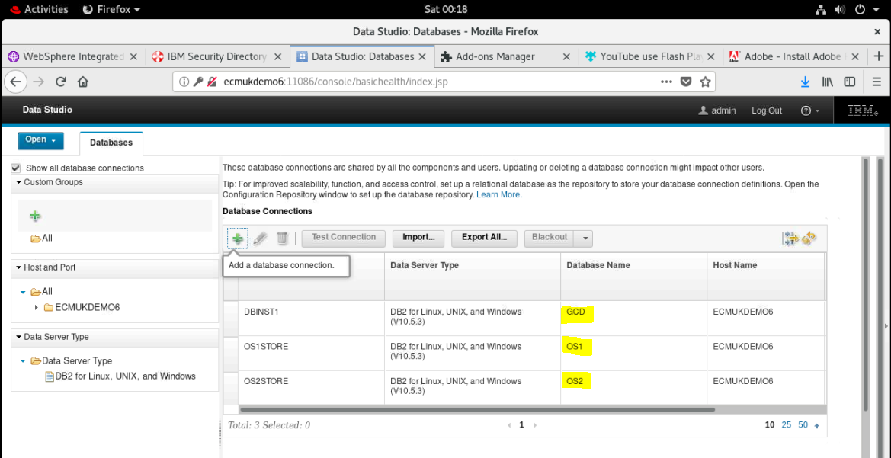

## Apply DB10.5 Fix Pack 10 and Interim Fix

**NB I found this is required to fix SQL errors when trying to use the acce tool to set up the IBM Content Foundation 5.5.3 P8 Domain of the Content Platform Engine.**

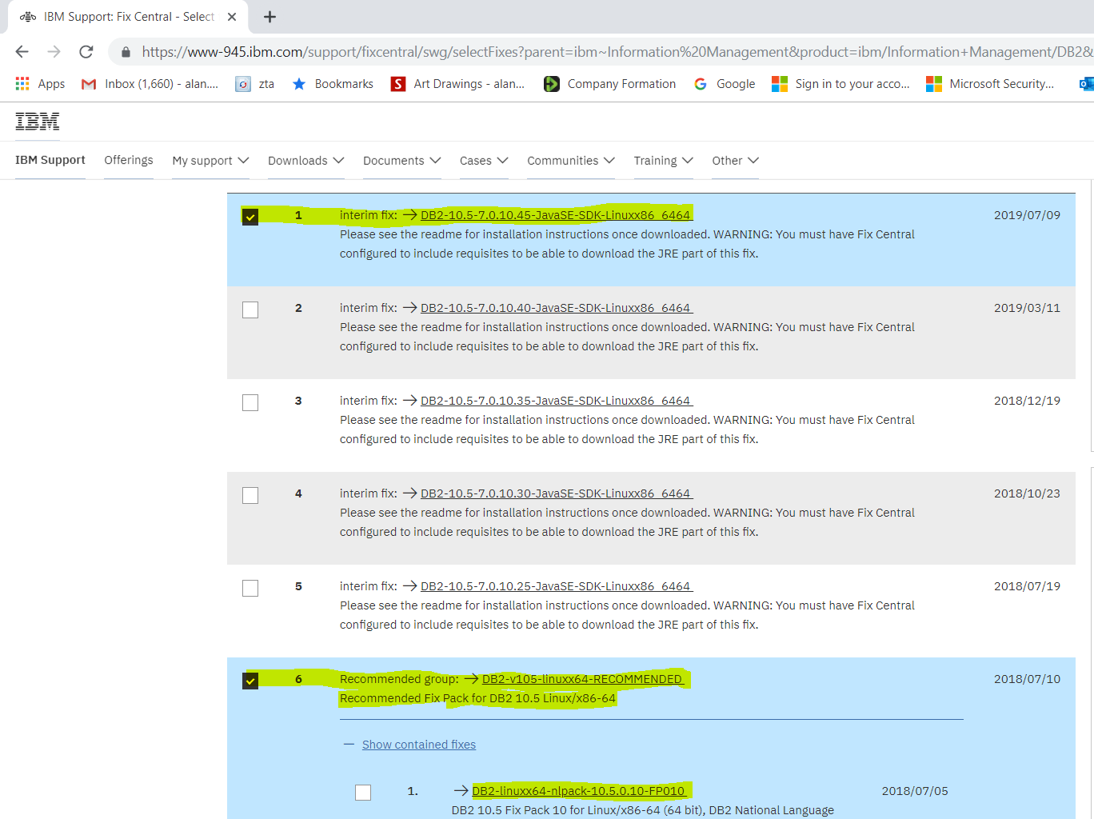

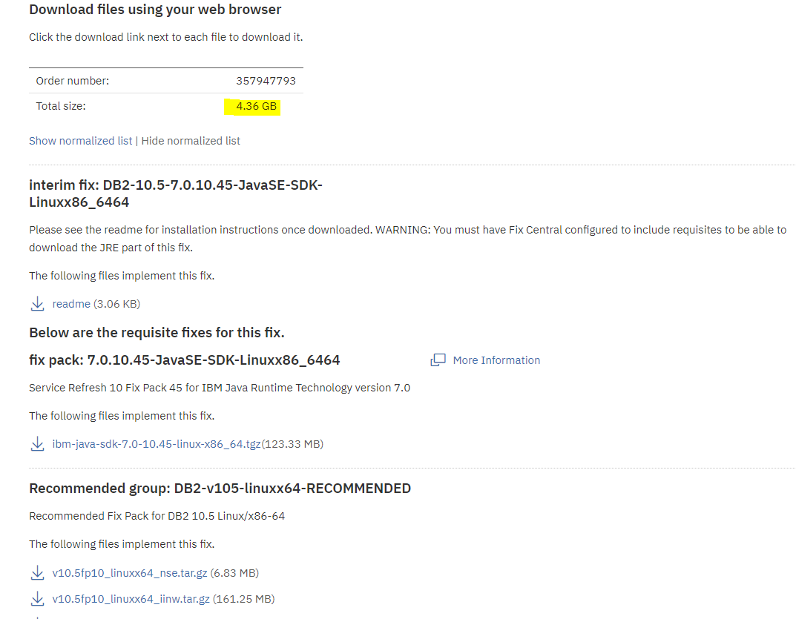

### Installation Notes for IBM JDK

**fix pack: 7.0.10.45-JavaSE-SDK-Linuxx86\_6464**

[More Information](https://www.ibm.com/developerworks/java)

Service Refresh 10 Fix Pack 45 for IBM Java Runtime Technology version 7.0

The following files implement this fix.

* [ibm-java-sdk-7.0-10.45-linux-x86\_64.tgz(123.33 MB)](https://ak-delivery04-mul.dhe.ibm.com/sdfdl/v2/sar/CM/WS/08814/0/Xa.2/Xb.jusyLTSp44S0BiC84nyYAb3zNRj0KSOi59zDfKtCzrUGf47J6APgyPYrLeY/Xc.CM/WS/08814/0/ibm-java-sdk-7.0-10.45-linux-x86_64.tgz/Xd./Xf.LPR.D1vk/Xg.10277842/Xi.habanero/XY.habanero/XZ.nljHXpMXvln6u_enoCK1_7RhQ70/ibm-java-sdk-7.0-10.45-linux-x86_64.tgz)

#### Instruction for IBM JDK Installation on Unix/Linux:

On Unix, the installFixPack tool will fail if you install in place. Fix pack update to new installation path is not affected.

1) Create a new temporary JDK directory (e.g. jdk64\_tmp), to store the extracted install files.

cd /tmp

mkdir jdk64\_tmp

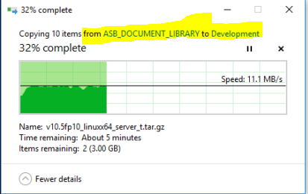

Copied the Fix Packs and JDK to the workstation server

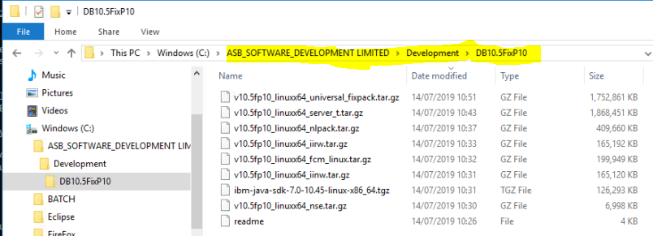

Copied from the Workstation Server to the RHEL 8.0 O/S on VMware using ftp

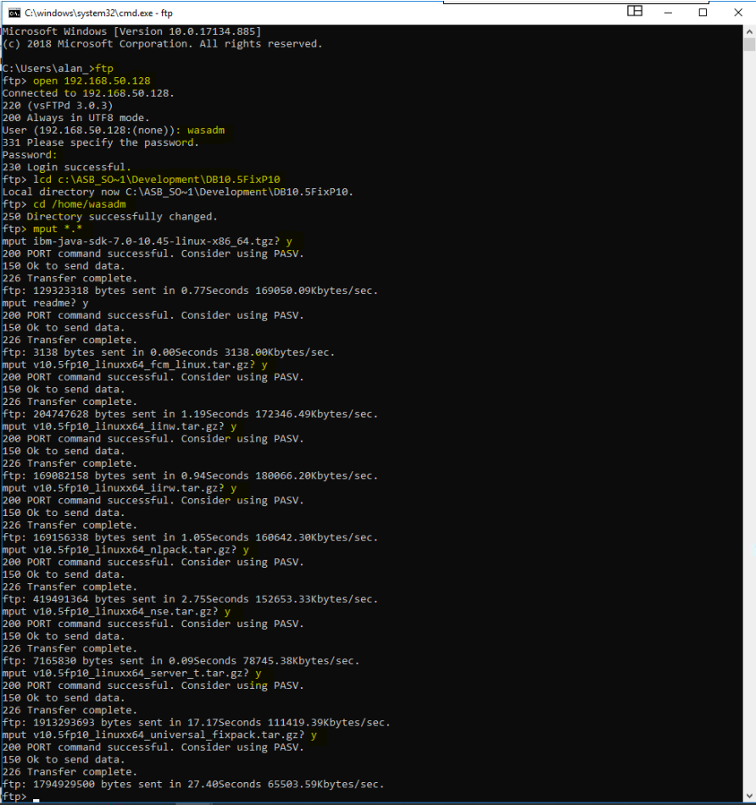

2) Run the following command to extract all the files from the IBM JDK install image tar file into the temporary JDK directory created in step 1 above.

tar -zxvf /home/wasadm/ibm-java-sdk-7.0-10.45-linux-x86\_64.tgz -C /tmp/jdk64\_tmp

tar -**z**xvf <IBM JDK install image tar file> -C <Temporary JDK directory>

**(NB z option missing from the readme notes)**

3) Stop all DB2 instances for the installation.

db2stop

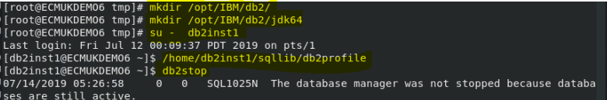

WebSphere needs to be stopped too, because it has a link to the GCD database:

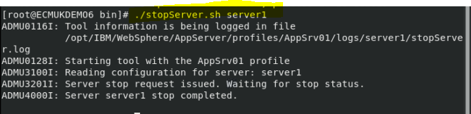

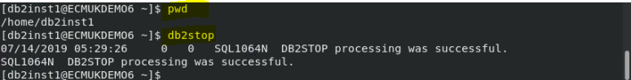

4) As root user, create a new JDK directory.

mkdir /opt/IBM/db2/

Create a new JDK directory jdk64 under /opt/IBM/db2.

E.g.

mkdir /opt/IBM/db2/jdk64

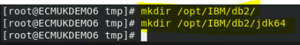

5) As root user, copy the extracted files from the temporary JDK directory created in step 1 to the new JDK directory.

E.g.

cp -R <Temporary JDK directory>/\* /opt/IBM/db2/jdk64/

cp -R /tmp/jdk64\_tmp/\* /opt/IBM/db2/jdk64/



Check that the files in the /opt/IBM/db2/jdk64/ directory have r-x permission for user/group.

ls -lsa /opt/IBM/db2/jdk64/

6) Change the group and owner for all the files in the new JDK directory to bin.

E.g.

chown -R bin:bin /opt/IBM/db2/jdk64/

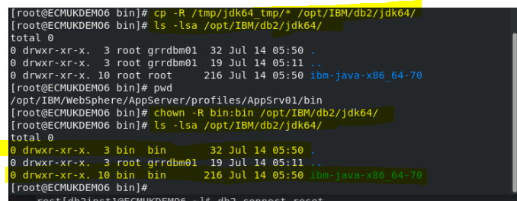

7) Update your CLASSPATH for Java Applications and configure DB2 to use the new JDK:

e.g.

db2 update dbm cfg using JDK\_PATH /opt/IBM/db2/jdk64/

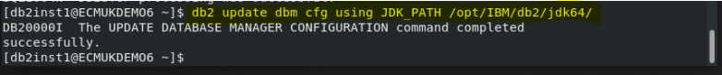

#### JDK Update Notes:

1) With this update, the metadata of the new JDK is not being recorded with the installer. Hence, for fix pack update in the same installation path, **execution of the db2val utility (i.e.** **the tool that validate files laid down by the DB2 installer at the system level, instance level, or database level after new installation) may fail even though the installation succeeded**. Fix pack update to new installation path is not affected.

2) Uninstall will not be able to remove the jdk64 and jdk64\_tmp folder, user will have to remove it manually.

3) Installing a new fixpack will overwrite the Java directory. If you need a different version of Java, you will have to follow the installation steps again.

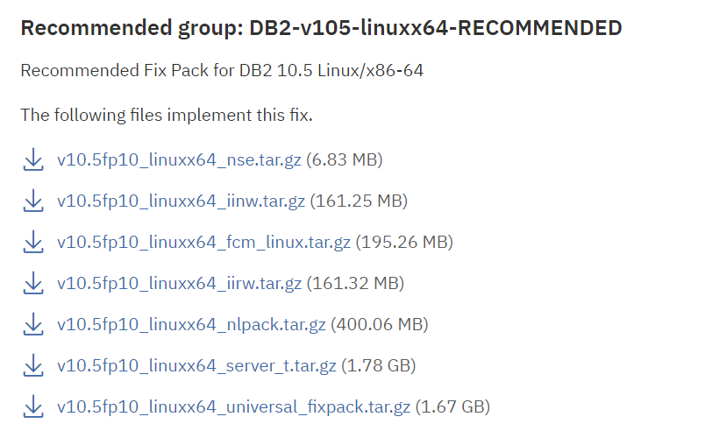

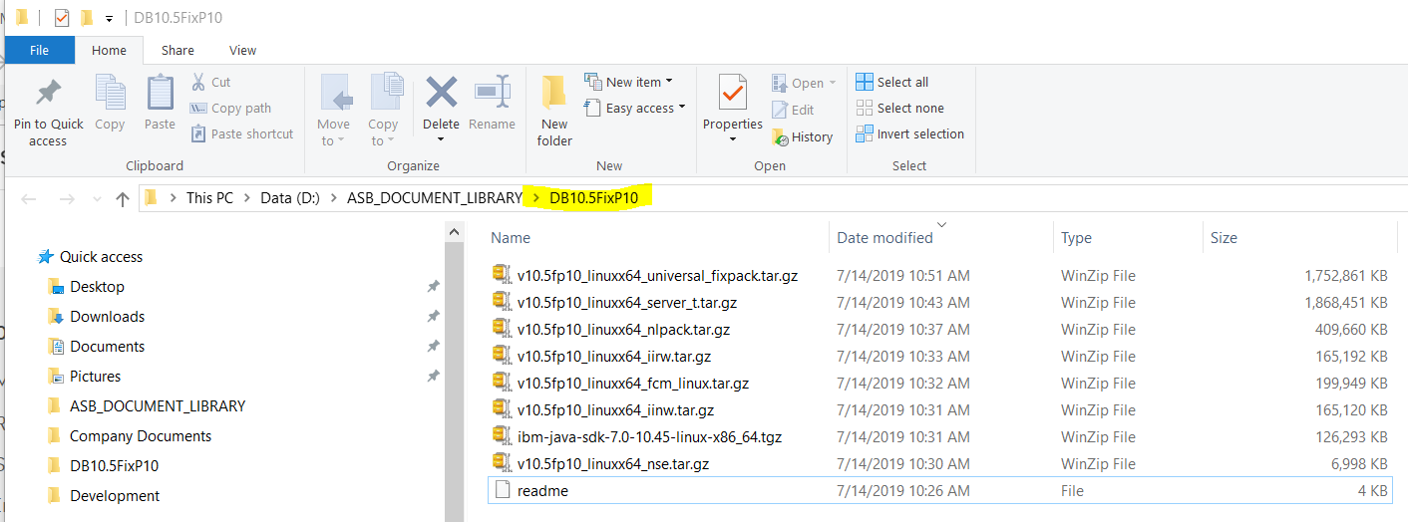

### Installation of the Recommended Fix Pack 10 for DB2 10.5

REF

<https://www.ibm.com/support/knowledgecenter/SSEPGG_10.5.0/com.ibm.db2.luw.qb.server.doc/doc/c0025016.html>

and specifically:

<https://www.ibm.com/support/knowledgecenter/SSEPGG_10.5.0/com.ibm.db2.luw.qb.server.doc/doc/t0024956.html>

If you want to update an existing DB2 database product with national languages installed, you must obtain the national language fix pack in addition to either an individual fix pack or a universal fix pack. National language fix packs cannot be used alone.

For example, to install a fix pack on a DB2 database product with non-English support installed, download the DB2 database product-specific fix pack image (or the universal fix pack image) and the national language fix pack. Then, run **installFixPack** from the DB2 database product-specific fix pack image (or the universal fix pack image).

## Procedure

To install a fix pack:

1. For root installations, log on as root. For non-root installations, log on with the user ID that owns the non-root installation.
2. Change to the directory that contains the fix pack image.

mkdir /opt/IBM/Installs/DB2\_FP10

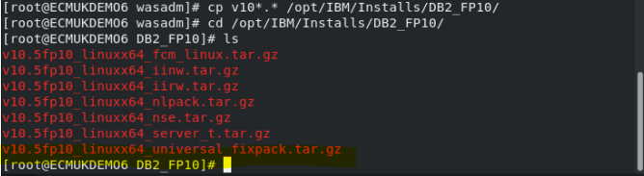

tar -zxvf v10.5fp10\_linuxx64\_universal\_fixpack.tar.gz

1. Start the installation by running the **installFixPack** command. For example,

./installFixPack -b DB2DIR[](javascript:void(0);)

where DB2DIR is the location of the DB2 database products that you want to update.

./installFixPack -b /opt/ibm/db2/V10.5/

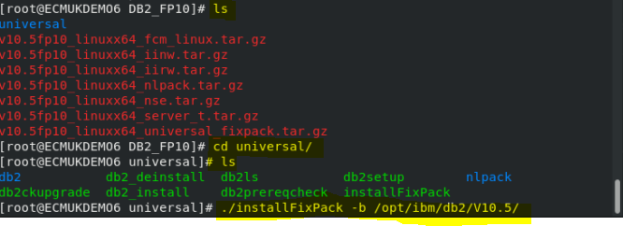

In clustered environments where some instances are not mounted, add the **-f ha\_standby\_ignore** option. For example,

./installFixPack -b DB2DIR -f ha\_standby\_ignore

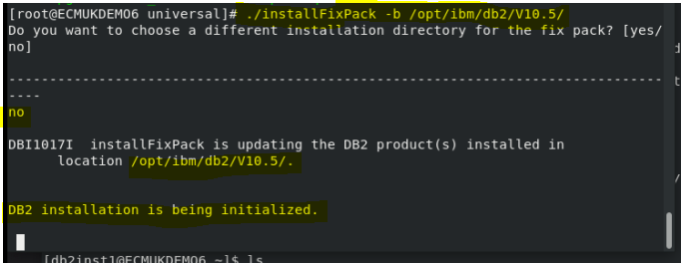

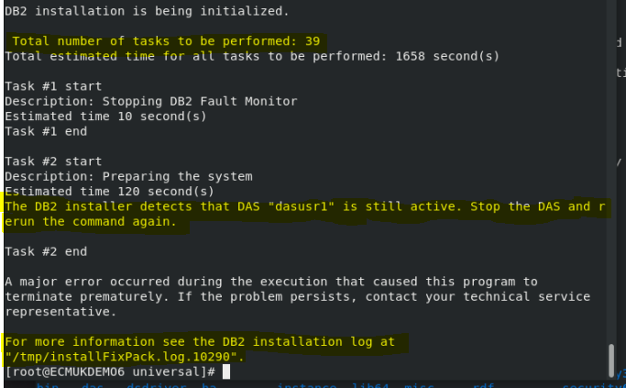

Stop DAS as the user “dasusr1” is still active

REF <https://www.ibm.com/support/knowledgecenter/en/SSEPGG_9.7.0/com.ibm.db2.luw.admin.gui.doc/doc/t0005170.html>

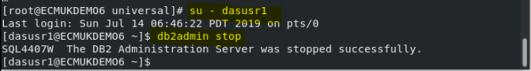

Full update log in Appendix M Appendix M - DB10.5 Universal Fix pack 10 Update log

Restart services (if required)

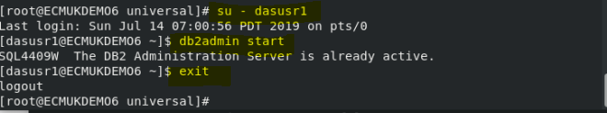



Start the WebSphere server

cd /opt/IBM/WebSphere/AppServer/profiles/AppSrv01/bin

./startServer.sh server1

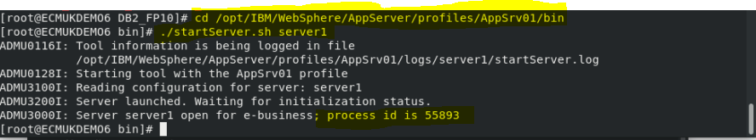

# Recreate the GCD

## Procedure to Drop DB2 GCD DataBase to rebuild the P8 Domain

**NOTE I had to drop and recreate the GCD because the acce tool was halfway through building the P8 Domain Object and I entered an incorrect LDAP attribute for the System Administration Group**

**The acce tool will only allow a rebuild from a completely empty Database!**

REF:

<https://www.tutorialspoint.com/db2/db2_databases.htm>

<https://www.tutorialspoint.com/db2/db2_tables.htm>

su - db2inst1

/home/db2inst1/sqllib/db2profile

[root@ECMUKDEMO6 ~]# **su - db2inst1**

Last login: Sun Jul 14 07:01:17 PDT 2019 on pts/0

[db2inst1@ECMUKDEMO6 ~]$ **/home/db2inst1/sqllib/db2profile**

[db2inst1@ECMUKDEMO6 ~]$ **db2 list database directory**

System Database Directory

Number of entries in the directory = 3

Database 1 entry:

Database alias = GCD

Database name = GCD

Local database directory = /opt/IBM/GCDDB

Database release level = 10.00

Comment =

Directory entry type = Indirect

Catalog database partition number = 0

Alternate server hostname =

Alternate server port number =

Database 2 entry:

Database alias = OS1

Database name = OS1

Local database directory = /opt/IBM/OS1DB

Database release level = 10.00

Comment =

Directory entry type = Indirect

Catalog database partition number = 0

Alternate server hostname =

Alternate server port number =

Database 3 entry:

Database alias = OS2

Database name = OS2

Local database directory = /opt/IBM/OS2DB

Database release level = 10.00

Comment =

Directory entry type = Indirect

Catalog database partition number = 0

Alternate server hostname =

Alternate server port number =

[db2inst1@ECMUKDEMO6 ~]$

db2 list database directory

db2 connect to GCD

db2 select tabname, tabschema, tbspace from syscat.tables

[db2inst1@ECMUKDEMO6 ~]$ **db2 connect to GCD**

Database Connection Information

Database server = DB2/LINUXX8664 10.5.10

SQL authorization ID = DB2INST1

Local database alias = GCD

**[db2inst1@ECMUKDEMO6 ~]$ db2 select tabname, tabschema, tbspace from syscat.tables**

SYSTABLES SYSIBM SYSCATSPACE

SYSCOLUMNS SYSIBM SYSCATSPACE

SYSINDEXES SYSIBM SYSCATSPACE

Etc ….

**FNGCD DB2INST1 CEDATA\_TS**

**FNGCD\_ADDON DB2INST1 CEDATA\_TS**

430 record(s) selected.

db2 describe table FNGCD

**NB You need to know the above Schema and tablespace names later for the P8 Object Store creation steps.**

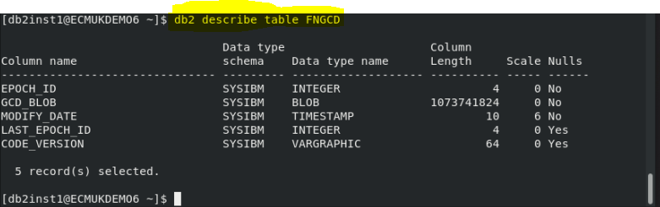

db2 describe table FNGCD\_ADDON

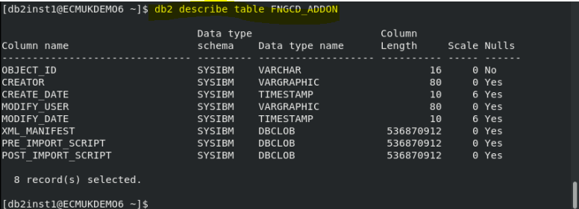

Stop the WebSphere 8.5.5.15 application server to release any DB2 connections

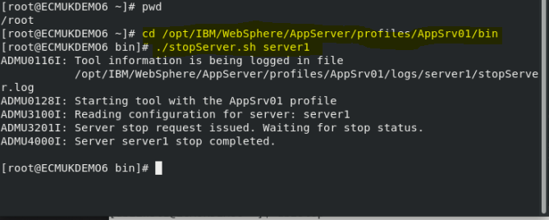

[root@ECMUKDEMO6 ~]# **cd /opt/IBM/WebSphere/AppServer/profiles/AppSrv01/bin**

[root@ECMUKDEMO6 bin]# **./stopServer.sh server1**

The next command forces off the users asynchronously

REF

<https://www-01.ibm.com/support/docview.wss?uid=swg21636292>

[db2inst1@ECMUKDEMO6 ~]$ **db2stop**

07/14/2019 23:29:52 0 0 SQL1064N DB2STOP processing was successful.

SQL1064N DB2STOP processing was successful.

[db2inst1@ECMUKDEMO6 ~]$ **db2start admin mode restricted access**

07/14/2019 23:30:48 0 0 SQL1063N DB2START processing was successful.

SQL1063N DB2START processing was successful.

[db2inst1@ECMUKDEMO6 ~]$ **db2 deactivate db GCD**

DB20000I The DEACTIVATE DATABASE command completed successfully.

[db2inst1@ECMUKDEMO6 ~]$ **pwd**

/home/db2inst1

[db2inst1@ECMUKDEMO6 ~]$ **db2 drop db GCD**

DB20000I The DROP DATABASE command completed successfully.

[db2inst1@ECMUKDEMO6 ~]$

[db2inst1@ECMUKDEMO6 ~]$ **db2stop**

07/14/2019 23:42:55 0 0 SQL1064N DB2STOP processing was successful.

SQL1064N DB2STOP processing was successful.

[db2inst1@ECMUKDEMO6 ~]$ **db2start**

07/14/2019 23:43:04 0 0 SQL1063N DB2START processing was successful.

SQL1063N DB2START processing was successful.

[db2inst1@ECMUKDEMO6 ~]$

Recreate the empty GCD database

[db2inst1@ECMUKDEMO6 ~]$ db2 CREATE DATABASE GCD AUTOMATIC STORAGE YES ON /opt/IBM/GCDDB USING CODESET UTF-8 TERRITORY US COLLATE USING SYSTEM PAGESIZE 32768

DB20000I The CREATE DATABASE command completed successfully.

REF: See **Create a GCD Database**

(Earlier in this book)

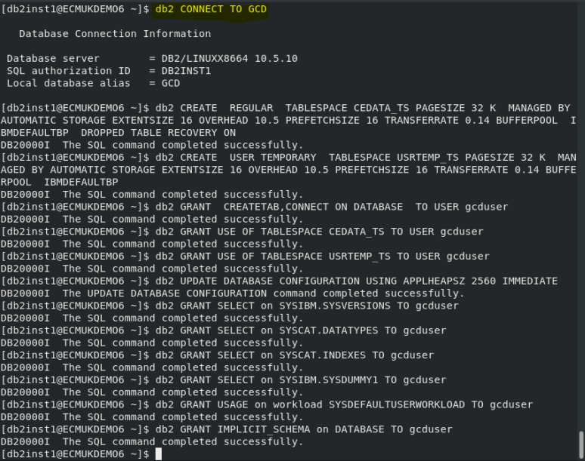

# Installation of IBM Content Foundation 5.5.3

There are two parts to this installation

IBM Content Foundation Enterprise 5.5 Server

ICFE\_5.5.3\_LINUX\_ML.tar.gz

And

IBM Content Foundation Enterprise Client

ICF\_EC\_5.5.3\_LINUX\_EN.tar.gz

Create a new installation directory and copy the ICFE\_5.5.0\_LINUX\_ML.tar.gz

[root@ECMUKDEMO6 Installs]# pwd

/opt/IBM/Installs

[root@ECMUKDEMO6 Installs]# mkdir ICF5\_5\_3

[root@ECMUKDEMO6 Installs]# cd ICF5\_5\_3/

[root@ECMUKDEMO6 ICF5\_5\_3]#

### Copy using a VMware folder

**cp /mnt/hgfs/LINUX/6\_ContentFoundation\_5-5.3/CF\_CPE\_V5.5.3\_ML\_LINUX.tar.gz .**

### Copy using ftp on windows to the Linux VMware

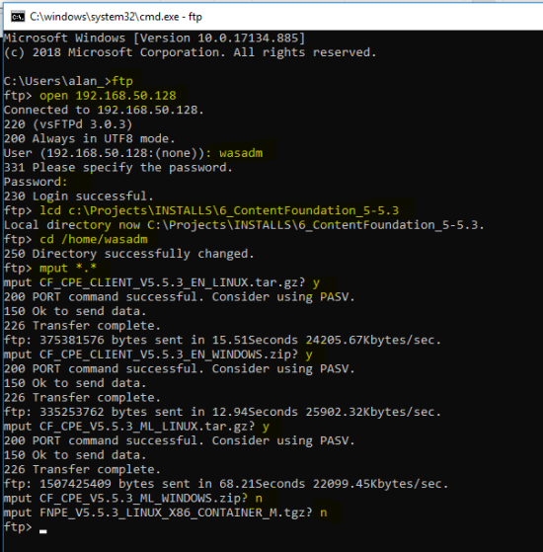

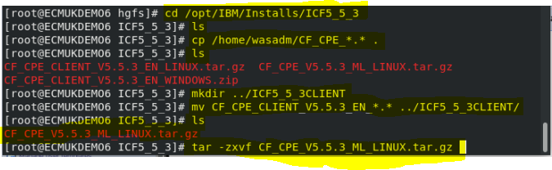

[root@ECMUKDEMO6 ICF5\_5\_3]# ls

CF\_CPE\_V5.5.3\_ML\_LINUX.tar.gz

[root@ECMUKDEMO6 ICF5\_5\_3]# **tar -zxvf CF\_CPE\_V5.5.3\_ML\_LINUX.tar.gz**

[root@ECMUKDEMO6 ICF5\_5\_3]# ls

5.5.3.0-ICFCPE-LINUX.BIN CPETools tsm100

Centera Hadoop version.txt

ce\_silent\_install.txt LanguagePacks

CF\_CPE\_V5.5.3\_ML\_LINUX.tar.gz Tools

[root@ECMUKDEMO6 ICF5\_5\_3]#

Create temp directory, /opt/IBM/tmp if it does not already exist

export IATEMPDIR=/opt/IBM/tmp

[root@ECMUKDEMO6 ICF5\_5\_3]# **mkdir /opt/IBM/tmp**

[root@ECMUKDEMO6 ICF5\_5\_3]# **export IATEMPDIR=/opt/IBM/tmp**

[root@ECMUKDEMO6 ICF5\_5\_3]#

### At this point ensure the following is installed first

1. Verify the instructions in technical notice "Linux libraries required for FileNet Content Manager and IBM Content Foundation installations" ([http://www.ibm.com/support/docview.wss?uid=swg27048088](http://www-01.ibm.com/support/docview.wss?uid=swg27048088)) have been completed. If they were not, you must complete the instructions in that technical notice prior to launching the graphical user interface for the Configuration Manager.

The gtk2, libXtst, and xorg-x11-fonts-Type1 packages are required to run the Content Platform Engine and related application installers, including Content Search Services,  in both silent and GUI mode, as well as when using various eclipse-based GUI tools, such as Configuration Manager and FileNet Deployment Manager.

1. On all hardware platforms, use the following command to install the required libraries:

yum install gtk2 libXtst xorg-x11-fonts-Type1

On this system already done:

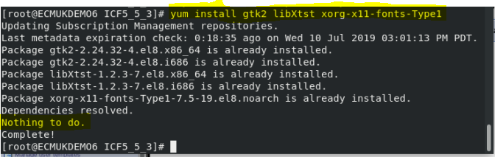

1. On 64-bit platforms, various 32-bit packages are also required.
   * On RedHat systems, before installing the packages, ensure the RPM repository rhel-8-server-optional-rpm is enabled. This repository is required for the installation of the compat-libstdc++-33 package. Use the following command to enable the repository:

yum-config-manager --enable rhel-8-server-optional-rpm

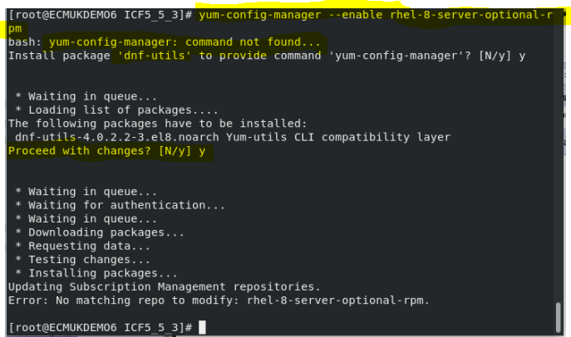

* + Use the following commands to install the required packages and their dependencies:

ARCH32=$(uname -m | sed -e 's/s390x/s390/g' -e 's/x86\_64/i686/g')

yum install glibc.$ARCH32 gtk2.$ARCH32 gtk3.$ARCH32 libXtst.$ARCH32 libXft.$ARCH32 libXtst.$ARCH32 adwaita\*theme.$ARCH32 compat-libstdc++-33.$ARCH32

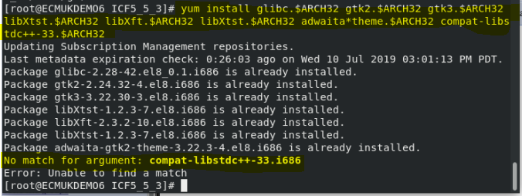

(See **Appendix B – Library updates for IBM Content Foundation 5.5 install** for the full output of this command)

### Libraries also required for IBM Content Foundation Installation GUI

**yum install libXext.so.6**

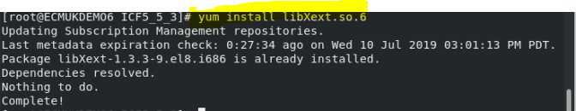

**yum install libXrender.so.1**

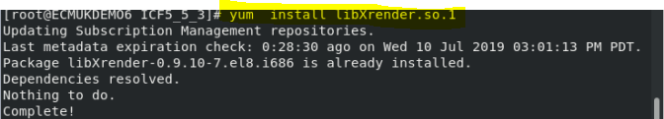

**yum install libXft.so.2**

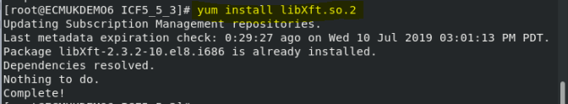

**yum install libXtst.so.6**

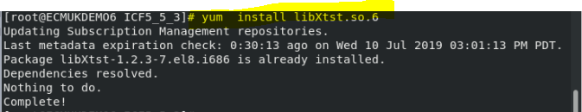

**yum install libstdc++.so.6**

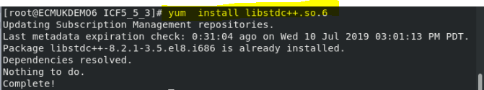

1. Ensure the 64-bit versions of the adwaita theme libraries are installed.

**yum install adwaita\*theme**

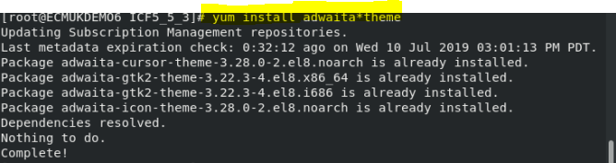

See **Appendix C – Font Library Installation of Adwaita Fonts for ICF 5.5 for** the full log of this install command

## Installation of ICF 5.5.3

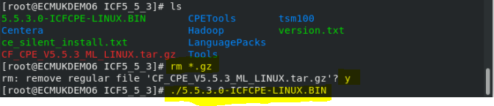

[root@ECMUKDEMO6 ICF5\_5\_3]# **./5.5.3.0-ICFCPE-LINU****X**

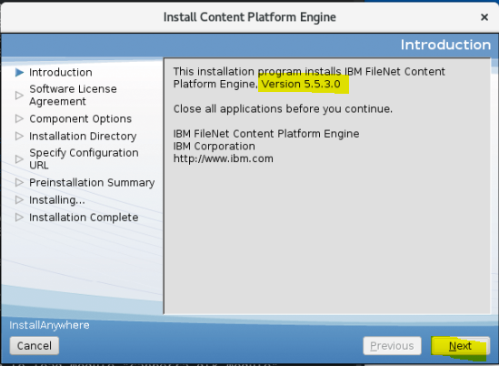

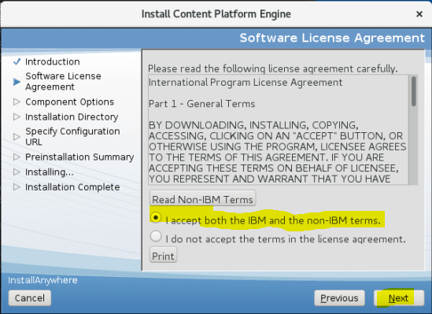

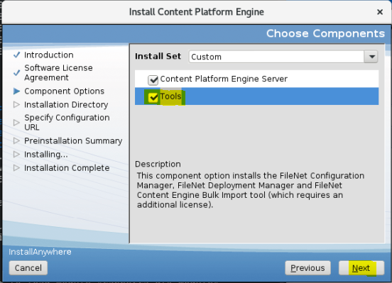

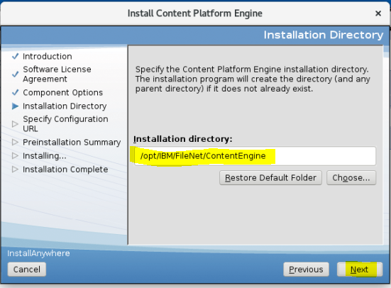

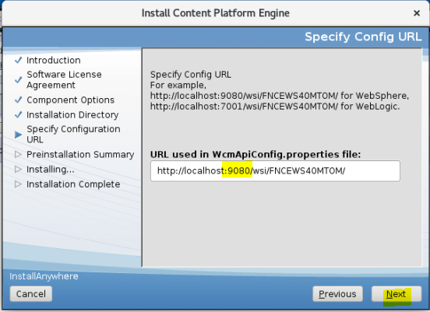

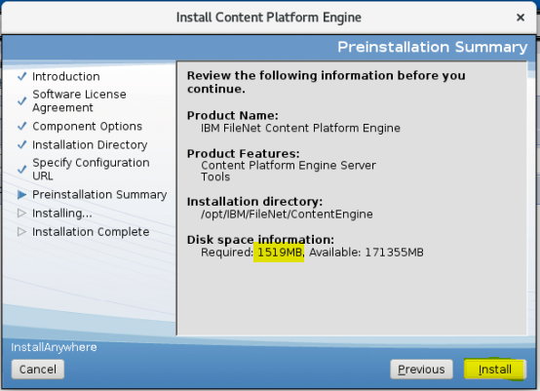

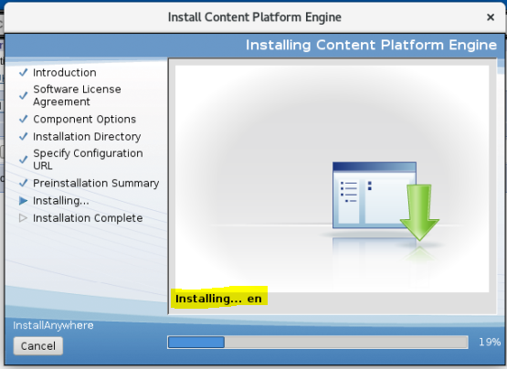

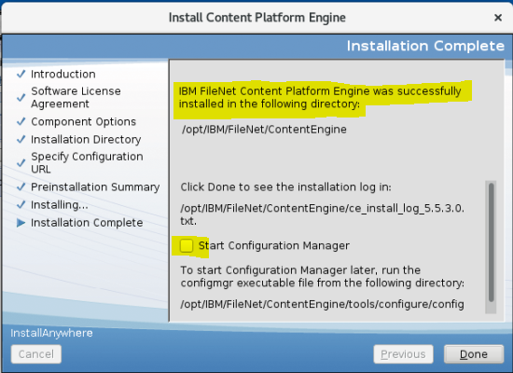

**Launch the configuration manager for IBM Content Foundation 5.5.3**

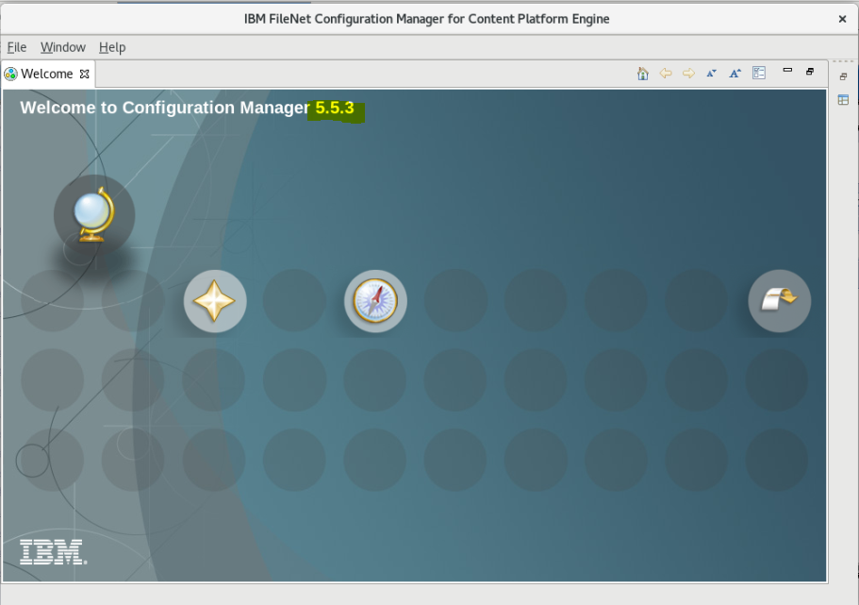

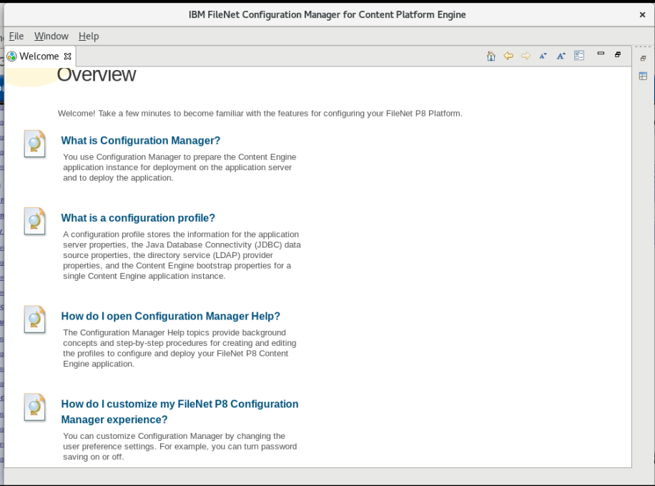

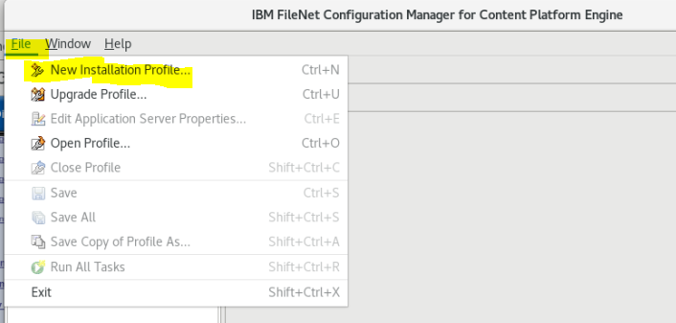

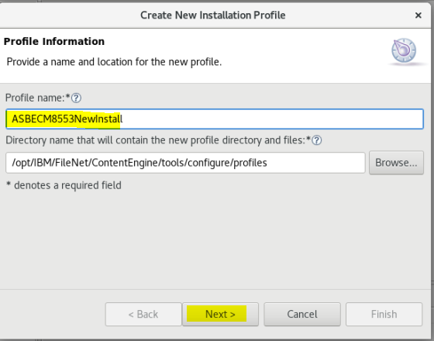

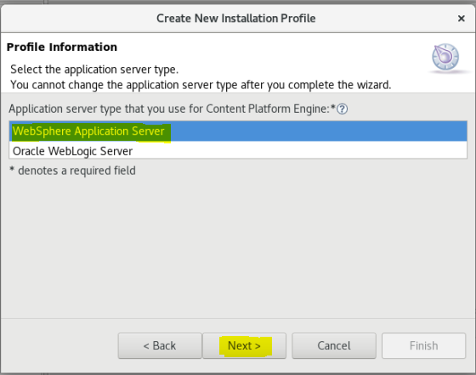

**Select the profile by clicking on the selection as shown above**

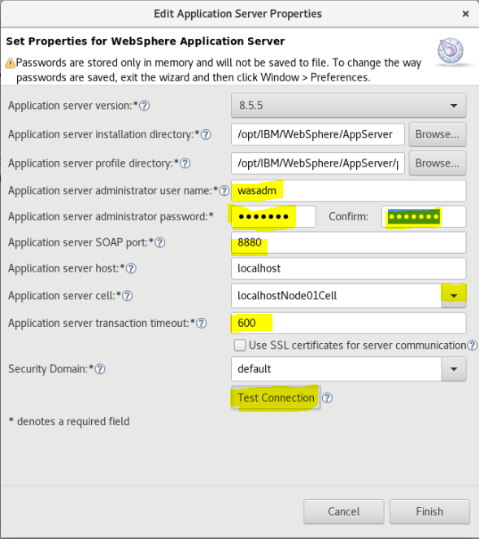

**Test the connection**

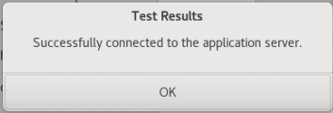

**Click Next>**

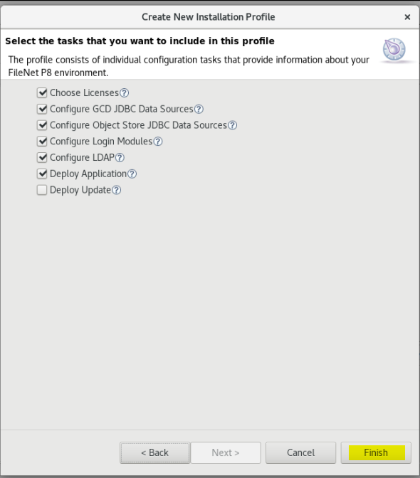

**Click Finish**

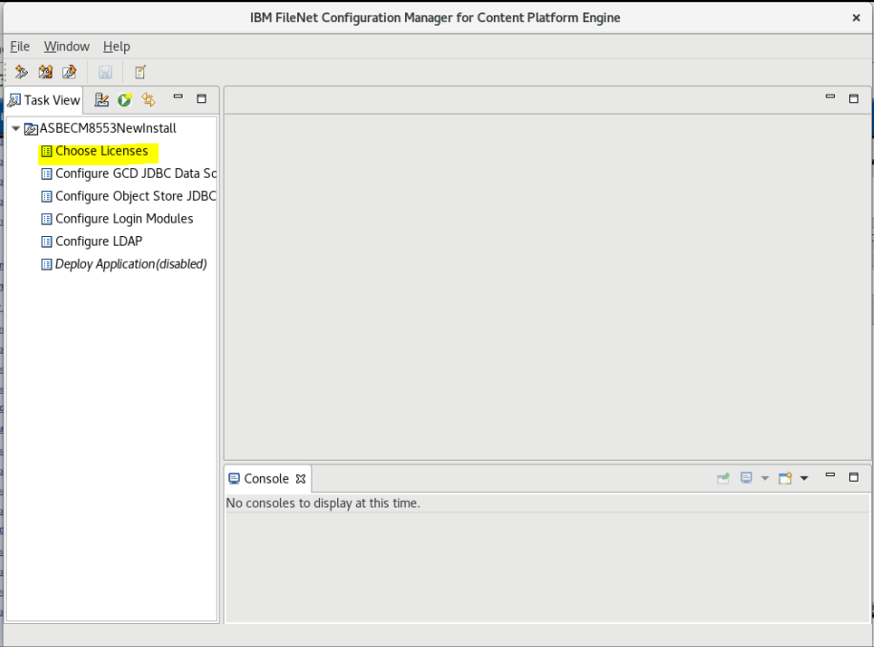

## Loading an existing Installation profile

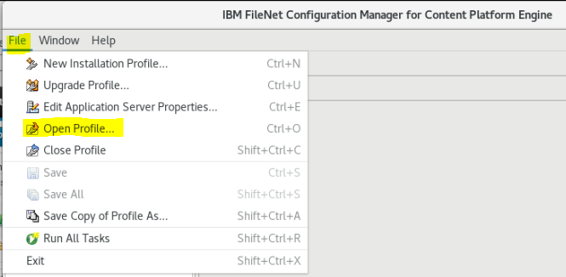

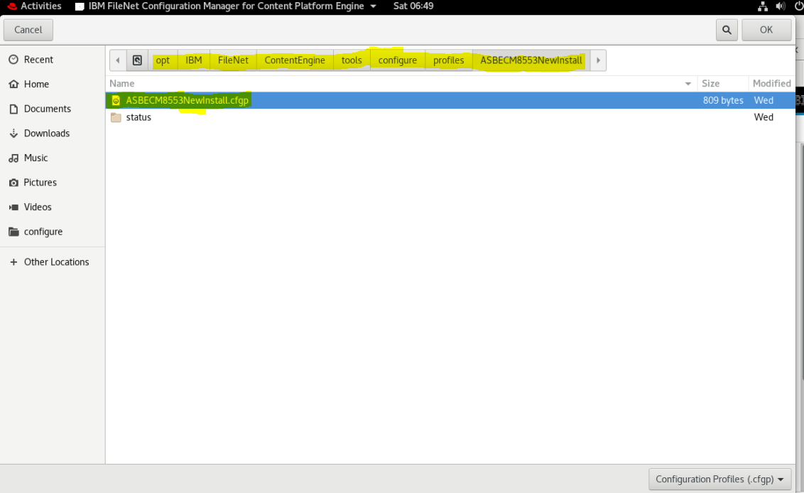

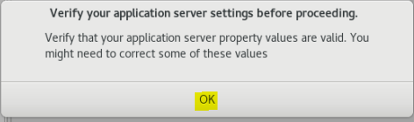

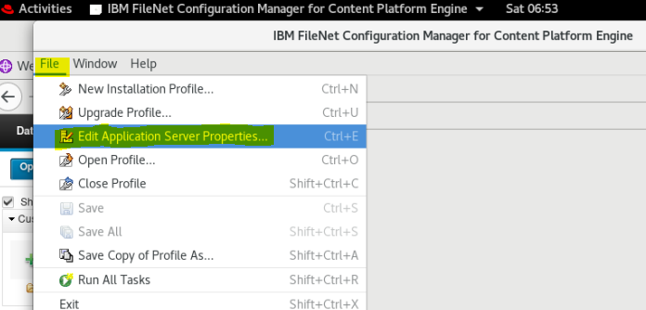

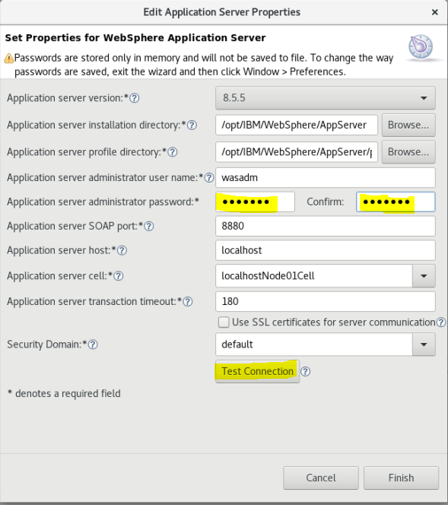

**NB Change the transaction timeout from 180 to 600 seconds!!!**

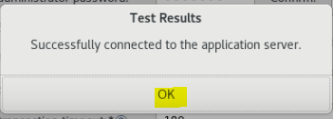

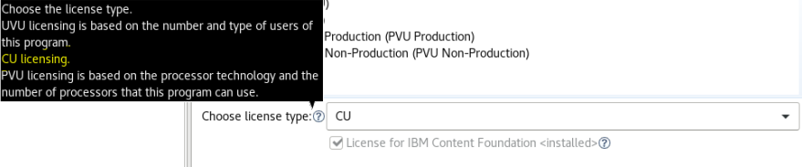

**NB I used the UVU License**

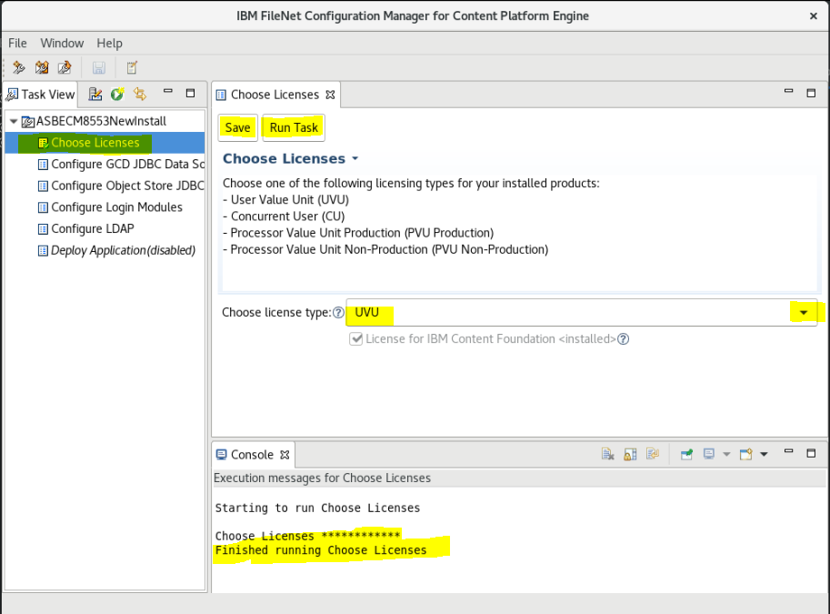

## Database SQL creation

**We need to create an Oracle, DB2 or SQl Server database for the IBM Content Foundation Content Platform Engine 5.5.3 Global Configuration Database (GCD)**

**See section above** Start or stop DB2

### For DB2

1. Set or verify the following parameter settings by entering the following command in the DB2 command-line processor:

Db2 for Linux, UNIX and Windows version 9.7

db2set DB2\_WORKLOAD=FILENET\_CM

db2set DB2\_MINIMIZE\_LISTPREFETCH=ON

db2set DB2\_OPTPROFILE=ON[](javascript:void(0);)

Db2 for Linux, UNIX and Windows version 9.7 Fix Pack 8 or later:

db2set DB2\_WORKLOAD=FILENET\_CM[](javascript:void(0);)

Db2 for Linux, UNIX and Windows version 9.8

db2set DB2\_WORKLOAD=FILENET\_CM

db2set DB2\_MINIMIZE\_LISTPREFETCH=ON

db2set DB2\_OPTPROFILE=ON[](javascript:void(0);)

Db2 for Linux, UNIX and Windows version 10.1

db2set DB2\_WORKLOAD=FILENET\_CM

db2set DB2\_MINIMIZE\_LISTPREFETCH=ON

db2set DB2\_OPTPROFILE=ON[](javascript:void(0);)

Db2 for Linux, UNIX and Windows version 10.1 Fix Pack 2 or later:

db2set DB2\_WORKLOAD=FILENET\_CM

Set CUR\_COMMIT=ON[](javascript:void(0);)

**Db2 for Linux, UNIX and Windows version 10.5 or later:**

**(I used this version)**

db2set DB2\_WORKLOAD=FILENET\_CM

db2Set CUR\_COMMIT=ON[](javascript:void(0);)

1. Connect to your object store databases by entering the following command:

db2 connect to *db\_name* user *user\_name* using *password*[](javascript:void(0);)

db2 connect to OS1

where

* + *db\_name* is the name of your object store database

Issue the following command:

db2 update db cfg using cur\_commit ON[](javascript:void(0);)

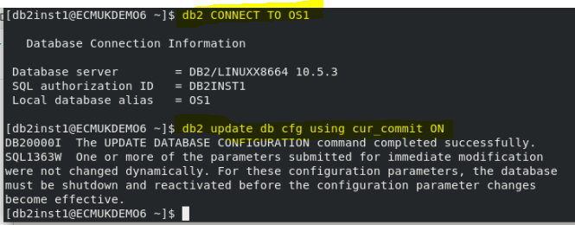

db2 connect reset

db2 connect to OS2

db2 update db cfg using cur\_commit ON

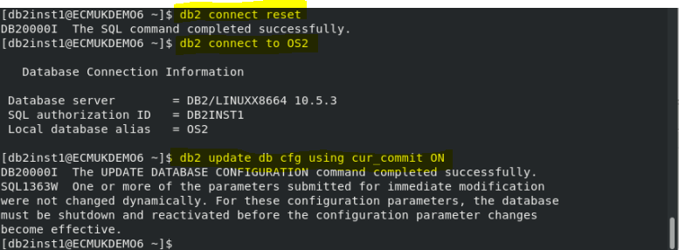

1. After making these changes, stop and restart the database using db2stop and db2start.

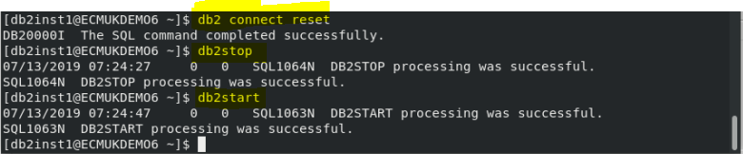

### To create and update the DB2 database:

1. Log on as the database instance owner.
2. At least two databases must be created, one for a Process Engine and single Content Engine object store, and one for the Content Engine GCD .

**NOTE: The database name needs to be unique and from 1 to 8 characters long.**

1. For a database to be used by Content Engine object stores, update the followingconfiguration parameter.

Set the value, minimally, to the value indicated here:

**APPLHEAPSZ 2560**

1. (DB2 version 9.7 only) Set the CUR\_COMMIT variable to ON.
2. For a database to be used by Content Engine, drop the default user [regular] tablespace - USERSPACE1 after creating the database

***Creating the DB2 tablespaces for Process and Content Engine:***

Create tablespaces for Process Engine on DB2 for Linux..

Create the tablespaces for Process Engine. The data tablespace is required.

While the index and BLOB tablespaces are optional, performance can be impacted by configuring for only a data tablespace.

Optionally, the Content Engine object store tablespace(s) can be shared by one Process Engine isolated region.

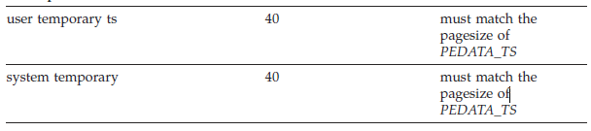

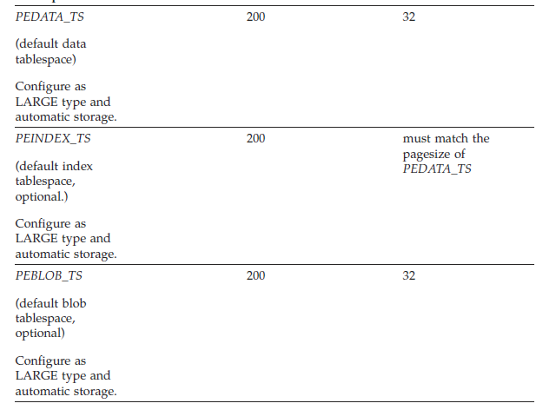

### DB2 SQL Script for the GCD for Windows Environment

**(NB The following is for information only as I haven’t used it in the current RHEL 8.0 system)**

CREATE DATABASE GCD ON 'D:' USING CODESET UTF-8 TERRITORY GB COLLATE USING SYSTEM CATALOG TABLESPACE MANAGED BY SYSTEM USING ('D:\DB2\GCD\sys') TEMPORARY TABLESPACE MANAGED BY SYSTEM USING ('D:\DB2\GCD\systmp') USER TABLESPACE MANAGED BY SYSTEM USING ('D:\DB2\GCD\usr')

UPDATE DATABASE CONFIGURATION FOR GCD USING APPLHEAPSZ 2560

UPDATE DATABASE CONFIGURATION FOR GCD USING STMTHEAP 8192

CONNECT TO GCD

Database Connection Information

Database server = DB2/NT 10.1.0

SQL authorization ID = DB2ADMIN

Local database alias = GCD

DROP TABLESPACE USERSPACE1

CREATE Bufferpool GCDBP IMMEDIATE SIZE -1 PAGESIZE 32K

CREATE Bufferpool GCDTEMPBP IMMEDIATE SIZE -1 PAGESIZE 32K

CREATE Bufferpool GCDSYSBP IMMEDIATE SIZE -1 PAGESIZE 32K

CONNECT RESET

CONNECT TO GCD

Database Connection Information

Database server = DB2/NT 10.1.0

SQL authorization ID = DB2ADMIN

Local database alias = GCD

CREATE REGULAR TABLESPACE GCD PAGESIZE 32K MANAGED BY DATABASE USING(FILE 'D:\DB2\GCD\usr2\GCD\_tbs.dbf' 512M) AUTORESIZE YES BUFFERPOOL GCDBP

CREATE USER TEMPORARY TABLESPACE USERTEMP1 PAGESIZE 32K MANAGED BY DATABASE USING (FILE 'D:\DB2\GCD\usrtmp\GCD\_tmp.dbf' 64M) AUTORESIZE YES BUFFERPOOL OS1TEMPBP

CREATE SYSTEM TEMPORARY TABLESPACE TEMPSYS1 PAGESIZE 32K MANAGED BY SYSTEM USING ('D:\DB2\GCD\systmp2') BUFFERPOOL GCDSYSBP

GRANT CREATETAB,CONNECT ON DATABASE TO user GCDUSER

GRANT USE OF TABLESPACE GCD TO user GCDUSER

GRANT USE OF TABLESPACE USERTEMP1 TO user GCDUSER

CONNECT RESET

### DB2 SQL Script for the GCD for LINUX Environments

**NB The database name needs to be unique and from 1 to 8 characters long.**

(Enter your values where shown ***in italic bold*** below)

See previous section **Create a GCD Database**

#-- Close any outstanding connection

db2 CONNECT RESET

echo "Creating Content Engine ***GCD*** *or Object Store* database, tablespaces, and granting proper rights to osdbuser ..."

db2 CREATE DATABASE ***GCD*** AUTOMATIC STORAGE YES ON ***/opt/IBM/GCDDB*** USING CODESET UTF-8 TERRITORY US COLLATE USING SYSTEM PAGESIZE 32768

db2 CONNECT TO ***GCD***

db2 CREATE REGULAR TABLESPACE CEDATA\_TS PAGESIZE 32 K MANAGED BY AUTOMATIC STORAGE EXTENTSIZE 16 OVERHEAD 10.5 PREFETCHSIZE 16 TRANSFERRATE 0.14 BUFFERPOOL IBMDEFAULTBP DROPPED TABLE RECOVERY ON

db2 CREATE USER TEMPORARY TABLESPACE USRTEMP\_TS PAGESIZE 32 K MANAGED BY AUTOMATIC STORAGE EXTENTSIZE 16 OVERHEAD 10.5 PREFETCHSIZE 16 TRANSFERRATE 0.14 BUFFERPOOL IBMDEFAULTBP

db2 GRANT CREATETAB,CONNECT ON DATABASE TO USER ***gcduser***

db2 GRANT USE OF TABLESPACE CEDATA\_TS TO USER ***gcduser***

db2 GRANT USE OF TABLESPACE USRTEMP\_TS TO USER ***gcduser***

db2 GRANT SELECT on SYSIBM.SYSVERSIONS TO ***gcduser***

db2 GRANT SELECT on SYSCAT.DATATYPES TO ***gcduser***

db2 GRANT SELECT on SYSCAT.INDEXES TO ***gcduser***

db2 GRANT SELECT on SYSIBM.SYSDUMMY1 TO ***gcduser***

db2 GRANT USAGE on workload SYSDEFAULTUSERWORKLOAD TO **gcduser**

db2 GRANT IMPLICIT\_SCHEMA on DATABASE TO ***gcduser***

db2 UPDATE DATABASE CONFIGURATION USING APPLHEAPSZ 2560 IMMEDIATE

db2 CONNECT RESET

echo "--------------------"

**The above should be used to create:**

1. **The IBM FileNet Content Engine GCD Database**

**(Global Cofiguration Database)**

1. **The IBM FileNet Content Engine Object Store Database**
2. **The IBM FileNet Process Engine Database**

**REFs**

[**https://www.ibm.com/support/knowledgecenter/en/SSNW2F\_5.5.0/com.ibm.p8.planprepare.doc/p8ppi132.htm**](https://www.ibm.com/support/knowledgecenter/en/SSNW2F_5.5.0/com.ibm.p8.planprepare.doc/p8ppi132.htm)

[**https://www.ibm.com/support/knowledgecenter/en/SSNW2F\_5.5.0/com.ibm.p8.planprepare.doc/p8ppi259.htm**](https://www.ibm.com/support/knowledgecenter/en/SSNW2F_5.5.0/com.ibm.p8.planprepare.doc/p8ppi259.htm)

**and**

[**http://www-01.ibm.com/support/knowledgecenter/SSNW2F\_5.1.0/com.ibm.p8.planprepare.doc/p8ppi135.htm?lang=en**](http://www-01.ibm.com/support/knowledgecenter/SSNW2F_5.1.0/com.ibm.p8.planprepare.doc/p8ppi135.htm?lang=en)

**Content Platform Engine database user (Db2 for Linux, UNIX and Windows)**

**Unique identifier**

*cpe\_db\_user*

**Description**

The IT administrator (ITA) creates this operating system account, after which the database administrator (DBA) grants it additional database permissions. Separate accounts can be used for each object store, but are not required.

Do not create databases with the RESTRICTIVE option.

**Minimum required permissions**

Use your database tools to grant the following database permissions to this user account:

* GRANT CONNECT ON DATABASE TO *cpe\_db\_user*
* GRANT CREATETAB ON DATABASE TO *cpe\_db\_user*
* GRANT USE OF TABLESPACE *UserTablespace* TO *cpe\_db\_user*
* GRANT USE OF TABLESPACE *UserTemporaryTablespace* TO *cpe\_db\_user*
* GRANT SELECT on SYSIBM.SYSVERSIONS TO *cpe\_db\_user*
* GRANT SELECT on SYSCAT.DATATYPES TO *cpe\_db\_user*
* GRANT SELECT on SYSCAT.INDEXES TO *cpe\_db\_user*
* GRANT SELECT on SYSIBM.SYSDUMMY1 TO *cpe\_db\_user*
* GRANT USAGE on workload SYSDEFAULTUSERWORKLOAD TO *cpe\_db\_user*
* GRANT IMPLICIT\_SCHEMA on DATABASE TO *cpe\_db\_user*

For added security in a shared database environment, you can remove the Connect privilege from the Public group.

Grant the following permissions if you want to use dedicated table spaces for Data, Index, and LOB.

* GRANT USE OF TABLESPACE *UserDataTablespace* TO *cpe\_db\_user*
* GRANT USE OF TABLESPACE *UserIndexTablespace* TO *cpe\_db\_user*
* GRANT USE OF TABLESPACE *UserLOBTablespace* TO *cpe\_db\_user*
* GRANT USE OF TABLESPACE *UserTemporaryTablespace* TO *cpe\_db\_user*

### Oracle SQL Script for the GCD User

REF

<https://www.ibm.com/support/knowledgecenter/en/SSNW2F_5.5.0/com.ibm.p8.planprepare.doc/p8ppi215.htm>

A database user account that Content Platform Engine uses to connect to Oracle databases containing the GCD and object stores.

## Procedure

1. Create the following database account after creating the database instance:

**Content Platform Engine database user (Oracle)**

**Unique identifier**

cpe\_db\_user

**Description**

The owner account that Content Platform Engine uses to access Oracle. Use one account for the object store and one for the GCD.

In order to share database connections in Oracle, you must grant additional privileges to cpe\_db\_user . See the topic Sharing database connections in Oracle.

**Minimum required permissions**

Grant each cpe\_db\_user at least the following permissions:

* + CREATE SESSION
  + CREATE TABLE
  + CREATE VIEW
  + CREATE SEQUENCE
  + Alter user set QUOTA UNLIMITED on all table spaces used by db user
  + SELECT on pending\_trans$
  + SELECT on dba\_2pc\_pending
  + SELECT on dba\_pending\_transactions
  + SELECT on DUAL
  + SELECT on product\_component\_version
  + SELECT on USER\_INDEXES
  + EXECUTE on dbms\_xa

### Additional sqlplus command for pluggable Oracle 12c Database

**NB Note the following for 12c if the pluggable database is created!**

<http://www.dba-oracle.com/t_ora_65096_create_user_12c_without_c_prefix.htm>

**Use**

**alter session set "\_ORACLE\_SCRIPT"=true;**

=================================================================

G C D U S E R

=================================================================

CREATE USER GCD IDENTIFIED BY filenet;

GRANT SELECT on pending\_trans$ TO GCD;

GRANT SELECT on dba\_2pc\_pending TO GCD;

GRANT SELECT on dba\_pending\_transactions TO GCD;

GRANT SELECT on DUAL TO GCD;

GRANT SELECT on product\_component\_version TO GCD;

GRANT SELECT on USER\_INDEXES TO GCD;

GRANT EXECUTE ON SYS.DBMS\_SYSTEM TO GCD;

GRANT EXECUTE ON SYS.DBMS\_XA TO GCD;

ALTER USER GCD QUOTA UNLIMITED ON USERS;

GRANT CREATE TYPE TO GCD;

GRANT CREATE VIEW TO GCD;

GRANT CREATE TABLE TO GCD;

GRANT CREATE CLUSTER TO GCD;

GRANT CREATE SESSION TO GCD;

GRANT CREATE TRIGGER TO GCD;

GRANT CREATE SEQUENCE TO GCD;

GRANT CREATE DIMENSION TO GCD;

GRANT CREATE INDEXTYPE TO GCD;

GRANT CREATE PROCEDURE TO GCD;

GRANT CREATE MATERIALIZED VIEW TO GCD;

alter user GCD account unlock;

### SQL Server Script for the GCD User

<https://www.ibm.com/support/knowledgecenter/en/SSNW2F_5.5.0/com.ibm.p8.planprepare.doc/p8ppi022.htm>

**Do not share the database that is used for the GCD with object stores or IBM® Content Navigator configuration data.**

## Procedure

1. Create the database with a minimum size of 100 MB. In Microsoft SQL Server, the PRIMARY file group holds the database system objects. Create an extra file group and designate it as the default file group to hold the FileNet® P8 tables.



Record the values for the **Database** name, the **Database** port number, and the file group name in your customized Installation and Upgrade Worksheet. To find these properties, set the Autofilter for Column E **Installation or Configuration Program** for **CM: Configure GCD JDBC Data Sources**. Then, set the Autofilter for Column D **ISV Component Vendor** to **SQL Server**.

1. READ\_COMMITTED\_SNAPSHOT must be enabled for the GCD. Run the following command:

ALTER DATABASE mydbname SET READ\_COMMITTED\_SNAPSHOT ON

#### Object Store Database

<https://www.ibm.com/support/knowledgecenter/en/SSNW2F_5.5.0/com.ibm.p8.planprepare.doc/p8ppi023.htm>

REF: <https://www.ibm.com/support/knowledgecenter/en/SSNW2F_5.5.0/com.ibm.p8.installingcfs.doc/cfsin017.htm>

**NOTE: Use SQL Server database credentials, not Windows credentials, to log on. Windows Integrated Logon to SQL Server is not supported.**

In a Microsoft SQL Server environment, the database administrator creates the database, table space, and user account.

## Procedure

To create a database, table space, and user

1. Configure the JDBC Distributed Transaction Components by completing the following steps on every SQL Server to be used as a database:
   1. Download the Microsoft SQL Server JDBC driver that is specified on the [IBM® FileNet® P8 system requirements](http://www.ibm.com/support/docview.wss?uid=swg27013654) web page.
   2. Copy the sqljdbc\_xa.dll file from the JDBC installation directory to the C:\Program Files\Microsoft SQL Server\MSSQL$instance name\Bindirectory. If you use a 32-bit processor, use the sqljdbc\_xa.dll file in the x86 folder. If you use a 64-bit processor, use the sqljdbc\_xa.dll file in the x64 folder.
   3. Log on as a database administrator and run the xa\_install.sql database script on every SQL Server instance that participates in distributed transactions.This script installs the sqljdbc\_xa.dll file as an extended stored procedure and creates the SqlJDBCXAUser role in the Master database.
2. Create a Microsoft SQL Server database. Set an initial size of at least 200 MB.
3. Create a database user account.
   1. Specify that the account uses SQL Server Authentication when it connects to the database.
   2. Select the database as the default database for this account.
   3. Assign the following database roles to this account:
      * public
      * db\_owner
4. Add the account to the Microsoft SQL Server master database and grant it the public and SqlJDBCXAUser roles. This action grants permissions to the account to participate in distributed transactions with the JDBC driver.
5. Enable XA Transactions by completing the following steps on every SQL Server that has a Federator database:
   1. From Control Panel, open Administrative Tools, and then open Component Services.
   2. Expand Component Services, right-click **My Computer**, and then select **Properties**.
   3. Click the **MSDTC** tab, and then click **Security Configuration**.
   4. Select the **Enable XA Transactions** check box and click **OK**. The MS DTC service is restarted.
   5. Click **OK** to close the Properties window and close Component Services.
   6. Stop and restart SQL Server.

If you want to add a workflow system to an object store that does not already have one, the workflow system can use the file groups that are used by the object store. Alternatively, you can create new file groups for the workflow system, according to the rules on file group names and minimum sizes that are documented here.

## Procedure

1. Use your Database tools to create a database for an object store. In Microsoft SQL Server, the PRIMARY file group holds the database system objects. Create an extra file group and designate it as the default file group to hold the FileNet® P8 tables.

| *Table 1. File group names and minimum sizes* | | |
| --- | --- | --- |
| **File group Name** | **Minimum Size (MB)** | **Description** |
| data | 400 | The default name of the data file group that is used by Content Platform Engine.  Icon representing the worksheet  Record this value in your customized Installation and Upgrade Worksheet. To find this property, use the Autofilter down arrow in Column F, **Property or Parameter (in user interface)**, to select **Data tablespace name**. |
| index(optional) | 300 | The default name of the optional default index file group that is used by Content Platform Engine. If you do not create an index file group, the data file group is used for indexes.  Icon representing the worksheet  Record this value in your customized Installation and Upgrade Worksheet. To find this property, use the Autofilter down arrow in Column F, **Property or Parameter (in user interface)**, to select **Index tablespace name**. |
| lob(optional) | 300 | The default name of the optional default LOB file group that is used by Content Platform Engine. If you do not create a LOB file group, the data file group is used for LOB data.  Icon representing the worksheet  Record this value in your customized Installation and Upgrade Worksheet. To find this property, use the Autofilter down arrow in Column F, **Property or Parameter (in user interface)**, to select **LOB tablespace name**. |
| temp | 160 | The default temporary file group, which is required for Content Platform Engine use. |

1. READ\_COMMITTED\_SNAPSHOT must be enabled for the object store database. Run the following command:

ALTER DATABASE mydbname SET READ\_COMMITTED\_SNAPSHOT ON[](javascript:void(0);)

**Important:** The user who runs the command must be the only user who is connected to the database when this command is run. For more information, see the Microsoft SQL Server documentation that was provided with your database.

Record the values for the database name, the database port number, and the file group names in your customized Installation and Upgrade Worksheet. To find these properties, set the Autofilter for Column E **Installation or Configuration Program** for **CM: Configure Object Store JDBC Data Sources** (object store 1). Then, set the Autofilter for Column D**ISV Component Vendor** to **SQL Server**. If your customized worksheet shows more than one object store, create and provide values for all of them.

See also Appendix K – Microsoft SQL\*Server pre-requisites

### Websphere Environment For the Database JDBC jar files

**We need to create the WebSphere Environment Variables to point to an Oracle, DB2 or Sql Server jdbc .jar file location (/opt/jars used)**

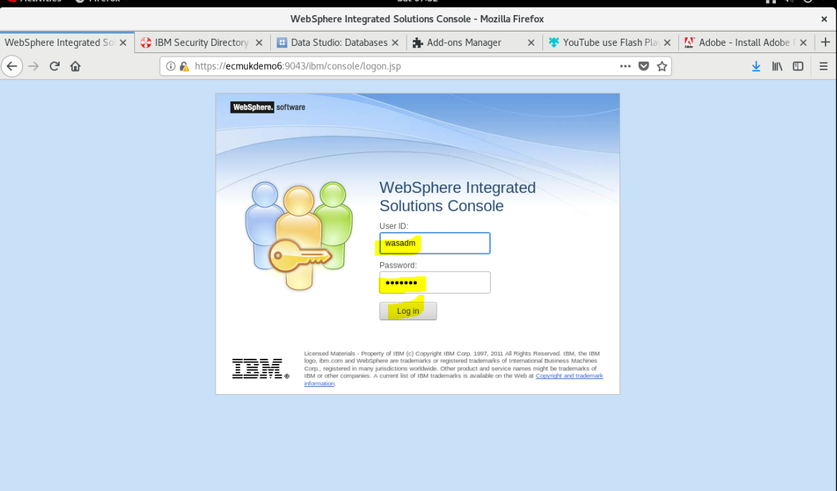

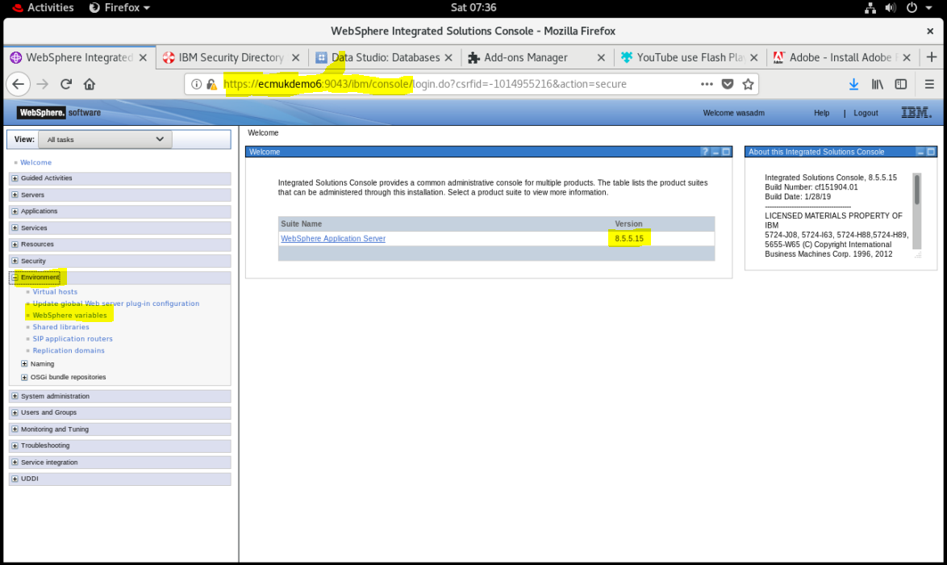

### DB2 Environment variables

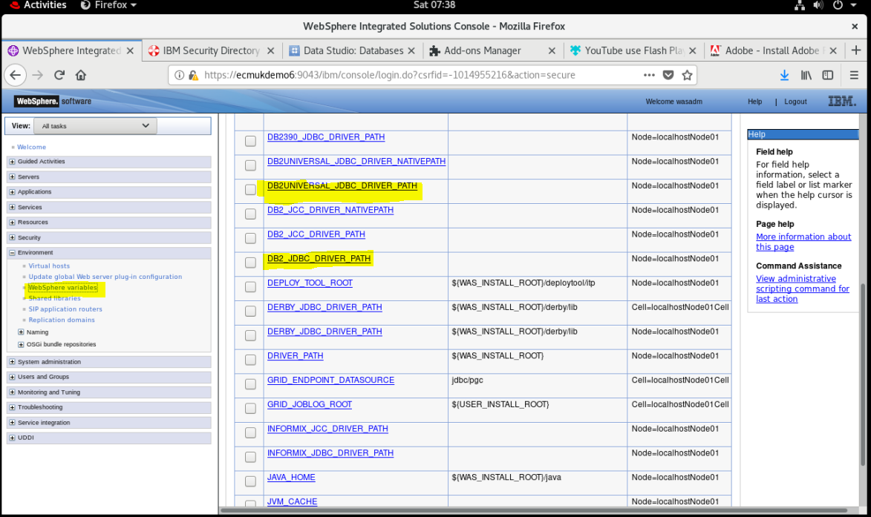

**mkdir /opt/jars**

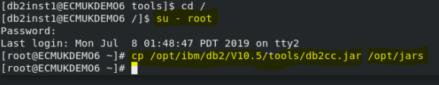

cp /opt/ibm/db2/V10.5/java/db2jcc4.jar /opt/jars

cp /opt/ibm/db2/V10.5/java/db2jcc.jar /opt/jars

**NB Stop and restart the WebSphere server!**

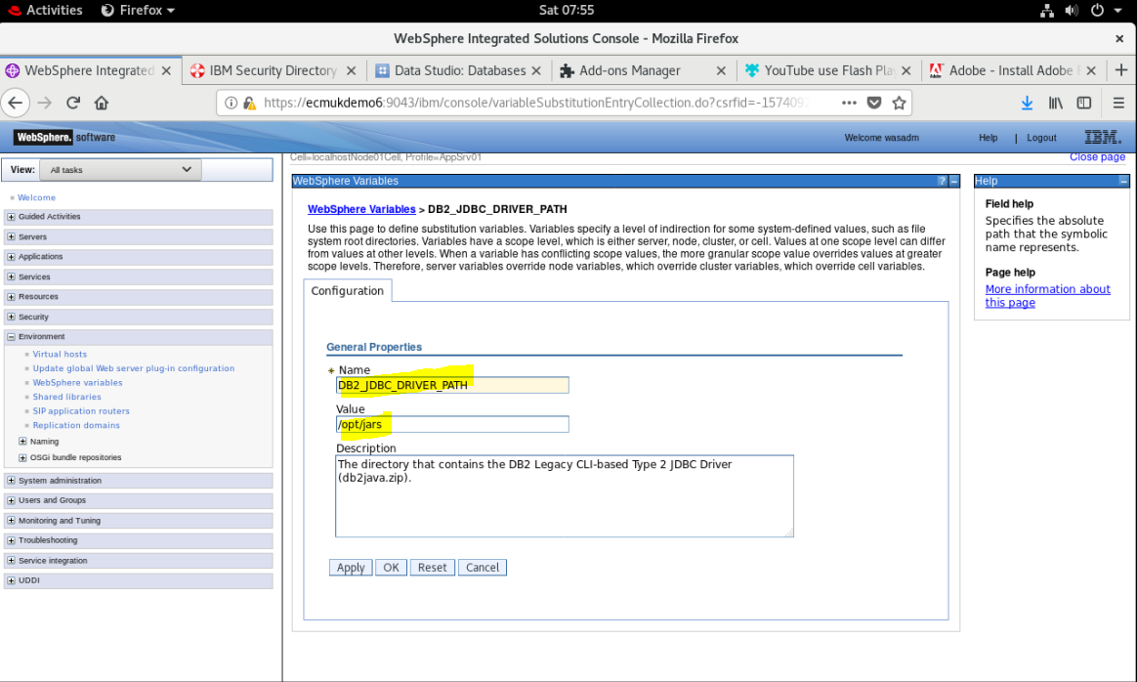

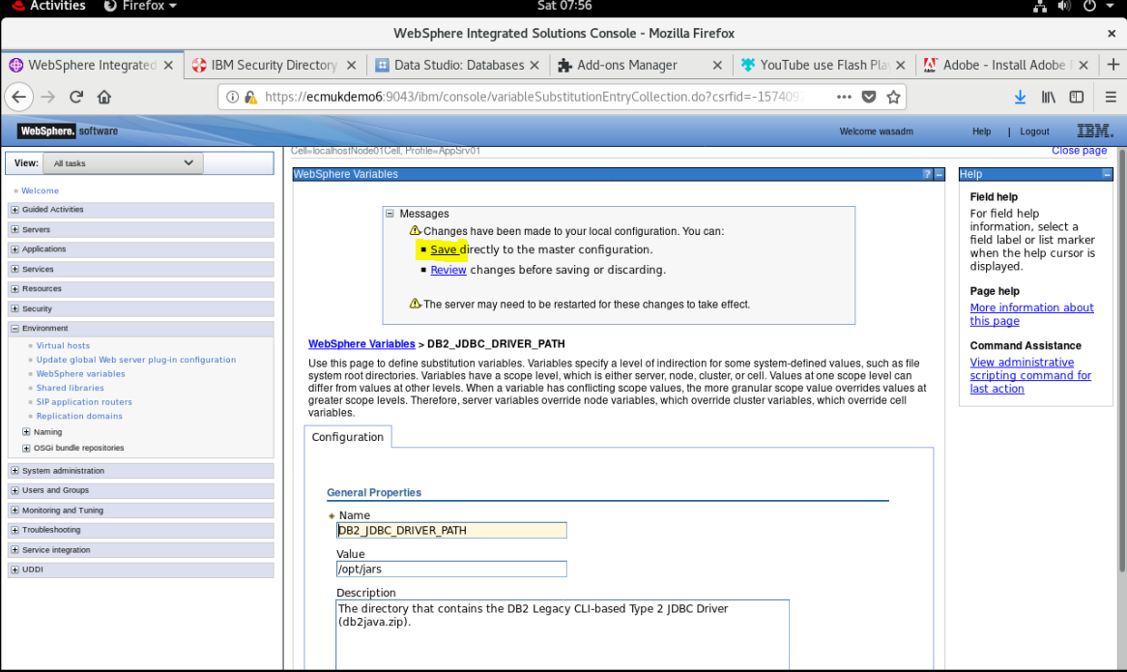

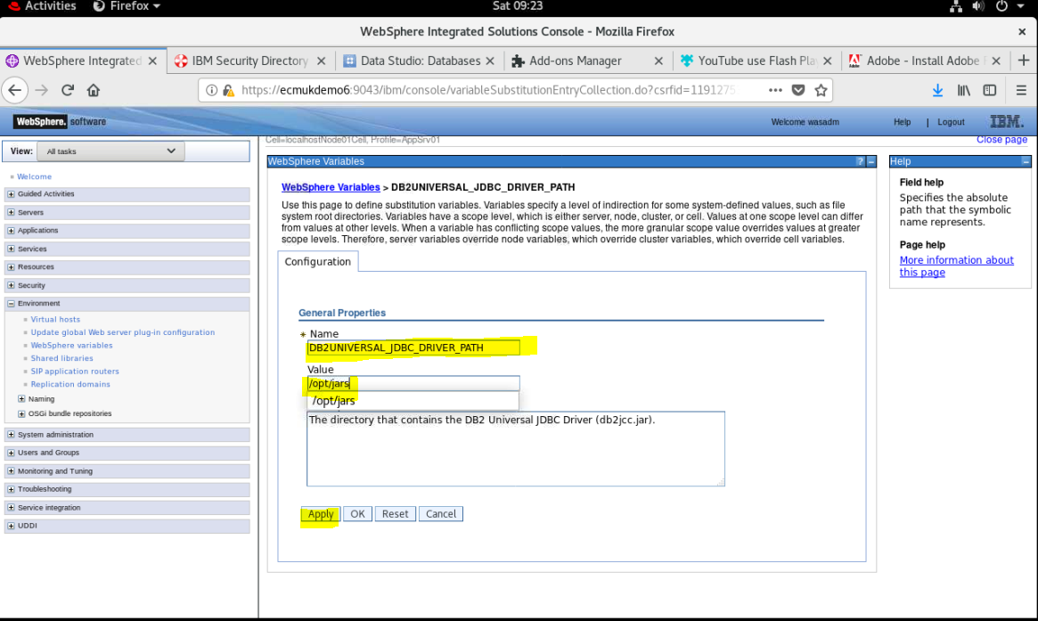

### Oracle Environment variables

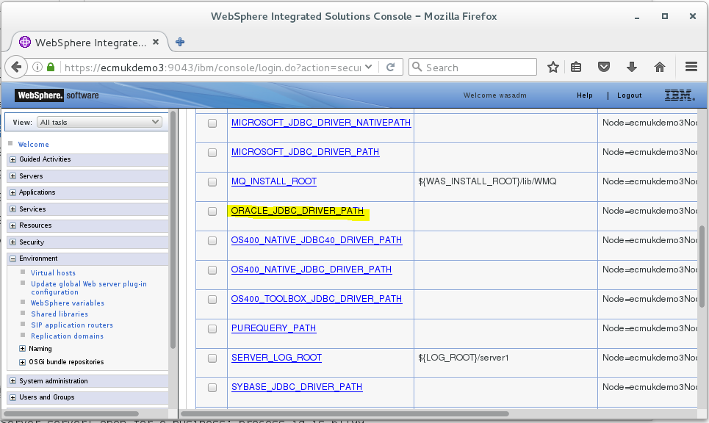

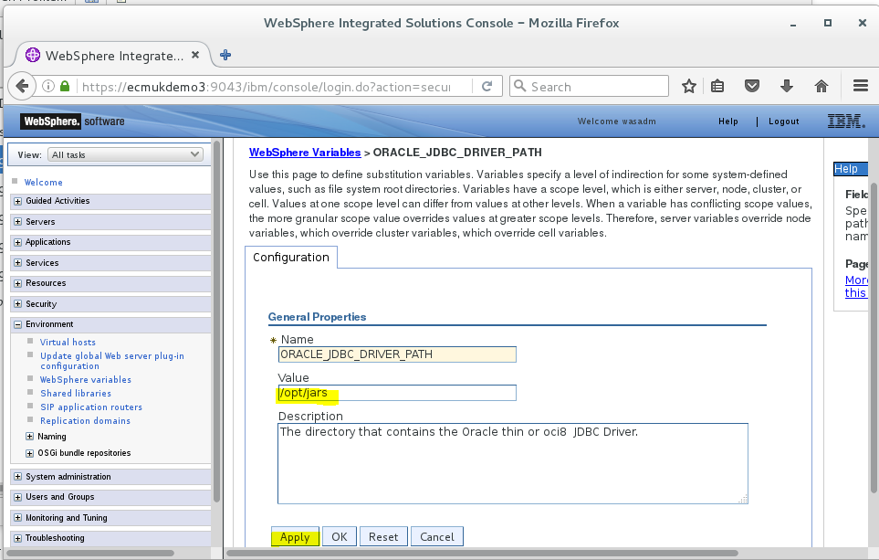



Apply and Save the changes to the WebSphere repository

### Copy DB2 jar files

**Copy out the required DB2 jar files and copy into the sub-folder**

**Ref**

<https://www-01.ibm.com/support/docview.wss?uid=swg21363866>

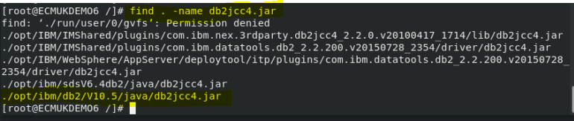



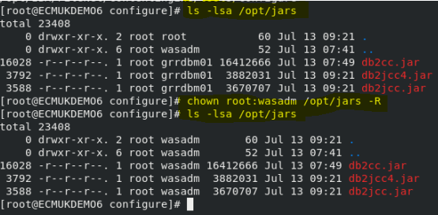

**Change the owner group to wasadm**

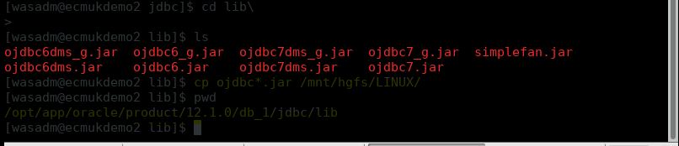

### Copy ORACLE jar files

**Copy out the required Oracle jar files and copy into the sub-folder**

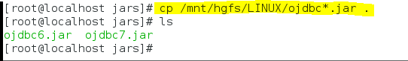

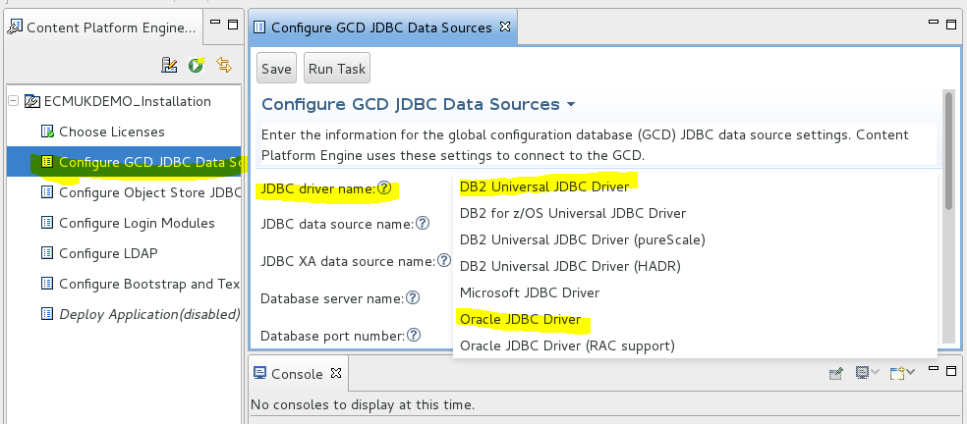

### Select the Oracle or DB2 JDBC Driver

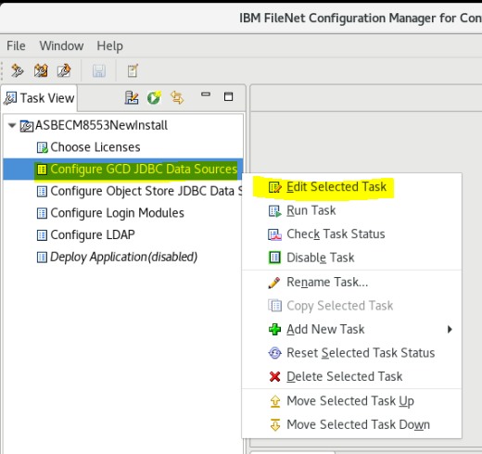

**Select the Configure GCD JDBC Data Sources**

**Right-mouse click and select Edit Selected Task**

### Configure for DB2 10.5 Fix Pack 10 Database

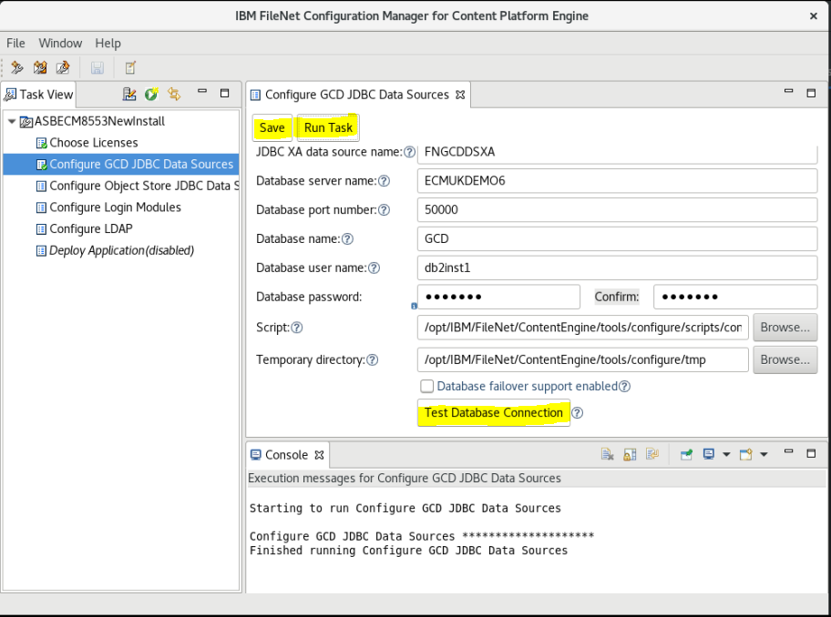

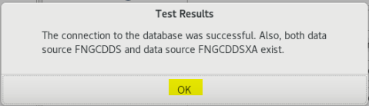

### Configure the DB2 OS1 Development Object Store

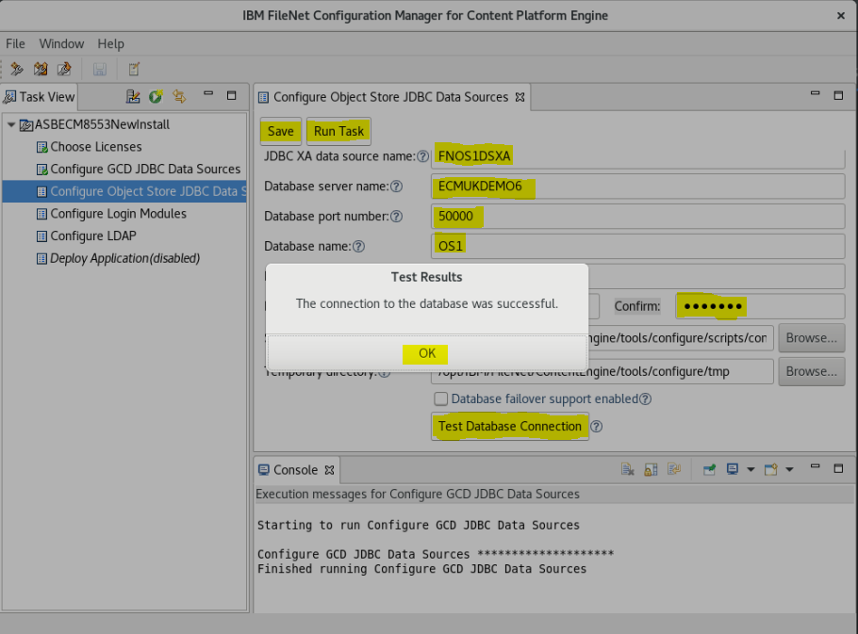

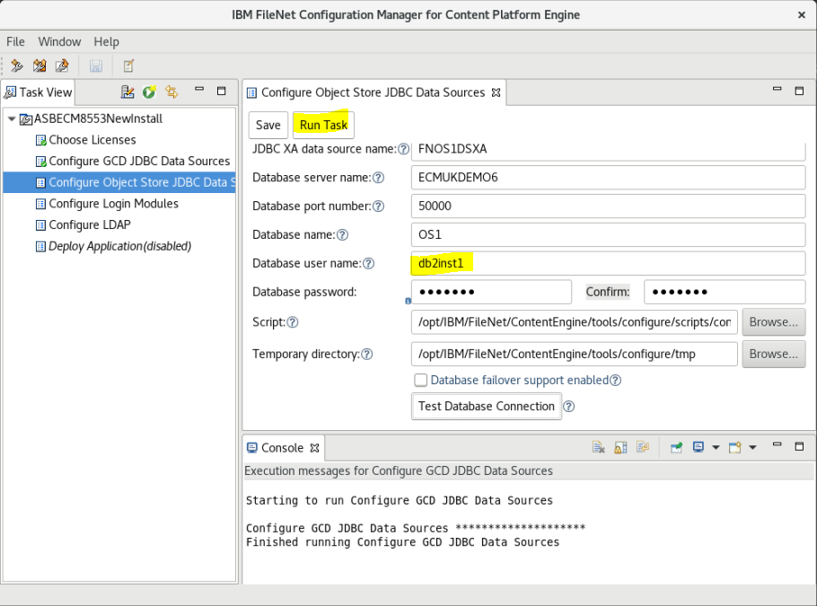

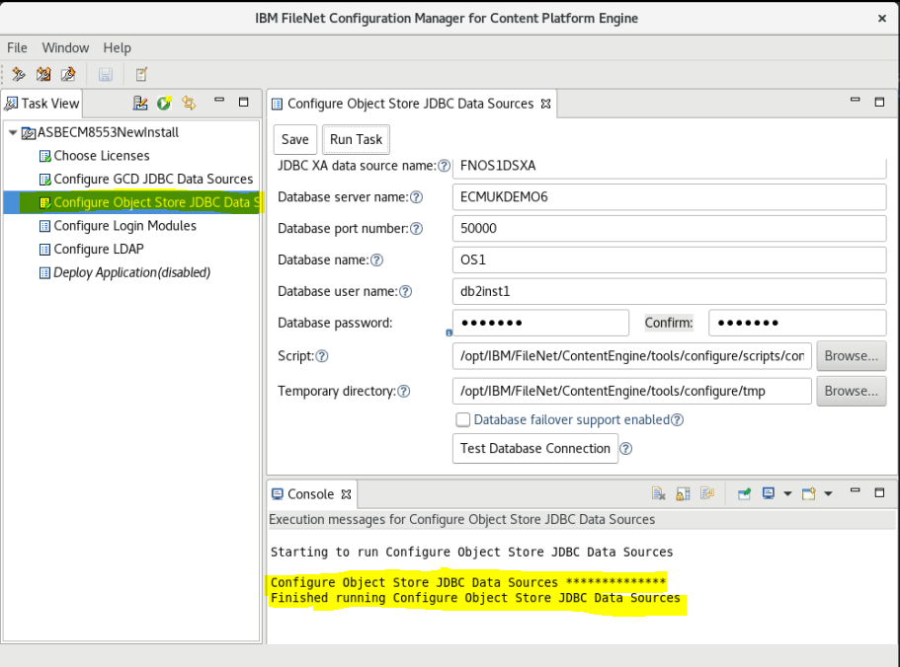

### Copy the Configure Object Store JDBC task for the OS2 Target Store

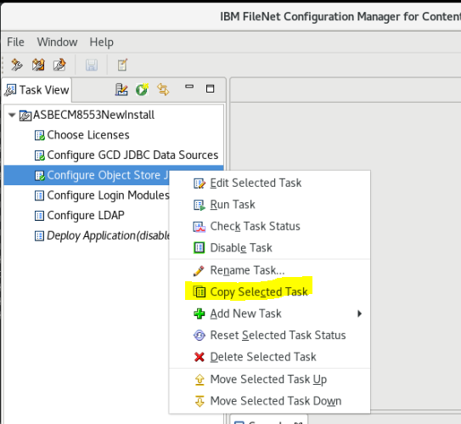

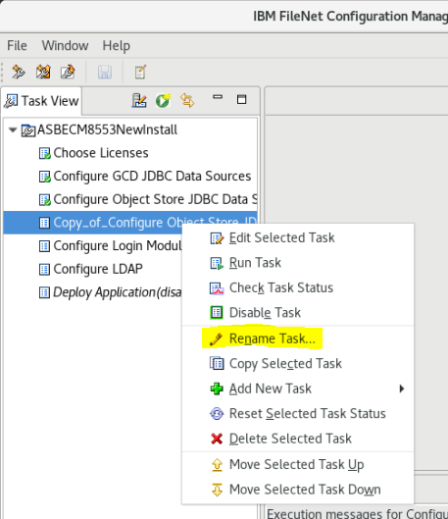

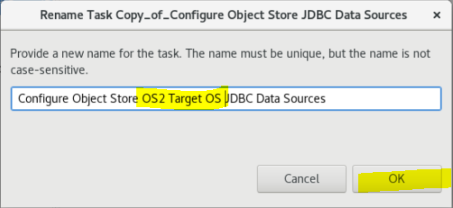

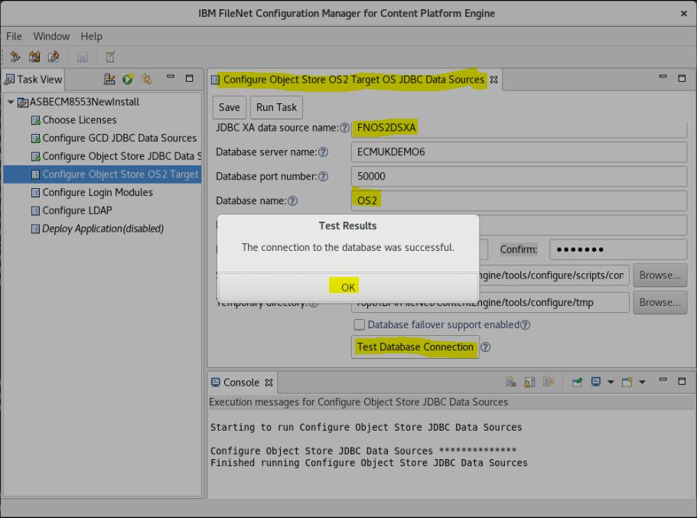

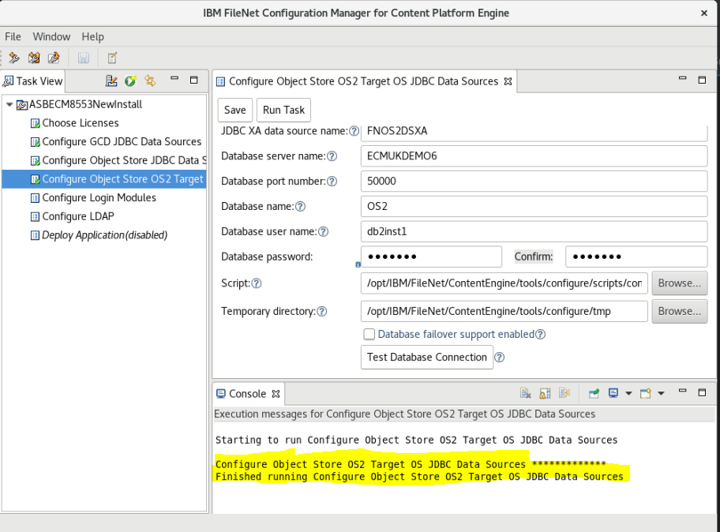

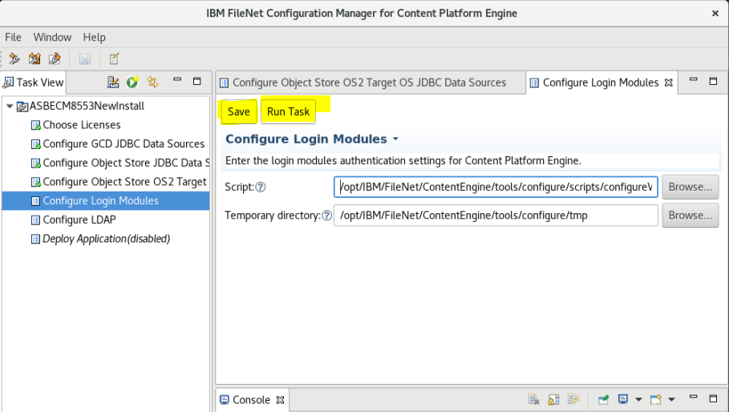

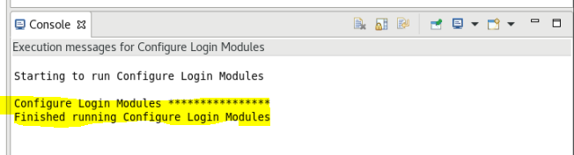

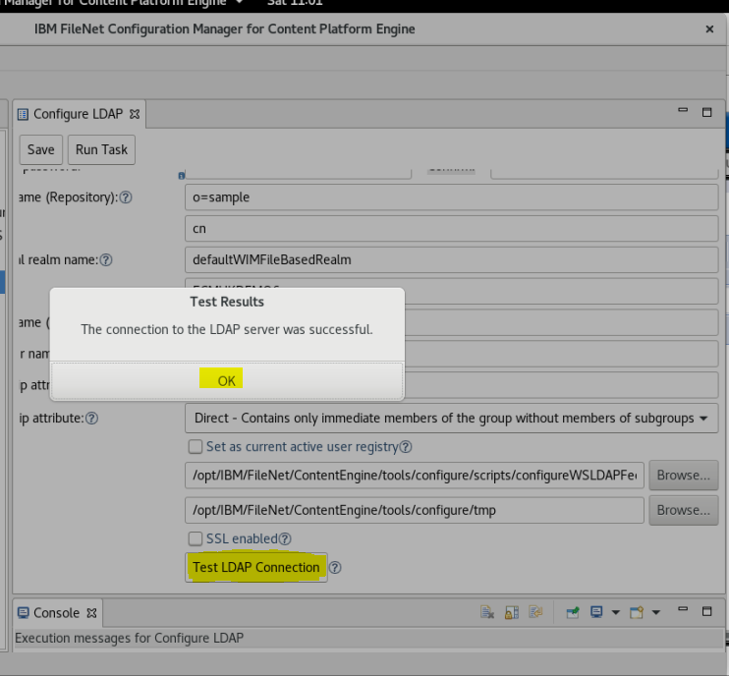

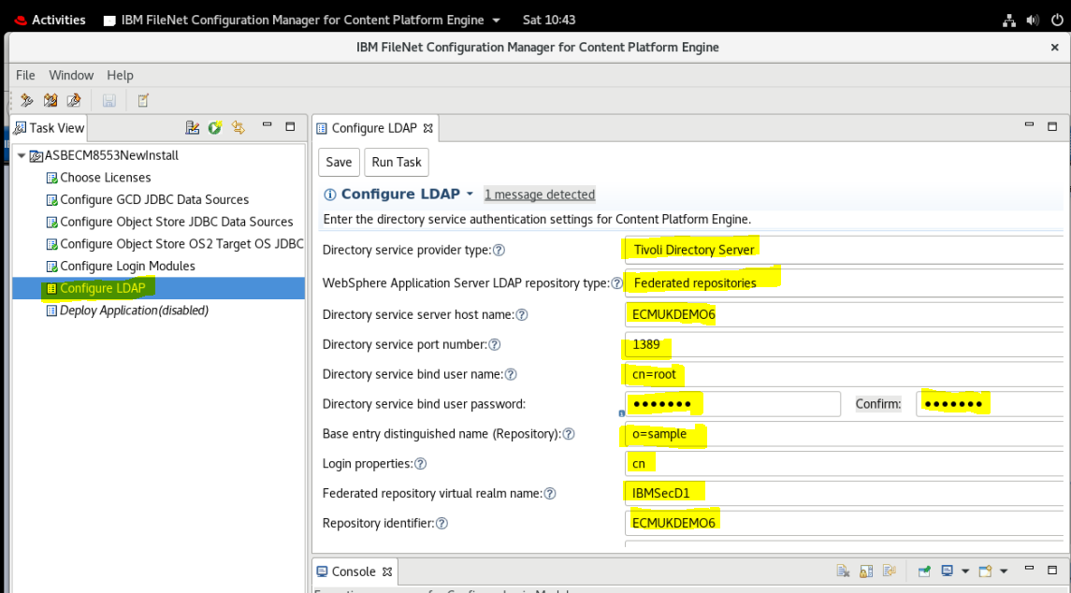

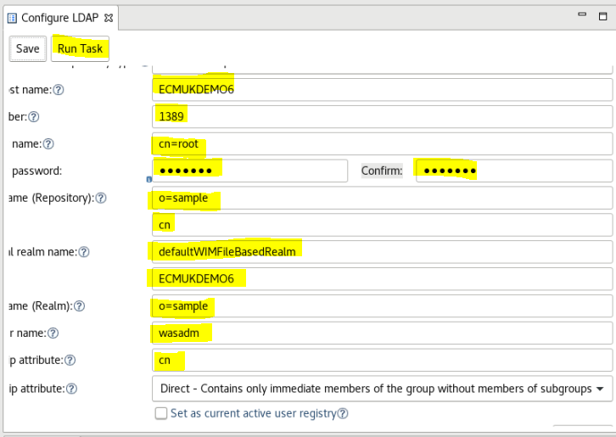

**Now changed to use 389!!!**

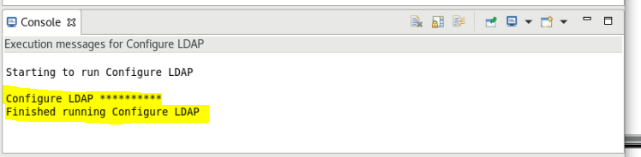

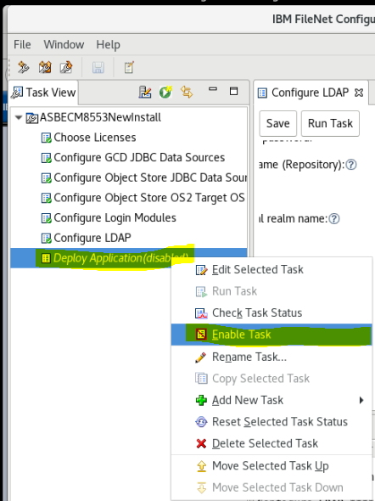

**Check Datasources connect OK**

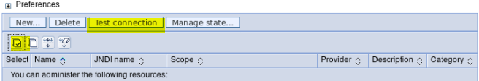

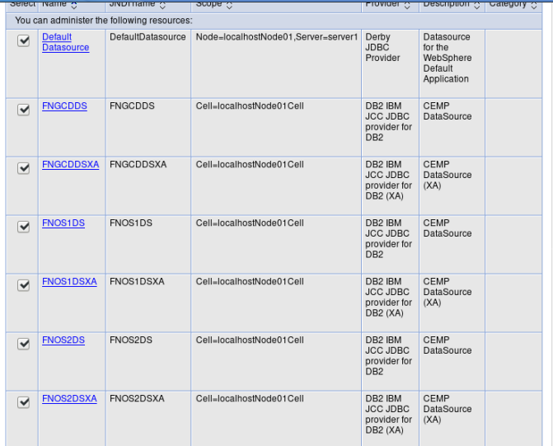

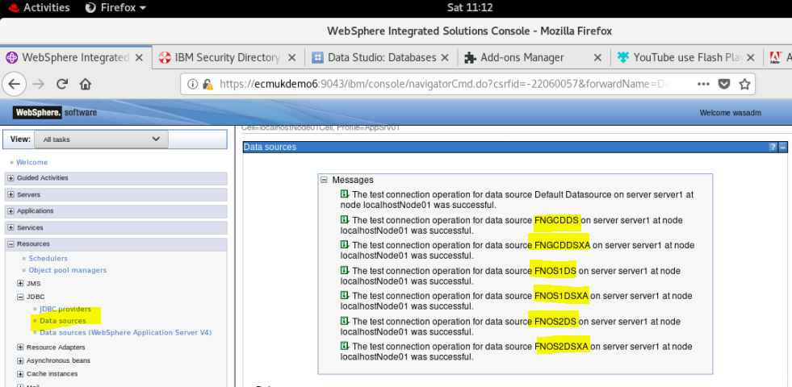

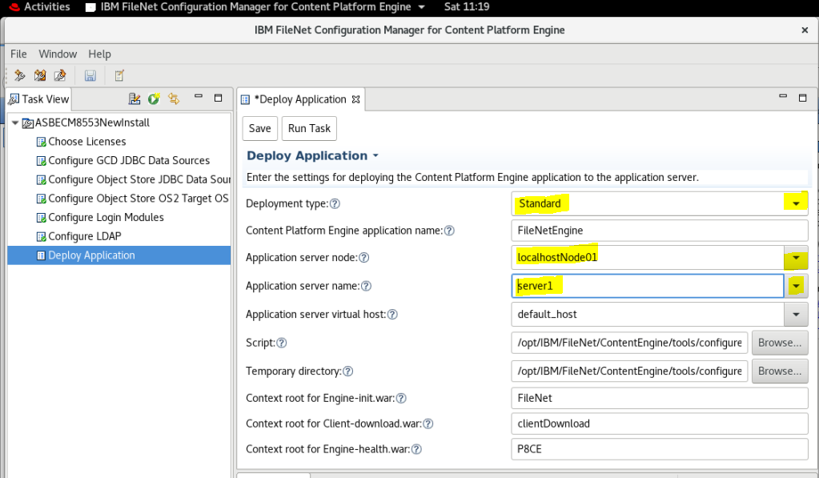

**Note : Although this is a Network Deployable WebSphere version; in a non-cluster environment (which I am installing to) we must use the Standard deployment type shown above.**

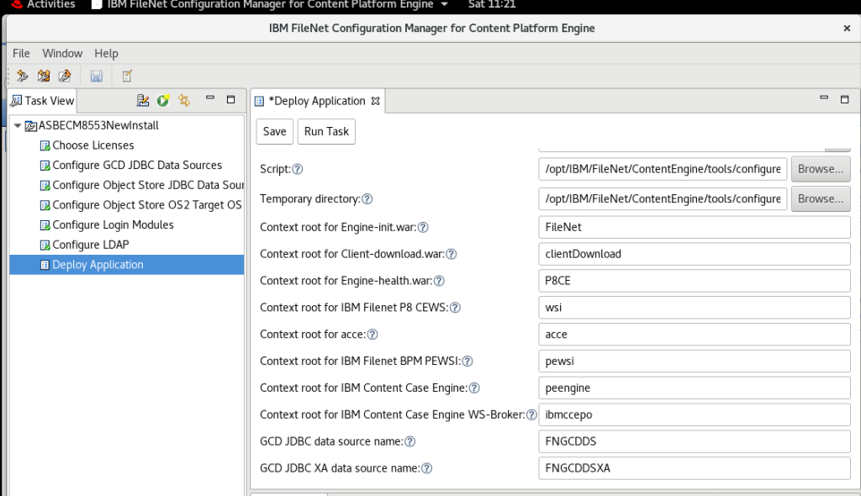

**Save and Run**

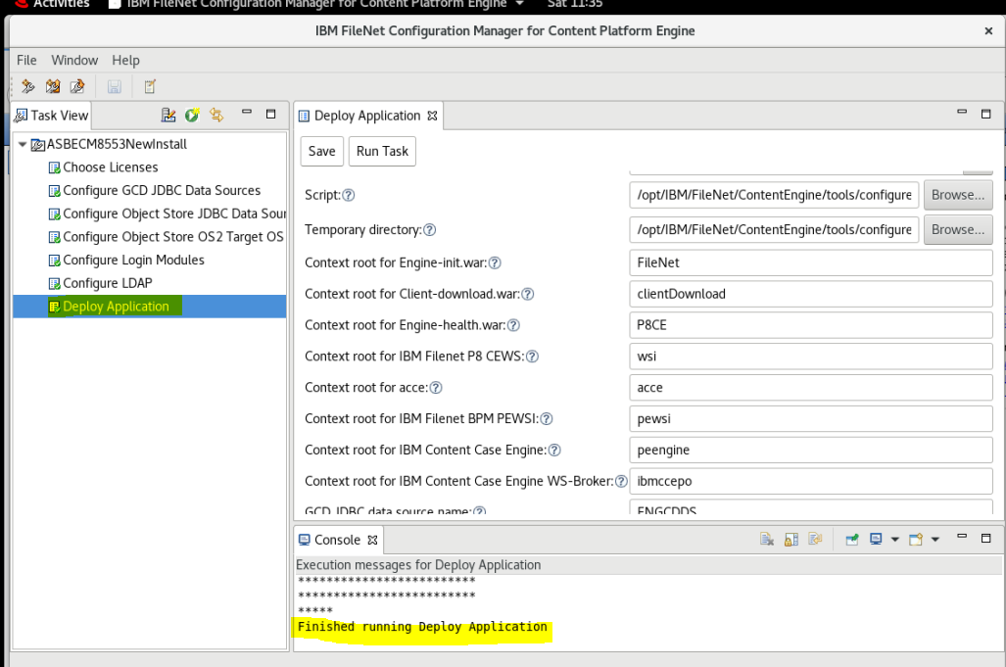

### Configure for Oracle GCD Database (example)

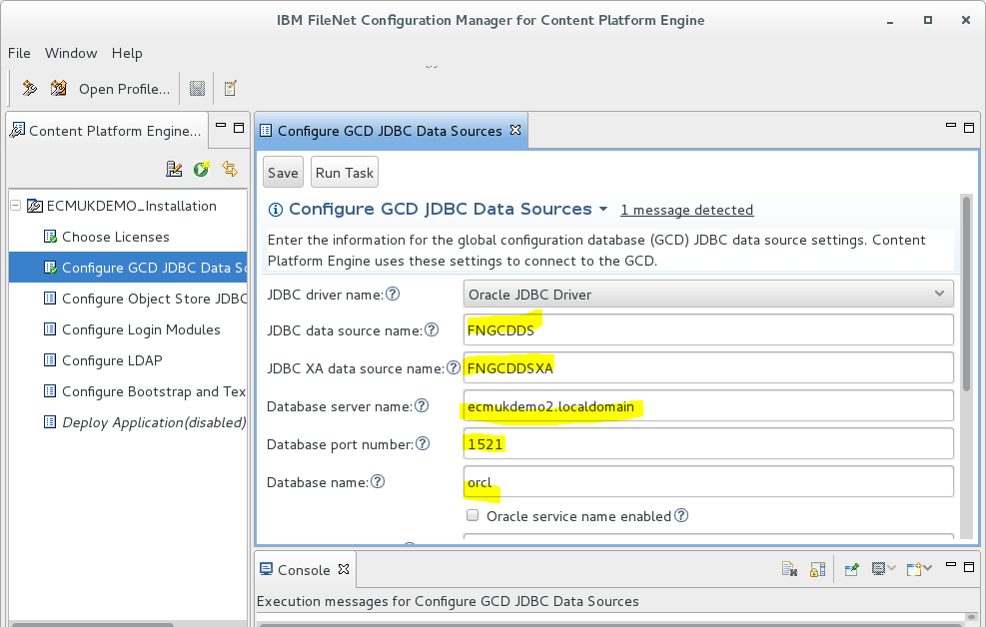

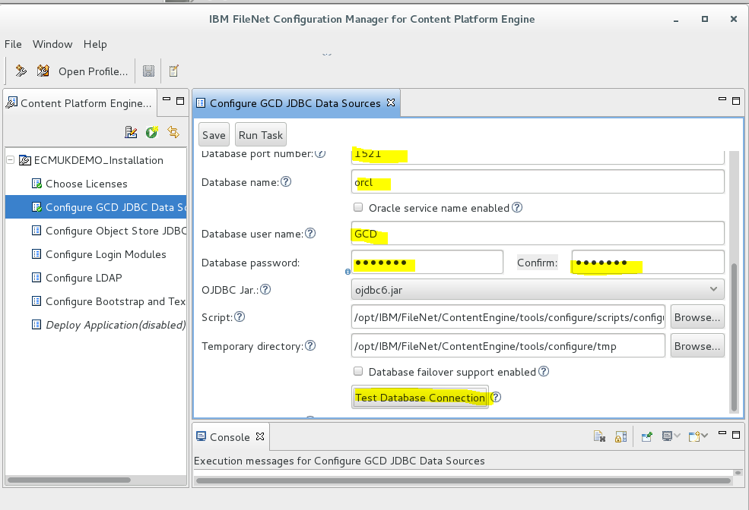

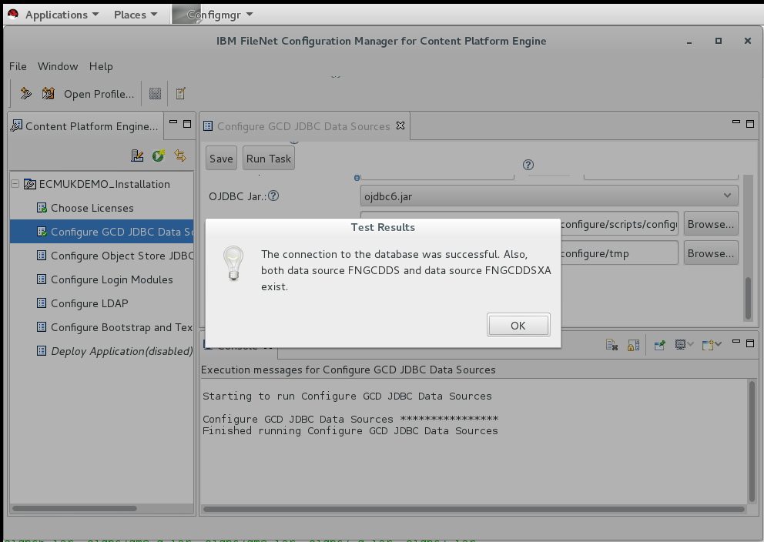

**NB lsnrctl used to set the listener.ora file config to use ECMUKDEMO6 rather than localhost on the CENTOS73 vmware where Oracle is installed.**

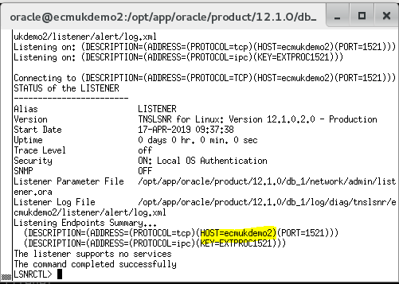

**NB Above is shown for the RHEL 7.3 , ecmukdemo2 server**

## Create and run the Oracle Object Store SQL script (Example)

=================================================================

OS1 U S E R

=================================================================

CREATE USER OS1 IDENTIFIED BY filenet;

GRANT SELECT on pending\_trans$ TO OS1;

GRANT SELECT on dba\_2pc\_pending TO OS1;

GRANT SELECT on dba\_pending\_transactions TO OS1;

GRANT SELECT on DUAL TO OS1;

GRANT SELECT on product\_component\_version TO OS1;

GRANT SELECT on USER\_INDEXES TO OS1;

GRANT EXECUTE ON SYS.DBMS\_SYSTEM TO OS1;

GRANT EXECUTE ON SYS.DBMS\_XA TO OS1;

ALTER USER OS1 QUOTA UNLIMITED ON USERS;

GRANT CREATE TYPE TO OS1;

GRANT CREATE VIEW TO OS1;

GRANT CREATE TABLE TO OS1;

GRANT CREATE CLUSTER TO OS1;

GRANT CREATE SESSION TO OS1;

GRANT CREATE TRIGGER TO OS1;

GRANT CREATE SEQUENCE TO OS1;

GRANT CREATE DIMENSION TO OS1;

GRANT CREATE INDEXTYPE TO OS1;

GRANT CREATE PROCEDURE TO OS1;

GRANT CREATE MATERIALIZED VIEW TO OS1;

alter user OS1 account unlock;

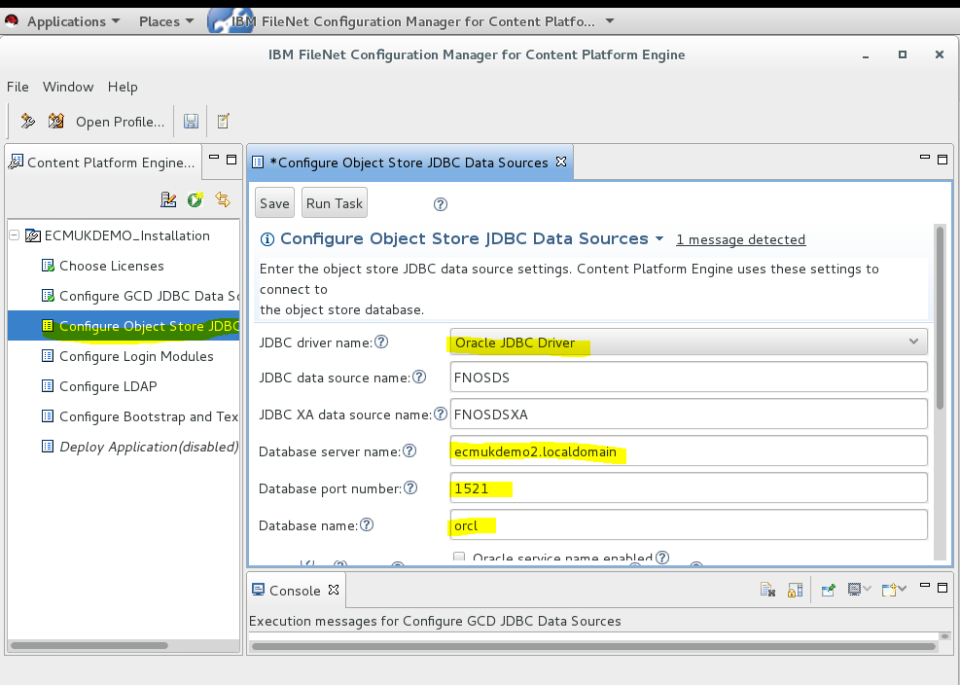

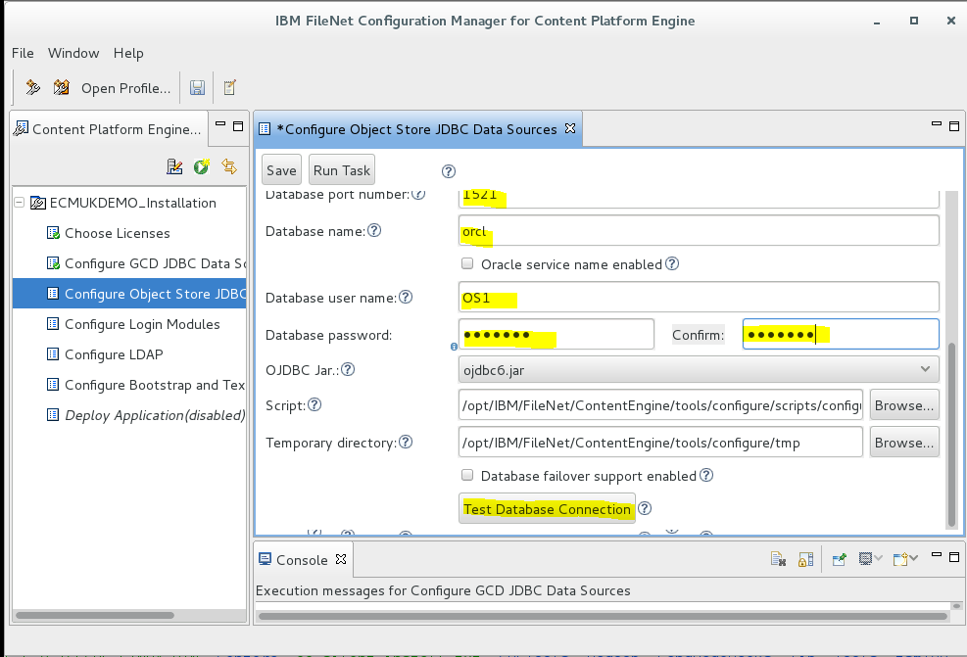

Test Database Connection

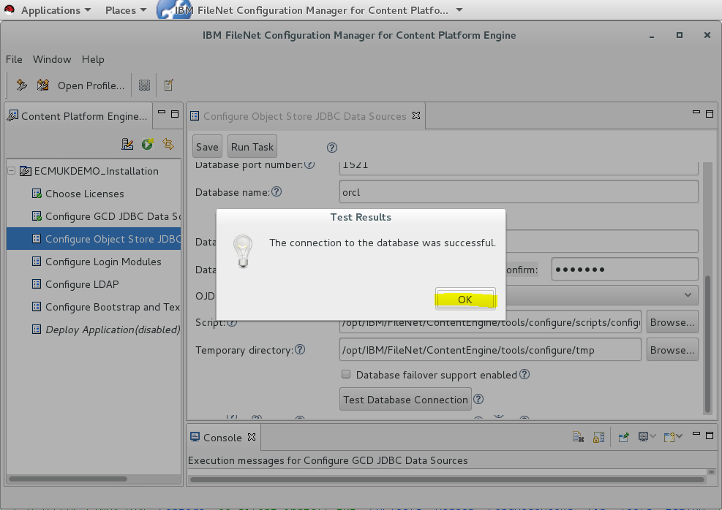

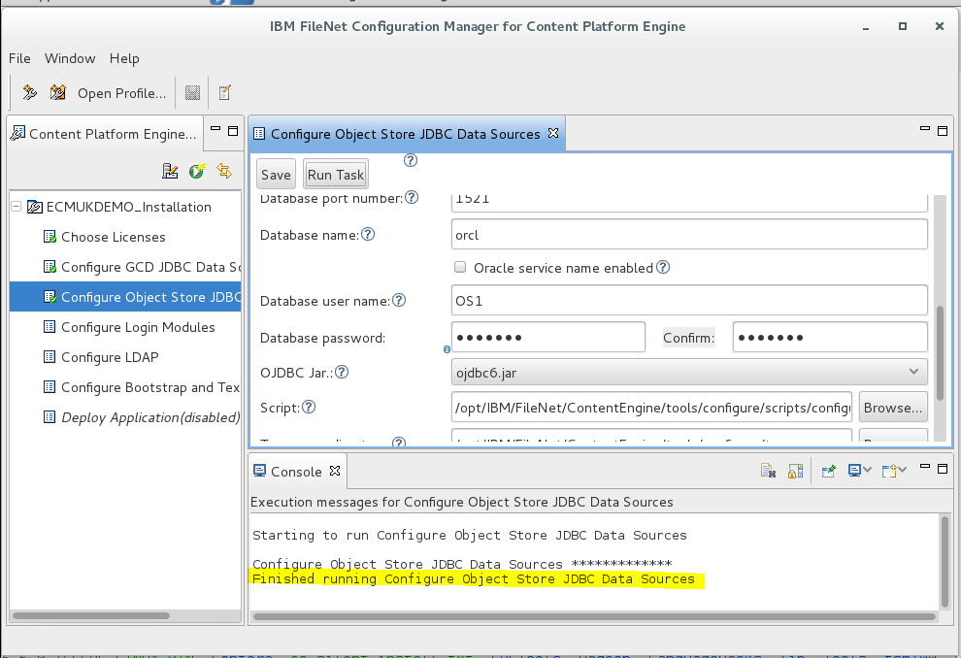

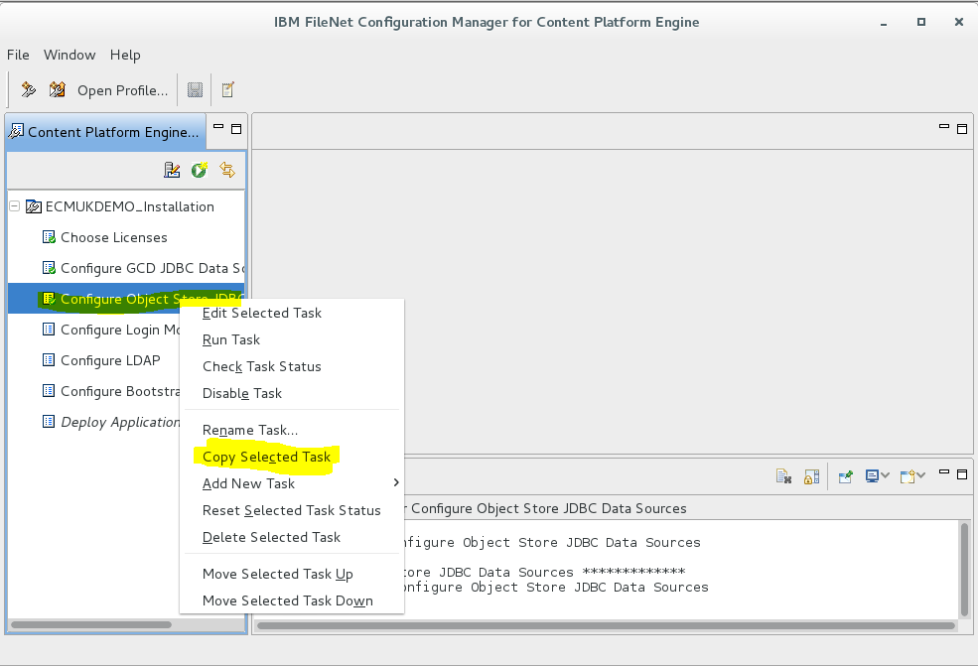

Right-mouse click and copy selected task

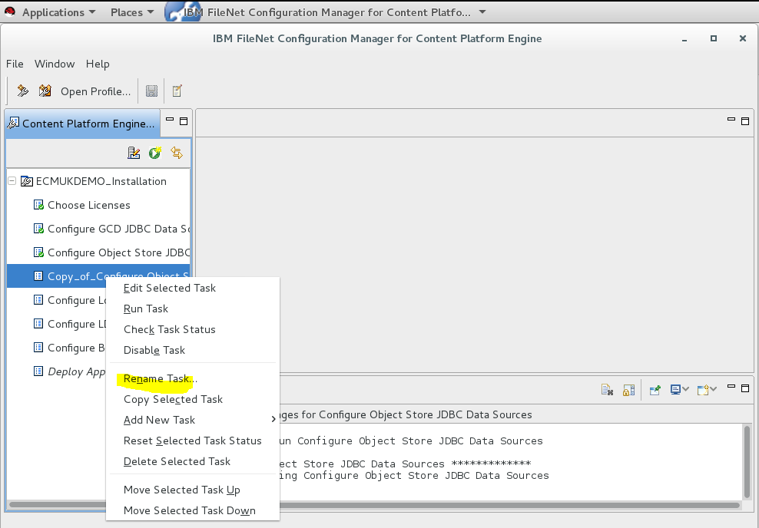

Right-mouse click and rename task

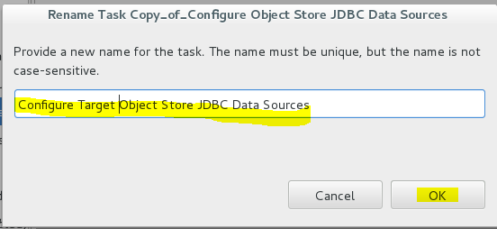

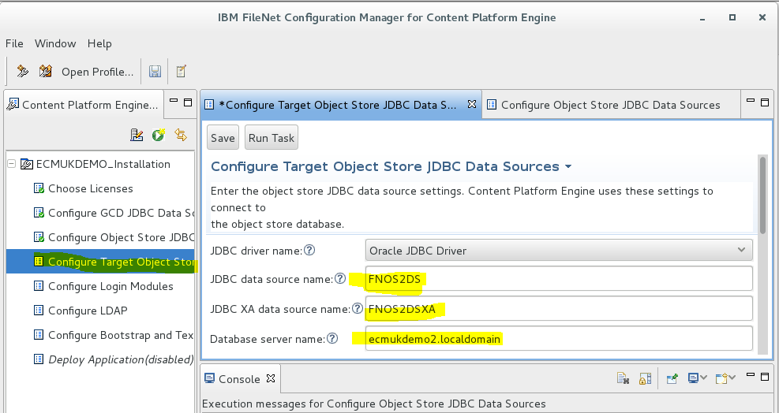

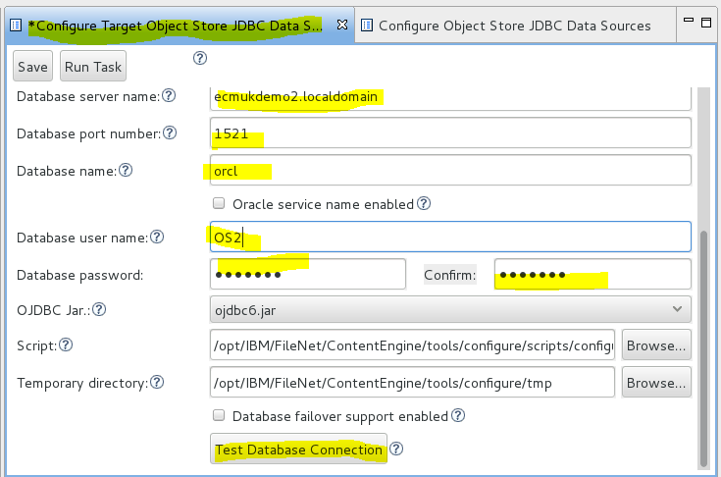

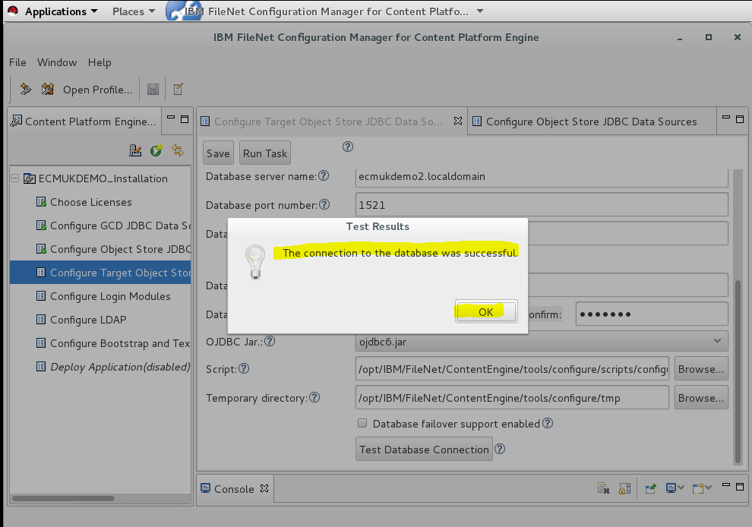

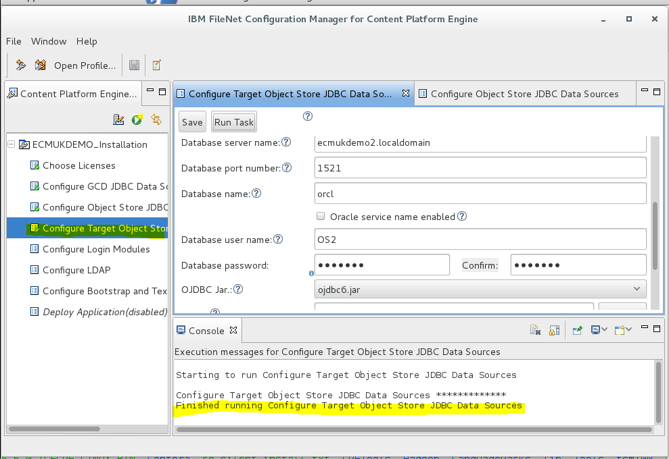

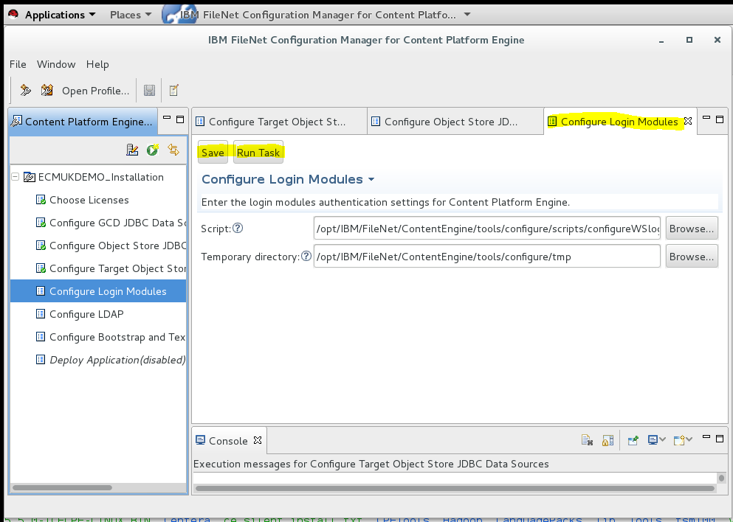

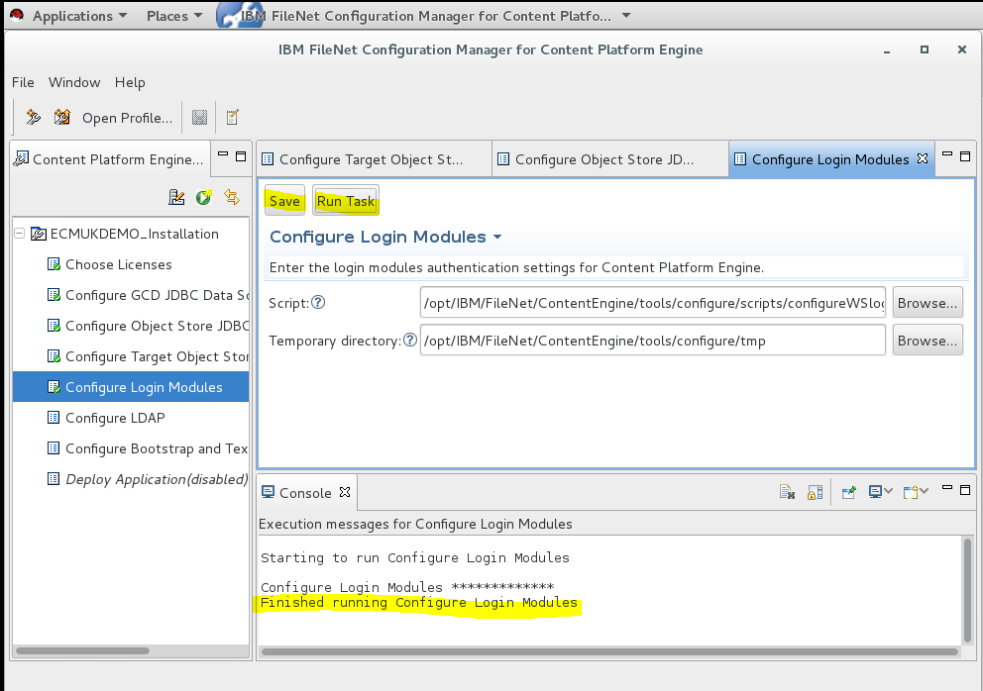

**NB Ensure Firewall has port 389 open for the LDAP port**

## Open LDAP and DB2 ports 389, 50000 connections:

firewall-cmd --zone=public --permanent --add-port=389/tcp

firewall-cmd --zone=public --permanent --add-port=50000/tcp

firewall-cmd --reload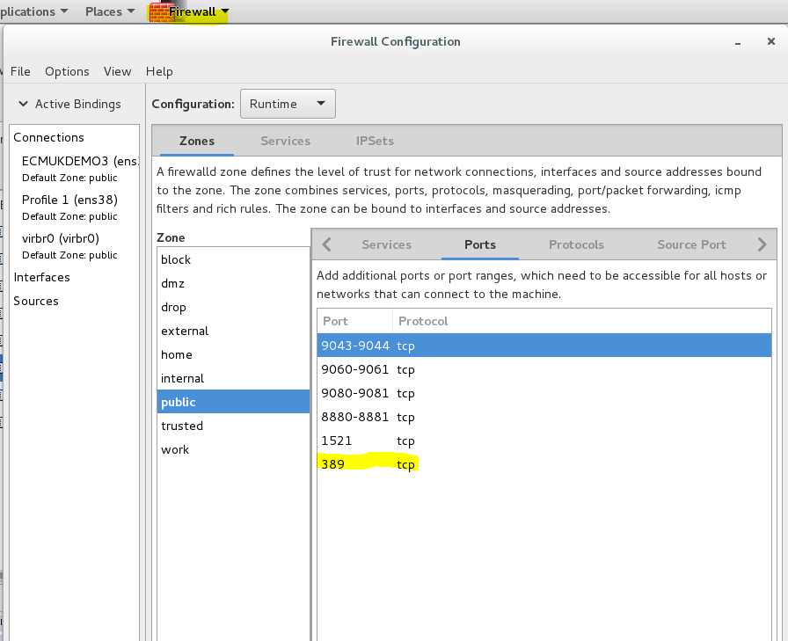

firewall-cmd --list-ports

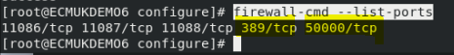

### Also added the iiop port, 2809

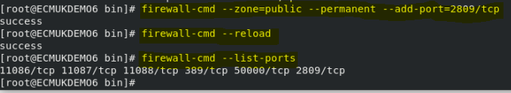

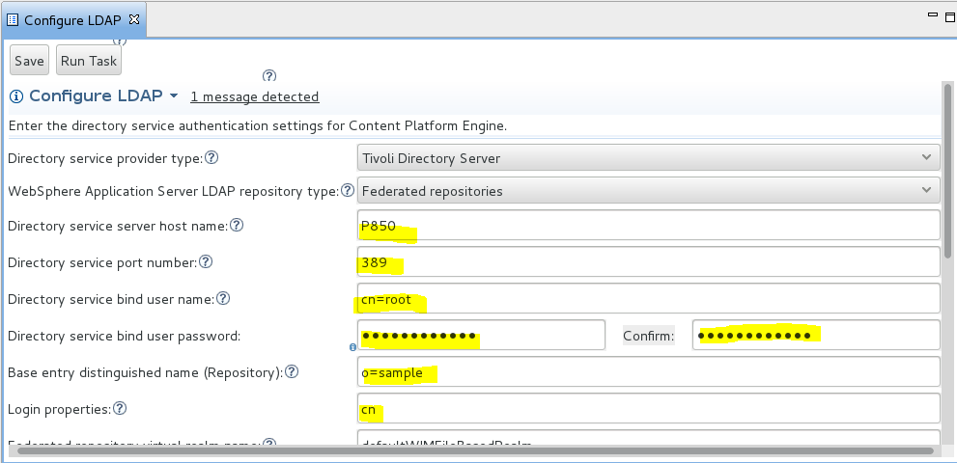

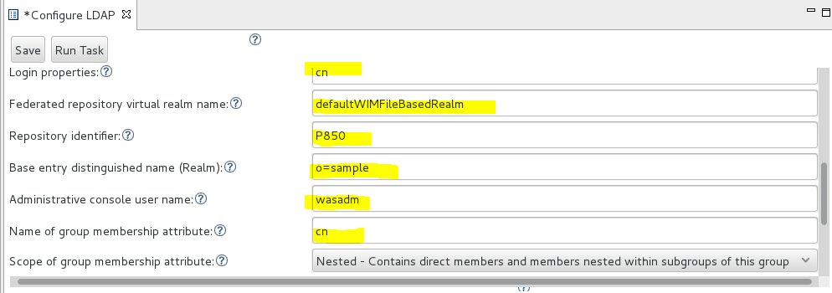

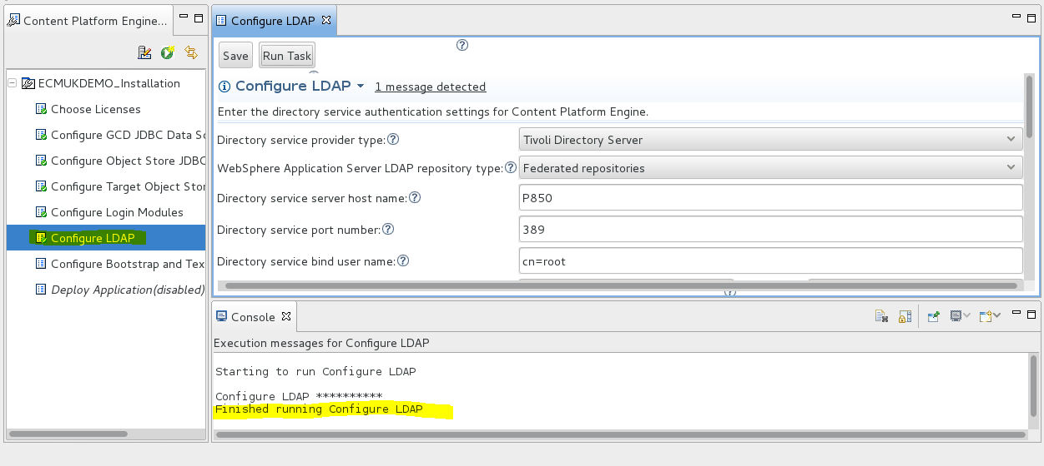

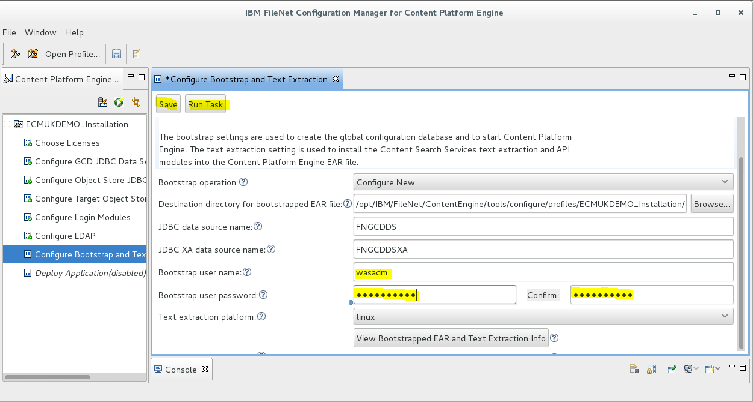

**NB Primary WAS administrator cannot be the Bootstrap user!!!**

**NB I had to modify the Bootstrap user to P8Admin as wasadm was originally used!**

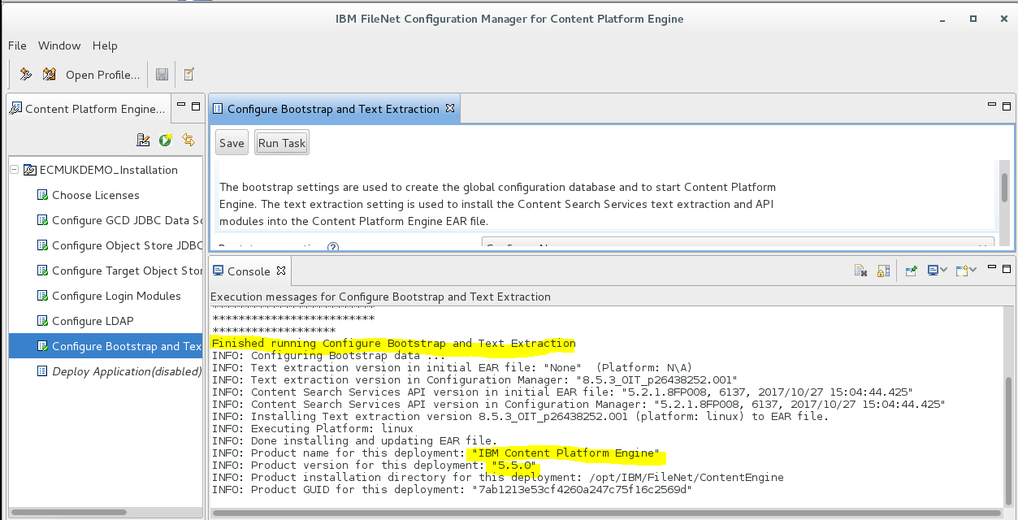

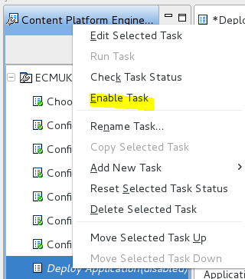

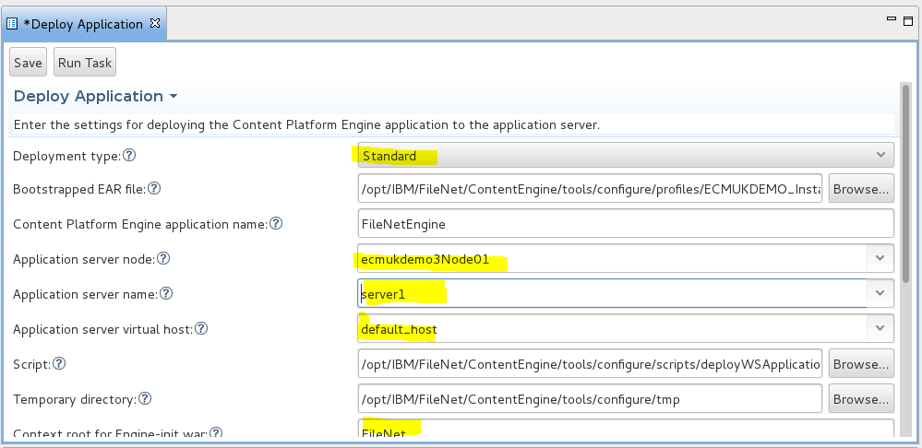

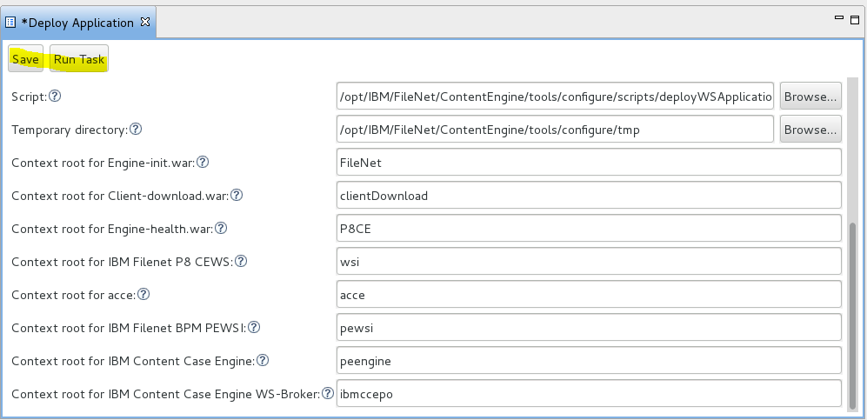

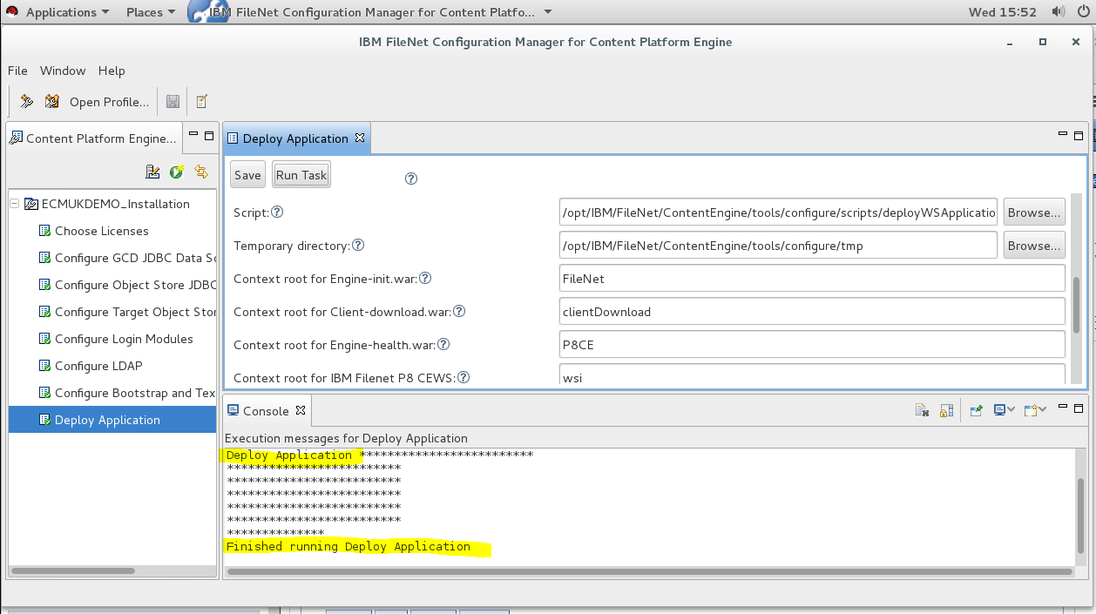

### Start the FileNet Engine application

* Check the Datasources are installed correctly

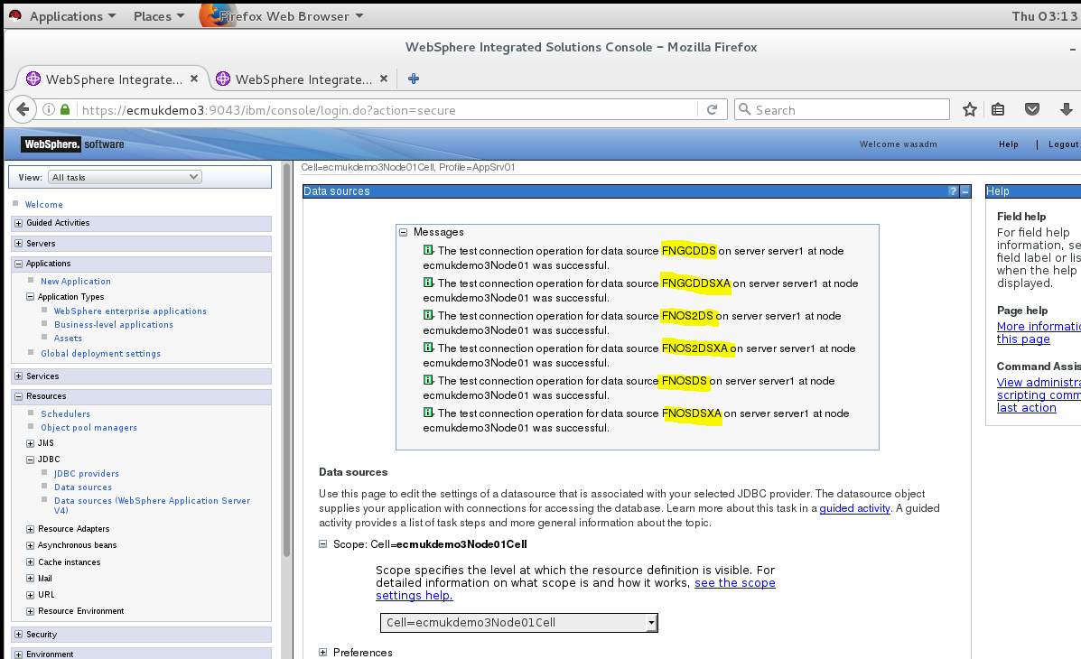

### DB2 on RHEL8 Configuration for LDAP using IBM Security Directory Services 6.4

* Start the FileNet application in WebSphere console
* NB I had to restart WebSphere after removing the local WIM based security in the Federated LDAP to get the authentication running against Tivoli Directory Services which we set up earlier.

First Test LDAP from IBM Security Directory Service running on ECMUKDEMO6

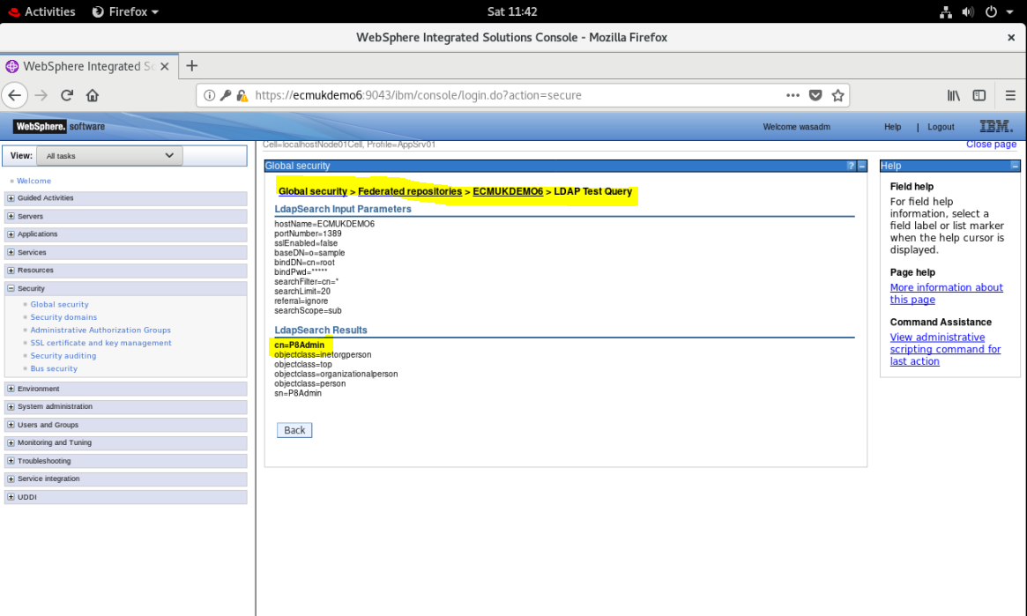

Add the following additional Users and Groups used with IBM Content Foundation 5.5.3 and IBM Case Manager 5.3.3 using the LDAP Directory Service administration console

REF NB I am using a very small sub-set of the recommended users, see the full list in the URLs:

<https://www.ibm.com/support/knowledgecenter/SSNW2F_5.5.0/com.ibm.p8.security.doc/p8psu074.htm>

<https://www.ibm.com/support/knowledgecenter/SSNW2F_5.5.0/com.ibm.p8.security.doc/p8psu002.htm>

<https://www.ibm.com/support/knowledgecenter/SSNW2F_5.5.0/com.ibm.p8.security.doc/p8psu031.htm>

|  |  |  |  |
| --- | --- | --- | --- |
| Group Name | User Name | Password | Description |
| P8Admins  *workflow\_system\_admin Group*  (*cpe\_system\_user Group)* | P8Admin | IBMFileNetP8 | Bootstrap User  *gcd\_admin\_user* |
|  | Alan | filenet | P8 Administrator  (Workflow System Admin)  *cpe\_system\_user* |
|  | wasadm | filenet |  |
| GeneralUsers |  |  |  |
|  | sue | sue |  |
|  | mark | mark |  |
|  | joe | joe |  |
|  | ana | ana |  |
|  |  |  |  |
|  |  |  |  |

Add the P8Admins group

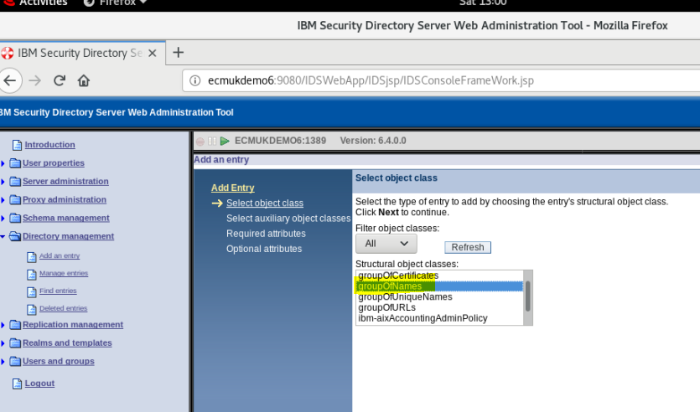

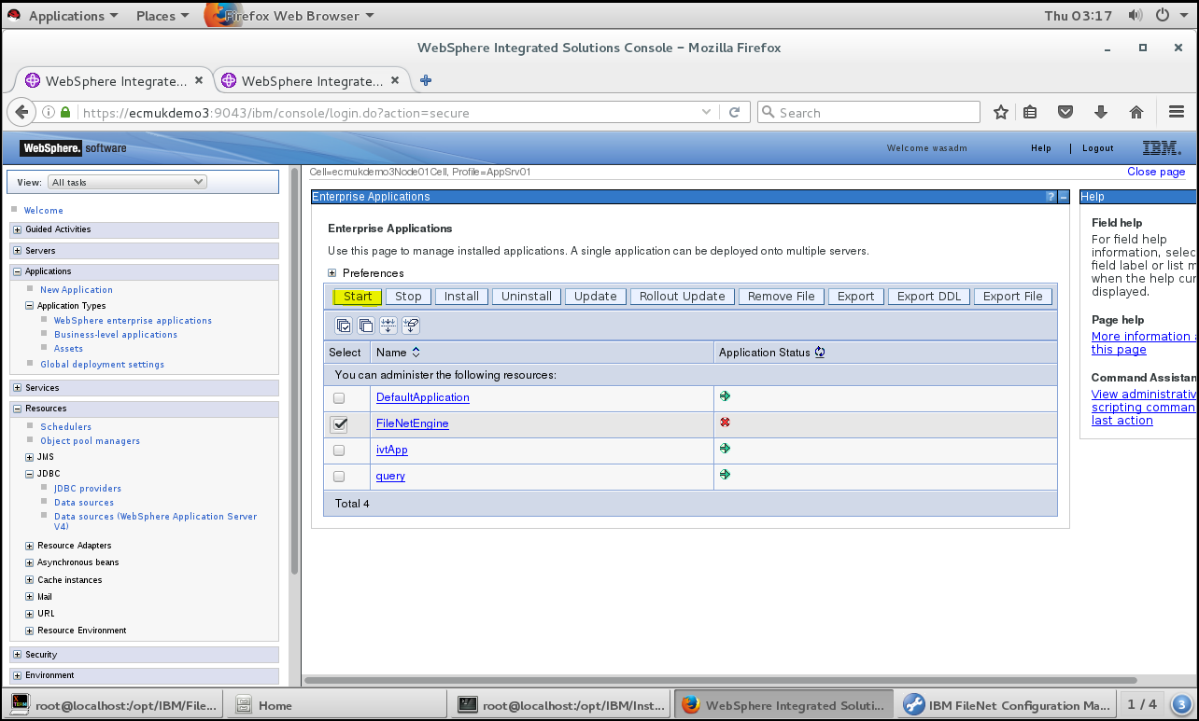

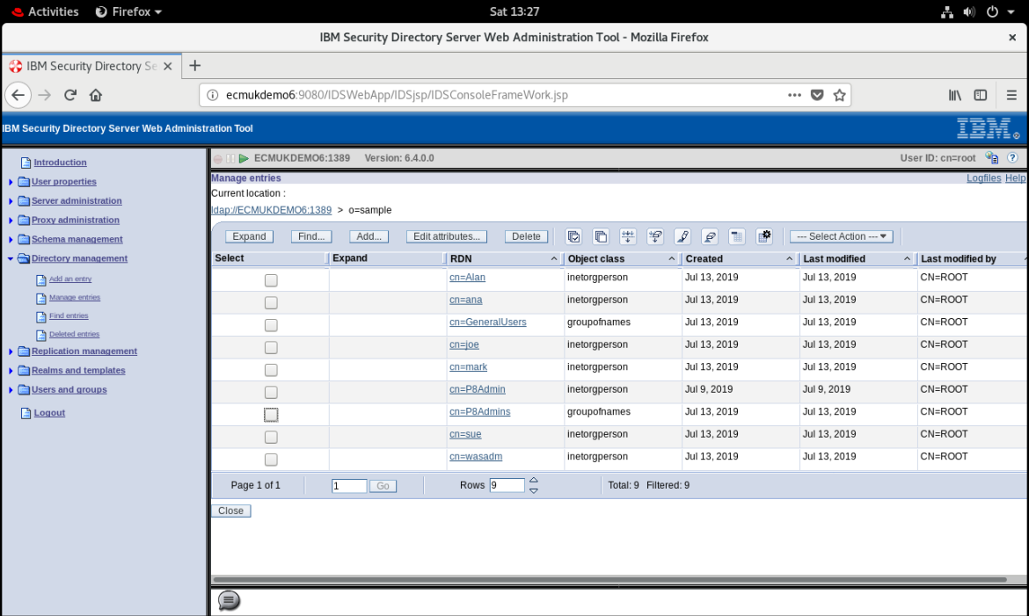

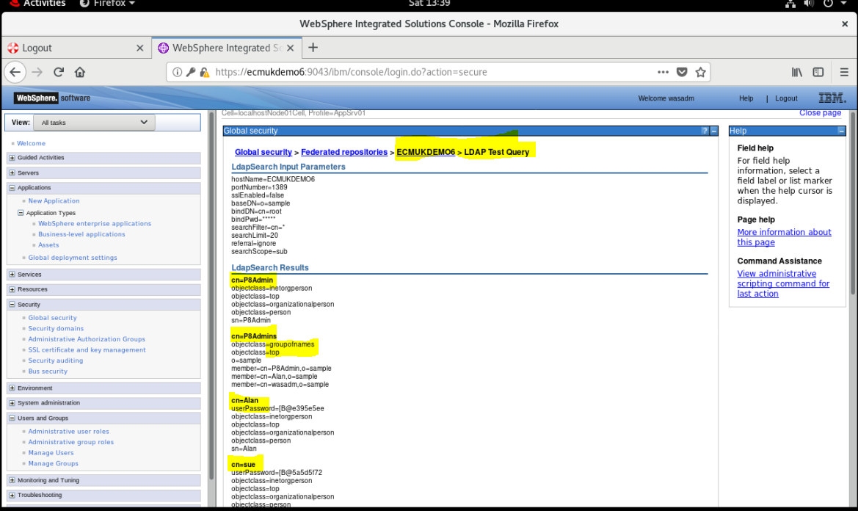

**Add P8Admin as a WebSphere Administrator**

**(Important: leave wasadm as the primary administrator)**

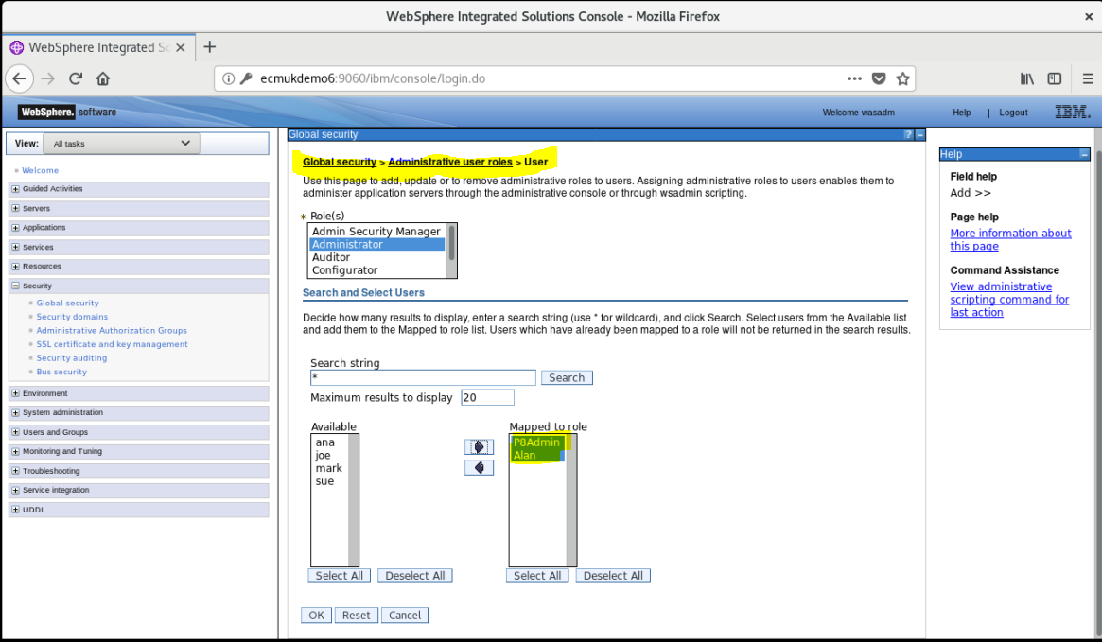

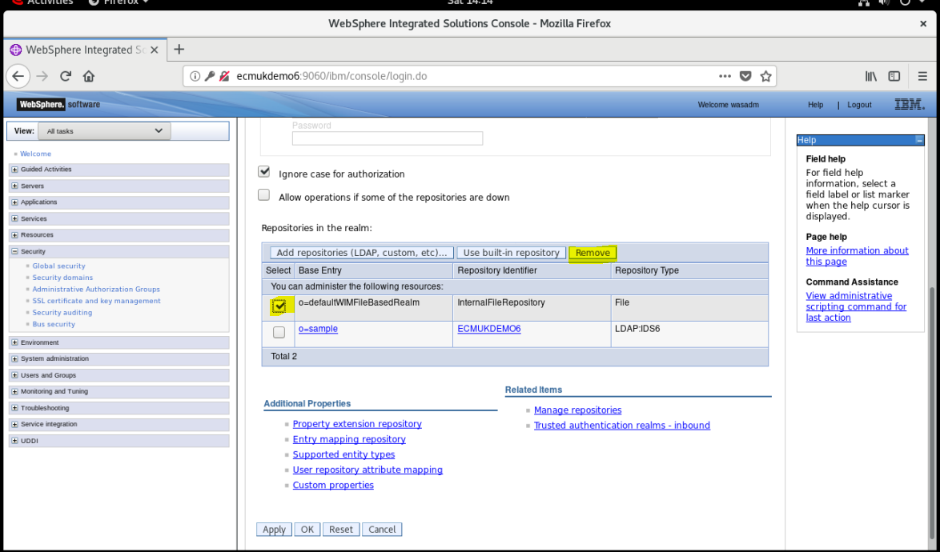

Remove the InternalFileRepository

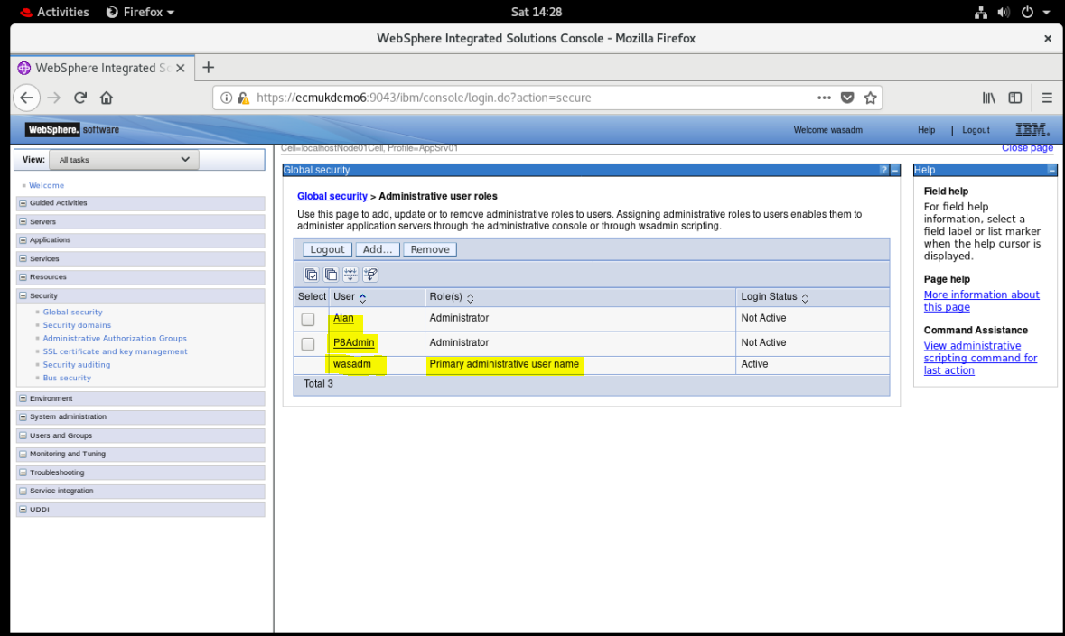

**NB It is quite likely that you will have to edit the security.xml file to temporarily disable the log-in security, remove the WebSphere application server process using kill -9 and add additional Administrators as part of the removal of the File based repository from the Federation.**

**See Appendix :**Appendix N - Disabling WebSphere 8.5.5.15 security for LDAP config

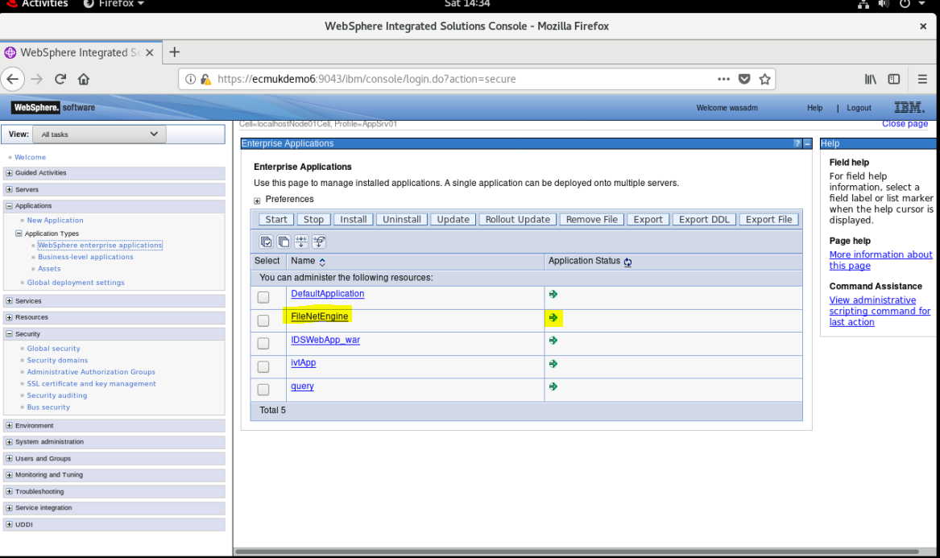

Run the acce tool to set up the P8 Domain and the Object Stores

Log in as the system administrator user (Alan/*password* in our installation)

**NB Primary WAS administrator cannot be the Bootstrap user**

**NB I had to modify the Bootstrap user to P8Admin as wasadm was originally used!**

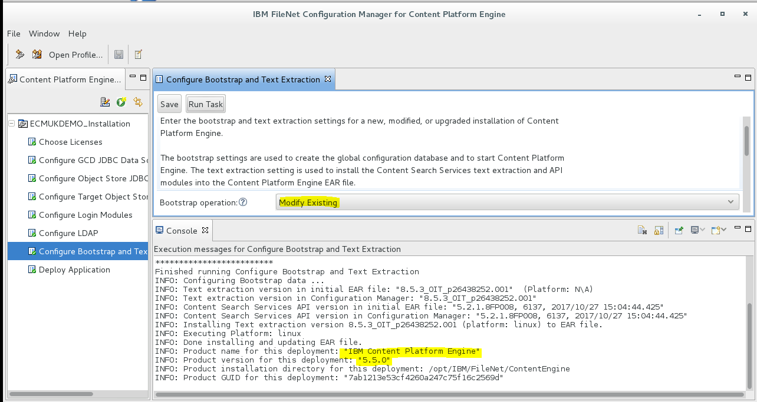

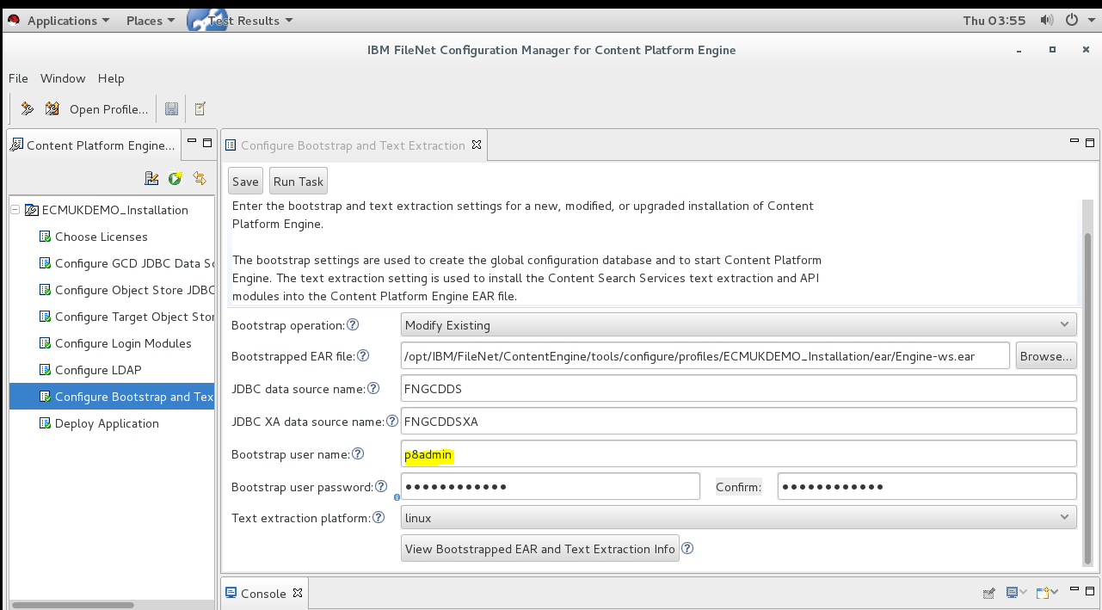

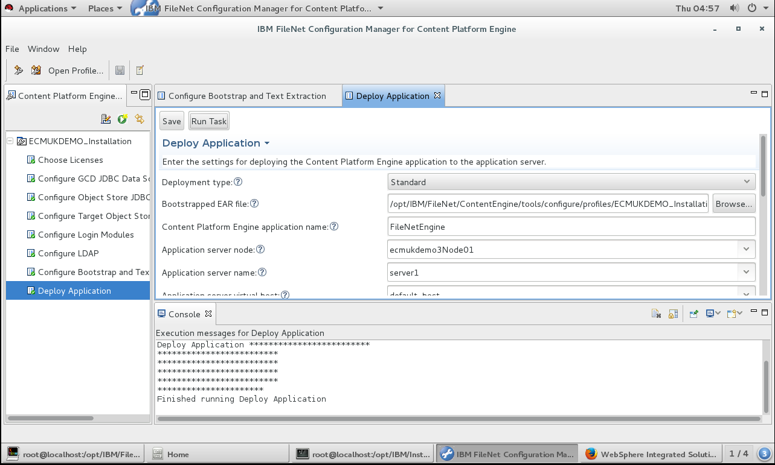

**NB Now logging in as Alan/*password* (a WebSphere Administrator, but not the primary Administrator!)**

**NB First attempt failed as I had not used the correct Group Id attribute**

The server was not able to access the LDAP provider while attempting the operation Domain[P8ECMRHEL8].getSecurityToken for the security principal Alan. The cause of the error is: cn: [LDAP: error code 34 - Invalid DN Syntax] Message was: cn: [LDAP: error code 34 - Invalid DN Syntax]

<https://www-01.ibm.com/support/docview.wss?uid=swg1PH09574>

<https://www-01.ibm.com/support/docview.wss?uid=swg27009661>

**I fixed this by dropping and recreating the GCD database**

See Recreate the GCD

This shows the step by step DB2 commands to clear and rebuild the DB2 GCD database

(And screens below show using the correct Group reference in the P8 Domain creation in the acce tool!)

Enter the P8 Domain name

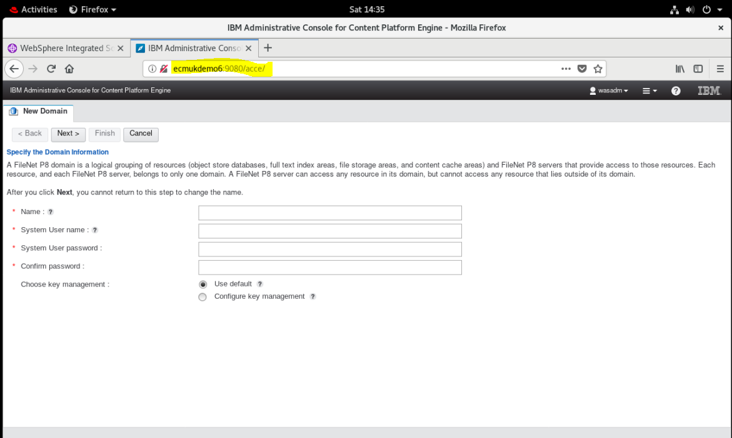

I used P8ECMRHEL8

System User name : Alan

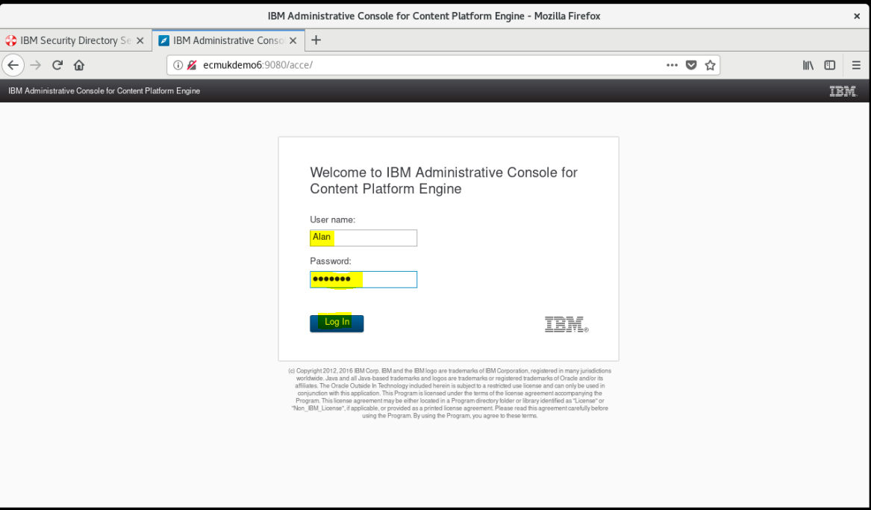

Click Next

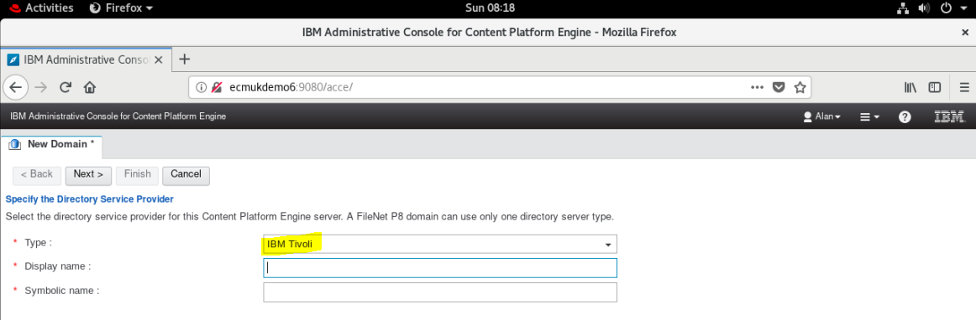

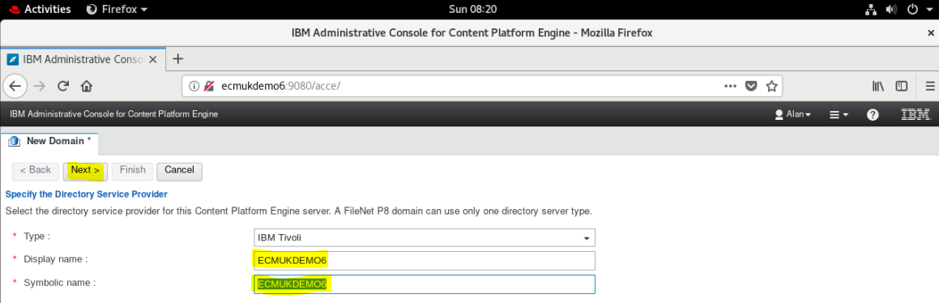

Enter the Tivoli Directory Server (or whatever is in your Federated LDAP)

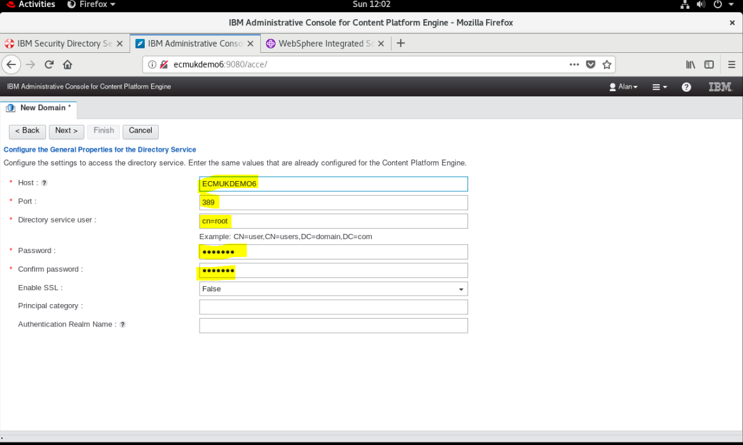

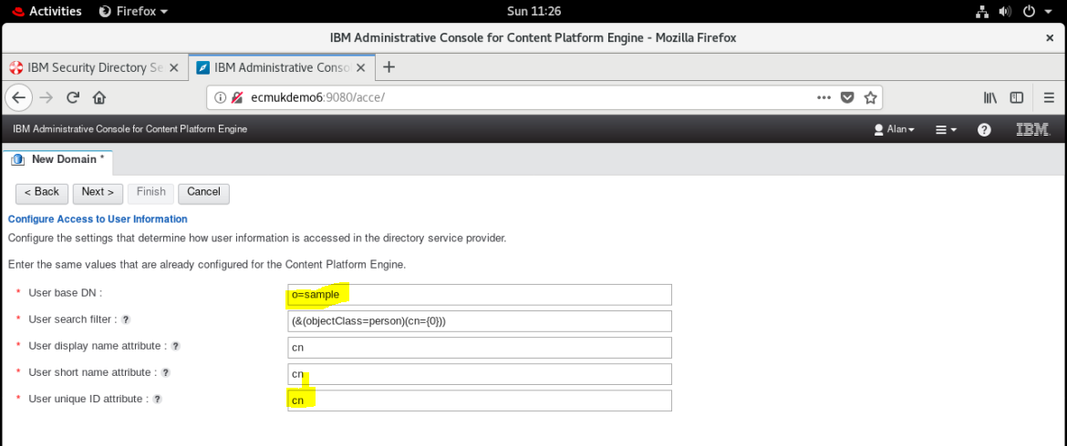

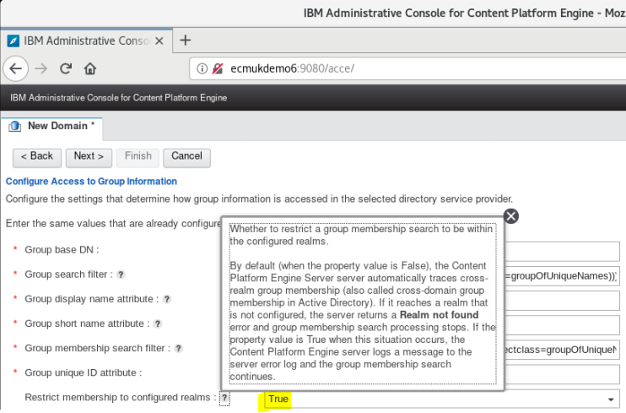

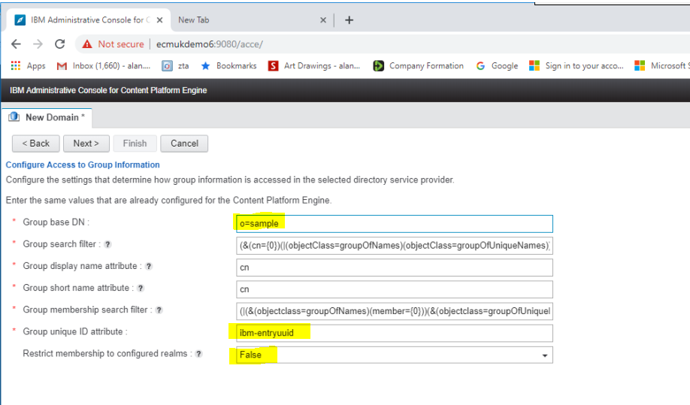

Above is Group unique ID attribute set as **ibm-entryuuid** leave this default as shown above

**(as I tried cn first, and this is incorrect, and then requires you to delete and recreate the GCD!)**

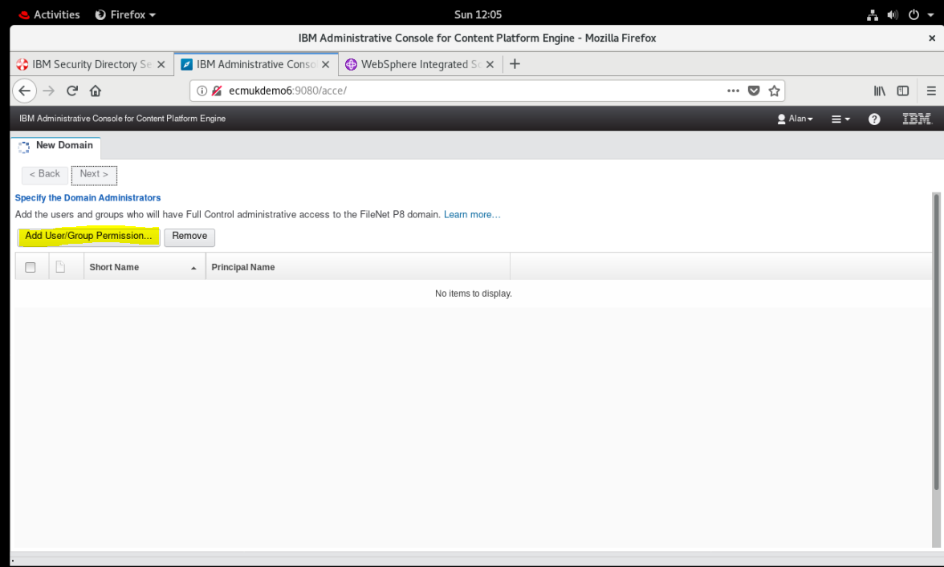

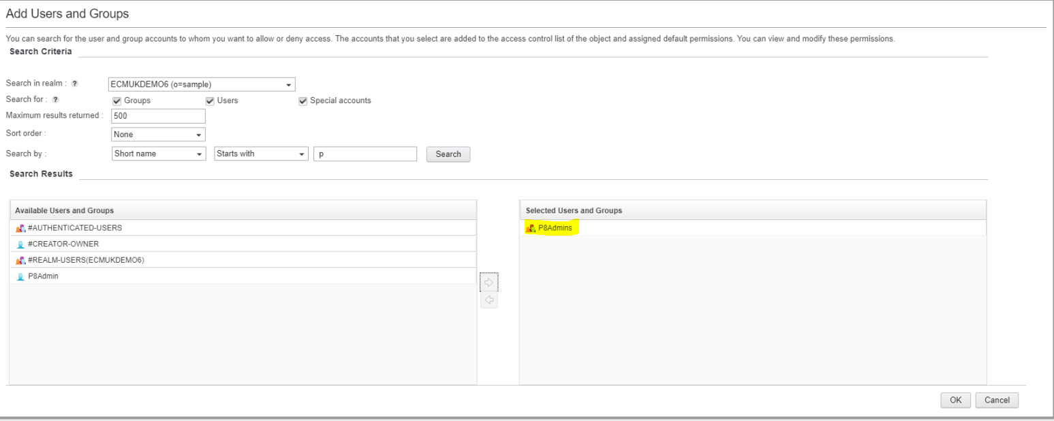

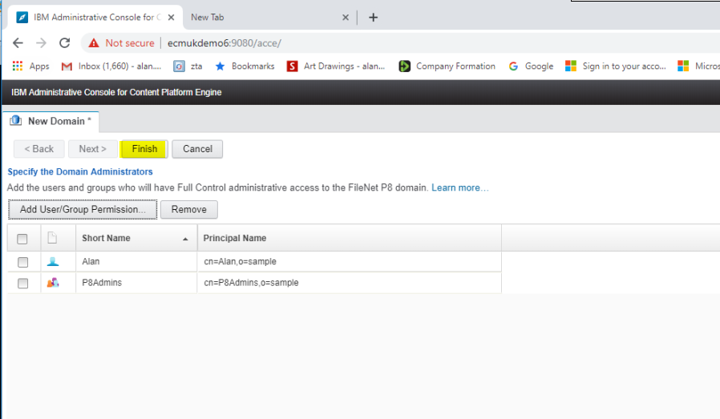

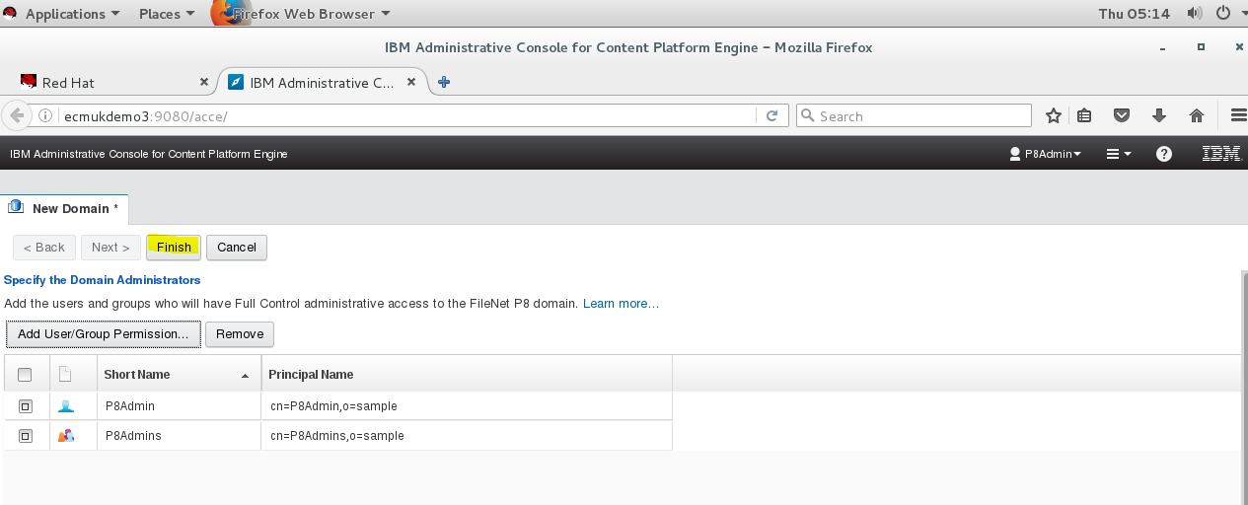

Click Finish

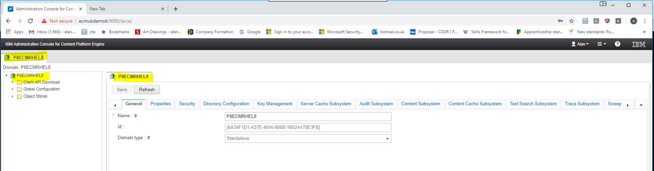

The P8ECMRHEL8 Domain is now created!

Add the two Object Stores (from the Data sources created earlier)

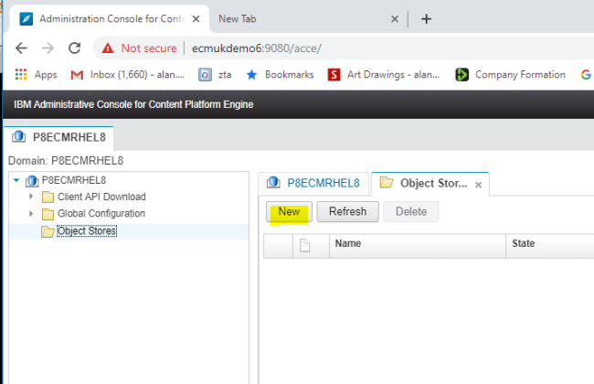

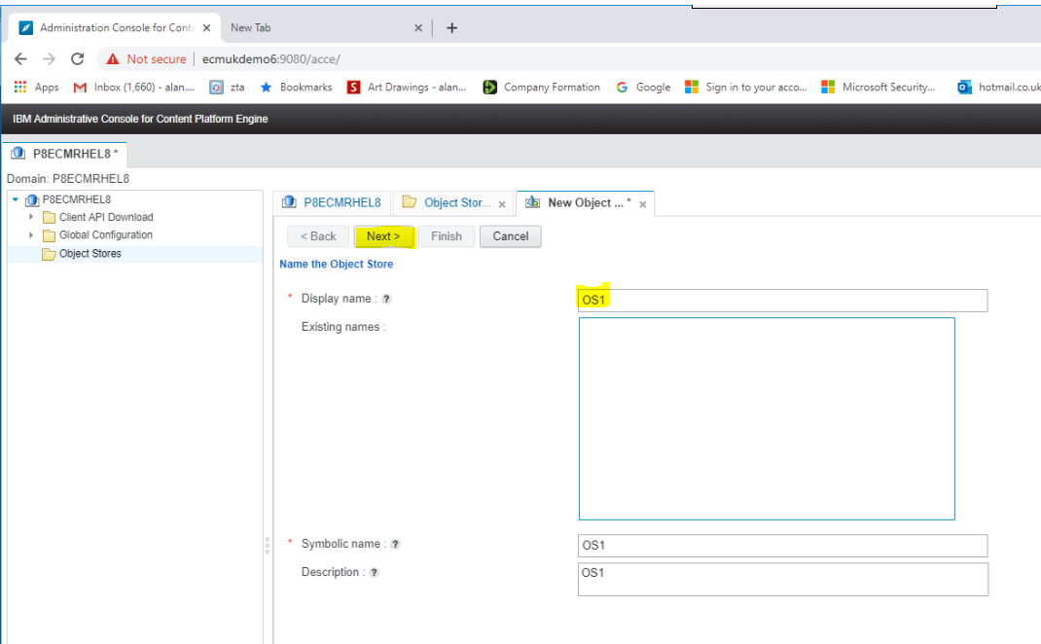

### Section For DB2



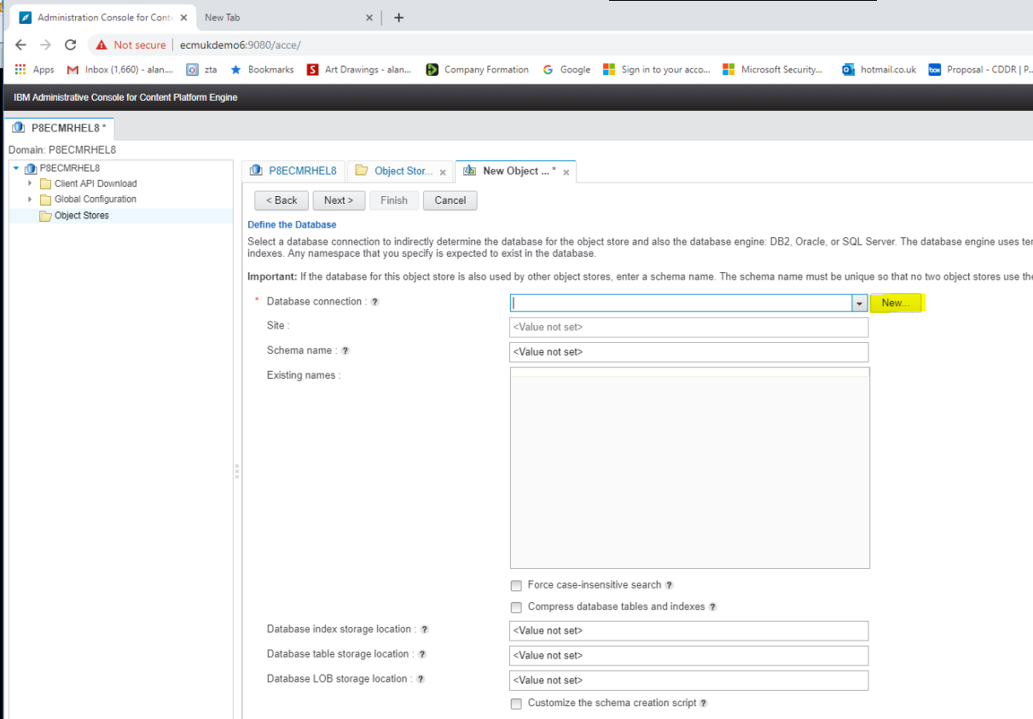

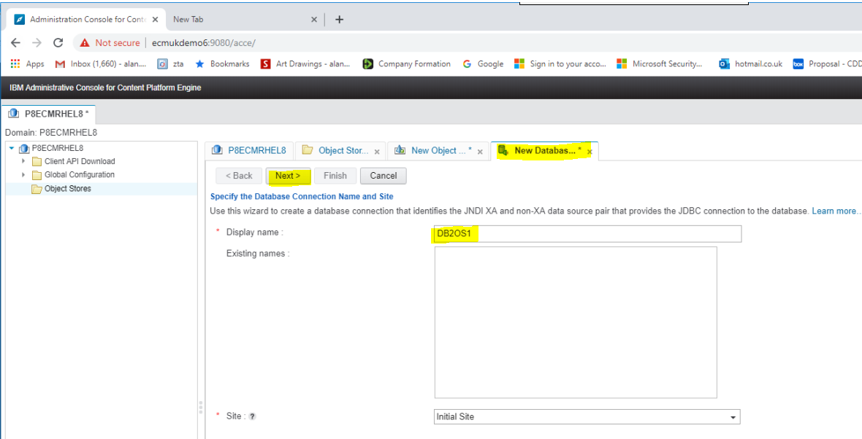

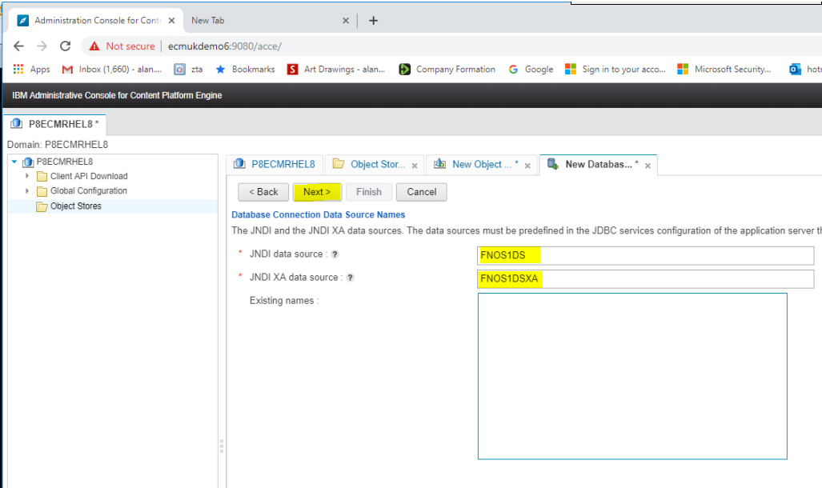

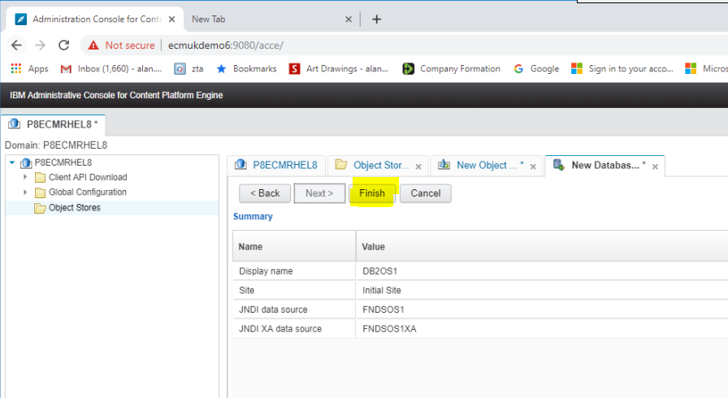

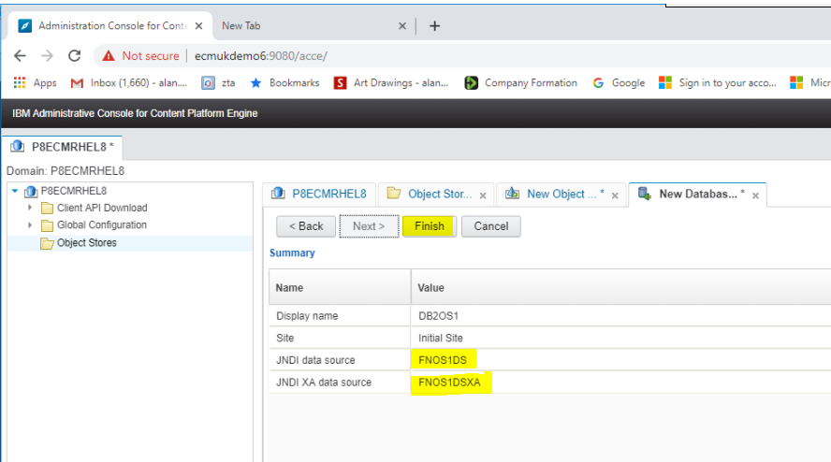

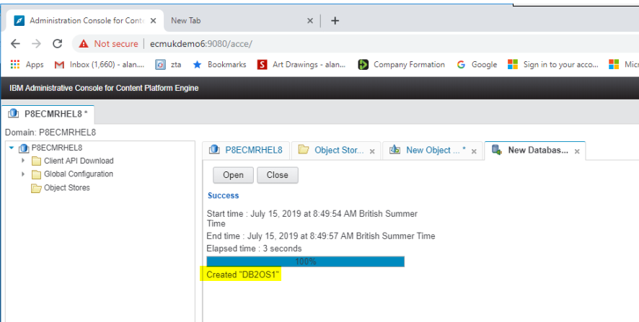

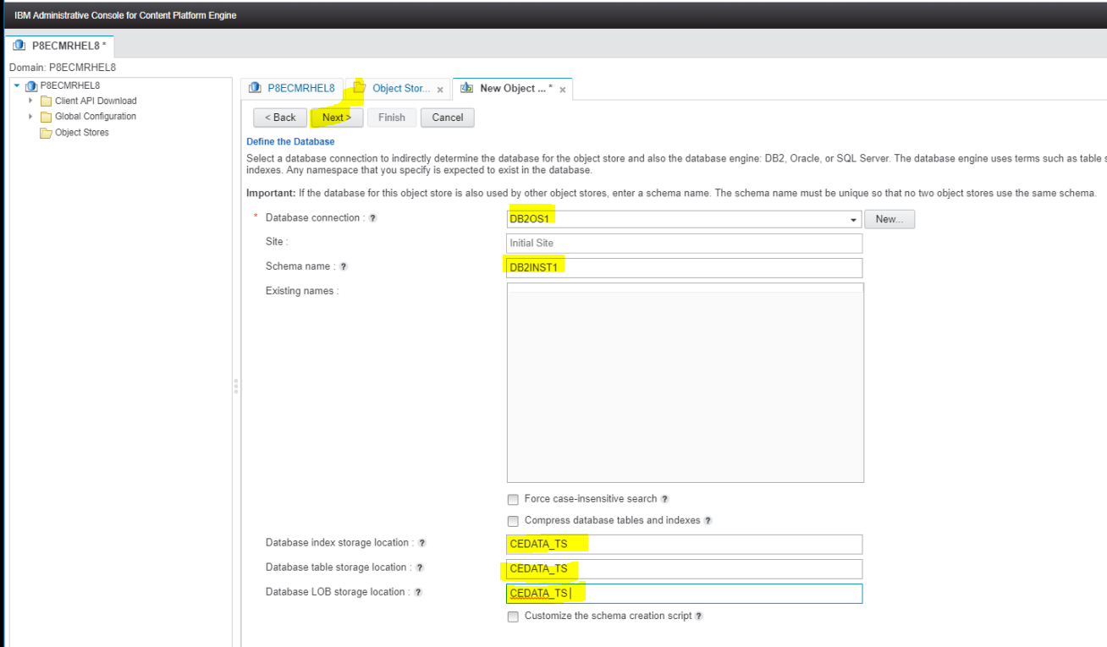

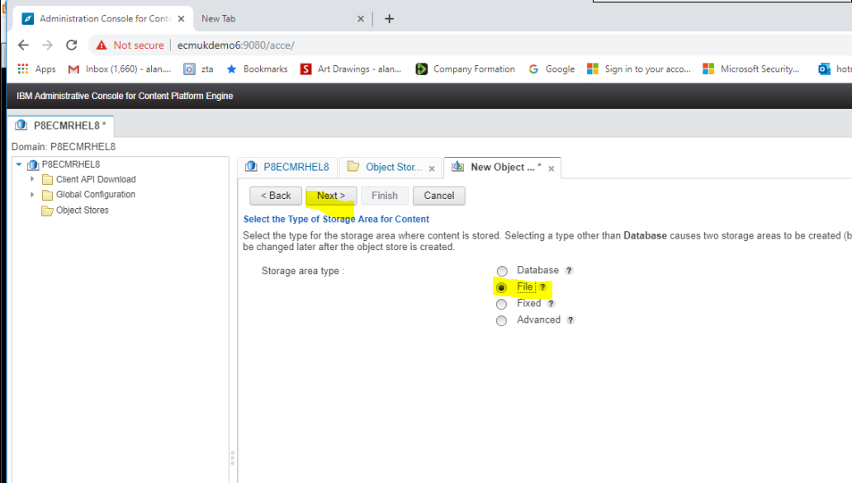

Make the storage directory using the root user

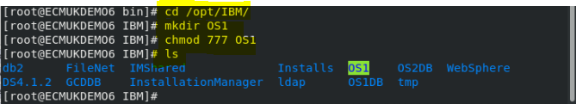

**NB Security can be adjusted later as I gave full permissions on this.**

**Don’t use this for a Production System!!**

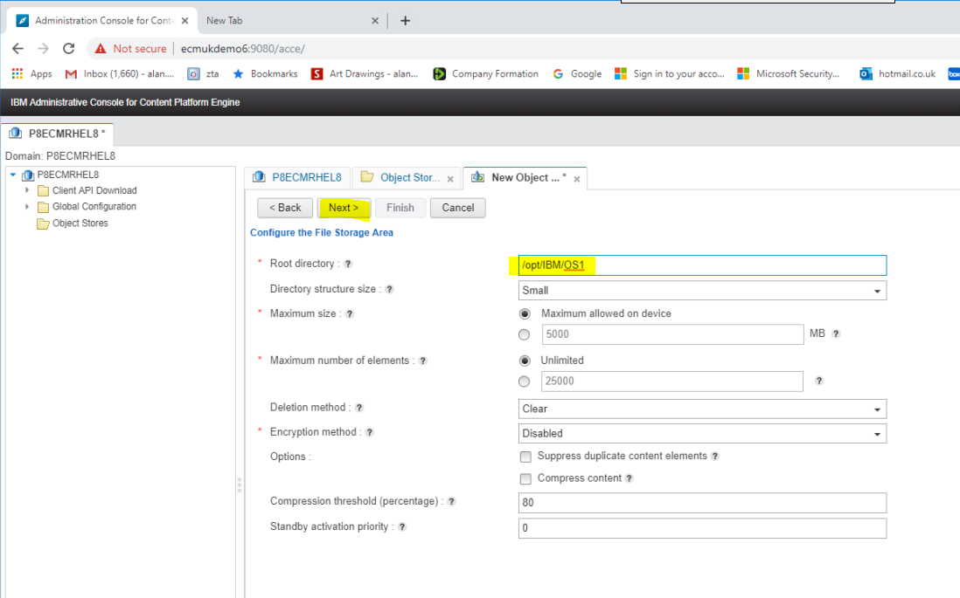

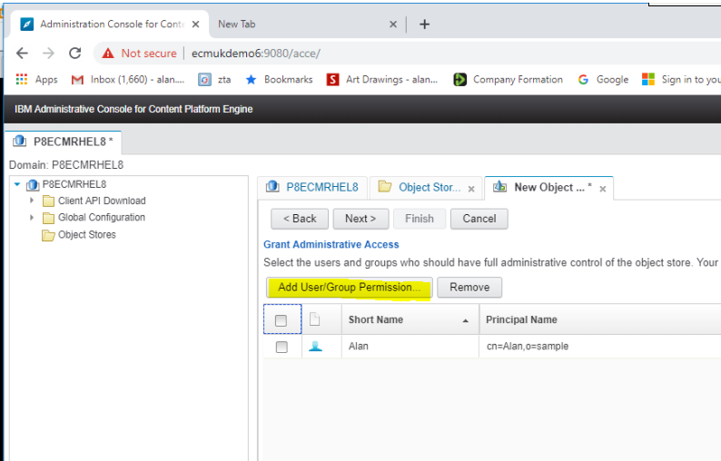

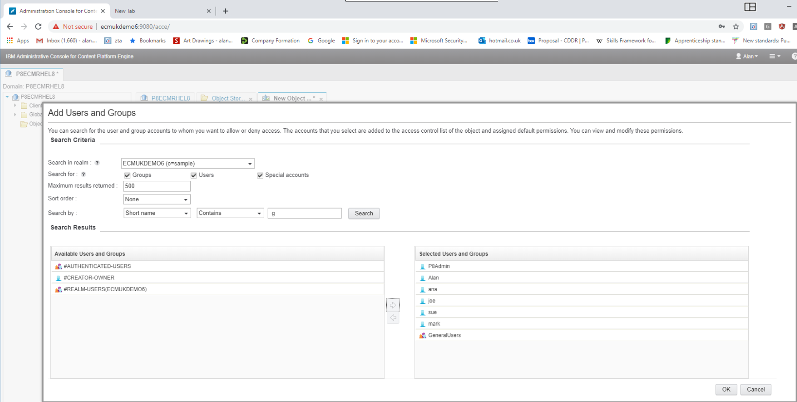

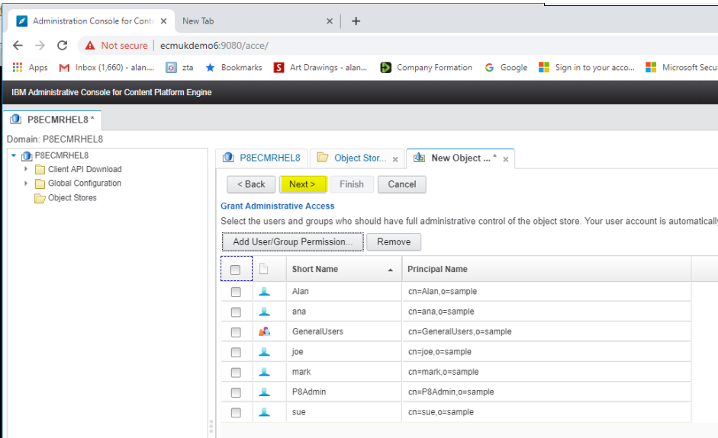

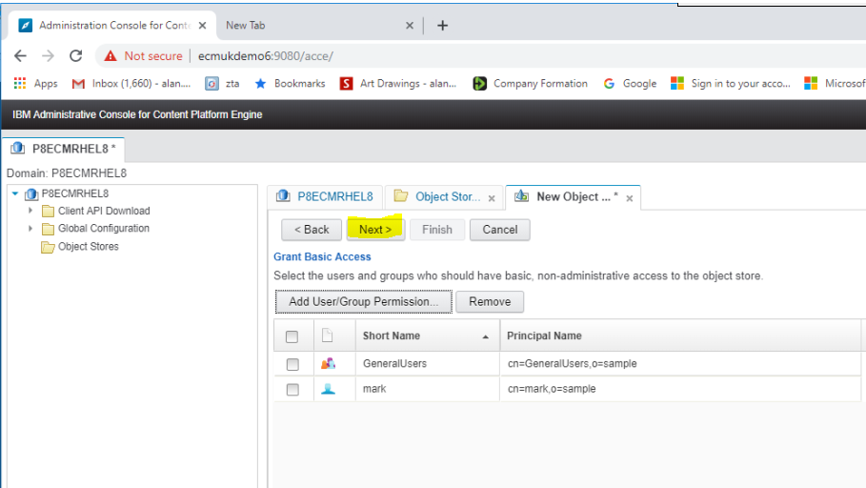

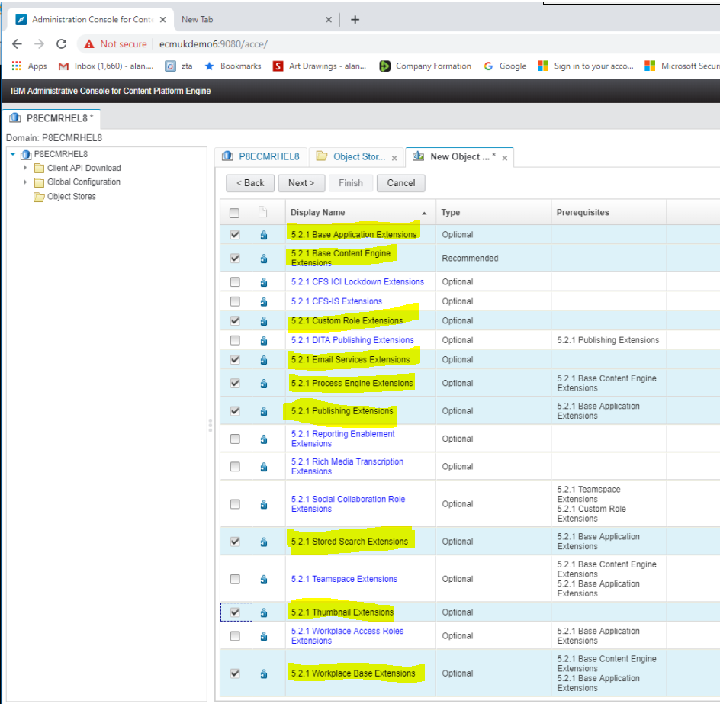

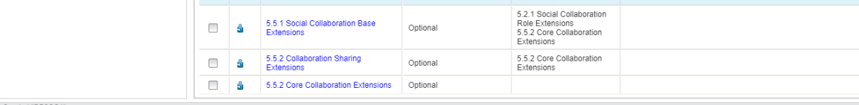

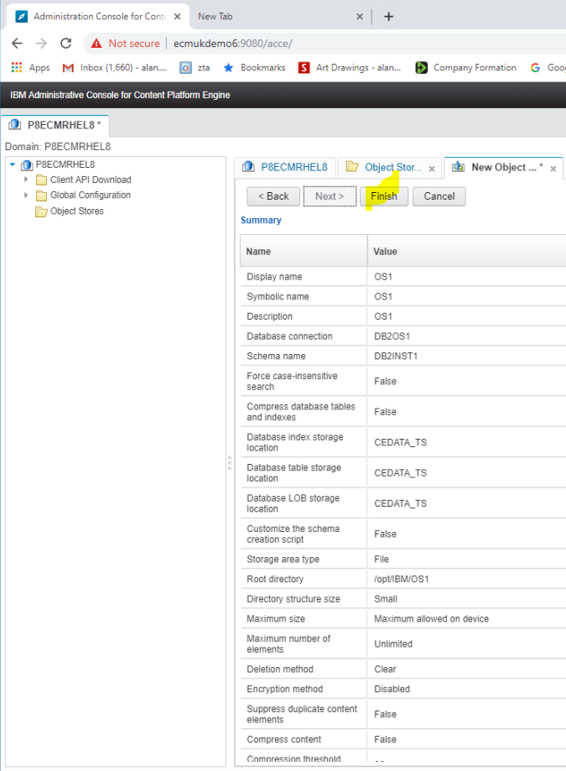

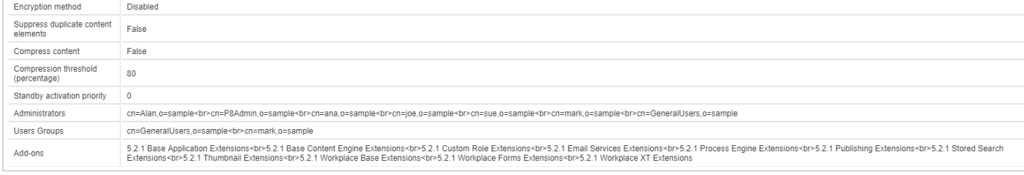

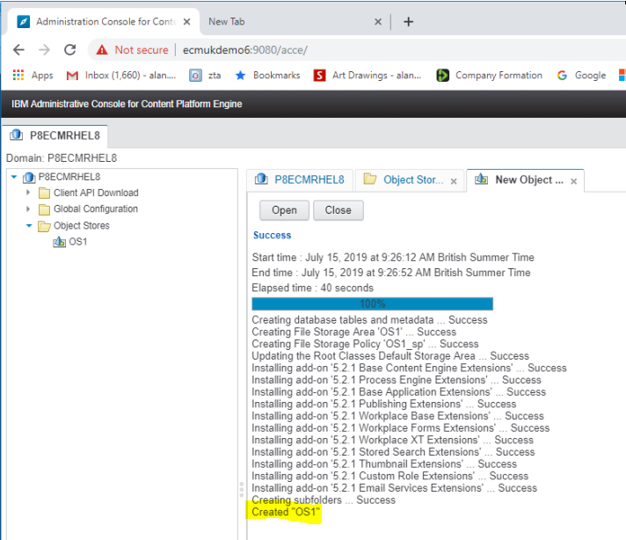

Repeat the above for the OS2 Object Store,( using OS2 specific names!)

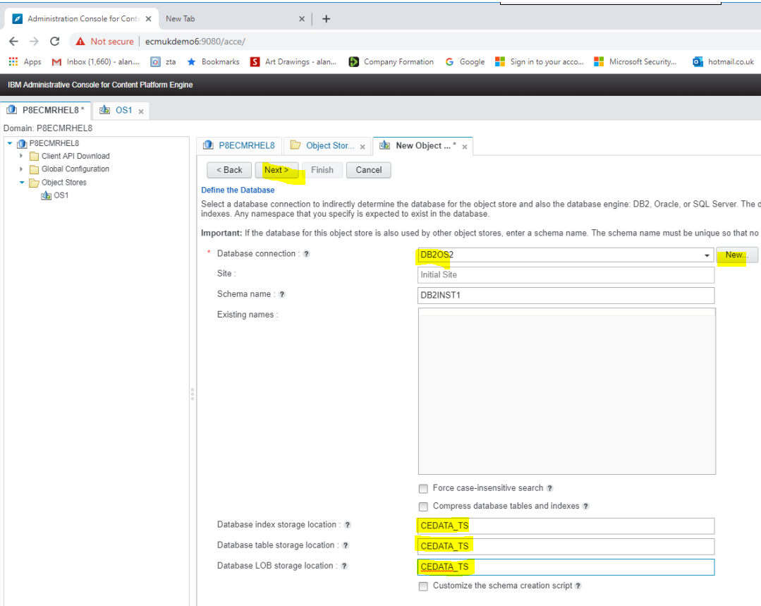

NOTE:

Each Object Store requires a separate Database Connection

Create the File Store location

**(NB My test system only … requires a higher security permission and user/group ownership**

**Level for a Production system!)**

[root@ECMUKDEMO6 IBM]# mkdir OS2

[root@ECMUKDEMO6 IBM]# chmod 777 OS2

[root@ECMUKDEMO6 IBM]# pwd

/opt/IBM

[root@ECMUKDEMO6 IBM]#

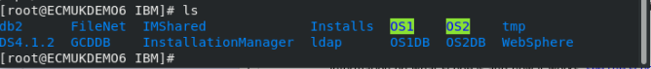

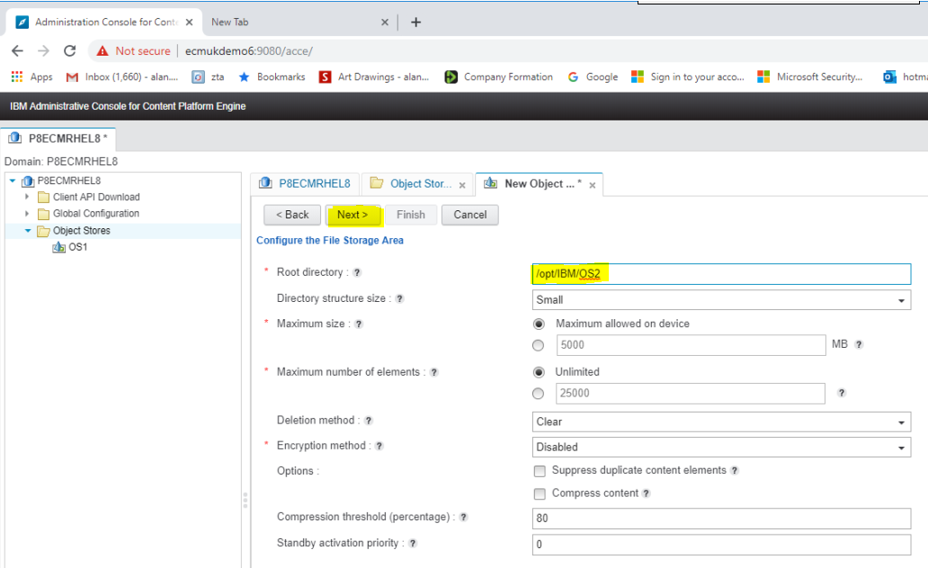

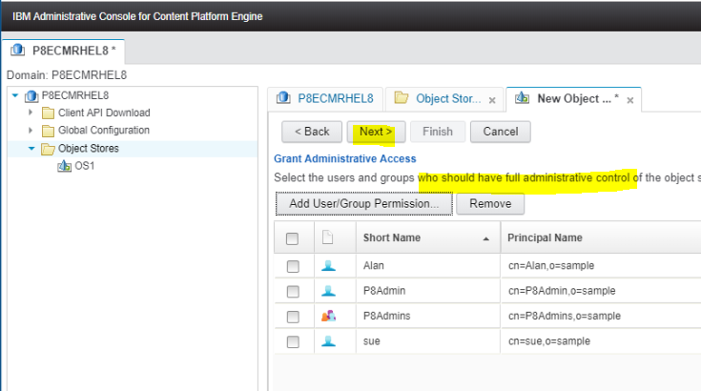

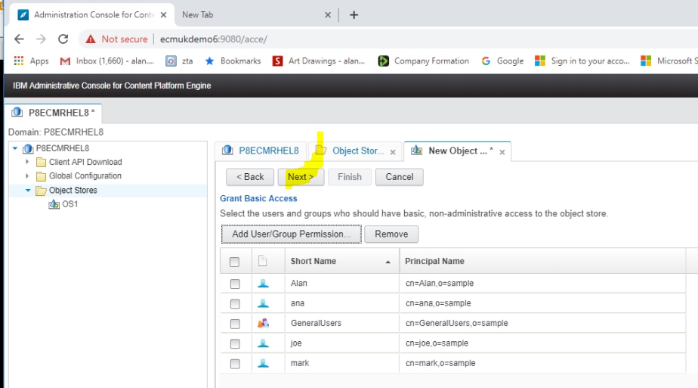

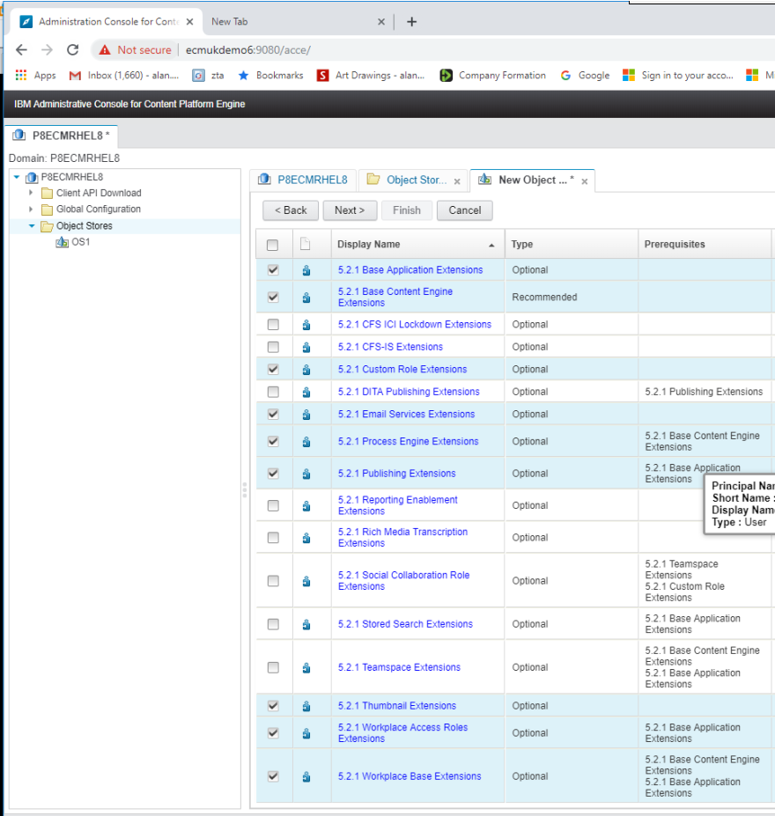

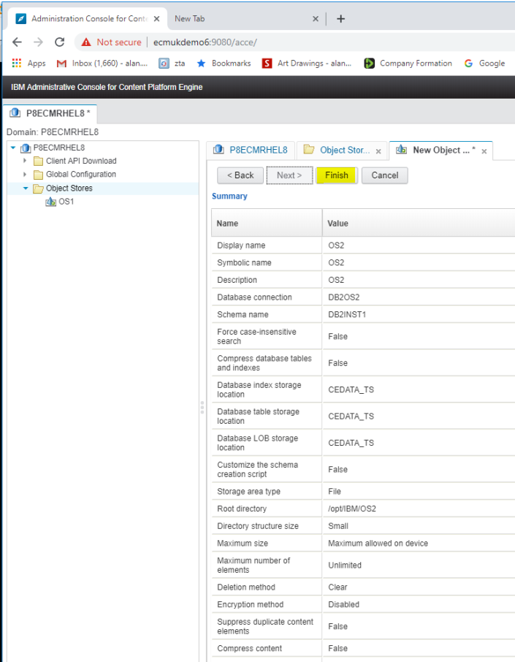

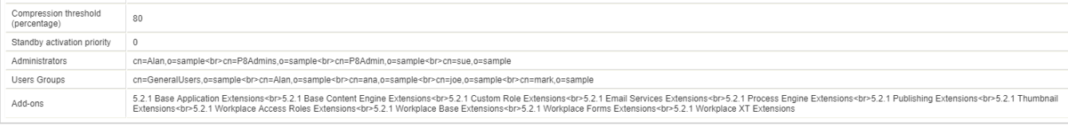

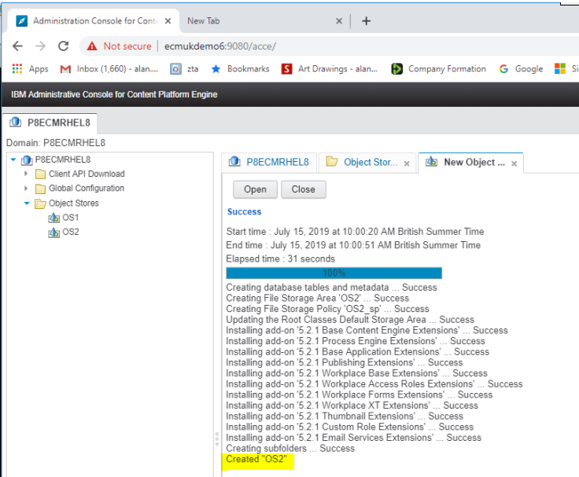

### Section For ORACLE

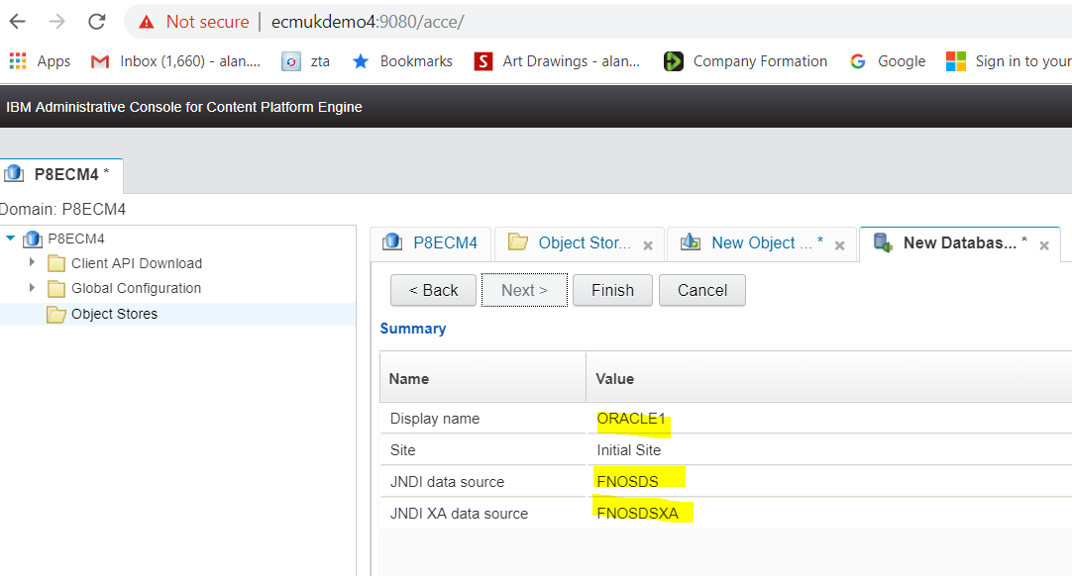

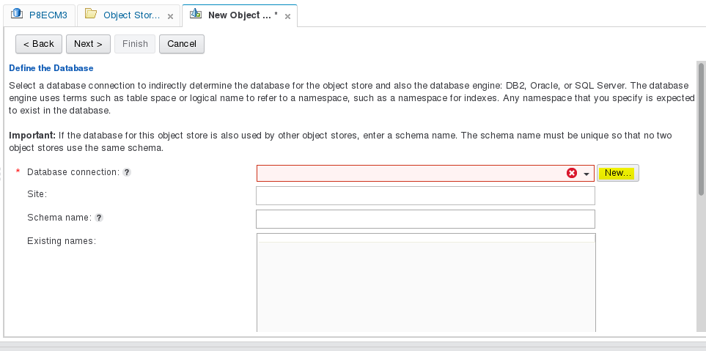

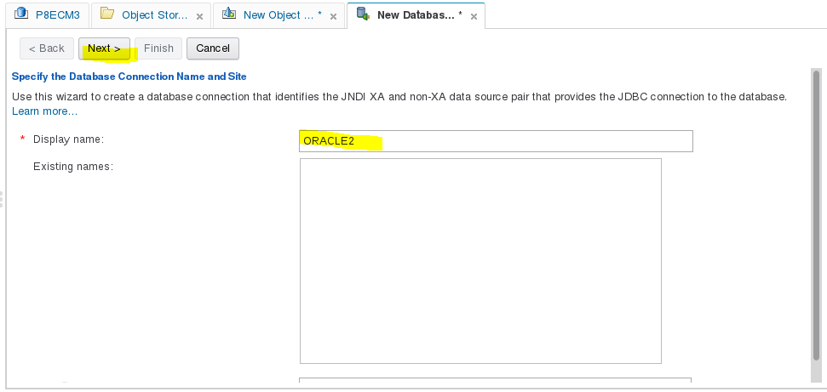

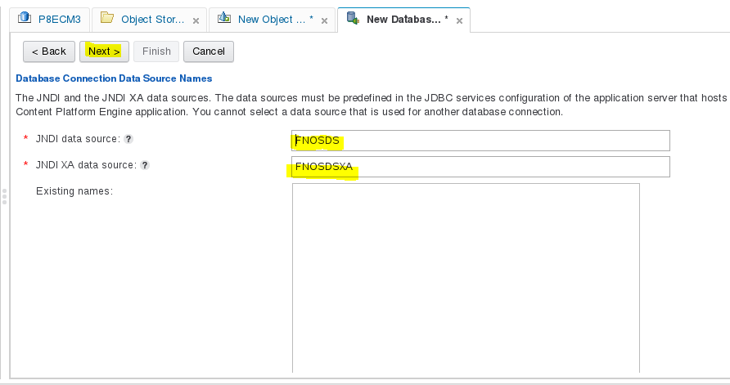

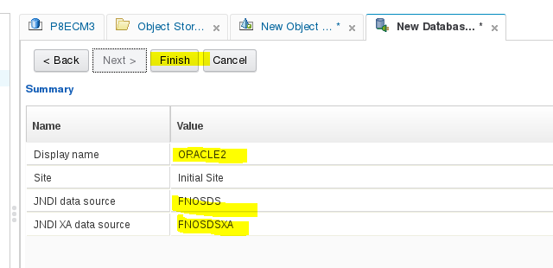

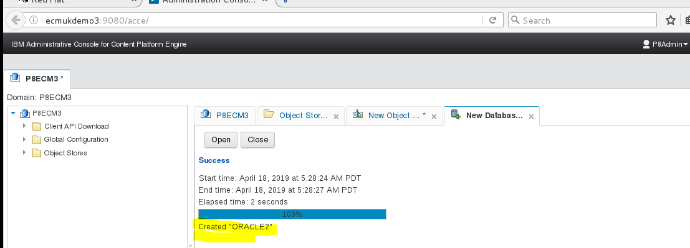

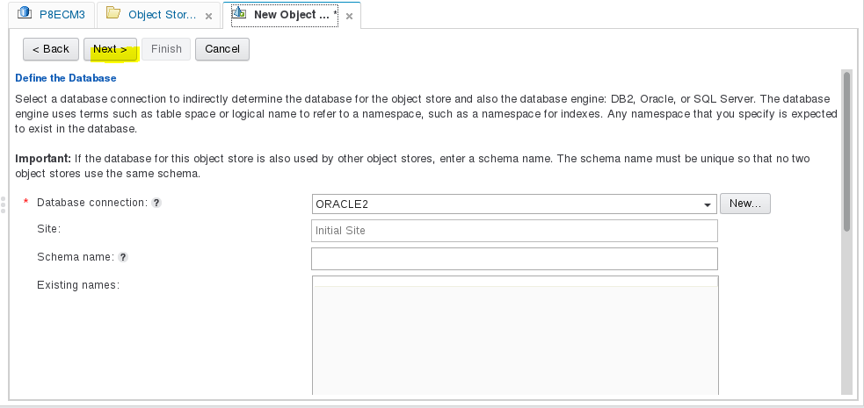

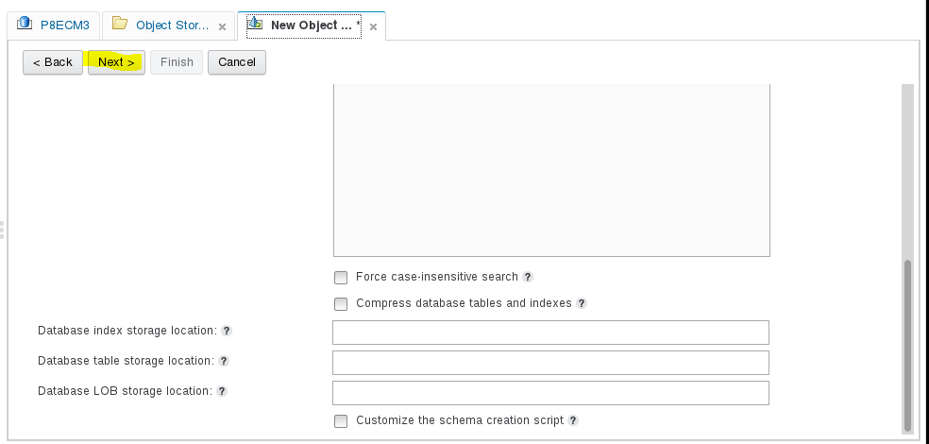

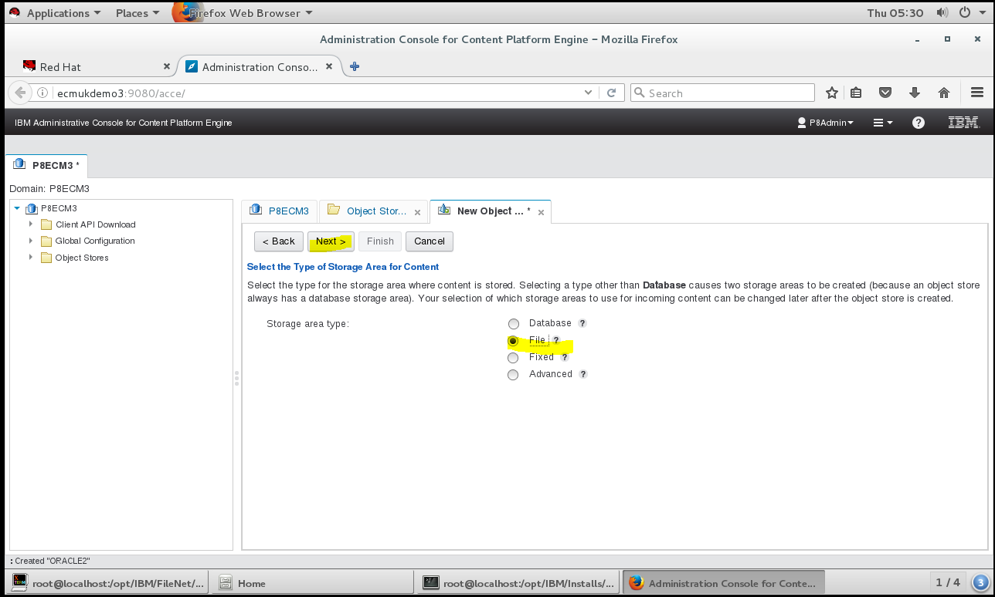

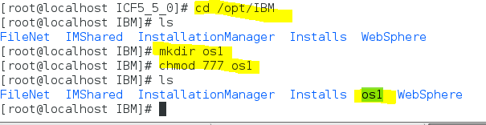

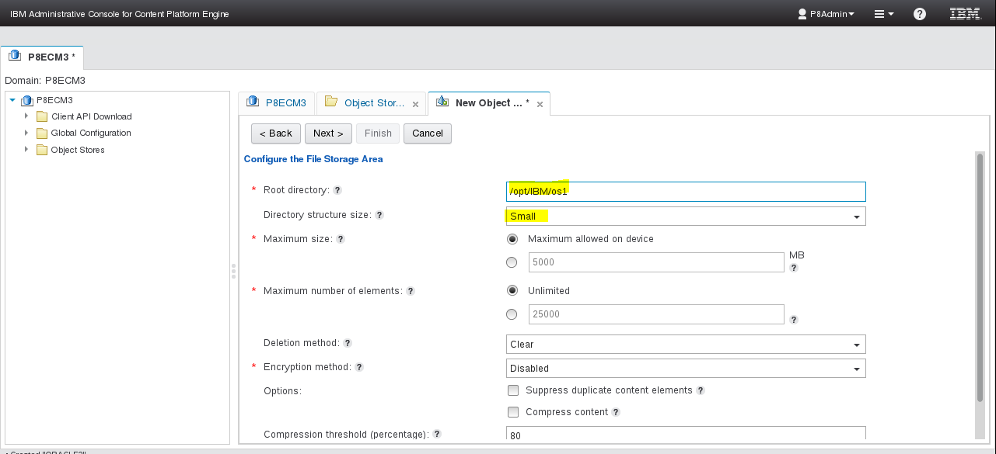

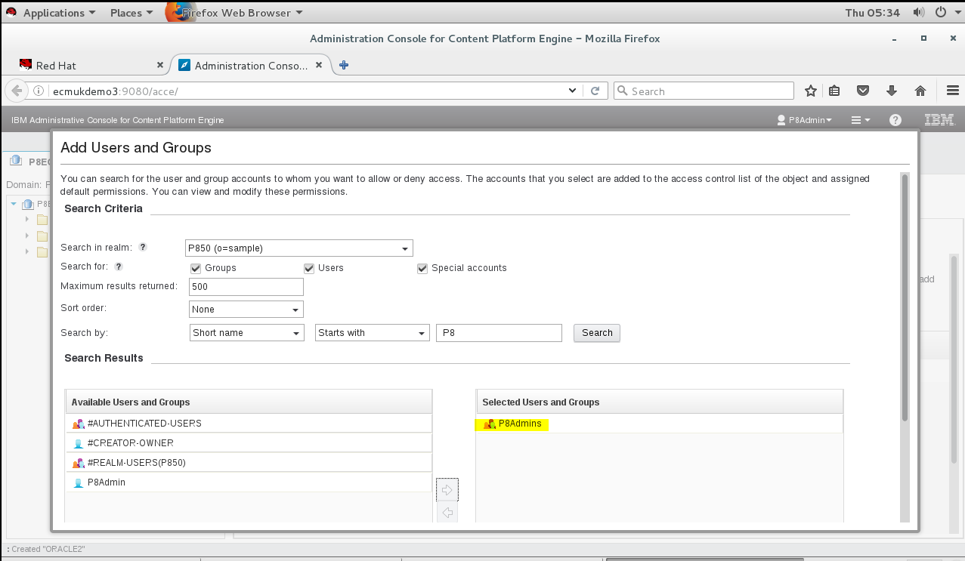

### Installing Google Chrome

# wget <https://dl.google.com/linux/direct/google-chrome-stable_current_x86_64.rpm>

**NB This installed a number of additional libraries but didn’t result in a working Chrome Browser!!! – See errors highlighted in red below.**

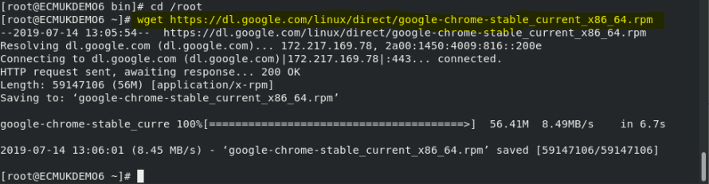

# yum -y install redhat-lsb libXScrnSaver

(for full install see -Appendix O- yum -y install redhat-lsb libXScrnSaver

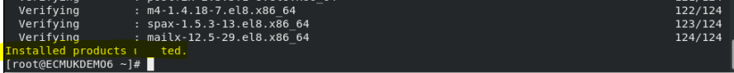

[root@ECMUKDEMO6 ~]# **yum -y localinstall google-chrome-stable\_current\_x86\_64.rpm**

Updating Subscription Management repositories.

Last metadata expiration check: 0:14:24 ago on Sun 14 Jul 2019 01:02:30 PM PDT.

Dependencies resolved.

===========================================================================================================

Package Arch Version Repository Size

===========================================================================================================

Installing:

google-chrome-stable x86\_64 75.0.3770.100-1 @commandline 56 M

Installing dependencies:

libdbusmenu-gtk3 x86\_64 16.04.0-12.el8 rhel-8-for-x86\_64-appstream-rpms 41 k

libdbusmenu x86\_64 16.04.0-12.el8 rhel-8-for-x86\_64-appstream-rpms 140 k

libindicator-gtk3 x86\_64 12.10.1-14.el8 rhel-8-for-x86\_64-appstream-rpms 70 k

libappindicator-gtk3 x86\_64 12.10.0-19.el8 rhel-8-for-x86\_64-appstream-rpms 43 k

liberation-serif-fonts noarch 1:2.00.3-4.el8 rhel-8-for-x86\_64-baseos-rpms 607 k

liberation-fonts noarch 1:2.00.3-4.el8 rhel-8-for-x86\_64-baseos-rpms 19 k

Transaction Summary

===========================================================================================================

Install 7 Packages

Total size: 57 M

Total download size: 920 k

Installed size: 201 M

Downloading Packages:

(1/6): libdbusmenu-gtk3-16.04.0-12.el8.x86\_64.rpm 31 kB/s | 41 kB 00:01

(2/6): libindicator-gtk3-12.10.1-14.el8.x86\_64.rpm 50 kB/s | 70 kB 00:01

(3/6): libdbusmenu-16.04.0-12.el8.x86\_64.rpm 93 kB/s | 140 kB 00:01

(4/6): libappindicator-gtk3-12.10.0-19.el8.x86\_64.rpm 150 kB/s | 43 kB 00:00

(5/6): liberation-serif-fonts-2.00.3-4.el8.noarch.rpm 2.0 MB/s | 607 kB 00:00

(6/6): liberation-fonts-2.00.3-4.el8.noarch.rpm 100 kB/s | 19 kB 00:00

-----------------------------------------------------------------------------------------------------------

Total 538 kB/s | 920 kB 00:01

Running transaction check

Transaction check succeeded.

Running transaction test

Transaction test succeeded.

Running transaction

Preparing : 1/1

Installing : libdbusmenu-16.04.0-12.el8.x86\_64 1/7

Installing : libdbusmenu-gtk3-16.04.0-12.el8.x86\_64 2/7

Installing : liberation-serif-fonts-1:2.00.3-4.el8.noarch 3/7

Installing : liberation-fonts-1:2.00.3-4.el8.noarch 4/7

Installing : libindicator-gtk3-12.10.1-14.el8.x86\_64 5/7

Installing : libappindicator-gtk3-12.10.0-19.el8.x86\_64 6/7

Running scriptlet: google-chrome-stable-75.0.3770.100-1.x86\_64 7/7

Installing : google-chrome-stable-75.0.3770.100-1.x86\_64 7/7

Running scriptlet: google-chrome-stable-75.0.3770.100-1.x86\_64 7/7

**error: can't create transaction lock on /var/lib/rpm/.rpm.lock (Resource temporarily unavailable)**

**error: /tmp/google.sig.fmhchI: key 1 import failed.**

**error: can't create transaction lock on /var/lib/rpm/.rpm.lock (Resource temporarily unavailable)**

**error: /tmp/google.sig.fmhchI: key 2 import failed.**

**Redirecting to /bin/systemctl start atd.service**

Verifying : libdbusmenu-gtk3-16.04.0-12.el8.x86\_64 1/7

Verifying : libdbusmenu-16.04.0-12.el8.x86\_64 2/7

Verifying : libindicator-gtk3-12.10.1-14.el8.x86\_64 3/7

Verifying : libappindicator-gtk3-12.10.0-19.el8.x86\_64 4/7

Verifying : liberation-serif-fonts-1:2.00.3-4.el8.noarch 5/7

Verifying : liberation-fonts-1:2.00.3-4.el8.noarch 6/7

Verifying : google-chrome-stable-75.0.3770.100-1.x86\_64 7/7

Installed products updated.

Installed:

google-chrome-stable-75.0.3770.100-1.x86\_64 libdbusmenu-gtk3-16.04.0-12.el8.x86\_64

libdbusmenu-16.04.0-12.el8.x86\_64 libindicator-gtk3-12.10.1-14.el8.x86\_64

libappindicator-gtk3-12.10.0-19.el8.x86\_64 liberation-serif-fonts-1:2.00.3-4.el8.noarch

liberation-fonts-1:2.00.3-4.el8.noarch

Complete!

[root@ECMUKDEMO6 ~]#

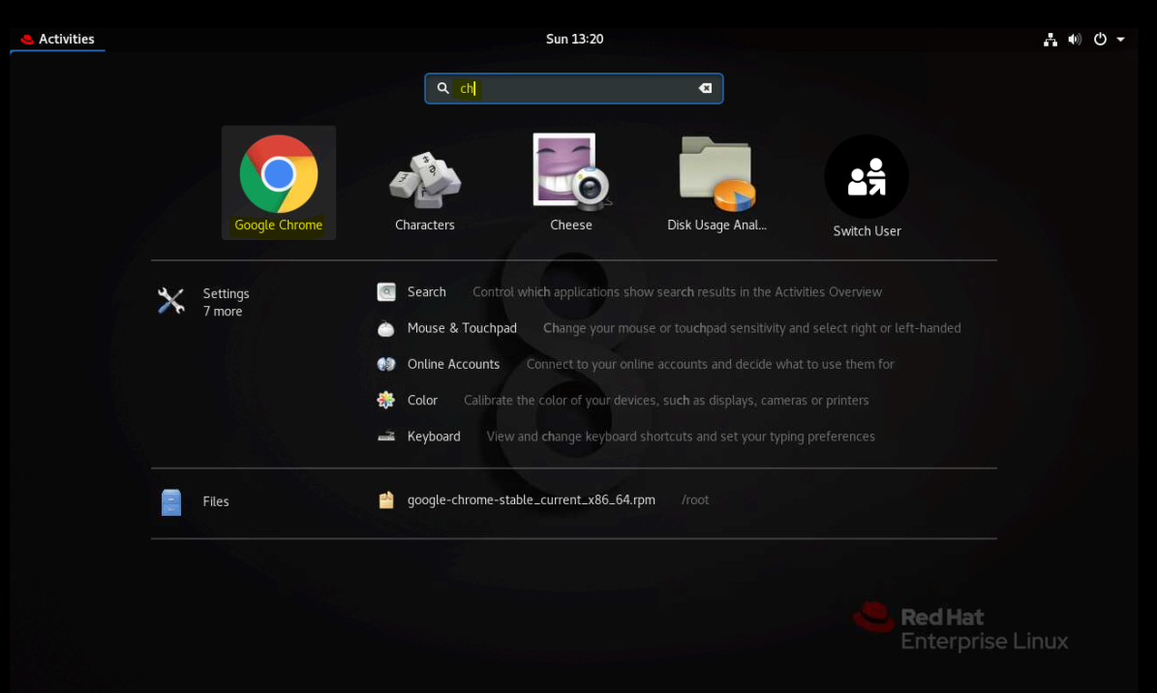

**NOTE Does not create a working browser though**

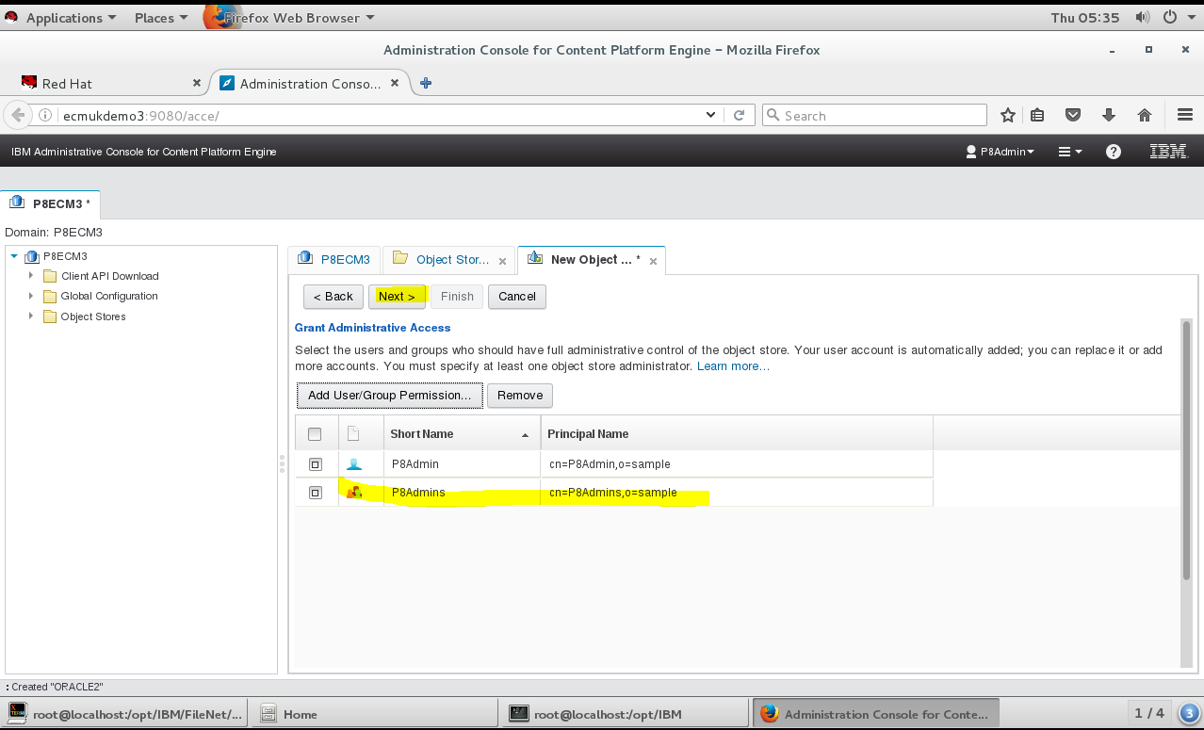

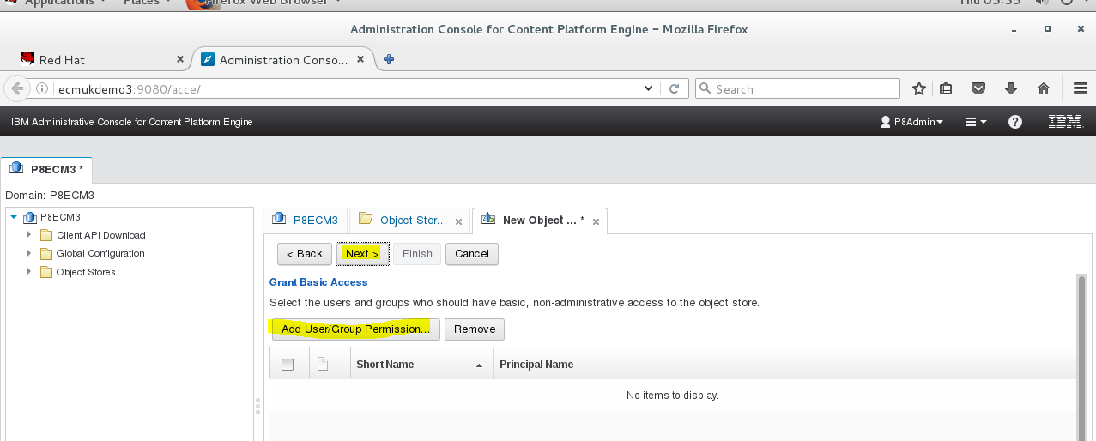

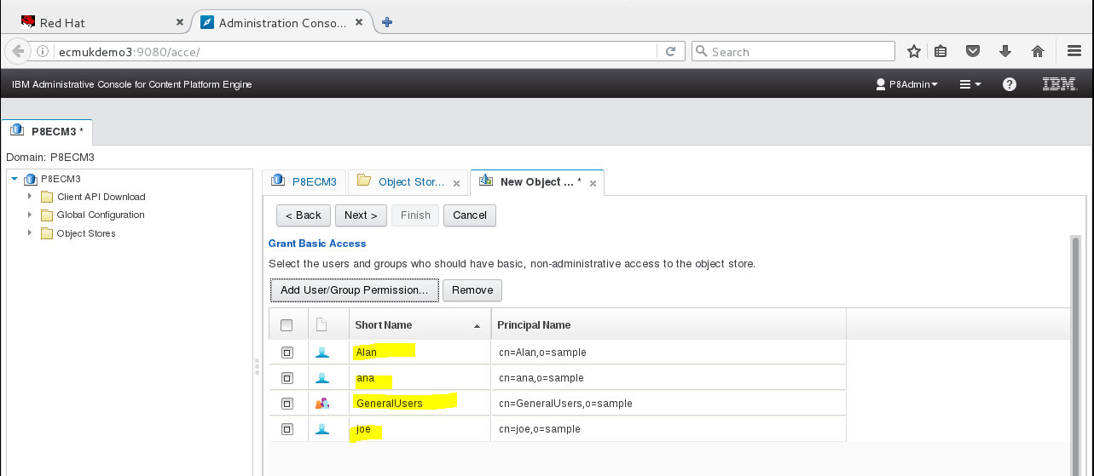

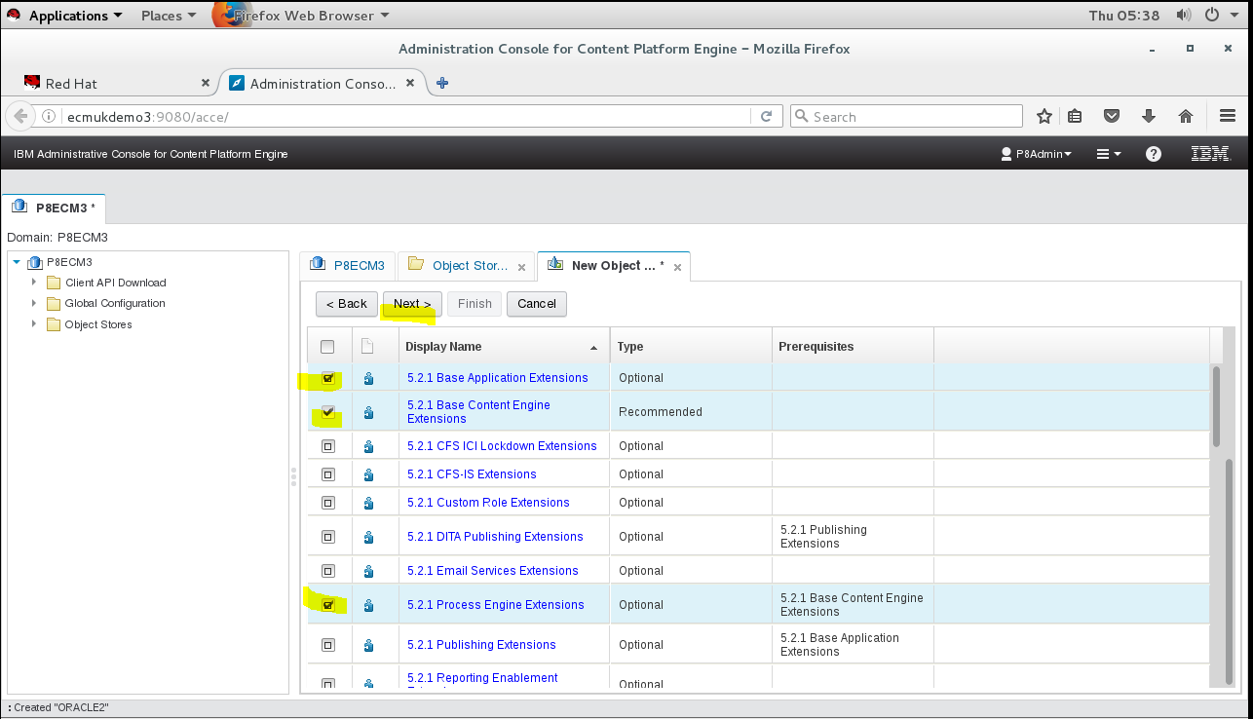

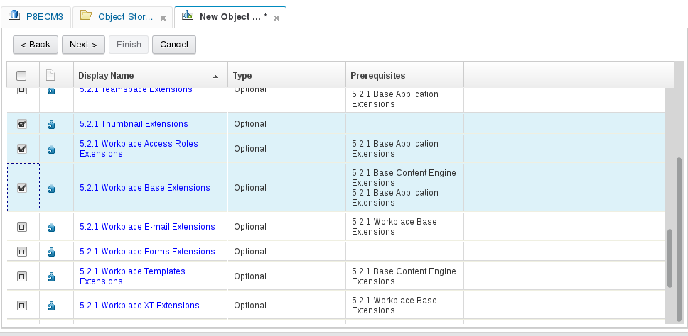

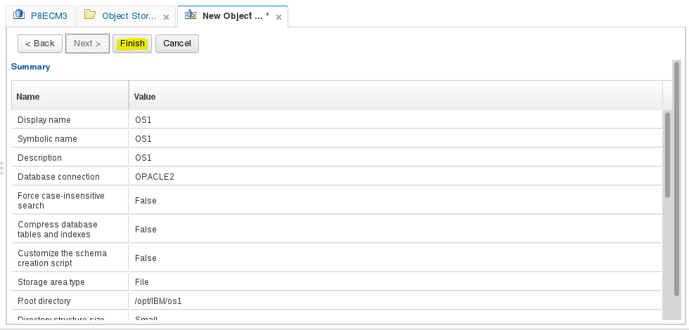

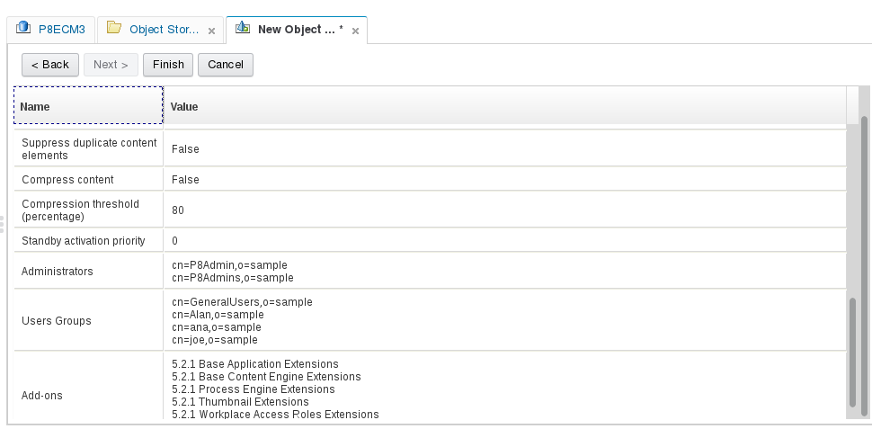

Oracle Object Store OS1 created successfully! 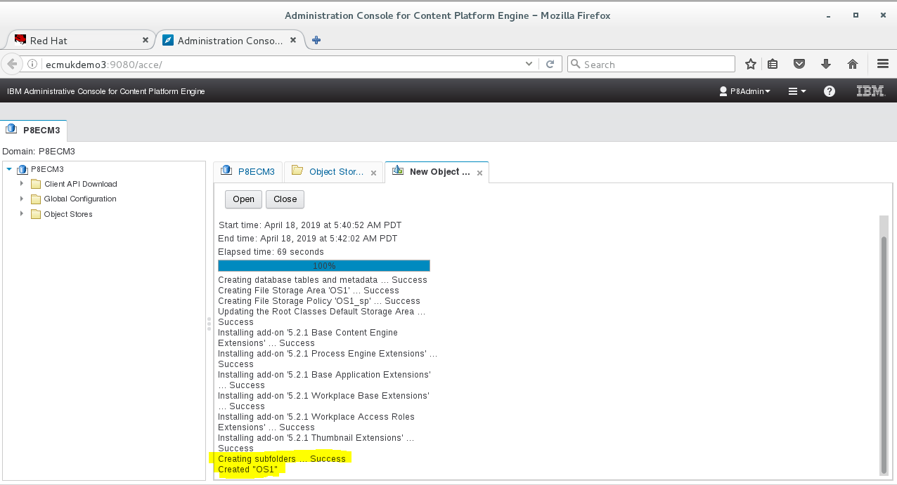

### On Centos 7.3

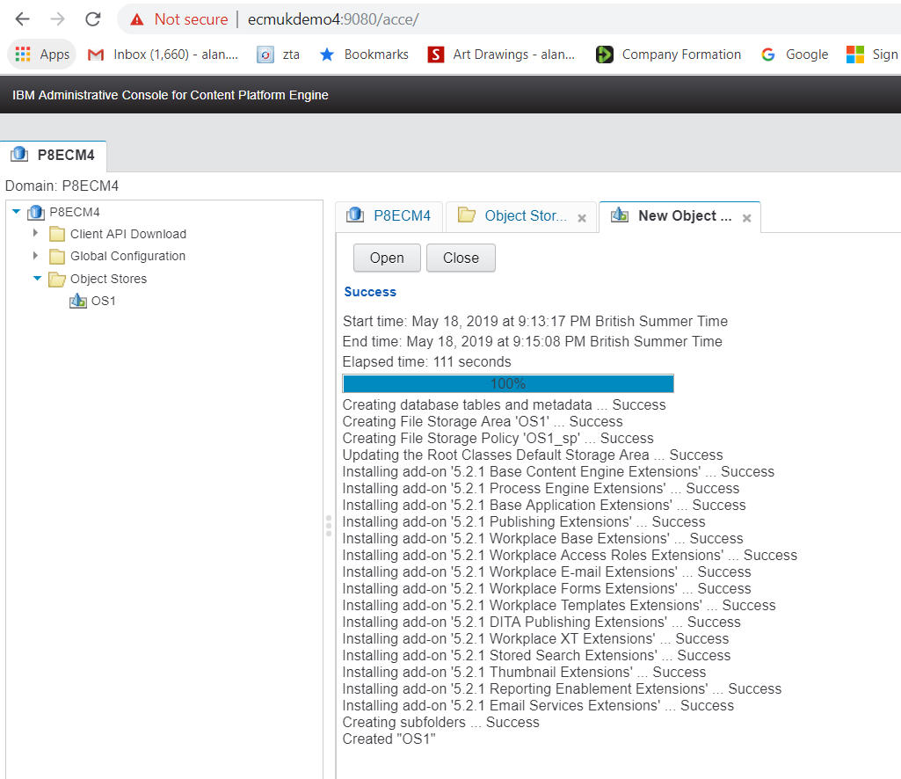

### Starting Oracle

Startup of Oracle can be set to be automatic on boot of the Linux server see the detailed set-up of this in AutoStart setting, Appendix G.

**Set the environment**

*export ORACLE\_SID=orcl  
export ORACLE\_HOME=/opt/app/oracle/product/12.1.0/db\_1/  
export PATH=$PATH:$ORACLE\_HOME/bin*

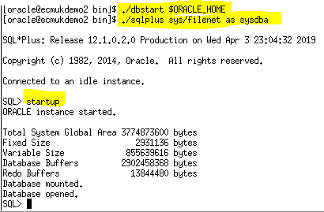

### Open Firewall ports for the Windows Host server Chrome Browser

firewall-cmd --zone=public --permanent --add-port=9080/tcp

firewall-cmd --zone=public --permanent --add-port=9060/tcp

firewall-cmd --zone=public --permanent --add-port=9043/tcp

firewall-cmd --reload

**Above to get remote web browser access**

# Appendix A – Installation of VMware tools on the RHEL 8.0 System

Copy the file VMwareTools-10.1.6-5214329.tar.gz from the mount point

/run/media/root/VMware Tools to /home/wasadm/vmware as root

@ECMUKDEMO6 wasadm]# **ls**

Desktop Documents Downloads Music Pictures Public Templates Videos vmware

[root@ECMUKDEMO6 wasadm]# **cd vmware**

[root@ECMUKDEMO6 vmware]# **ls**

VMwareTools-10.1.6-5214329.tar.gz

[root@ECMUKDEMO6 vmware]# **tar -zxvf VMwareTools-10.1.6-5214329.tar.gz**

….

[root@ECMUKDEMO6 vmware]# **ls**

VMwareTools-10.1.6-5214329.tar.gz vmware-tools-distrib

[root@ECMUKDEMO6 vmware]# **cd vmware-tools-distrib/**

[root@ECMUKDEMO6 vmware-tools-distrib]# **ls**

bin caf doc etc FILES INSTALL installer lib vgauth vmware-install.pl

**NB Used all the defaults (in [] brackets) in the responses in bold below (just return on the prompts**

[root@ECMUKDEMO6 vmware-tools-distrib]# **./vmware-install.pl**

The installer has detected an existing installation of open-vm-tools packages

on this system and will not attempt to remove and replace these user-space

applications. It is recommended to use the open-vm-tools packages provided by

the operating system. If you do not want to use the existing installation of

open-vm-tools packages and use VMware Tools, you must uninstall the

open-vm-tools packages and re-run this installer.

The packages that need to be removed are:

open-vm-tools

The installer will next check if there are any missing kernel drivers. Type yes

if you want to do this, otherwise type no **[yes]**

A previous installation of VMware Tools has been detected.

The previous installation was made by the tar installer (version 4).

Keeping the tar4 installer database format.

You have a version of VMware Tools installed. Continuing this install will

first uninstall the currently installed version. Do you wish to continue?

(yes/no) **[yes]**

Uninstalling the tar installation of VMware Tools.

Stopping services for VMware Tools

The removal of VMware Tools 10.1.6 build-5214329 for Linux completed

successfully.

Installing VMware Tools.

In which directory do you want to install the binary files?

**[/usr/bin]**

What is the directory that contains the init directories (rc0.d/ to rc6.d/)?

**[/etc/rc.d]**

What is the directory that contains the init scripts?

**[/etc/rc.d/init.d]**

In which directory do you want to install the daemon files?

**[/usr/sbin]**

In which directory do you want to install the library files?

**[/usr/lib/vmware-tools]**

The path "/usr/lib/vmware-tools" does not exist currently. This program is

going to create it, including needed parent directories. Is this what you want?

**[yes]**

In which directory do you want to install the documentation files?

**[/usr/share/doc/vmware-tools]**

The path "/usr/share/doc/vmware-tools" does not exist currently. This program

is going to create it, including needed parent directories. Is this what you

want? **[yes]**

The installation of VMware Tools 10.1.6 build-5214329 for Linux completed

successfully. You can decide to remove this software from your system at any

time by invoking the following command: "/usr/bin/vmware-uninstall-tools.pl".

Before running VMware Tools for the first time, you need to configure it by

invoking the following command: "/usr/bin/vmware-config-tools.pl". Do you want

this program to invoke the command for you now? **[yes]**

You have chosen to install VMware Tools on top of an open-vm-tools package.

You will now be given the option to replace some commands provided by

open-vm-tools. Please note that if you replace any commands at this time and

later remove VMware Tools, it may be necessary to re-install the open-vm-tools.

The file /usr/bin/vmware-hgfsclient that this program was about to install

already exists. Overwrite? **[no]**

The file /usr/bin/vmhgfs-fuse that this program was about to install already

exists. Overwrite? **[no]**

Initializing...

Making sure services for VMware Tools are stopped.

The module vmci has already been installed on this system by another installer

or package and will not be modified by this installer.

The module vsock has already been installed on this system by another installer

or package and will not be modified by this installer.

The module vmxnet3 has already been installed on this system by another

installer or package and will not be modified by this installer.

The module pvscsi has already been installed on this system by another

installer or package and will not be modified by this installer.

The module vmmemctl has already been installed on this system by another

installer or package and will not be modified by this installer.

The VMware Host-Guest Filesystem allows for shared folders between the host OS

and the guest OS in a Fusion or Workstation virtual environment. Do you wish

to enable this feature? **[yes]**

Before you can compile modules, you need to have the following installed...

make

gcc

kernel headers of the running kernel

Searching for GCC...

Detected GCC binary at "/bin/gcc".

The path "/bin/gcc" appears to be a valid path to the gcc binary.

Would you like to change it? **[no]**

Searching for a valid kernel header path...

Detected the kernel headers at

"/lib/modules/3.10.0-514.el7.x86\_64/build/include".

The path "/lib/modules/3.10.0-514.el7.x86\_64/build/include" appears to be a

valid path to the 3.10.0-514.el7.x86\_64 kernel headers.

Would you like to change it? **[no]**

Using kernel build system.

make: Entering directory `/tmp/modconfig-91Vqps/vmhgfs-only'

/bin/make -C /lib/modules/3.10.0-514.el7.x86\_64/build/include/.. SUBDIRS=$PWD SRCROOT=$PWD/. \

MODULEBUILDDIR= modules

make[1]: Entering directory `/usr/src/kernels/3.10.0-514.el7.x86\_64'

CC [M] /tmp/modconfig-91Vqps/vmhgfs-only/message.o

CC [M] /tmp/modconfig-91Vqps/vmhgfs-only/dir.o

CC [M] /tmp/modconfig-91Vqps/vmhgfs-only/rpcout.o

CC [M] /tmp/modconfig-91Vqps/vmhgfs-only/hgfsUtil.o

CC [M] /tmp/modconfig-91Vqps/vmhgfs-only/cpName.o

CC [M] /tmp/modconfig-91Vqps/vmhgfs-only/request.o

CC [M] /tmp/modconfig-91Vqps/vmhgfs-only/hgfsEscape.o

CC [M] /tmp/modconfig-91Vqps/vmhgfs-only/link.o

CC [M] /tmp/modconfig-91Vqps/vmhgfs-only/bdhandler.o

CC [M] /tmp/modconfig-91Vqps/vmhgfs-only/backdoor.o

CC [M] /tmp/modconfig-91Vqps/vmhgfs-only/transport.o

CC [M] /tmp/modconfig-91Vqps/vmhgfs-only/inode.o

CC [M] /tmp/modconfig-91Vqps/vmhgfs-only/file.o

CC [M] /tmp/modconfig-91Vqps/vmhgfs-only/super.o

CC [M] /tmp/modconfig-91Vqps/vmhgfs-only/stubs.o

CC [M] /tmp/modconfig-91Vqps/vmhgfs-only/fsutil.o

CC [M] /tmp/modconfig-91Vqps/vmhgfs-only/cpNameLinux.o

CC [M] /tmp/modconfig-91Vqps/vmhgfs-only/hgfsBd.o

CC [M] /tmp/modconfig-91Vqps/vmhgfs-only/filesystem.o

CC [M] /tmp/modconfig-91Vqps/vmhgfs-only/module.o

CC [M] /tmp/modconfig-91Vqps/vmhgfs-only/page.o

CC [M] /tmp/modconfig-91Vqps/vmhgfs-only/backdoorGcc64.o

CC [M] /tmp/modconfig-91Vqps/vmhgfs-only/dentry.o

/tmp/modconfig-91Vqps/vmhgfs-only/backdoorGcc64.o: warning: objtool: BackdoorHbIn()+0xd: duplicate frame pointer save

/tmp/modconfig-91Vqps/vmhgfs-only/backdoorGcc64.o: warning: objtool: BackdoorHbOut()+0xd: duplicate frame pointer save

CC [M] /tmp/modconfig-91Vqps/vmhgfs-only/cpNameLite.o

CC [M] /tmp/modconfig-91Vqps/vmhgfs-only/kernelStubsLinux.o

LD [M] /tmp/modconfig-91Vqps/vmhgfs-only/vmhgfs.o

Building modules, stage 2.

MODPOST 1 modules

CC /tmp/modconfig-91Vqps/vmhgfs-only/vmhgfs.mod.o

LD [M] /tmp/modconfig-91Vqps/vmhgfs-only/vmhgfs.ko

make[1]: Leaving directory `/usr/src/kernels/3.10.0-514.el7.x86\_64'

/bin/make -C $PWD SRCROOT=$PWD/. \

MODULEBUILDDIR= postbuild

make[1]: Entering directory `/tmp/modconfig-91Vqps/vmhgfs-only'

make[1]: `postbuild' is up to date.

make[1]: Leaving directory `/tmp/modconfig-91Vqps/vmhgfs-only'

cp -f vmhgfs.ko ./../vmhgfs.o

make: Leaving directory `/tmp/modconfig-91Vqps/vmhgfs-only'

The vmxnet driver is no longer supported on kernels 3.3 and greater. Please

upgrade to a newer virtual NIC. (e.g., vmxnet3 or e1000e)

VMware automatic kernel modules enables automatic building and installation of

VMware kernel modules at boot that are not already present. This feature can

be enabled/disabled by re-running vmware-config-tools.pl.

Would you like to enable VMware automatic kernel modules?

**[yes]**

Thinprint provides driver-free printing. Do you wish to enable this feature?

**[yes]**

Creating a new initrd boot image for the kernel.

The configuration of **VMware Tools 10.1.6 build-5214329** for Linux for this

running kernel completed successfully.

Enjoy,

--the VMware team

Found VMware Tools CDROM mounted at /run/media/root/VMware Tools. Ejecting

device /dev/sr0 ...

[root@ECMUKDEMO6 vmware-tools-distrib]#

# Appendix B – Network configuration changes for a Static IP Address

The addresses in the two Network cards originally set up in VMware use DHCP so are allocated dynamically on system start-up and can change! Because we need to connect to other VMware servers (potentially), including a Tivoli Directory service server, I have allocated a fixed IP address, 10.10.10.70 to the ens33 card.

First, in Vmware, ensure that the network cards are set as Host only

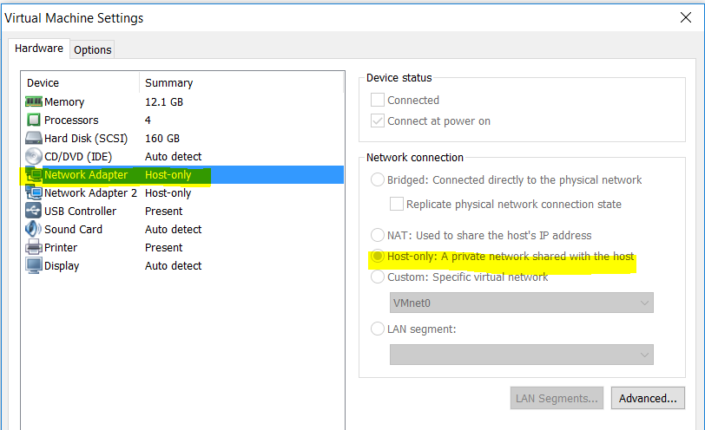

Prior to this (see also the earlier pages in this document) the following base ens34 network was set up: **Network set up for the Linux Environment** (**Ctrl+Click** to see this section of the document)

* + 1. Select Applications -> System Tools -> Settings :

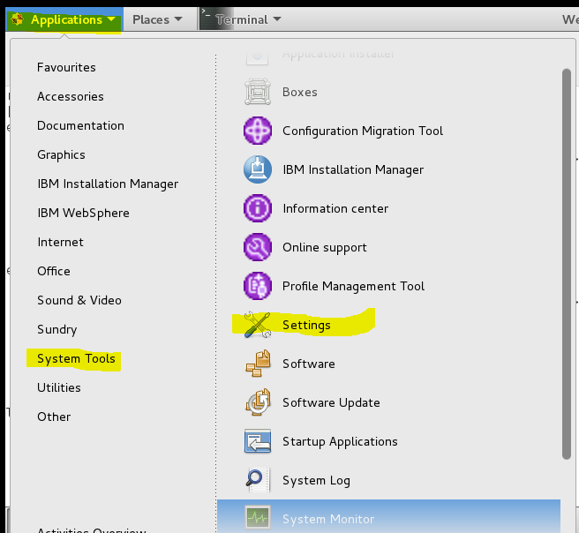

* + 1. In Settings, double click to open the Network configuration:

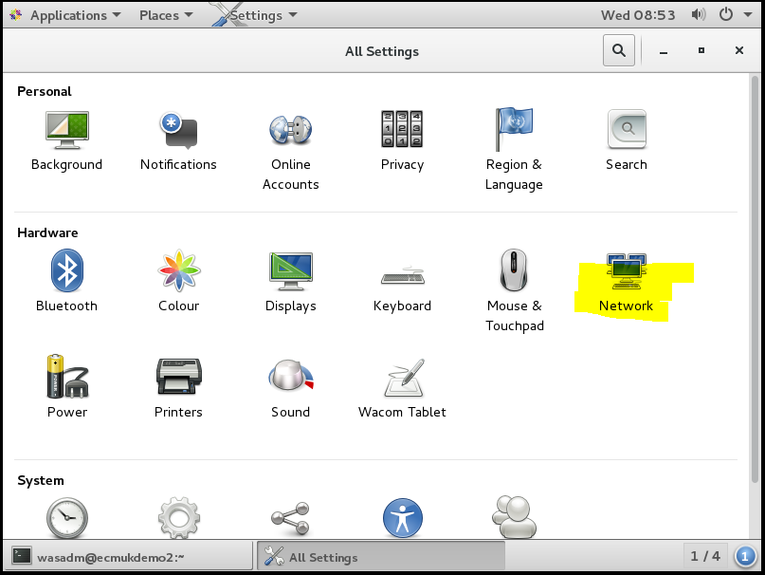

* + 1. Select ens33 and click on this to edit the configuration of this to static

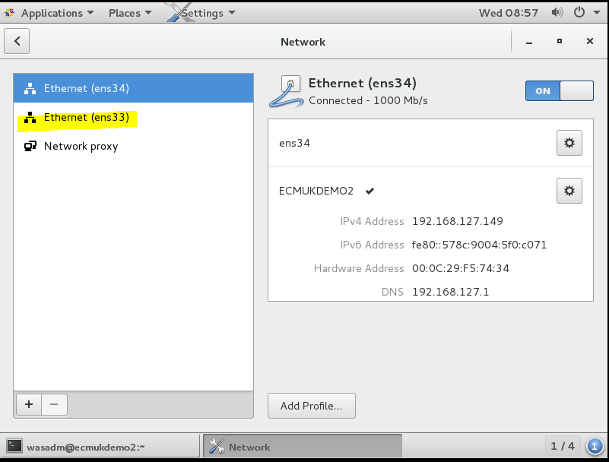

* + 1. Click on the 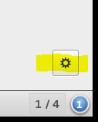 cogwheel icon bottom right as shown above
    2. Select the IPV4 configuration

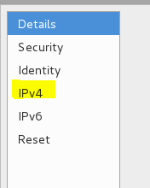

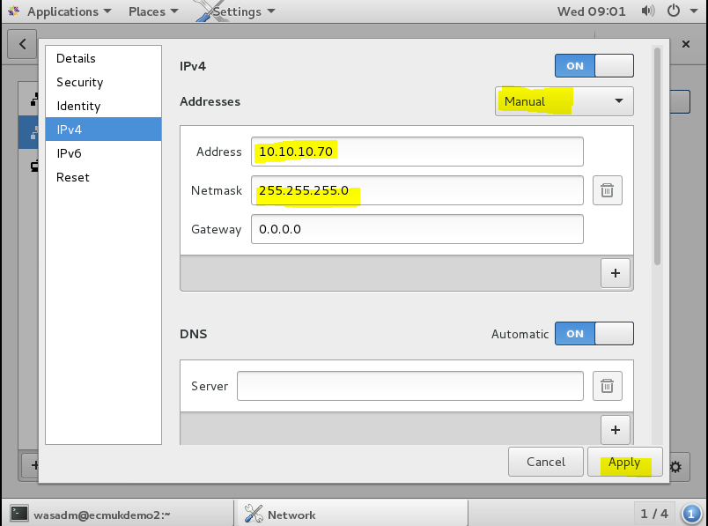

Change the Addresses to Manual and enter the required static IP address and Netmask

(mine was for class C address of 10.10.10.70 as shown above)

**Then click Apply**

* + 1. Log in as root

**su - root**

* + 1. **vi /etc/hosts**

**Edit the required IPs into the /etc/hosts file to resolve the static IP address**

**(Assuming you do not have a separate DNS server, of course)**

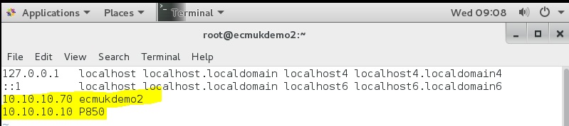

* + 1. Save the /etc/hosts file and reboot the server using

**shutdown -r now**

You will now see the following using **ifconfig**

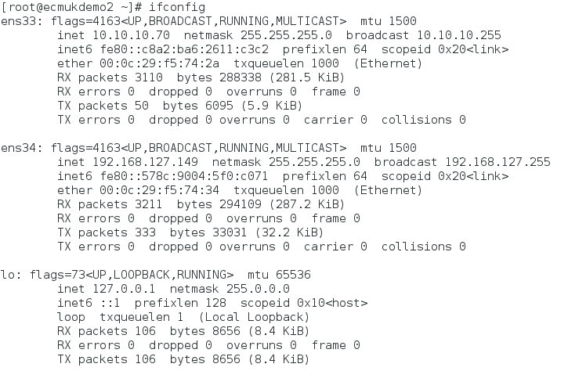

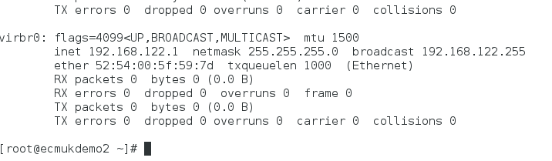

# Appendix H – Clear-down of Oracle Object Store tables to re-apply

It is possible that the acce tool can create the tables of an Object Store, but not complete the process, usually if there is an error part-way though because the File folder path name is incorrect for a FileStore or the permissions are set incorrectly.

The acce tool will not then allow the creation to be continued for that Object Store unless the tablespace for the schema user is ‘empty’ of any table objects.

The following Oracle SQL script has been used to correct the above scenario in an Oracle 12c Linux system environment, using the Oracle sql\*plus command line tool.

conn OS1/*password*

set head off

set pagesize 0

set verify off

set feedback off

spool drop\_objects.sql;

select 'drop '||object\_type||' '|| object\_name||';'

from all\_objects where owner='OS1';

spool off;

@drop\_objects.sql;

# Appendix M - DB10.5 Universal Fix pack 10 Update log

**[root@ECMUKDEMO6 universal]# ./installFixPack -b /opt/ibm/db2/V10.5/**

Do you want to choose a different installation directory for the fix pack? [yes/no]

------------------------------------------------------------------------------------

**no**

DBI1017I installFixPack is updating the DB2 product(s) installed in

location /opt/ibm/db2/V10.5/.

DB2 installation is being initialized.

Total number of tasks to be performed: 39

Total estimated time for all tasks to be performed: 1658 second(s)

Task #1 start

Description: Stopping DB2 Fault Monitor

Estimated time 10 second(s)

Task #1 end

Task #2 start

Description: Preparing the system

Estimated time 120 second(s)

Task #2 end

Task #3 start

Description: Base Client Support for installation with root privileges

Estimated time 3 second(s)

Task #3 end

Task #4 start

Description: Product Messages - English

Estimated time 14 second(s)

Task #4 end

Task #5 start

Description: Base client support

Estimated time 319 second(s)

Task #5 end

Task #6 start

Description: Java Runtime Support

Estimated time 169 second(s)

Task #6 end

Task #7 start

Description: Java Help (HTML) - English

Estimated time 7 second(s)

Task #7 end

Task #8 start

Description: Base server support for installation with root privileges

Estimated time 7 second(s)

Task #8 end

Task #9 start

Description: Global Secure ToolKit

Estimated time 53 second(s)

Task #9 end

Task #10 start

Description: Java support

Estimated time 13 second(s)

Task #10 end

Task #11 start

Description: SQL procedures

Estimated time 3 second(s)

Task #11 end

Task #12 start

Description: ICU Utilities

Estimated time 35 second(s)

Task #12 end

Task #13 start

Description: Java Common files

Estimated time 18 second(s)

Task #13 end

Task #14 start

Description: Base server support

Estimated time 500 second(s)

Task #14 end

Task #15 start

Description: Control Center Help (HTML) - English

Estimated time 13 second(s)

Task #15 end

Task #16 start

Description: Connect support

Estimated time 3 second(s)

Task #16 end

Task #17 start

Description: DB2 data source support

Estimated time 6 second(s)

Task #17 end

Task #18 start

Description: IBM Software Development Kit (SDK) for Java(TM)

Estimated time 50 second(s)

Task #18 end

Task #19 start

Description: DB2 LDAP support

Estimated time 4 second(s)

Task #19 end

Task #20 start

Description: DB2 Instance Setup wizard

Estimated time 20 second(s)

Task #20 end

Task #21 start

Description: Integrated Flash Copy Support

Estimated time 3 second(s)

Task #21 end

Task #22 start

Description: Communication support - TCP/IP

Estimated time 3 second(s)

Task #22 end

Task #23 start

Description: DB2 Update Service

Estimated time 4 second(s)

Task #23 end

Task #24 start

Description: Parallel Extension

Estimated time 3 second(s)

Task #24 end

Task #25 start

Description: EnterpriseDB code

Estimated time 4 second(s)

Task #25 end

Task #26 start

Description: Replication tools

Estimated time 61 second(s)

Task #26 end

Task #27 start

Description: Sample database source

Estimated time 4 second(s)

Task #27 end

Task #28 start

Description: itlm

Estimated time 3 second(s)

Task #28 end

Task #29 start

Description: Command Line Processor Plus

Estimated time 6 second(s)

Task #29 end

Task #30 start

Description: First Steps

Estimated time 3 second(s)

Task #30 end

Task #31 start

Description: Product Signature for DB2 Server Edition

Estimated time 7 second(s)

Task #31 end

Task #32 start

Description: Guardium Installation Manager Client

Estimated time 36 second(s)

Task #32 end

Task #33 start

Description: Setting DB2 library path

Estimated time 180 second(s)

Task #33 end

Task #34 start

Description: Executing control tasks

Estimated time 20 second(s)

Task #34 end

Task #35 start

Description: Updating global registry

Estimated time 20 second(s)

Task #35 end

Task #36 start

Description: Starting DB2 Fault Monitor

Estimated time 10 second(s)

Task #36 end

Task #37 start

Description: Updating the db2ls and db2greg link

Estimated time 1 second(s)

Task #37 end

Task #38 start

Description: Updating the DB2 Administration Server

Estimated time 40 second(s)

Task #38 end

Task #39 start

Description: Updating existing DB2 instances

Estimated time 60 second(s)

Task #39 end

The execution completed successfully.

**For more information see the DB2 installation log at**

**"/tmp/installFixPack.log.16229".**

[root@ECMUKDEMO6 universal]#

[root@ECMUKDEMO6 universal]# **cat /tmp/installFixPack.log.16229**

DB2 Fix Pack Update log file started at: Sun Jul 14 06:58:56 AM 2019 PDT

============================================================

Operating system information: Linux 4.18.0-80.el8.x86\_64.#1 SMP Wed Mar 13 12:02:46 UTC 2019 x86\_64

Previously Installed Components:

Base client support

Java support

SQL procedures

Base server support

Connect support

DB2 data source support

IBM Software Development Kit (SDK) for Java(TM)

DB2 LDAP support

DB2 Instance Setup wizard

Integrated Flash Copy Support

Communication support - TCP/IP

DB2 Update Service

Replication tools

Sample database source

First Steps

Guardium Installation Manager Client

Selected Components:

Base client support

Java support

SQL procedures

Base server support

Connect support

DB2 data source support

IBM Software Development Kit (SDK) for Java(TM)

DB2 LDAP support

DB2 Instance Setup wizard

Integrated Flash Copy Support

Communication support - TCP/IP

DB2 Update Service

Replication tools

Sample database source

First Steps

Guardium Installation Manager Client

Languages:

English (already installed )

Target directory: /opt/ibm/db2/V10.5

Space required: 1138 MB

Stopping DB2 Fault Monitor :.......Success

Preparing the system :.......Success

Backing up installed components.

Updating selected components.

Installing: BASE\_CLIENT\_R

Installing: DB2\_PRODUCT\_MESSAGES\_EN

Installing: BASE\_CLIENT

Installing: JAVA\_RUNTIME\_SUPPORT

Installing: DB2\_JAVA\_HELP\_EN

Installing: BASE\_DB2\_ENGINE\_R

Installing: GSK

Installing: JAVA\_SUPPORT

Installing: SQL\_PROCEDURES

Installing: ICU\_SUP

Installing: JAVA\_COMMON\_FILES

Installing: BASE\_DB2\_ENGINE

Installing: DB2\_CONTROL\_CENTER\_HELP\_EN

Installing: CONNECT\_SUPPORT

Installing: DB2\_DATA\_SOURCE\_SUPPORT

Installing: JDK

Installing: LDAP\_EXPLOITATION

Installing: INSTANCE\_SETUP\_SUPPORT

Installing: ACS

Installing: COMMUNICATION\_SUPPORT\_TCPIP

Installing: DB2\_UPDATE\_SERVICE

Installing: DATABASE\_PARTITIONING\_SUPPORT

Installing: EDB

Installing: REPL\_CLIENT

Installing: DB2\_SAMPLE\_DATABASE

Installing: ITLM

Installing: CLPPLUS

Installing: FIRST\_STEPS

Installing: ESE\_PRODUCT\_SIGNATURE

Installing: GUARDIUM\_INST\_MNGR\_CLIENT

Updating DB2 file sets :.......Success

Executing control tasks :.......Success

Updating global registry :.......Success

Starting DB2 Fault Monitor :.......Success

Updating the db2ls and db2greg link :.......Success

Updating the DB2 Administration Server :.......Success

The instance "db2inst1" has been updated successfully.

The following instances were successfully updated: db2inst1

Updating existing DB2 instances :.......Success

Post Fix Pack Update Recommendations

-------------------------------------

Required steps:

Perform the post-installation tasks specified in the fix pack Readme.

DB2 Fix Pack Update log file finished at: Sun Jul 14 07:01:18 AM 2019 PDT

============================================================

[root@ECMUKDEMO6 universal]#

# Appendix N - Disabling WebSphere 8.5.5.15 security for LDAP config

## Configuration of WebSphere 8.5.5 for JAAS User Authentication

After changes to the Network to allow for access to a separate Directory Service VMware server

(See Appendix D – Network configuration changes for a Static IP Address )the WebSphere Console needs to be loaded and the following changes made to each profile in turn to support user authentication (Used by IBM Case Foundation 5.5.0 and IBM Case Manager 5.3.2.)

Log into the IBM WebSphere administration console from a browser:

[http://ecmukdemo2:/9060/ibm/console](http://ecmukdemo2:/9060/ibm/console%20%20)  for the AppSrv01 profile

<http://ecmukdemo2:/9061/ibm/console> for the AppSrv02 profile

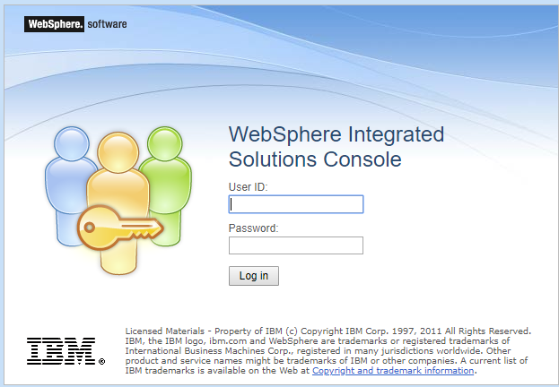

Log into the WebSphere Administration console as wasadm/*password (as entered and noted during the VMware installation)*

### Unlocking WebSphere if the security requires re-configuration

NB During this process it is possible to lock out the WebSphere Administrator to fix this and allow the Administrator to correct any configuration issues the security.xml file can be edited using vi **(back up this file first!)** to temporarily disable logon security by changing the first occurrence of enabled=true to enabled=false:

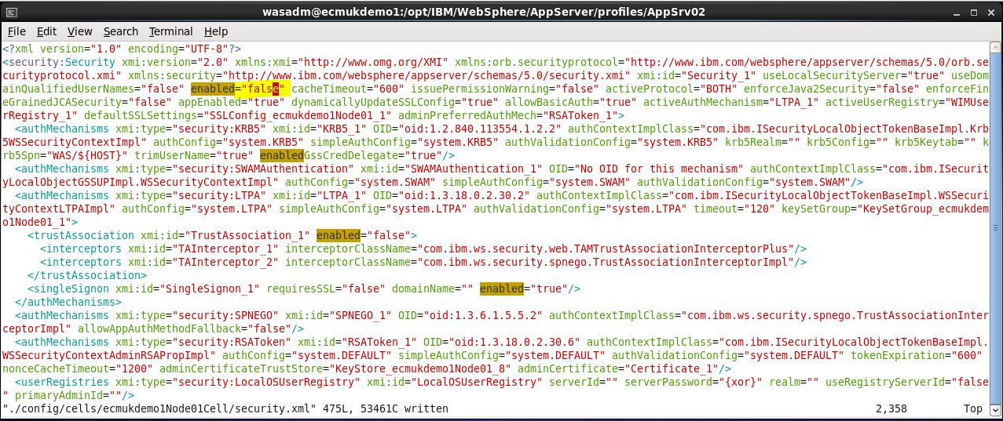

As highlighted above

In order to stop a WebSphere process ‘stuck’ with an unusable wasdmin user you may also have to force the process out of memory using

**ps -eaf|grep was (**or for a more selective list **ps -eaf|grep AppSrv02 )**

and then from the process identity

**kill -9 11474**

(or whatever the process Id as highlighted in the example below)

[wasadm@ecmukdemo1 bin]$ ps -eaf|grep was

wasadm 9067 3894 0 07:27 pts/1 00:00:00 grep was

wasadm **11474**  **1 12 Mar12 pts/1 06:55:13 /opt/IBM/WebSphere/AppServer/java\_1.7\_64/bin/java -Dosgi.install.area=/opt/IBM/WebSphere/AppServer -Dwas.status.socket=19082 -Dosgi.configuration.area=/opt/IBM/WebSphere/AppServer/profiles/AppSrv02/servers/server1/configuration** -Djava.awt.headless=true -Dosgi.framework.extensions=com.ibm.cds,com.ibm.ws.eclipse.adaptors -Xshareclasses:name=webspherev85\_1.7\_64\_%g,nonFatal -Dcom.ibm.xtq.processor.overrideSecureProcessing=true -Xcheck:dump -Xbootclasspath/p:/opt/IBM/WebSphere/AppServer/java\_1.7\_64/jre/lib/ibmorb.jar -classpath /opt/IBM/WebSphere/AppServer/profiles/AppSrv02/properties:/opt/IBM/WebSphere/AppServer/properties:/opt/IBM/WebSphere/AppServer/lib/startup.jar:/opt/IBM/WebSphere/AppServer/lib/bootstrap.jar:/opt/IBM/WebSphere/AppServer/lib/jsf-nls.jar:/opt/IBM/WebSphere/AppServer/lib/lmproxy.jar:/opt/IBM/WebSphere/AppServer/lib/urlprotocols.jar:/opt/IBM/WebSphere/AppServer/deploytool/itp/batchboot.jar:/opt/IBM/WebSphere/AppServer/deploytool/itp/batch2.jar:/opt/IBM/WebSphere/AppServer/java\_1.7\_64/lib/tools.jar -Dibm.websphere.internalClassAccessMode=allow -Xms1024m -Xmx3096m -Xcompressedrefs -Xscmaxaot4M -Xscmx60M -Dws.ext.dirs=/opt/IBM/WebSphere/AppServer/java\_1.7\_64/lib:/opt/IBM/WebSphere/AppServer/profiles/AppSrv02/classes:/opt/IBM/WebSphere/AppServer/classes:/opt/IBM/WebSphere/AppServer/lib:/opt/IBM/WebSphere/AppServer/installedChannels:/opt/IBM/WebSphere/AppServer/lib/ext:/opt/IBM/WebSphere/AppServer/web/help:/opt/IBM/WebSphere/AppServer/deploytool/itp/plugins/com.ibm.etools.ejbdeploy/runtime -Dderby.system.home=/opt/IBM/WebSphere/AppServer/derby -Dcom.ibm.itp.location=/opt/IBM/WebSphere/AppServer/bin -Djava.util.logging.configureByServer=true -Duser.install.root=/opt/IBM/WebSphere/AppServer/profiles/AppSrv02 -Djava.ext.dirs=/opt/IBM/WebSphere/AppServer/tivoli/tam:/opt/IBM/WebSphere/AppServer/java\_1.7\_64/jre/lib/ext -Djavax.management.builder.initial=com.ibm.ws.management.PlatformMBeanServerBuilder -Dpython.cachedir=/opt/IBM/WebSphere/AppServer/profiles/AppSrv02/temp/cachedir -Dwas.install.root=/opt/IBM/WebSphere/AppServer -Djava.util.logging.manager=com.ibm.ws.bootstrap.WsLogManager -Dserver.root=/opt/IBM/WebSphere/AppServer/profiles/AppSrv02 -Dcom.ibm.security.jgss.debug=off -Dcom.ibm.security.krb5.Krb5Debug=off -Djaxws.payload.highFidelity=true -Dicm.shared.folder=/opt/IBM/CaseManagement/configure/properties -DmaxHttpCacheAge=5 -DICMCBELogFilePattern=icm/icmcbe%g.log -Dcom.ibm.casemgmt.config.keep.alive.interval=30000 -Djava.library.path=/opt/IBM/WebSphere/AppServer/lib/native/linux/x86\_64/:/opt/IBM/WebSphere/AppServer/java\_1.7\_64/jre/lib/amd64/compressedrefs:/opt/IBM/WebSphere/AppServer/java\_1.7\_64/jre/lib/amd64:/opt/IBM/WebSphere/AppServer/bin:/opt/IBM/WebSphere/AppServer/nulldllsdir:/usr/lib64:/usr/lib: -Djava.endorsed.dirs=/opt/IBM/WebSphere/AppServer/endorsed\_apis:/opt/IBM/WebSphere/AppServer/java\_1.7\_64/jre/lib/endorsed:/opt/IBM/WebSphere/AppServer/java/jre/lib/endorsed -Djava.security.auth.login.config=/opt/IBM/WebSphere/AppServer/profiles/AppSrv02/properties/wsjaas.conf -Djava.security.policy=/opt/IBM/WebSphere/AppServer/profiles/AppSrv02/properties/server.policy com.ibm.wsspi.bootstrap.WSPreLauncher -nosplash -application com.ibm.ws.bootstrap.WSLauncher com.ibm.ws.runtime.WsServer /opt/IBM/WebSphere/AppServer/profiles/AppSrv02/config ecmukdemo1Node01Cell ecmukdemo1Node01 server1

After making this change and restarting the WebSphere application server you will see a login with no password prompt:

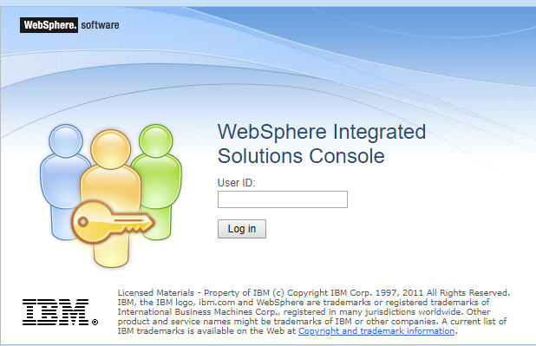

So now you can just log in as the wasadm administrator (or any name you like!) and you will be straight into the system as the administrator.

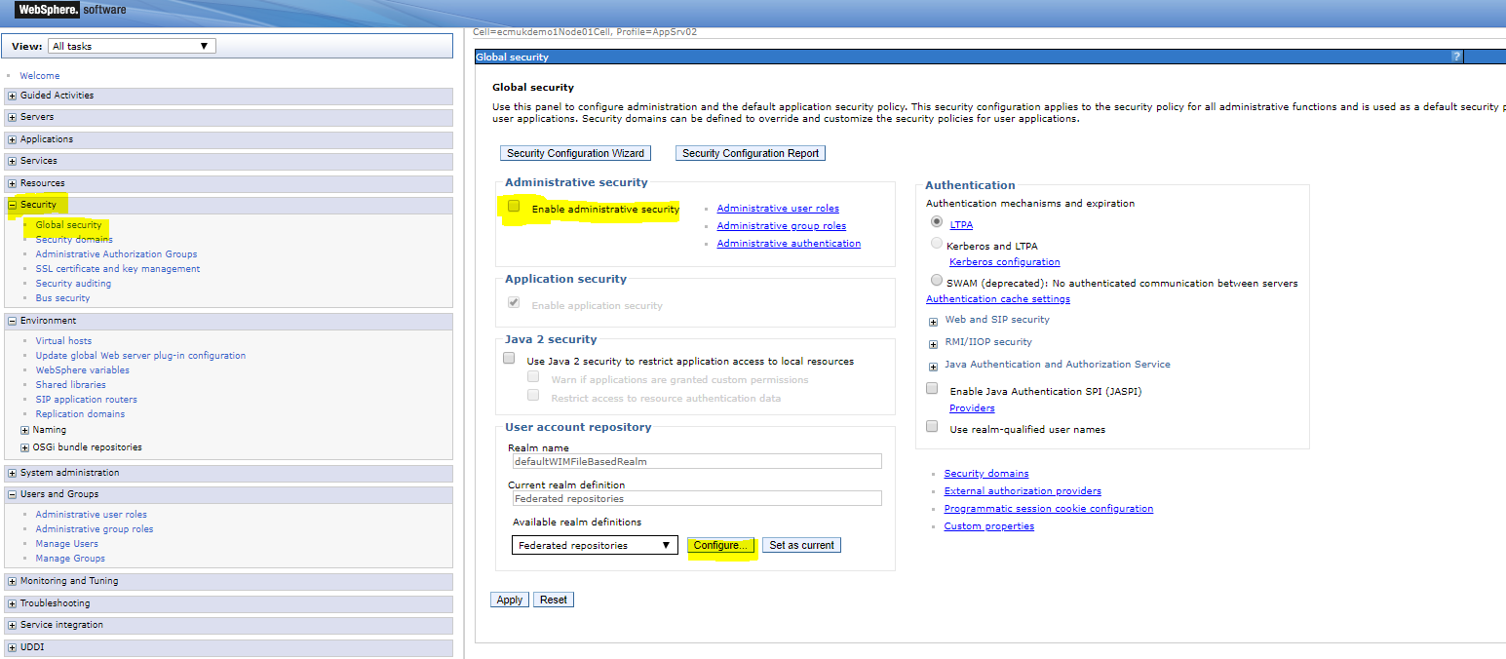

**Select Security – Global Security** and **Configure** to edit the LDAP settings required

(NB note as highlighted, the true/to false change we made to the security.xml file shows as an unticked box against the ‘Enable administrative security’ tick box above.)

After clicking Configure you see the following

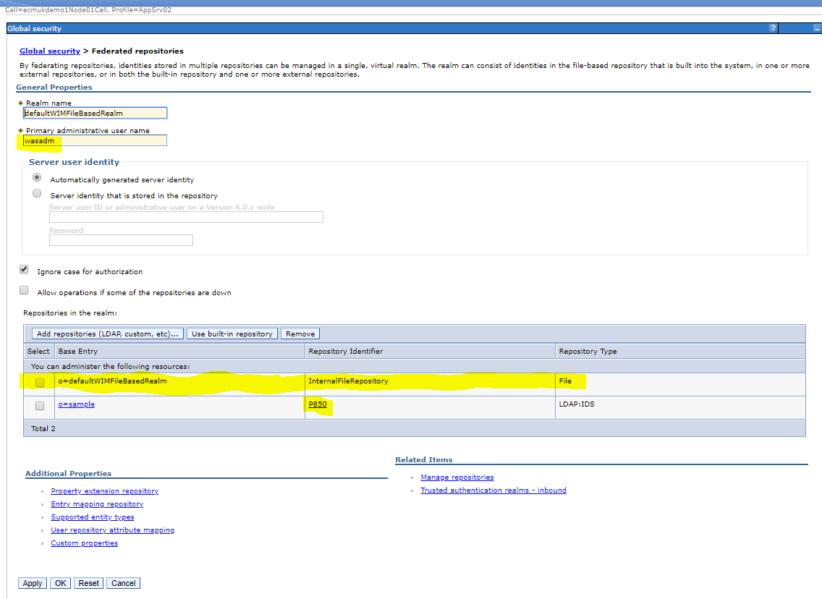

wasadm is the WIM based (security file referenced) repository user and we have added a P850 server repository which points to an IBM Tivoli Directory Server service (on a separate VMware server) for LDAP authentication

This example is very simple as the BaseDN shows

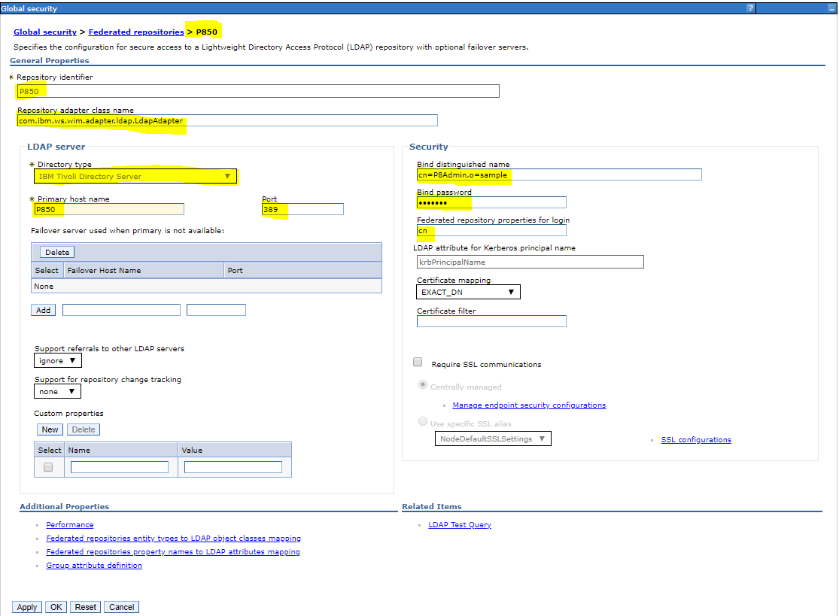

The server host name is P850 and can be pinged (set with an I/P address of 10.10.10.10 )

With an entry in /etc/hosts.

The base domain organisational unit of **o=sample** (the first installed default root for the LDAP)

So the user **P8Admin** has a Base Distinguished name of **cn=P8Admin,o=sample** but this user is not set up correctly so we are going to use **cn=root**

The standard LDAP port of 389 is used

(**NB ensure this port 389 is added to the list of ports allowed for access in the Server Firewall!**)

Bottom right is a link LDAP Test Query which if you click gives the following screen

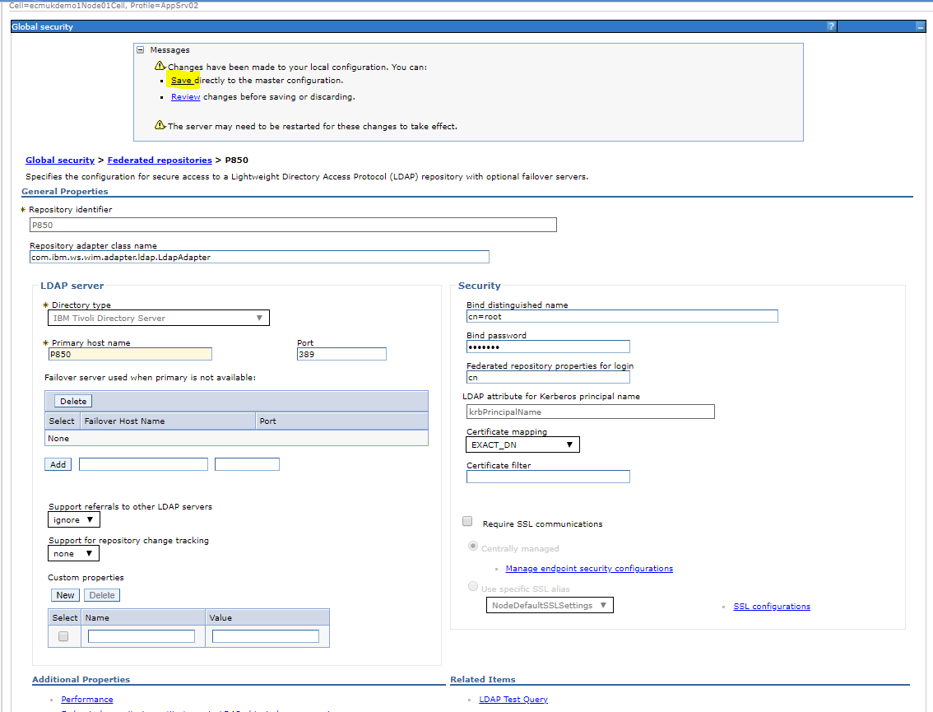

Changes made to use **cn=root** as the Base distinguished name (user authenticated to search the P850 LDAP server on port 389)

After clicking **Apply** we also need to click **Save** (highlighted) to update the WebSphere Master configuration.

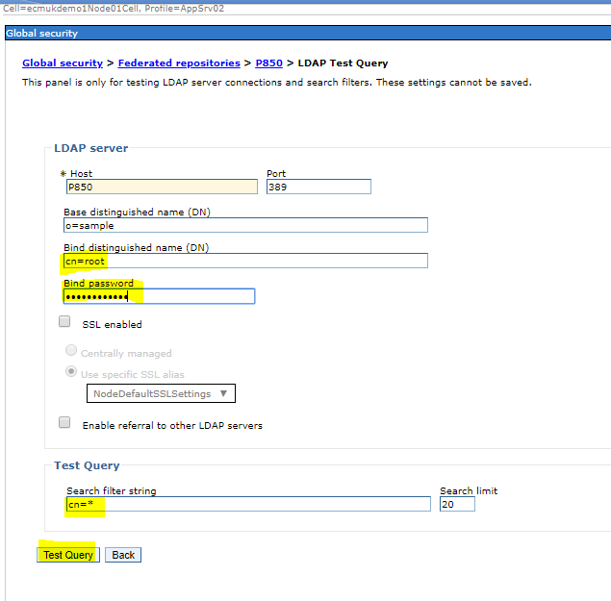

Now we go back in and select the LDAP Test Query and enter the Bind password and a search

(I have used the cn=\* LDAP search which will return the complete user list! )

NB Obviously this would not be advisable in a real production environment, although the search is usually limited to returning just the first 20 entries.

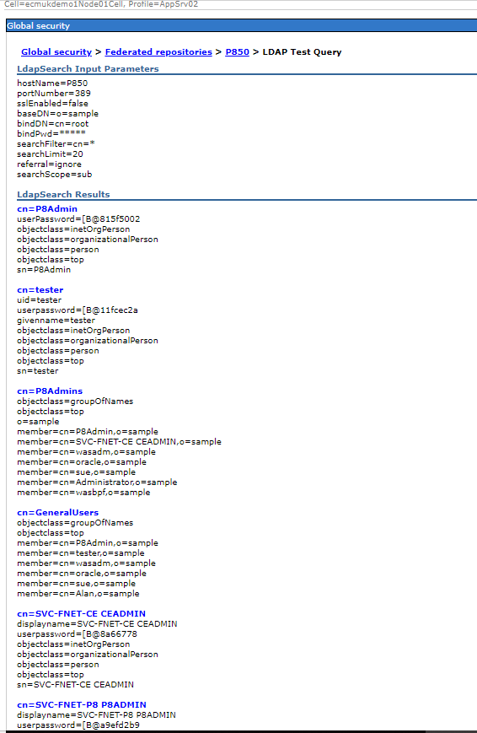

Now we need to remove the WIM based entry from the Federated LDAP list:

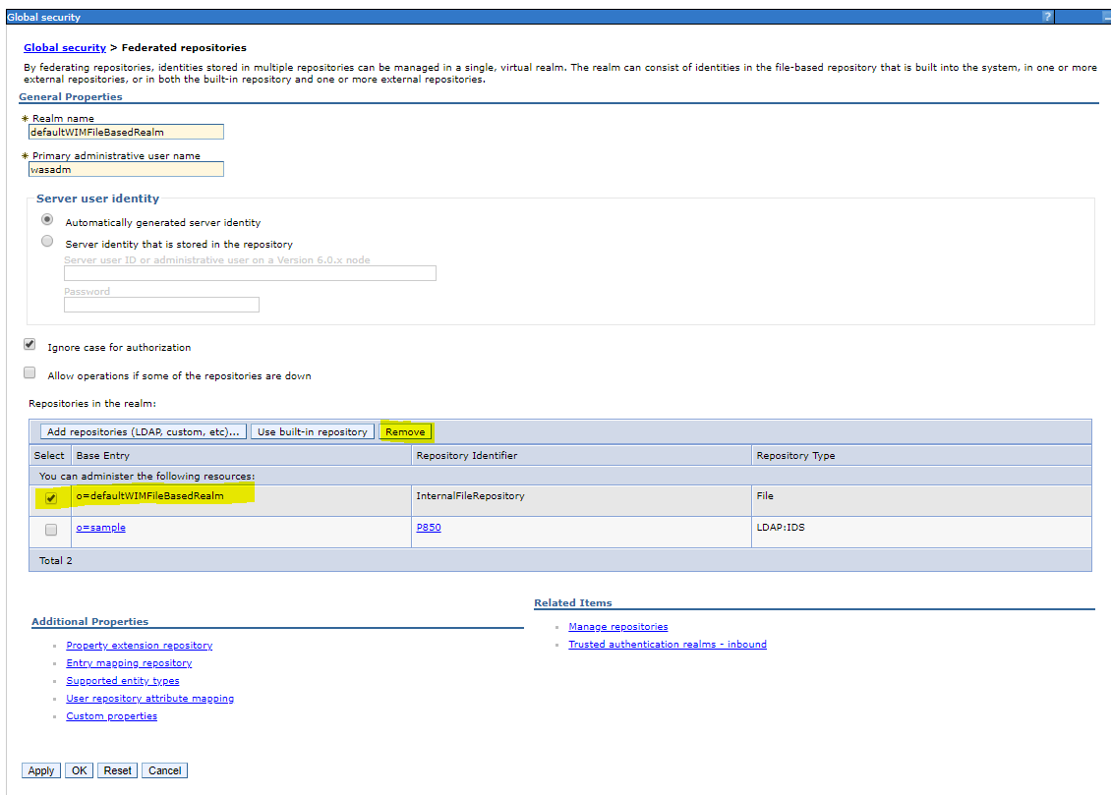

And click to save

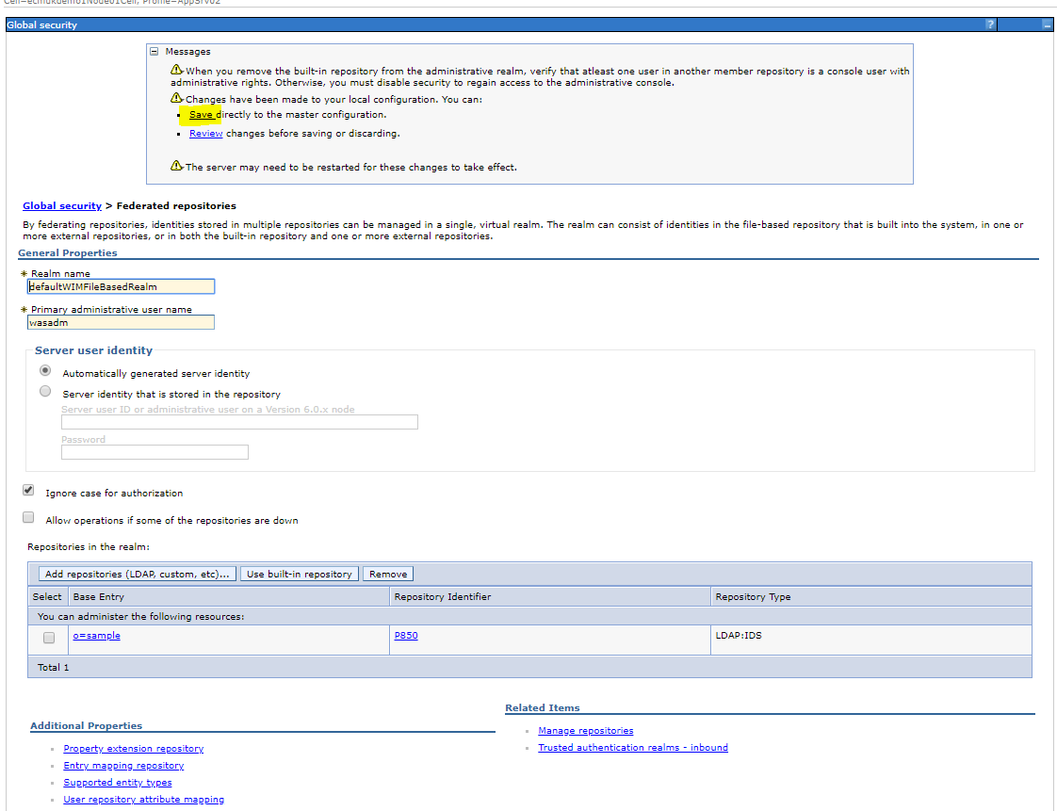

Then at the bottom of the page Click Apply:

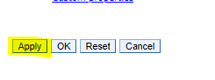

And save again!

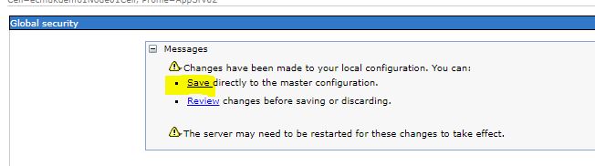

Then

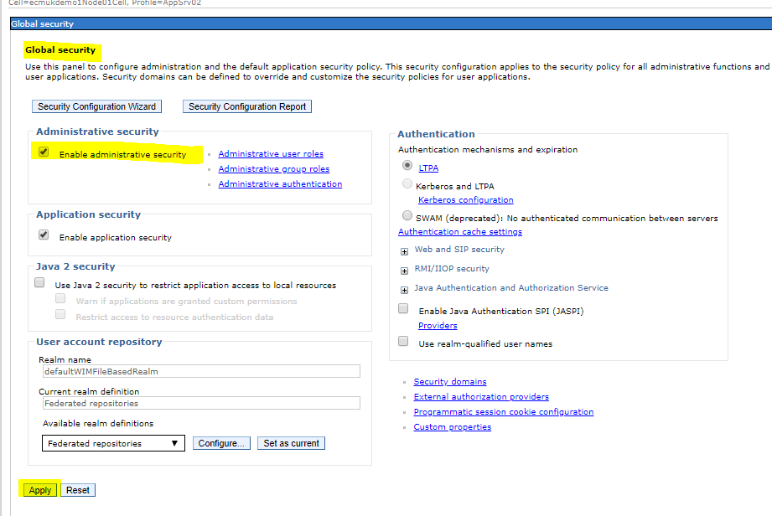

Select the tick box to **Enable administrative security**

And click Apply

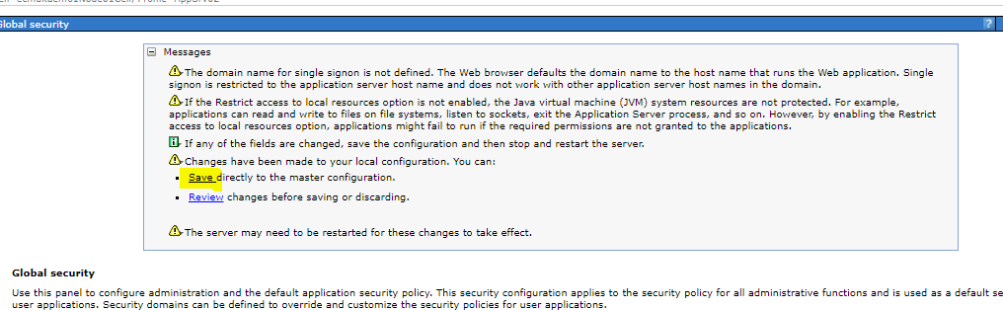

Then Click save

Additional WebSphere Administrator roles can be added either from the above screen, or:

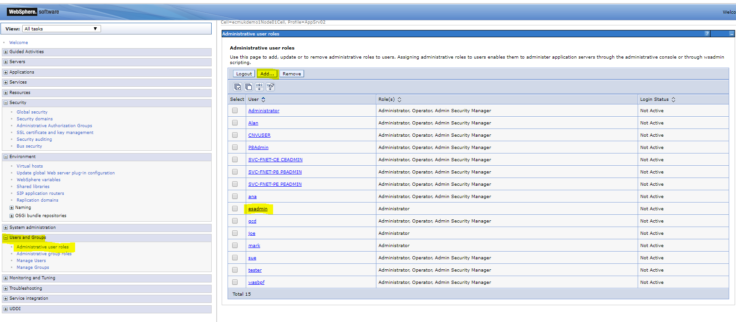

From Users and Groups -> Administrative roles as shown above.

Log-out and restart the WebSphere server process for the changes you have made to take affect

[wasadm@ecmukdemo1 bin]$ **./stopServer.sh server1**

ADMU0116I: Tool information is being logged in file

/opt/IBM/WebSphere/AppServer/profiles/AppSrv02/logs/server1/stopServer.log

ADMU0128I: Starting tool with the AppSrv02 profile

ADMU3100I: Reading configuration for server: server1

ADMU3201I: Server stop request issued. Waiting for stop status.

ADMU4000I: Server server1 stop completed.

[wasadm@ecmukdemo1 bin]$ **./startServer.sh server1**

ADMU0116I: Tool information is being logged in file

/opt/IBM/WebSphere/AppServer/profiles/AppSrv02/logs/server1/startServer.log

ADMU0128I: Starting tool with the AppSrv02 profile

ADMU3100I: Reading configuration for server: server1

ADMU3200I: Server launched. Waiting for initialization status.

ADMU3000I: Server server1 open for e-business; process id is 12274

[wasadm@ecmukdemo1 bin]$

Now we have the logon with the password prompt back again:

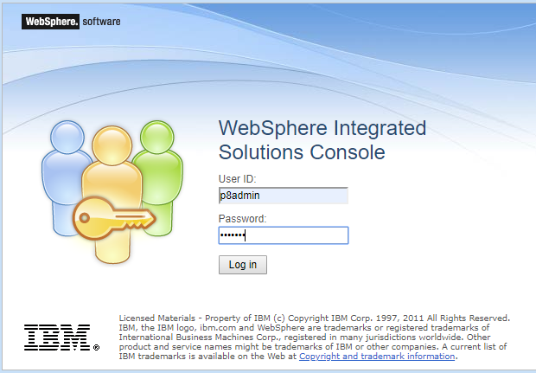

And now we can get in

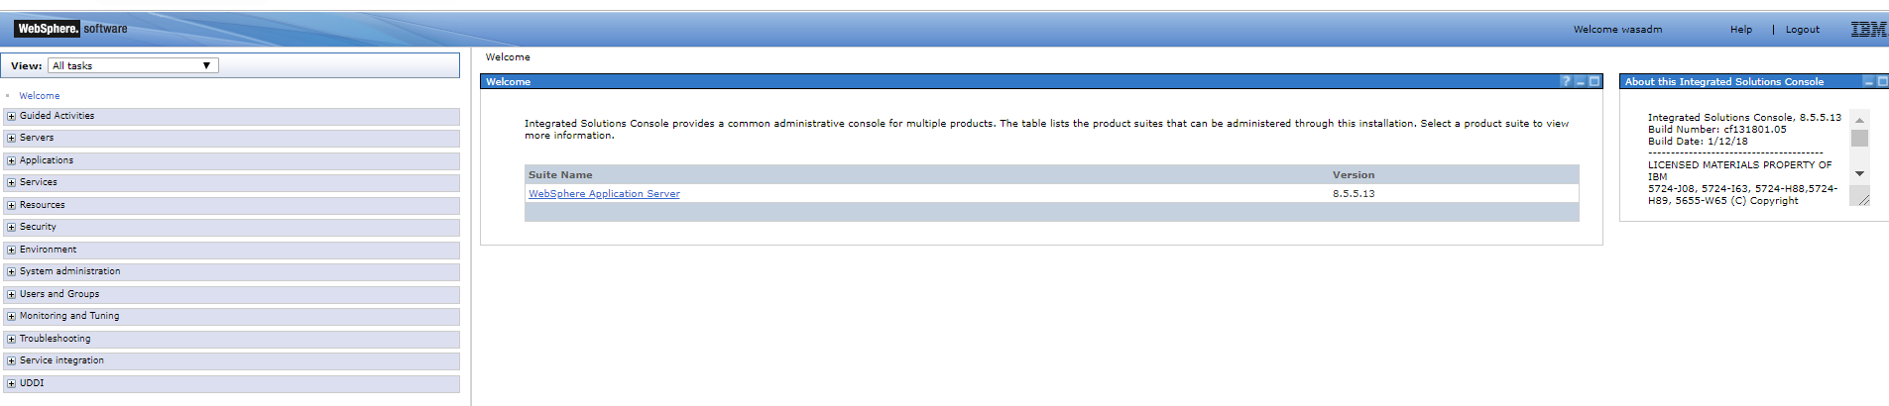

And the box is ticked to show LDAP authentication is active

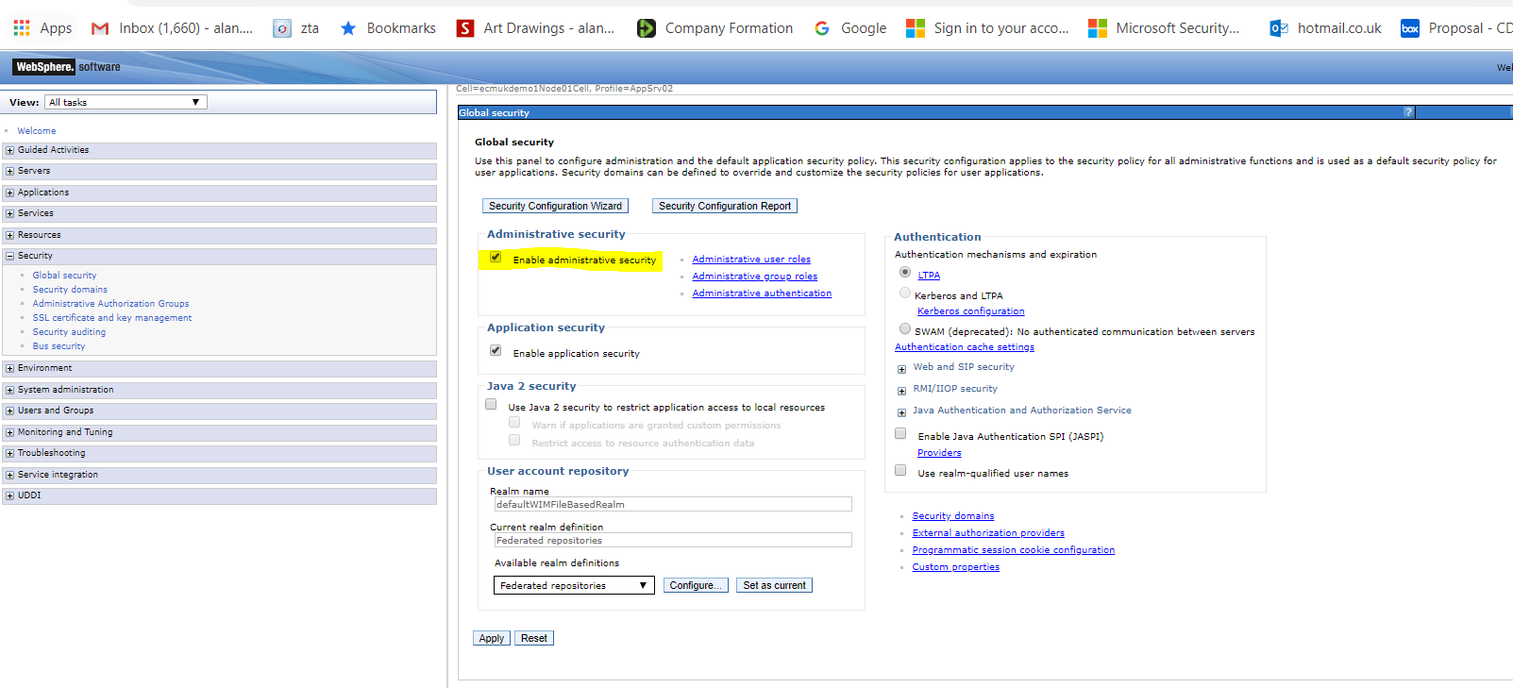

Working settings in our example system are now:

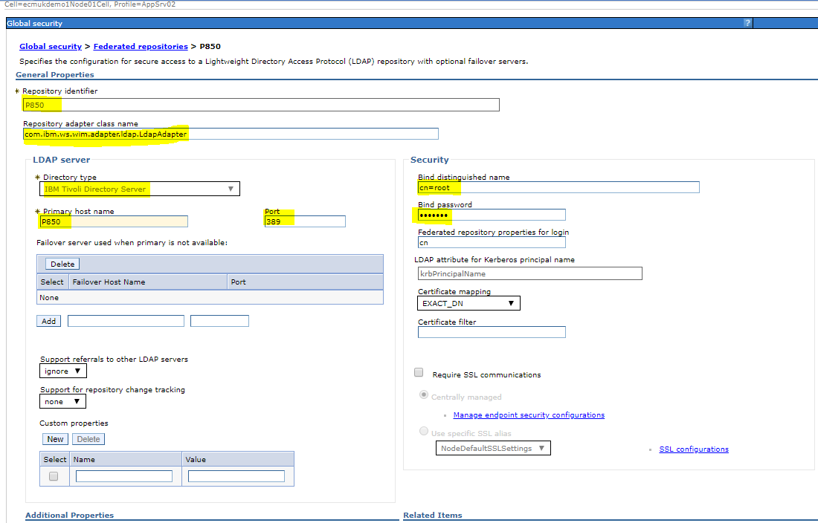

# Appendix O- yum -y install redhat-lsb libXScrnSaver

[root@ECMUKDEMO6 ~]# **yum -y install redhat-lsb libXScrnSaver**

Updating Subscription Management repositories.

Last metadata expiration check: 0:05:10 ago on Sun 14 Jul 2019 01:02:30 PM PDT.

Dependencies resolved.

===========================================================================================================

Package Arch Version Repository Size

===========================================================================================================

Installing:

libXScrnSaver x86\_64 1.2.3-1.el8 rhel-8-for-x86\_64-appstream-rpms 31 k

redhat-lsb x86\_64 4.1-47.el8 rhel-8-for-x86\_64-appstream-rpms 30 k

Installing dependencies:

perl-ExtUtils-Install noarch 2.14-4.el8 rhel-8-for-x86\_64-appstream-rpms 46 k

perl-IO-Compress noarch 2.081-1.el8 rhel-8-for-x86\_64-appstream-rpms 258 k

perl-HTML-Tagset noarch 3.20-33.el8 rhel-8-for-x86\_64-appstream-rpms 24 k

perl-CGI noarch 4.38-2.el8 rhel-8-for-x86\_64-appstream-rpms 208 k

go-srpm-macros noarch 2-16.el8 rhel-8-for-x86\_64-appstream-rpms 14 k

perl-Sub-Install noarch 0.928-14.el8 rhel-8-for-x86\_64-appstream-rpms 27 k

perl-Algorithm-Diff noarch 1.1903-9.el8 rhel-8-for-x86\_64-appstream-rpms 52 k

perl-XML-SAX noarch 1.00-1.el8 rhel-8-for-x86\_64-appstream-rpms 65 k

perl-Text-Unidecode noarch 1.30-5.el8 rhel-8-for-x86\_64-appstream-rpms 149 k

perl-Data-Dump noarch 1.23-7.el8 rhel-8-for-x86\_64-appstream-rpms 37 k

perl-Digest-HMAC noarch 1.03-17.el8 rhel-8-for-x86\_64-appstream-rpms 20 k

perl-CPAN noarch 2.18-397.el8 rhel-8-for-x86\_64-appstream-rpms 554 k

perl-Module-Load-Conditional noarch 0.68-395.el8 rhel-8-for-x86\_64-appstream-rpms 24 k

perl-WWW-RobotRules noarch 6.02-18.el8 rhel-8-for-x86\_64-appstream-rpms 22 k

perl-libwww-perl noarch 6.34-1.el8 rhel-8-for-x86\_64-appstream-rpms 212 k

python-srpm-macros noarch 3-37.el8 rhel-8-for-x86\_64-appstream-rpms 14 k

perl-Pod-Checker noarch 4:1.73-395.el8 rhel-8-for-x86\_64-appstream-rpms 33 k

perl-File-HomeDir noarch 1.002-4.el8 rhel-8-for-x86\_64-appstream-rpms 62 k

perl-Pod-LaTeX noarch 0.61-302.el8 rhel-8-for-x86\_64-appstream-rpms 41 k

redhat-rpm-config noarch 116-1.el8 rhel-8-for-x86\_64-appstream-rpms 82 k

perl-Net-HTTP noarch 6.17-2.el8 rhel-8-for-x86\_64-appstream-rpms 43 k

perl-File-Listing noarch 6.04-17.el8 rhel-8-for-x86\_64-appstream-rpms 18 k

perl-TimeDate noarch 1:2.30-13.el8 rhel-8-for-x86\_64-appstream-rpms 53 k

perl-ExtUtils-Manifest noarch 1.70-395.el8 rhel-8-for-x86\_64-appstream-rpms 37 k

perl-HTTP-Cookies noarch 6.04-2.el8 rhel-8-for-x86\_64-appstream-rpms 39 k

perl-ExtUtils-MM-Utils noarch 1:7.34-1.el8 rhel-8-for-x86\_64-appstream-rpms 17 k

perl-Software-License noarch 0.103013-2.el8 rhel-8-for-x86\_64-appstream-rpms 137 k

perl-local-lib noarch 2.000024-2.el8 rhel-8-for-x86\_64-appstream-rpms 74 k

perl-Encode-Locale noarch 1.05-9.el8 rhel-8-for-x86\_64-appstream-rpms 21 k

perl-Perl-OSType noarch 1.010-396.el8 rhel-8-for-x86\_64-appstream-rpms 29 k

perl-NTLM noarch 1.09-17.el8 rhel-8-for-x86\_64-appstream-rpms 24 k

perl-Module-Pluggable noarch 2:5.2-7.el8 rhel-8-for-x86\_64-appstream-rpms 34 k

perl-Text-Glob noarch 0.11-4.el8 rhel-8-for-x86\_64-appstream-rpms 17 k

perl-ExtUtils-CBuilder noarch 1:0.280230-2.el8 rhel-8-for-x86\_64-appstream-rpms 48 k

qt5-srpm-macros noarch 5.11.1-2.el8 rhel-8-for-x86\_64-appstream-rpms 11 k

perl-HTTP-Negotiate noarch 6.01-19.el8 rhel-8-for-x86\_64-appstream-rpms 22 k

perl-Locale-Codes noarch 3.57-1.el8 rhel-8-for-x86\_64-appstream-rpms 310 k

perl-CPAN-Meta noarch 2.150010-396.el8 rhel-8-for-x86\_64-appstream-rpms 191 k

perl-Data-OptList noarch 0.110-6.el8 rhel-8-for-x86\_64-appstream-rpms 31 k

efi-srpm-macros noarch 3-2.el8 rhel-8-for-x86\_64-appstream-rpms 22 k

perl-Module-Metadata noarch 1.000033-395.el8 rhel-8-for-x86\_64-appstream-rpms 45 k

perl-autodie noarch 2.29-396.el8 rhel-8-for-x86\_64-appstream-rpms 98 k

perl-Pod-Html noarch 1.22.02-416.el8 rhel-8-for-x86\_64-appstream-rpms 87 k

perl-Locale-Maketext noarch 1.28-396.el8 rhel-8-for-x86\_64-appstream-rpms 99 k

rust-srpm-macros noarch 5-2.el8 rhel-8-for-x86\_64-appstream-rpms 9.3 k

perl-Data-Section noarch 0.200007-3.el8 rhel-8-for-x86\_64-appstream-rpms 30 k

perl-Params-Check noarch 1:0.38-395.el8 rhel-8-for-x86\_64-appstream-rpms 24 k

ocaml-srpm-macros noarch 5-4.el8 rhel-8-for-x86\_64-appstream-rpms 9.5 k

perl-IPC-Cmd noarch 2:1.02-1.el8 rhel-8-for-x86\_64-appstream-rpms 43 k

perl-IO-Zlib noarch 1:1.10-416.el8 rhel-8-for-x86\_64-appstream-rpms 80 k

perl-JSON-PP noarch 1:2.97.001-3.el8 rhel-8-for-x86\_64-appstream-rpms 68 k

perl-IPC-System-Simple noarch 1.25-17.el8 rhel-8-for-x86\_64-appstream-rpms 43 k

perl-ExtUtils-MakeMaker noarch 1:7.34-1.el8 rhel-8-for-x86\_64-appstream-rpms 301 k

perl-Try-Tiny noarch 0.30-2.el8 rhel-8-for-x86\_64-appstream-rpms 45 k

perl-Test-Simple noarch 1:1.302135-1.el8 rhel-8-for-x86\_64-appstream-rpms 516 k

perl-Env noarch 1.04-395.el8 rhel-8-for-x86\_64-appstream-rpms 21 k

perl-Test-Harness noarch 1:3.42-1.el8 rhel-8-for-x86\_64-appstream-rpms 279 k

perl-Package-Generator noarch 1.106-11.el8 rhel-8-for-x86\_64-appstream-rpms 27 k

ghc-srpm-macros noarch 1.4.2-7.el8 rhel-8-for-x86\_64-appstream-rpms 9.4 k

perl-Class-ISA noarch 0.36-1022.el8 rhel-8-for-x86\_64-appstream-rpms 15 k

perl-Archive-Tar noarch 2.30-1.el8 rhel-8-for-x86\_64-appstream-rpms 79 k

perl-IO-HTML noarch 1.001-10.el8 rhel-8-for-x86\_64-appstream-rpms 28 k

perl-inc-latest noarch 2:0.500-9.el8 rhel-8-for-x86\_64-appstream-rpms 25 k

perl-File-Which noarch 1.22-2.el8 rhel-8-for-x86\_64-appstream-rpms 24 k

perl-Archive-Zip noarch 1.60-3.el8 rhel-8-for-x86\_64-appstream-rpms 108 k

perl-ExtUtils-Command noarch 1:7.34-1.el8 rhel-8-for-x86\_64-appstream-rpms 19 k

python3-rpm-macros noarch 3-37.el8 rhel-8-for-x86\_64-appstream-rpms 13 k

perl-Module-Load noarch 1:0.32-395.el8 rhel-8-for-x86\_64-appstream-rpms 19 k

perl-Module-CoreList noarch 1:5.20181130-1.el8 rhel-8-for-x86\_64-appstream-rpms 87 k

perl-CPAN-Meta-YAML noarch 0.018-397.el8 rhel-8-for-x86\_64-appstream-rpms 34 k

perl-File-CheckTree noarch 4.42-303.el8 rhel-8-for-x86\_64-appstream-rpms 23 k

perl-Sub-Exporter noarch 0.987-15.el8 rhel-8-for-x86\_64-appstream-rpms 73 k

perl-Pod-Parser noarch 1.63-396.el8 rhel-8-for-x86\_64-appstream-rpms 108 k

perl-MRO-Compat noarch 0.13-4.el8 rhel-8-for-x86\_64-appstream-rpms 24 k

perl-Text-Template noarch 1.51-1.el8 rhel-8-for-x86\_64-appstream-rpms 64 k

perl-HTTP-Date noarch 6.02-18.el8 rhel-8-for-x86\_64-appstream-rpms 19 k

perl-B-Lint noarch 1.20-11.el8 rhel-8-for-x86\_64-appstream-rpms 25 k

openblas-srpm-macros noarch 2-2.el8 rhel-8-for-x86\_64-appstream-rpms 8.0 k

perl-srpm-macros noarch 1-25.el8 rhel-8-for-x86\_64-appstream-rpms 11 k

perl-Text-Diff noarch 1.45-2.el8 rhel-8-for-x86\_64-appstream-rpms 45 k

perl-Pod-Plainer noarch 1.04-7.el8 rhel-8-for-x86\_64-appstream-rpms 14 k

perl-Net-Ping noarch 2.55-416.el8 rhel-8-for-x86\_64-appstream-rpms 101 k

perl-CPAN-Meta-Requirements noarch 2.140-396.el8 rhel-8-for-x86\_64-appstream-rpms 37 k

perl-LWP-MediaTypes noarch 6.02-14.el8 rhel-8-for-x86\_64-appstream-rpms 29 k

perl-HTTP-Message noarch 6.18-1.el8 rhel-8-for-x86\_64-appstream-rpms 100 k

perl-Locale-Maketext-Simple noarch 1:0.21-416.el8 rhel-8-for-x86\_64-appstream-rpms 78 k

perl-XML-NamespaceSupport noarch 1.12-4.el8 rhel-8-for-x86\_64-appstream-rpms 30 k

perl-Module-Build noarch 2:0.42.24-5.el8 rhel-8-for-x86\_64-appstream-rpms 273 k

perl-ExtUtils-ParseXS noarch 1:3.35-2.el8 rhel-8-for-x86\_64-appstream-rpms 83 k

perl-XML-SAX-Base noarch 1.09-4.el8 rhel-8-for-x86\_64-appstream-rpms 35 k

perl-XML-LibXML x86\_64 1:2.0132-2.el8 rhel-8-for-x86\_64-appstream-rpms 372 k

perl-Time-HiRes x86\_64 1.9758-1.el8 rhel-8-for-x86\_64-appstream-rpms 61 k

perl-Params-Util x86\_64 1.07-22.el8 rhel-8-for-x86\_64-appstream-rpms 44 k

redhat-lsb-core x86\_64 4.1-47.el8 rhel-8-for-x86\_64-appstream-rpms 45 k

perl-Sys-Syslog x86\_64 0.35-397.el8 rhel-8-for-x86\_64-appstream-rpms 50 k

redhat-lsb-cxx x86\_64 4.1-47.el8 rhel-8-for-x86\_64-appstream-rpms 23 k

annobin x86\_64 8.64-1.el8 rhel-8-for-x86\_64-appstream-rpms 187 k

perl-Compress-Raw-Zlib x86\_64 2.081-1.el8 rhel-8-for-x86\_64-appstream-rpms 68 k

perl-HTML-Parser x86\_64 3.72-14.el8 rhel-8-for-x86\_64-appstream-rpms 119 k

perl-devel x86\_64 4:5.26.3-416.el8 rhel-8-for-x86\_64-appstream-rpms 599 k

dwz x86\_64 0.12-9.el8 rhel-8-for-x86\_64-appstream-rpms 109 k

perl-Compress-Raw-Bzip2 x86\_64 2.081-1.el8 rhel-8-for-x86\_64-appstream-rpms 41 k

systemtap-sdt-devel x86\_64 4.0-7.el8 rhel-8-for-x86\_64-appstream-rpms 79 k

perl-Devel-Size x86\_64 0.81-2.el8 rhel-8-for-x86\_64-appstream-rpms 34 k

redhat-lsb-languages x86\_64 4.1-47.el8 rhel-8-for-x86\_64-appstream-rpms 25 k

perl-Text-Soundex x86\_64 3.05-8.el8 rhel-8-for-x86\_64-appstream-rpms 32 k

perl-Digest-SHA x86\_64 1:6.02-1.el8 rhel-8-for-x86\_64-appstream-rpms 66 k

libpng12 x86\_64 1.2.57-5.el8 rhel-8-for-x86\_64-appstream-rpms 160 k

perl-version x86\_64 6:0.99.24-1.el8 rhel-8-for-x86\_64-appstream-rpms 67 k

mesa-libGLU x86\_64 9.0.0-15.el8 rhel-8-for-x86\_64-appstream-rpms 185 k

redhat-lsb-submod-security x86\_64 4.1-47.el8 rhel-8-for-x86\_64-appstream-rpms 22 k

redhat-lsb-submod-multimedia x86\_64 4.1-47.el8 rhel-8-for-x86\_64-appstream-rpms 22 k

redhat-lsb-printing x86\_64 4.1-47.el8 rhel-8-for-x86\_64-appstream-rpms 23 k

perl-Compress-Bzip2 x86\_64 2.26-6.el8 rhel-8-for-x86\_64-appstream-rpms 72 k

redhat-lsb-desktop x86\_64 4.1-47.el8 rhel-8-for-x86\_64-appstream-rpms 26 k

ncurses-compat-libs x86\_64 6.1-7.20180224.el8 rhel-8-for-x86\_64-baseos-rpms 331 k

postfix x86\_64 2:3.3.1-8.el8 rhel-8-for-x86\_64-baseos-rpms 1.5 M

m4 x86\_64 1.4.18-7.el8 rhel-8-for-x86\_64-baseos-rpms 223 k

spax x86\_64 1.5.3-13.el8 rhel-8-for-x86\_64-baseos-rpms 217 k

mailx x86\_64 12.5-29.el8 rhel-8-for-x86\_64-baseos-rpms 257 k

Installing weak dependencies:

perl-Module-Runtime noarch 0.016-2.el8 rhel-8-for-x86\_64-appstream-rpms 26 k

perl-TermReadKey x86\_64 2.37-7.el8 rhel-8-for-x86\_64-appstream-rpms 40 k

Transaction Summary

===========================================================================================================

Install 124 Packages

Total download size: 11 M

Installed size: 30 M

Downloading Packages:

(1/124): perl-HTML-Tagset-3.20-33.el8.noarch.rpm 18 kB/s | 24 kB 00:01

(2/124): perl-ExtUtils-Install-2.14-4.el8.noarch.rpm 34 kB/s | 46 kB 00:01

(3/124): perl-IO-Compress-2.081-1.el8.noarch.rpm 169 kB/s | 258 kB 00:01

(4/124): perl-CGI-4.38-2.el8.noarch.rpm 878 kB/s | 208 kB 00:00

(5/124): go-srpm-macros-2-16.el8.noarch.rpm 40 kB/s | 14 kB 00:00

(6/124): perl-Sub-Install-0.928-14.el8.noarch.rpm 101 kB/s | 27 kB 00:00

(7/124): perl-Algorithm-Diff-1.1903-9.el8.noarch.rpm 149 kB/s | 52 kB 00:00

(8/124): perl-XML-SAX-1.00-1.el8.noarch.rpm 200 kB/s | 65 kB 00:00

(9/124): perl-Text-Unidecode-1.30-5.el8.noarch.rpm 470 kB/s | 149 kB 00:00

(10/124): perl-Data-Dump-1.23-7.el8.noarch.rpm 111 kB/s | 37 kB 00:00

(11/124): perl-Digest-HMAC-1.03-17.el8.noarch.rpm 77 kB/s | 20 kB 00:00

(12/124): perl-CPAN-2.18-397.el8.noarch.rpm 1.6 MB/s | 554 kB 00:00

(13/124): perl-Module-Load-Conditional-0.68-395.el8.noarch.rpm 92 kB/s | 24 kB 00:00

(14/124): perl-WWW-RobotRules-6.02-18.el8.noarch.rpm 65 kB/s | 22 kB 00:00

(15/124): perl-libwww-perl-6.34-1.el8.noarch.rpm 831 kB/s | 212 kB 00:00

(16/124): python-srpm-macros-3-37.el8.noarch.rpm 70 kB/s | 14 kB 00:00

(17/124): perl-Pod-Checker-1.73-395.el8.noarch.rpm 132 kB/s | 33 kB 00:00

(18/124): perl-File-HomeDir-1.002-4.el8.noarch.rpm 288 kB/s | 62 kB 00:00

(19/124): perl-Pod-LaTeX-0.61-302.el8.noarch.rpm 192 kB/s | 41 kB 00:00

(20/124): perl-Net-HTTP-6.17-2.el8.noarch.rpm 140 kB/s | 43 kB 00:00

(21/124): perl-File-Listing-6.04-17.el8.noarch.rpm 56 kB/s | 18 kB 00:00

(22/124): redhat-rpm-config-116-1.el8.noarch.rpm 156 kB/s | 82 kB 00:00

(23/124): perl-ExtUtils-Manifest-1.70-395.el8.noarch.rpm 183 kB/s | 37 kB 00:00

(24/124): perl-TimeDate-2.30-13.el8.noarch.rpm 248 kB/s | 53 kB 00:00

(25/124): perl-ExtUtils-MM-Utils-7.34-1.el8.noarch.rpm 78 kB/s | 17 kB 00:00

(26/124): perl-HTTP-Cookies-6.04-2.el8.noarch.rpm 177 kB/s | 39 kB 00:00

(27/124): perl-Software-License-0.103013-2.el8.noarch.rpm 334 kB/s | 137 kB 00:00

(28/124): perl-Encode-Locale-1.05-9.el8.noarch.rpm 106 kB/s | 21 kB 00:00

(29/124): perl-local-lib-2.000024-2.el8.noarch.rpm 186 kB/s | 74 kB 00:00

(30/124): perl-Perl-OSType-1.010-396.el8.noarch.rpm 139 kB/s | 29 kB 00:00

(31/124): perl-NTLM-1.09-17.el8.noarch.rpm 62 kB/s | 24 kB 00:00

(32/124): perl-Module-Pluggable-5.2-7.el8.noarch.rpm 156 kB/s | 34 kB 00:00

(33/124): perl-Text-Glob-0.11-4.el8.noarch.rpm 46 kB/s | 17 kB 00:00

(34/124): perl-ExtUtils-CBuilder-0.280230-2.el8.noarch.rpm 225 kB/s | 48 kB 00:00

(35/124): qt5-srpm-macros-5.11.1-2.el8.noarch.rpm 56 kB/s | 11 kB 00:00

(36/124): perl-HTTP-Negotiate-6.01-19.el8.noarch.rpm 105 kB/s | 22 kB 00:00

(37/124): perl-Module-Runtime-0.016-2.el8.noarch.rpm 125 kB/s | 26 kB 00:00

(38/124): perl-Locale-Codes-3.57-1.el8.noarch.rpm 748 kB/s | 310 kB 00:00

(39/124): perl-Data-OptList-0.110-6.el8.noarch.rpm 135 kB/s | 31 kB 00:00

(40/124): perl-CPAN-Meta-2.150010-396.el8.noarch.rpm 455 kB/s | 191 kB 00:00

(41/124): efi-srpm-macros-3-2.el8.noarch.rpm 101 kB/s | 22 kB 00:00

(42/124): perl-Module-Metadata-1.000033-395.el8.noarch.rpm 120 kB/s | 45 kB 00:00

(43/124): perl-autodie-2.29-396.el8.noarch.rpm 429 kB/s | 98 kB 00:00

(44/124): perl-Pod-Html-1.22.02-416.el8.noarch.rpm 234 kB/s | 87 kB 00:00

(45/124): perl-Locale-Maketext-1.28-396.el8.noarch.rpm 439 kB/s | 99 kB 00:00

(46/124): rust-srpm-macros-5-2.el8.noarch.rpm 47 kB/s | 9.3 kB 00:00

(47/124): perl-Data-Section-0.200007-3.el8.noarch.rpm 135 kB/s | 30 kB 00:00

(48/124): perl-Params-Check-0.38-395.el8.noarch.rpm 115 kB/s | 24 kB 00:00

(49/124): ocaml-srpm-macros-5-4.el8.noarch.rpm 46 kB/s | 9.5 kB 00:00

(50/124): perl-JSON-PP-2.97.001-3.el8.noarch.rpm 329 kB/s | 68 kB 00:00

(51/124): perl-IPC-Cmd-1.02-1.el8.noarch.rpm 196 kB/s | 43 kB 00:00

(52/124): perl-IO-Zlib-1.10-416.el8.noarch.rpm 193 kB/s | 80 kB 00:00

(53/124): perl-ExtUtils-MakeMaker-7.34-1.el8.noarch.rpm 1.2 MB/s | 301 kB 00:00

(54/124): perl-IPC-System-Simple-1.25-17.el8.noarch.rpm 108 kB/s | 43 kB 00:00

(55/124): perl-Try-Tiny-0.30-2.el8.noarch.rpm 172 kB/s | 45 kB 00:00

(56/124): perl-Test-Simple-1.302135-1.el8.noarch.rpm 1.4 MB/s | 516 kB 00:00

(57/124): perl-Env-1.04-395.el8.noarch.rpm 78 kB/s | 21 kB 00:00

(58/124): perl-Test-Harness-3.42-1.el8.noarch.rpm 835 kB/s | 279 kB 00:00

(59/124): perl-Package-Generator-1.106-11.el8.noarch.rpm 99 kB/s | 27 kB 00:00

(60/124): ghc-srpm-macros-1.4.2-7.el8.noarch.rpm 47 kB/s | 9.4 kB 00:00

(61/124): perl-Class-ISA-0.36-1022.el8.noarch.rpm 54 kB/s | 15 kB 00:00

(62/124): perl-IO-HTML-1.001-10.el8.noarch.rpm 135 kB/s | 28 kB 00:00

(63/124): perl-Archive-Tar-2.30-1.el8.noarch.rpm 199 kB/s | 79 kB 00:00

(64/124): perl-inc-latest-0.500-9.el8.noarch.rpm 117 kB/s | 25 kB 00:00

(65/124): perl-TermReadKey-2.37-7.el8.x86\_64.rpm 105 kB/s | 40 kB 00:00

(66/124): perl-File-Which-1.22-2.el8.noarch.rpm 112 kB/s | 24 kB 00:00

(67/124): perl-Archive-Zip-1.60-3.el8.noarch.rpm 295 kB/s | 108 kB 00:00

(68/124): perl-ExtUtils-Command-7.34-1.el8.noarch.rpm 57 kB/s | 19 kB 00:00

(69/124): python3-rpm-macros-3-37.el8.noarch.rpm 42 kB/s | 13 kB 00:00

(70/124): perl-Module-Load-0.32-395.el8.noarch.rpm 53 kB/s | 19 kB 00:00

(71/124): perl-CPAN-Meta-YAML-0.018-397.el8.noarch.rpm 155 kB/s | 34 kB 00:00

(72/124): perl-Module-CoreList-5.20181130-1.el8.noarch.rpm 215 kB/s | 87 kB 00:00

(73/124): perl-File-CheckTree-4.42-303.el8.noarch.rpm 102 kB/s | 23 kB 00:00

(74/124): perl-Sub-Exporter-0.987-15.el8.noarch.rpm 191 kB/s | 73 kB 00:00

(75/124): perl-Pod-Parser-1.63-396.el8.noarch.rpm 328 kB/s | 108 kB 00:00

(76/124): perl-MRO-Compat-0.13-4.el8.noarch.rpm 66 kB/s | 24 kB 00:00

(77/124): perl-Text-Template-1.51-1.el8.noarch.rpm 182 kB/s | 64 kB 00:00

(78/124): perl-HTTP-Date-6.02-18.el8.noarch.rpm 51 kB/s | 19 kB 00:00

(79/124): perl-B-Lint-1.20-11.el8.noarch.rpm 70 kB/s | 25 kB 00:00

(80/124): openblas-srpm-macros-2-2.el8.noarch.rpm 40 kB/s | 8.0 kB 00:00

(81/124): perl-srpm-macros-1-25.el8.noarch.rpm 43 kB/s | 11 kB 00:00

(82/124): perl-Pod-Plainer-1.04-7.el8.noarch.rpm 70 kB/s | 14 kB 00:00

(83/124): perl-Text-Diff-1.45-2.el8.noarch.rpm 111 kB/s | 45 kB 00:00

(84/124): perl-CPAN-Meta-Requirements-2.140-396.el8.noarch.rpm 175 kB/s | 37 kB 00:00

(85/124): perl-Net-Ping-2.55-416.el8.noarch.rpm 234 kB/s | 101 kB 00:00

(86/124): perl-LWP-MediaTypes-6.02-14.el8.noarch.rpm 127 kB/s | 29 kB 00:00

(87/124): perl-HTTP-Message-6.18-1.el8.noarch.rpm 240 kB/s | 100 kB 00:00

(88/124): perl-XML-NamespaceSupport-1.12-4.el8.noarch.rpm 140 kB/s | 30 kB 00:00

(89/124): perl-Locale-Maketext-Simple-0.21-416.el8.noarch.rpm 184 kB/s | 78 kB 00:00

(90/124): perl-ExtUtils-ParseXS-3.35-2.el8.noarch.rpm 371 kB/s | 83 kB 00:00

(91/124): perl-Module-Build-0.42.24-5.el8.noarch.rpm 629 kB/s | 273 kB 00:00

(92/124): perl-XML-SAX-Base-1.09-4.el8.noarch.rpm 129 kB/s | 35 kB 00:00

(93/124): perl-XML-LibXML-2.0132-2.el8.x86\_64.rpm 894 kB/s | 372 kB 00:00

(94/124): perl-Time-HiRes-1.9758-1.el8.x86\_64.rpm 225 kB/s | 61 kB 00:00

(95/124): libXScrnSaver-1.2.3-1.el8.x86\_64.rpm 88 kB/s | 31 kB 00:00

(96/124): perl-Params-Util-1.07-22.el8.x86\_64.rpm 171 kB/s | 44 kB 00:00

(97/124): redhat-lsb-core-4.1-47.el8.x86\_64.rpm 130 kB/s | 45 kB 00:00

(98/124): perl-Sys-Syslog-0.35-397.el8.x86\_64.rpm 192 kB/s | 50 kB 00:00

(99/124): redhat-lsb-cxx-4.1-47.el8.x86\_64.rpm 68 kB/s | 23 kB 00:00

(100/124): annobin-8.64-1.el8.x86\_64.rpm 724 kB/s | 187 kB 00:00

(101/124): perl-Compress-Raw-Zlib-2.081-1.el8.x86\_64.rpm 196 kB/s | 68 kB 00:00

(102/124): perl-HTML-Parser-3.72-14.el8.x86\_64.rpm 440 kB/s | 119 kB 00:00

(103/124): perl-devel-5.26.3-416.el8.x86\_64.rpm 1.6 MB/s | 599 kB 00:00

(104/124): dwz-0.12-9.el8.x86\_64.rpm 425 kB/s | 109 kB 00:00

(105/124): perl-Compress-Raw-Bzip2-2.081-1.el8.x86\_64.rpm 111 kB/s | 41 kB 00:00

(106/124): systemtap-sdt-devel-4.0-7.el8.x86\_64.rpm 327 kB/s | 79 kB 00:00

(107/124): perl-Devel-Size-0.81-2.el8.x86\_64.rpm 96 kB/s | 34 kB 00:00

(108/124): redhat-lsb-4.1-47.el8.x86\_64.rpm 128 kB/s | 30 kB 00:00

(109/124): redhat-lsb-languages-4.1-47.el8.x86\_64.rpm 70 kB/s | 25 kB 00:00

(110/124): perl-Text-Soundex-3.05-8.el8.x86\_64.rpm 128 kB/s | 32 kB 00:00

(111/124): perl-Digest-SHA-6.02-1.el8.x86\_64.rpm 190 kB/s | 66 kB 00:00

(112/124): libpng12-1.2.57-5.el8.x86\_64.rpm 639 kB/s | 160 kB 00:00

(113/124): perl-version-0.99.24-1.el8.x86\_64.rpm 194 kB/s | 67 kB 00:00

(114/124): mesa-libGLU-9.0.0-15.el8.x86\_64.rpm 740 kB/s | 185 kB 00:00

(115/124): redhat-lsb-submod-security-4.1-47.el8.x86\_64.rpm 61 kB/s | 22 kB 00:00

(116/124): redhat-lsb-submod-multimedia-4.1-47.el8.x86\_64.rpm 95 kB/s | 22 kB 00:00

(117/124): redhat-lsb-printing-4.1-47.el8.x86\_64.rpm 63 kB/s | 23 kB 00:00

(118/124): perl-Compress-Bzip2-2.26-6.el8.x86\_64.rpm 313 kB/s | 72 kB 00:00

(119/124): redhat-lsb-desktop-4.1-47.el8.x86\_64.rpm 70 kB/s | 26 kB 00:00

(120/124): ncurses-compat-libs-6.1-7.20180224.el8.x86\_64.rpm 1.3 MB/s | 331 kB 00:00

(121/124): postfix-3.3.1-8.el8.x86\_64.rpm 3.8 MB/s | 1.5 MB 00:00

(122/124): m4-1.4.18-7.el8.x86\_64.rpm 967 kB/s | 223 kB 00:00

(123/124): spax-1.5.3-13.el8.x86\_64.rpm 574 kB/s | 217 kB 00:00

(124/124): mailx-12.5-29.el8.x86\_64.rpm 1.1 MB/s | 257 kB 00:00

-----------------------------------------------------------------------------------------------------------

Total 870 kB/s | 11 MB 00:13

Running transaction check

Transaction check succeeded.

Running transaction test

Transaction test succeeded.

Running transaction

Preparing : 1/1

Installing : perl-version-6:0.99.24-1.el8.x86\_64 1/124

Installing : perl-Time-HiRes-1.9758-1.el8.x86\_64 2/124

Installing : perl-Compress-Raw-Zlib-2.081-1.el8.x86\_64 3/124

Installing : perl-Test-Harness-1:3.42-1.el8.noarch 4/124

Installing : perl-CPAN-Meta-Requirements-2.140-396.el8.noarch 5/124

Installing : perl-ExtUtils-ParseXS-1:3.35-2.el8.noarch 6/124

Installing : perl-Encode-Locale-1.05-9.el8.noarch 7/124

Installing : perl-ExtUtils-Manifest-1.70-395.el8.noarch 8/124

Installing : perl-Module-Metadata-1.000033-395.el8.noarch 9/124

Installing : perl-Digest-SHA-1:6.02-1.el8.x86\_64 10/124

Installing : perl-Params-Util-1.07-22.el8.x86\_64 11/124

Installing : perl-XML-SAX-Base-1.09-4.el8.noarch 12/124

Installing : perl-XML-NamespaceSupport-1.12-4.el8.noarch 13/124

Installing : perl-LWP-MediaTypes-6.02-14.el8.noarch 14/124

Installing : perl-Pod-Parser-1.63-396.el8.noarch 15/124

Installing : perl-Module-Load-1:0.32-395.el8.noarch 16/124

Installing : perl-JSON-PP-1:2.97.001-3.el8.noarch 17/124

Installing : perl-Locale-Maketext-1.28-396.el8.noarch 18/124

Installing : perl-Locale-Maketext-Simple-1:0.21-416.el8.noarch 19/124

Installing : perl-Params-Check-1:0.38-395.el8.noarch 20/124

Installing : perl-Perl-OSType-1.010-396.el8.noarch 21/124

Installing : perl-Sub-Install-0.928-14.el8.noarch 22/124

Installing : perl-Data-OptList-0.110-6.el8.noarch 23/124

Installing : perl-Pod-LaTeX-0.61-302.el8.noarch 24/124

Installing : perl-Pod-Plainer-1.04-7.el8.noarch 25/124

Installing : perl-Digest-HMAC-1.03-17.el8.noarch 26/124

Installing : perl-NTLM-1.09-17.el8.noarch 27/124

Installing : perl-Archive-Zip-1.60-3.el8.noarch 28/124

Installing : perl-Net-Ping-2.55-416.el8.noarch 29/124

Installing : perl-Module-CoreList-1:5.20181130-1.el8.noarch 30/124

Installing : perl-Module-Load-Conditional-0.68-395.el8.noarch 31/124

Installing : mailx-12.5-29.el8.x86\_64 32/124

Installing : spax-1.5.3-13.el8.x86\_64 33/124

Running scriptlet: spax-1.5.3-13.el8.x86\_64 33/124

Installing : m4-1.4.18-7.el8.x86\_64 34/124

Running scriptlet: m4-1.4.18-7.el8.x86\_64 34/124

Running scriptlet: postfix-2:3.3.1-8.el8.x86\_64 35/124

Installing : postfix-2:3.3.1-8.el8.x86\_64 35/124

Running scriptlet: postfix-2:3.3.1-8.el8.x86\_64 35/124

Installing : ncurses-compat-libs-6.1-7.20180224.el8.x86\_64 36/124

Installing : perl-Compress-Bzip2-2.26-6.el8.x86\_64 37/124

Installing : redhat-lsb-submod-multimedia-4.1-47.el8.x86\_64 38/124

Installing : redhat-lsb-submod-security-4.1-47.el8.x86\_64 39/124

Installing : redhat-lsb-core-4.1-47.el8.x86\_64 40/124

Installing : redhat-lsb-cxx-4.1-47.el8.x86\_64 41/124

Installing : redhat-lsb-printing-4.1-47.el8.x86\_64 42/124

Installing : mesa-libGLU-9.0.0-15.el8.x86\_64 43/124

Installing : libpng12-1.2.57-5.el8.x86\_64 44/124

Running scriptlet: libpng12-1.2.57-5.el8.x86\_64 44/124

Installing : redhat-lsb-desktop-4.1-47.el8.x86\_64 45/124

Installing : perl-Devel-Size-0.81-2.el8.x86\_64 46/124

Installing : systemtap-sdt-devel-4.0-7.el8.x86\_64 47/124

Installing : perl-Compress-Raw-Bzip2-2.081-1.el8.x86\_64 48/124

Installing : perl-IO-Compress-2.081-1.el8.noarch 49/124

Installing : perl-Net-HTTP-6.17-2.el8.noarch 50/124

Installing : perl-IO-Zlib-1:1.10-416.el8.noarch 51/124

Installing : dwz-0.12-9.el8.x86\_64 52/124

Installing : annobin-8.64-1.el8.x86\_64 53/124

Installing : perl-Sys-Syslog-0.35-397.el8.x86\_64 54/124

Installing : perl-srpm-macros-1-25.el8.noarch 55/124

Installing : openblas-srpm-macros-2-2.el8.noarch 56/124

Installing : perl-Text-Template-1.51-1.el8.noarch 57/124

Installing : perl-MRO-Compat-0.13-4.el8.noarch 58/124

Installing : perl-File-CheckTree-4.42-303.el8.noarch 59/124

Installing : perl-CPAN-Meta-YAML-0.018-397.el8.noarch 60/124

Installing : perl-CPAN-Meta-2.150010-396.el8.noarch 61/124

Installing : python3-rpm-macros-3-37.el8.noarch 62/124

Installing : perl-ExtUtils-Command-1:7.34-1.el8.noarch 63/124

Installing : perl-File-Which-1.22-2.el8.noarch 64/124

Installing : perl-File-HomeDir-1.002-4.el8.noarch 65/124

Installing : perl-TermReadKey-2.37-7.el8.x86\_64 66/124

Installing : perl-IO-HTML-1.001-10.el8.noarch 67/124

Installing : perl-Class-ISA-0.36-1022.el8.noarch 68/124

Installing : ghc-srpm-macros-1.4.2-7.el8.noarch 69/124

Installing : perl-Package-Generator-1.106-11.el8.noarch 70/124

Installing : perl-Sub-Exporter-0.987-15.el8.noarch 71/124

Installing : perl-Data-Section-0.200007-3.el8.noarch 72/124

Installing : perl-Software-License-0.103013-2.el8.noarch 73/124

Installing : perl-Env-1.04-395.el8.noarch 74/124

Installing : perl-Test-Simple-1:1.302135-1.el8.noarch 75/124

Installing : perl-Try-Tiny-0.30-2.el8.noarch 76/124

Installing : perl-IPC-System-Simple-1.25-17.el8.noarch 77/124

Installing : perl-autodie-2.29-396.el8.noarch 78/124

Installing : ocaml-srpm-macros-5-4.el8.noarch 79/124

Installing : rust-srpm-macros-5-2.el8.noarch 80/124

Installing : perl-Pod-Html-1.22.02-416.el8.noarch 81/124

Installing : efi-srpm-macros-3-2.el8.noarch 82/124

Installing : perl-Module-Runtime-0.016-2.el8.noarch 83/124

Installing : perl-Module-Pluggable-2:5.2-7.el8.noarch 84/124

Installing : perl-B-Lint-1.20-11.el8.noarch 85/124

Installing : perl-Locale-Codes-3.57-1.el8.noarch 86/124

Installing : qt5-srpm-macros-5.11.1-2.el8.noarch 87/124

Installing : perl-Text-Glob-0.11-4.el8.noarch 88/124

Installing : perl-local-lib-2.000024-2.el8.noarch 89/124

Installing : perl-ExtUtils-MM-Utils-1:7.34-1.el8.noarch 90/124

Installing : perl-IPC-Cmd-2:1.02-1.el8.noarch 91/124

Installing : perl-TimeDate-1:2.30-13.el8.noarch 92/124

Installing : perl-HTTP-Date-6.02-18.el8.noarch 93/124

Installing : perl-HTTP-Message-6.18-1.el8.noarch 94/124

Installing : perl-HTTP-Cookies-6.04-2.el8.noarch 95/124

Installing : perl-HTTP-Negotiate-6.01-19.el8.noarch 96/124

Installing : perl-File-Listing-6.04-17.el8.noarch 97/124

Installing : perl-Pod-Checker-4:1.73-395.el8.noarch 98/124

Installing : python-srpm-macros-3-37.el8.noarch 99/124

Installing : perl-WWW-RobotRules-6.02-18.el8.noarch 100/124

Installing : perl-Data-Dump-1.23-7.el8.noarch 101/124

Installing : perl-Text-Unidecode-1.30-5.el8.noarch 102/124

Installing : perl-Text-Soundex-3.05-8.el8.x86\_64 103/124

Installing : perl-Algorithm-Diff-1.1903-9.el8.noarch 104/124

Installing : perl-Text-Diff-1.45-2.el8.noarch 105/124

Installing : perl-Archive-Tar-2.30-1.el8.noarch 106/124

Installing : go-srpm-macros-2-16.el8.noarch 107/124

Installing : redhat-rpm-config-116-1.el8.noarch 108/124

Installing : perl-ExtUtils-MakeMaker-1:7.34-1.el8.noarch 109/124

Installing : perl-ExtUtils-Install-2.14-4.el8.noarch 110/124

Installing : perl-devel-4:5.26.3-416.el8.x86\_64 111/124

Installing : perl-ExtUtils-CBuilder-1:0.280230-2.el8.noarch 112/124

Installing : perl-inc-latest-2:0.500-9.el8.noarch 113/124

Installing : perl-Module-Build-2:0.42.24-5.el8.noarch 114/124

Installing : perl-CPAN-2.18-397.el8.noarch 115/124

Installing : perl-HTML-Tagset-3.20-33.el8.noarch 116/124

Installing : perl-HTML-Parser-3.72-14.el8.x86\_64 117/124

Installing : perl-CGI-4.38-2.el8.noarch 118/124

Installing : perl-libwww-perl-6.34-1.el8.noarch 119/124

Installing : perl-XML-SAX-1.00-1.el8.noarch 120/124

Running scriptlet: perl-XML-SAX-1.00-1.el8.noarch 120/124

Installing : perl-XML-LibXML-1:2.0132-2.el8.x86\_64 121/124

Running scriptlet: perl-XML-LibXML-1:2.0132-2.el8.x86\_64 121/124

Installing : redhat-lsb-languages-4.1-47.el8.x86\_64 122/124

Running scriptlet: redhat-lsb-4.1-47.el8.x86\_64 123/124

Installing : redhat-lsb-4.1-47.el8.x86\_64 123/124

Installing : libXScrnSaver-1.2.3-1.el8.x86\_64 124/124

Running scriptlet: libXScrnSaver-1.2.3-1.el8.x86\_64 124/124

Verifying : perl-ExtUtils-Install-2.14-4.el8.noarch 1/124

Verifying : perl-IO-Compress-2.081-1.el8.noarch 2/124

Verifying : perl-HTML-Tagset-3.20-33.el8.noarch 3/124

Verifying : perl-CGI-4.38-2.el8.noarch 4/124

Verifying : go-srpm-macros-2-16.el8.noarch 5/124

Verifying : perl-Sub-Install-0.928-14.el8.noarch 6/124

Verifying : perl-Algorithm-Diff-1.1903-9.el8.noarch 7/124

Verifying : perl-XML-SAX-1.00-1.el8.noarch 8/124

Verifying : perl-Text-Unidecode-1.30-5.el8.noarch 9/124

Verifying : perl-Data-Dump-1.23-7.el8.noarch 10/124

Verifying : perl-Digest-HMAC-1.03-17.el8.noarch 11/124

Verifying : perl-CPAN-2.18-397.el8.noarch 12/124

Verifying : perl-Module-Load-Conditional-0.68-395.el8.noarch 13/124

Verifying : perl-WWW-RobotRules-6.02-18.el8.noarch 14/124

Verifying : perl-libwww-perl-6.34-1.el8.noarch 15/124

Verifying : python-srpm-macros-3-37.el8.noarch 16/124

Verifying : perl-Pod-Checker-4:1.73-395.el8.noarch 17/124

Verifying : perl-File-HomeDir-1.002-4.el8.noarch 18/124

Verifying : perl-Pod-LaTeX-0.61-302.el8.noarch 19/124

Verifying : redhat-rpm-config-116-1.el8.noarch 20/124

Verifying : perl-Net-HTTP-6.17-2.el8.noarch 21/124

Verifying : perl-File-Listing-6.04-17.el8.noarch 22/124

Verifying : perl-TimeDate-1:2.30-13.el8.noarch 23/124

Verifying : perl-ExtUtils-Manifest-1.70-395.el8.noarch 24/124

Verifying : perl-HTTP-Cookies-6.04-2.el8.noarch 25/124

Verifying : perl-ExtUtils-MM-Utils-1:7.34-1.el8.noarch 26/124

Verifying : perl-Software-License-0.103013-2.el8.noarch 27/124

Verifying : perl-local-lib-2.000024-2.el8.noarch 28/124

Verifying : perl-Encode-Locale-1.05-9.el8.noarch 29/124

Verifying : perl-Perl-OSType-1.010-396.el8.noarch 30/124

Verifying : perl-NTLM-1.09-17.el8.noarch 31/124

Verifying : perl-Module-Pluggable-2:5.2-7.el8.noarch 32/124

Verifying : perl-Text-Glob-0.11-4.el8.noarch 33/124

Verifying : perl-ExtUtils-CBuilder-1:0.280230-2.el8.noarch 34/124

Verifying : qt5-srpm-macros-5.11.1-2.el8.noarch 35/124

Verifying : perl-HTTP-Negotiate-6.01-19.el8.noarch 36/124

Verifying : perl-Locale-Codes-3.57-1.el8.noarch 37/124

Verifying : perl-Module-Runtime-0.016-2.el8.noarch 38/124

Verifying : perl-CPAN-Meta-2.150010-396.el8.noarch 39/124

Verifying : perl-Data-OptList-0.110-6.el8.noarch 40/124

Verifying : efi-srpm-macros-3-2.el8.noarch 41/124

Verifying : perl-Module-Metadata-1.000033-395.el8.noarch 42/124

Verifying : perl-autodie-2.29-396.el8.noarch 43/124

Verifying : perl-Pod-Html-1.22.02-416.el8.noarch 44/124

Verifying : perl-Locale-Maketext-1.28-396.el8.noarch 45/124

Verifying : rust-srpm-macros-5-2.el8.noarch 46/124

Verifying : perl-Data-Section-0.200007-3.el8.noarch 47/124

Verifying : perl-Params-Check-1:0.38-395.el8.noarch 48/124

Verifying : ocaml-srpm-macros-5-4.el8.noarch 49/124

Verifying : perl-IPC-Cmd-2:1.02-1.el8.noarch 50/124

Verifying : perl-IO-Zlib-1:1.10-416.el8.noarch 51/124

Verifying : perl-JSON-PP-1:2.97.001-3.el8.noarch 52/124

Verifying : perl-IPC-System-Simple-1.25-17.el8.noarch 53/124

Verifying : perl-ExtUtils-MakeMaker-1:7.34-1.el8.noarch 54/124

Verifying : perl-Try-Tiny-0.30-2.el8.noarch 55/124

Verifying : perl-Test-Simple-1:1.302135-1.el8.noarch 56/124

Verifying : perl-Env-1.04-395.el8.noarch 57/124

Verifying : perl-Test-Harness-1:3.42-1.el8.noarch 58/124

Verifying : perl-Package-Generator-1.106-11.el8.noarch 59/124

Verifying : ghc-srpm-macros-1.4.2-7.el8.noarch 60/124

Verifying : perl-Class-ISA-0.36-1022.el8.noarch 61/124

Verifying : perl-Archive-Tar-2.30-1.el8.noarch 62/124

Verifying : perl-IO-HTML-1.001-10.el8.noarch 63/124

Verifying : perl-inc-latest-2:0.500-9.el8.noarch 64/124

Verifying : perl-TermReadKey-2.37-7.el8.x86\_64 65/124

Verifying : perl-File-Which-1.22-2.el8.noarch 66/124

Verifying : perl-Archive-Zip-1.60-3.el8.noarch 67/124

Verifying : perl-ExtUtils-Command-1:7.34-1.el8.noarch 68/124

Verifying : python3-rpm-macros-3-37.el8.noarch 69/124

Verifying : perl-Module-Load-1:0.32-395.el8.noarch 70/124

Verifying : perl-Module-CoreList-1:5.20181130-1.el8.noarch 71/124

Verifying : perl-CPAN-Meta-YAML-0.018-397.el8.noarch 72/124

Verifying : perl-File-CheckTree-4.42-303.el8.noarch 73/124

Verifying : perl-Sub-Exporter-0.987-15.el8.noarch 74/124

Verifying : perl-Pod-Parser-1.63-396.el8.noarch 75/124

Verifying : perl-MRO-Compat-0.13-4.el8.noarch 76/124

Verifying : perl-Text-Template-1.51-1.el8.noarch 77/124

Verifying : perl-HTTP-Date-6.02-18.el8.noarch 78/124

Verifying : perl-B-Lint-1.20-11.el8.noarch 79/124

Verifying : openblas-srpm-macros-2-2.el8.noarch 80/124

Verifying : perl-srpm-macros-1-25.el8.noarch 81/124

Verifying : perl-Text-Diff-1.45-2.el8.noarch 82/124

Verifying : perl-Pod-Plainer-1.04-7.el8.noarch 83/124

Verifying : perl-Net-Ping-2.55-416.el8.noarch 84/124

Verifying : perl-CPAN-Meta-Requirements-2.140-396.el8.noarch 85/124

Verifying : perl-LWP-MediaTypes-6.02-14.el8.noarch 86/124

Verifying : perl-HTTP-Message-6.18-1.el8.noarch 87/124

Verifying : perl-Locale-Maketext-Simple-1:0.21-416.el8.noarch 88/124

Verifying : perl-XML-NamespaceSupport-1.12-4.el8.noarch 89/124

Verifying : perl-Module-Build-2:0.42.24-5.el8.noarch 90/124

Verifying : perl-ExtUtils-ParseXS-1:3.35-2.el8.noarch 91/124

Verifying : perl-XML-SAX-Base-1.09-4.el8.noarch 92/124

Verifying : perl-XML-LibXML-1:2.0132-2.el8.x86\_64 93/124

Verifying : perl-Time-HiRes-1.9758-1.el8.x86\_64 94/124

Verifying : libXScrnSaver-1.2.3-1.el8.x86\_64 95/124

Verifying : perl-Params-Util-1.07-22.el8.x86\_64 96/124

Verifying : redhat-lsb-core-4.1-47.el8.x86\_64 97/124

Verifying : perl-Sys-Syslog-0.35-397.el8.x86\_64 98/124

Verifying : redhat-lsb-cxx-4.1-47.el8.x86\_64 99/124

Verifying : annobin-8.64-1.el8.x86\_64 100/124

Verifying : perl-Compress-Raw-Zlib-2.081-1.el8.x86\_64 101/124

Verifying : perl-HTML-Parser-3.72-14.el8.x86\_64 102/124

Verifying : perl-devel-4:5.26.3-416.el8.x86\_64 103/124

Verifying : dwz-0.12-9.el8.x86\_64 104/124

Verifying : perl-Compress-Raw-Bzip2-2.081-1.el8.x86\_64 105/124

Verifying : systemtap-sdt-devel-4.0-7.el8.x86\_64 106/124

Verifying : perl-Devel-Size-0.81-2.el8.x86\_64 107/124

Verifying : redhat-lsb-4.1-47.el8.x86\_64 108/124

Verifying : redhat-lsb-languages-4.1-47.el8.x86\_64 109/124

Verifying : perl-Text-Soundex-3.05-8.el8.x86\_64 110/124

Verifying : perl-Digest-SHA-1:6.02-1.el8.x86\_64 111/124

Verifying : libpng12-1.2.57-5.el8.x86\_64 112/124

Verifying : perl-version-6:0.99.24-1.el8.x86\_64 113/124

Verifying : mesa-libGLU-9.0.0-15.el8.x86\_64 114/124

Verifying : redhat-lsb-submod-security-4.1-47.el8.x86\_64 115/124

Verifying : redhat-lsb-submod-multimedia-4.1-47.el8.x86\_64 116/124

Verifying : redhat-lsb-printing-4.1-47.el8.x86\_64 117/124

Verifying : perl-Compress-Bzip2-2.26-6.el8.x86\_64 118/124

Verifying : redhat-lsb-desktop-4.1-47.el8.x86\_64 119/124

Verifying : ncurses-compat-libs-6.1-7.20180224.el8.x86\_64 120/124

Verifying : postfix-2:3.3.1-8.el8.x86\_64 121/124

Verifying : m4-1.4.18-7.el8.x86\_64 122/124

Verifying : spax-1.5.3-13.el8.x86\_64 123/124

Verifying : mailx-12.5-29.el8.x86\_64 124/124

Installed products updated.

Installed:

libXScrnSaver-1.2.3-1.el8.x86\_64 redhat-lsb-4.1-47.el8.x86\_64

perl-Module-Runtime-0.016-2.el8.noarch perl-TermReadKey-2.37-7.el8.x86\_64

perl-ExtUtils-Install-2.14-4.el8.noarch perl-IO-Compress-2.081-1.el8.noarch

perl-HTML-Tagset-3.20-33.el8.noarch perl-CGI-4.38-2.el8.noarch

go-srpm-macros-2-16.el8.noarch perl-Sub-Install-0.928-14.el8.noarch

perl-Algorithm-Diff-1.1903-9.el8.noarch perl-XML-SAX-1.00-1.el8.noarch

perl-Text-Unidecode-1.30-5.el8.noarch perl-Data-Dump-1.23-7.el8.noarch

perl-Digest-HMAC-1.03-17.el8.noarch perl-CPAN-2.18-397.el8.noarch

perl-Module-Load-Conditional-0.68-395.el8.noarch perl-WWW-RobotRules-6.02-18.el8.noarch

perl-libwww-perl-6.34-1.el8.noarch python-srpm-macros-3-37.el8.noarch

perl-Pod-Checker-4:1.73-395.el8.noarch perl-File-HomeDir-1.002-4.el8.noarch

perl-Pod-LaTeX-0.61-302.el8.noarch redhat-rpm-config-116-1.el8.noarch

perl-Net-HTTP-6.17-2.el8.noarch perl-File-Listing-6.04-17.el8.noarch

perl-TimeDate-1:2.30-13.el8.noarch perl-ExtUtils-Manifest-1.70-395.el8.noarch

perl-HTTP-Cookies-6.04-2.el8.noarch perl-ExtUtils-MM-Utils-1:7.34-1.el8.noarch

perl-Software-License-0.103013-2.el8.noarch perl-local-lib-2.000024-2.el8.noarch

perl-Encode-Locale-1.05-9.el8.noarch perl-Perl-OSType-1.010-396.el8.noarch

perl-NTLM-1.09-17.el8.noarch perl-Module-Pluggable-2:5.2-7.el8.noarch

perl-Text-Glob-0.11-4.el8.noarch perl-ExtUtils-CBuilder-1:0.280230-2.el8.noarch

qt5-srpm-macros-5.11.1-2.el8.noarch perl-HTTP-Negotiate-6.01-19.el8.noarch

perl-Locale-Codes-3.57-1.el8.noarch perl-CPAN-Meta-2.150010-396.el8.noarch

perl-Data-OptList-0.110-6.el8.noarch efi-srpm-macros-3-2.el8.noarch

perl-Module-Metadata-1.000033-395.el8.noarch perl-autodie-2.29-396.el8.noarch

perl-Pod-Html-1.22.02-416.el8.noarch perl-Locale-Maketext-1.28-396.el8.noarch

rust-srpm-macros-5-2.el8.noarch perl-Data-Section-0.200007-3.el8.noarch

perl-Params-Check-1:0.38-395.el8.noarch ocaml-srpm-macros-5-4.el8.noarch

perl-IPC-Cmd-2:1.02-1.el8.noarch perl-IO-Zlib-1:1.10-416.el8.noarch

perl-JSON-PP-1:2.97.001-3.el8.noarch perl-IPC-System-Simple-1.25-17.el8.noarch

perl-ExtUtils-MakeMaker-1:7.34-1.el8.noarch perl-Try-Tiny-0.30-2.el8.noarch

perl-Test-Simple-1:1.302135-1.el8.noarch perl-Env-1.04-395.el8.noarch

perl-Test-Harness-1:3.42-1.el8.noarch perl-Package-Generator-1.106-11.el8.noarch

ghc-srpm-macros-1.4.2-7.el8.noarch perl-Class-ISA-0.36-1022.el8.noarch

perl-Archive-Tar-2.30-1.el8.noarch perl-IO-HTML-1.001-10.el8.noarch

perl-inc-latest-2:0.500-9.el8.noarch perl-File-Which-1.22-2.el8.noarch

perl-Archive-Zip-1.60-3.el8.noarch perl-ExtUtils-Command-1:7.34-1.el8.noarch

python3-rpm-macros-3-37.el8.noarch perl-Module-Load-1:0.32-395.el8.noarch

perl-Module-CoreList-1:5.20181130-1.el8.noarch perl-CPAN-Meta-YAML-0.018-397.el8.noarch

perl-File-CheckTree-4.42-303.el8.noarch perl-Sub-Exporter-0.987-15.el8.noarch

perl-Pod-Parser-1.63-396.el8.noarch perl-MRO-Compat-0.13-4.el8.noarch

perl-Text-Template-1.51-1.el8.noarch perl-HTTP-Date-6.02-18.el8.noarch

perl-B-Lint-1.20-11.el8.noarch openblas-srpm-macros-2-2.el8.noarch

perl-srpm-macros-1-25.el8.noarch perl-Text-Diff-1.45-2.el8.noarch

perl-Pod-Plainer-1.04-7.el8.noarch perl-Net-Ping-2.55-416.el8.noarch

perl-CPAN-Meta-Requirements-2.140-396.el8.noarch perl-LWP-MediaTypes-6.02-14.el8.noarch

perl-HTTP-Message-6.18-1.el8.noarch perl-Locale-Maketext-Simple-1:0.21-416.el8.noarch

perl-XML-NamespaceSupport-1.12-4.el8.noarch perl-Module-Build-2:0.42.24-5.el8.noarch

perl-ExtUtils-ParseXS-1:3.35-2.el8.noarch perl-XML-SAX-Base-1.09-4.el8.noarch

perl-XML-LibXML-1:2.0132-2.el8.x86\_64 perl-Time-HiRes-1.9758-1.el8.x86\_64

perl-Params-Util-1.07-22.el8.x86\_64 redhat-lsb-core-4.1-47.el8.x86\_64

perl-Sys-Syslog-0.35-397.el8.x86\_64 redhat-lsb-cxx-4.1-47.el8.x86\_64

annobin-8.64-1.el8.x86\_64 perl-Compress-Raw-Zlib-2.081-1.el8.x86\_64

perl-HTML-Parser-3.72-14.el8.x86\_64 perl-devel-4:5.26.3-416.el8.x86\_64

dwz-0.12-9.el8.x86\_64 perl-Compress-Raw-Bzip2-2.081-1.el8.x86\_64

systemtap-sdt-devel-4.0-7.el8.x86\_64 perl-Devel-Size-0.81-2.el8.x86\_64

redhat-lsb-languages-4.1-47.el8.x86\_64 perl-Text-Soundex-3.05-8.el8.x86\_64

perl-Digest-SHA-1:6.02-1.el8.x86\_64 libpng12-1.2.57-5.el8.x86\_64

perl-version-6:0.99.24-1.el8.x86\_64 mesa-libGLU-9.0.0-15.el8.x86\_64

redhat-lsb-submod-security-4.1-47.el8.x86\_64 redhat-lsb-submod-multimedia-4.1-47.el8.x86\_64

redhat-lsb-printing-4.1-47.el8.x86\_64 perl-Compress-Bzip2-2.26-6.el8.x86\_64

redhat-lsb-desktop-4.1-47.el8.x86\_64 ncurses-compat-libs-6.1-7.20180224.el8.x86\_64

postfix-2:3.3.1-8.el8.x86\_64 m4-1.4.18-7.el8.x86\_64

spax-1.5.3-13.el8.x86\_64 mailx-12.5-29.el8.x86\_64

Complete!

[root@ECMUKDEMO6 ~]#

# Appendix C – Full output of the library installs

[root@localhost ~]# **yum install gtk2 libXtst xorg-x11-fonts-Type1**

Updating Subscription Management repositories.

Last metadata expiration check: 0:11:32 ago on Sat 29 Jun 2019 12:40:05 PM PDT.

Package gtk2-2.24.32-4.el8.x86\_64 is already installed.

Package libXtst-1.2.3-7.el8.x86\_64 is already installed.

Package xorg-x11-fonts-Type1-7.5-19.el8.noarch is already installed.

Dependencies resolved.

**Nothing to do.**

**Complete!**

[root@localhost ~]# ARCH32=$(uname -m | sed -e 's/s390x/s390/g' -e 's/x86\_64/i686/g')

[root@localhost ~]# yum install glibc.$ARCH32 gtk2.$ARCH32 gtk3.$ARCH32 libXtst.$ARCH32 libXft.$ARCH32 libXtst.$ARCH32 adwaita\*theme.$ARCH32 compat-libstdc++-33.$ARCH32

Updating Subscription Management repositories.

Last metadata expiration check: 0:14:38 ago on Sat 29 Jun 2019 12:40:05 PM PDT.

No match for argument: compat-libstdc++-33.i686

Error: Unable to find a match

**[root@localhost ~]# yum install gtk3.$ARCH32**

Updating Subscription Management repositories.

Last metadata expiration check: 0:17:54 ago on Sat 29 Jun 2019 12:40:05 PM PDT.

Dependencies resolved.

================================================================================

Package Arch Version Repository Size

================================================================================

Installing:

gtk3 i686 3.22.30-3.el8 rhel-8-for-x86\_64-appstream-rpms 4.7 M

Installing dependencies:

pixman i686 0.36.0-1.el8 rhel-8-for-x86\_64-appstream-rpms 270 k

libXi i686 1.7.9-7.el8 rhel-8-for-x86\_64-appstream-rpms 51 k

at-spi2-atk i686 2.26.2-1.el8 rhel-8-for-x86\_64-appstream-rpms 95 k

libXcursor i686 1.1.15-3.el8 rhel-8-for-x86\_64-appstream-rpms 38 k

libjpeg-turbo i686 1.5.3-7.el8 rhel-8-for-x86\_64-appstream-rpms 165 k

libXau i686 1.0.8-13.el8 rhel-8-for-x86\_64-appstream-rpms 36 k

harfbuzz i686 1.7.5-3.el8 rhel-8-for-x86\_64-appstream-rpms 306 k

libXinerama i686 1.1.4-1.el8 rhel-8-for-x86\_64-appstream-rpms 16 k

libtiff i686 4.0.9-13.el8 rhel-8-for-x86\_64-appstream-rpms 202 k

lcms2 i686 2.9-2.el8 rhel-8-for-x86\_64-appstream-rpms 181 k

libXft i686 2.3.2-10.el8 rhel-8-for-x86\_64-appstream-rpms 67 k

graphite2 i686 1.3.10-10.el8 rhel-8-for-x86\_64-appstream-rpms 129 k

libXrender i686 0.9.10-7.el8 rhel-8-for-x86\_64-appstream-rpms 34 k

libepoxy i686 1.5.2-1.el8 rhel-8-for-x86\_64-appstream-rpms 237 k

libwayland-egl i686 1.15.0-1.el8 rhel-8-for-x86\_64-appstream-rpms 19 k

libXtst i686 1.2.3-7.el8 rhel-8-for-x86\_64-appstream-rpms 22 k

libXext i686 1.3.3-9.el8 rhel-8-for-x86\_64-appstream-rpms 48 k

cairo-gobject i686 1.15.12-3.el8 rhel-8-for-x86\_64-appstream-rpms 32 k

libXdamage i686 1.1.4-14.el8 rhel-8-for-x86\_64-appstream-rpms 27 k

libX11 i686 1.6.7-1.el8 rhel-8-for-x86\_64-appstream-rpms 640 k

libdatrie i686 0.2.9-7.el8 rhel-8-for-x86\_64-appstream-rpms 35 k

libwayland-client i686 1.15.0-1.el8 rhel-8-for-x86\_64-appstream-rpms 39 k

libXcomposite i686 0.4.4-14.el8 rhel-8-for-x86\_64-appstream-rpms 29 k

jbigkit-libs i686 2.1-14.el8 rhel-8-for-x86\_64-appstream-rpms 55 k

at-spi2-core i686 2.28.0-1.el8 rhel-8-for-x86\_64-appstream-rpms 176 k

libthai i686 0.1.27-2.el8 rhel-8-for-x86\_64-appstream-rpms 204 k

cairo i686 1.15.12-3.el8 rhel-8-for-x86\_64-appstream-rpms 797 k

libxkbcommon i686 0.8.2-1.el8 rhel-8-for-x86\_64-appstream-rpms 122 k

libXfixes i686 5.0.3-7.el8 rhel-8-for-x86\_64-appstream-rpms 25 k

jasper-libs i686 2.0.14-4.el8 rhel-8-for-x86\_64-appstream-rpms 175 k

atk i686 2.28.1-1.el8 rhel-8-for-x86\_64-appstream-rpms 273 k

libxcb i686 1.13-5.el8 rhel-8-for-x86\_64-appstream-rpms 249 k

fribidi i686 1.0.4-6.el8 rhel-8-for-x86\_64-appstream-rpms 89 k

rest i686 0.8.1-2.el8 rhel-8-for-x86\_64-appstream-rpms 73 k

gdk-pixbuf2-modules i686 2.36.12-2.el8 rhel-8-for-x86\_64-appstream-rpms 113 k

pango i686 1.42.4-1.el8 rhel-8-for-x86\_64-appstream-rpms 311 k

libXrandr i686 1.5.1-7.el8 rhel-8-for-x86\_64-appstream-rpms 35 k

libwayland-cursor i686 1.15.0-1.el8 rhel-8-for-x86\_64-appstream-rpms 27 k

colord-libs i686 1.4.2-1.el8 rhel-8-for-x86\_64-appstream-rpms 248 k

gdk-pixbuf2 i686 2.36.12-2.el8 rhel-8-for-x86\_64-baseos-rpms 475 k

libselinux i686 2.8-6.el8 rhel-8-for-x86\_64-baseos-rpms 186 k

systemd-libs i686 239-13.el8 rhel-8-for-x86\_64-baseos-rpms 581 k

libgcc i686 8.2.1-3.5.el8 rhel-8-for-x86\_64-baseos-rpms 84 k

libblkid i686 2.32.1-8.el8 rhel-8-for-x86\_64-baseos-rpms 229 k

libxml2 i686 2.9.7-5.el8 rhel-8-for-x86\_64-baseos-rpms 740 k

libuuid i686 2.32.1-8.el8 rhel-8-for-x86\_64-baseos-rpms 94 k

json-glib i686 1.4.4-1.el8 rhel-8-for-x86\_64-baseos-rpms 149 k

p11-kit i686 0.23.14-4.el8 rhel-8-for-x86\_64-baseos-rpms 271 k

libgusb i686 0.3.0-1.el8 rhel-8-for-x86\_64-baseos-rpms 50 k

glibc i686 2.28-42.el8 rhel-8-for-x86\_64-baseos-rpms 3.6 M

fontconfig i686 2.13.1-3.el8 rhel-8-for-x86\_64-baseos-rpms 287 k

libpng i686 2:1.6.34-5.el8 rhel-8-for-x86\_64-baseos-rpms 136 k

expat i686 2.2.5-3.el8 rhel-8-for-x86\_64-baseos-rpms 110 k

libverto i686 0.3.0-5.el8 rhel-8-for-x86\_64-baseos-rpms 25 k

krb5-libs i686 1.16.1-22.el8 rhel-8-for-x86\_64-baseos-rpms 906 k

gmp i686 1:6.1.2-8.el8 rhel-8-for-x86\_64-baseos-rpms 312 k

zlib i686 1.2.11-10.el8 rhel-8-for-x86\_64-baseos-rpms 103 k

libmount i686 2.32.1-8.el8 rhel-8-for-x86\_64-baseos-rpms 243 k

glib2 i686 2.56.4-1.el8 rhel-8-for-x86\_64-baseos-rpms 2.6 M

avahi-libs i686 0.7-19.el8 rhel-8-for-x86\_64-baseos-rpms 67 k

libcap i686 2.25-9.el8 rhel-8-for-x86\_64-baseos-rpms 58 k

nettle i686 3.4.1-1.el8 rhel-8-for-x86\_64-baseos-rpms 322 k

xz-libs i686 5.2.4-3.el8 rhel-8-for-x86\_64-baseos-rpms 102 k

pcre2 i686 10.32-1.el8 rhel-8-for-x86\_64-baseos-rpms 246 k

libmodman i686 2.0.1-17.el8 rhel-8-for-x86\_64-baseos-rpms 37 k

sqlite-libs i686 3.26.0-3.el8 rhel-8-for-x86\_64-baseos-rpms 619 k

libsepol i686 2.8-2.el8 rhel-8-for-x86\_64-baseos-rpms 366 k

cups-libs i686 1:2.2.6-25.el8 rhel-8-for-x86\_64-baseos-rpms 458 k

libproxy i686 0.4.15-5.2.el8 rhel-8-for-x86\_64-baseos-rpms 79 k

libgpg-error i686 1.31-1.el8 rhel-8-for-x86\_64-baseos-rpms 247 k

gnutls i686 3.6.5-2.el8 rhel-8-for-x86\_64-baseos-rpms 918 k

glib-networking i686 2.56.1-1.1.el8 rhel-8-for-x86\_64-baseos-rpms 162 k

libtasn1 i686 4.13-3.el8 rhel-8-for-x86\_64-baseos-rpms 79 k

libgcrypt i686 1.8.3-2.el8 rhel-8-for-x86\_64-baseos-rpms 440 k

libcom\_err i686 1.44.3-2.el8 rhel-8-for-x86\_64-baseos-rpms 48 k

libsoup i686 2.62.3-1.el8 rhel-8-for-x86\_64-baseos-rpms 429 k

libunistring i686 0.9.9-3.el8 rhel-8-for-x86\_64-baseos-rpms 429 k

libxcrypt i686 4.1.1-4.el8 rhel-8-for-x86\_64-baseos-rpms 74 k

freetype i686 2.9.1-4.el8 rhel-8-for-x86\_64-baseos-rpms 410 k

bzip2-libs i686 1.0.6-26.el8 rhel-8-for-x86\_64-baseos-rpms 49 k

pcre i686 8.42-4.el8 rhel-8-for-x86\_64-baseos-rpms 208 k

libusbx i686 1.0.22-1.el8 rhel-8-for-x86\_64-baseos-rpms 74 k

lz4-libs i686 1.8.1.2-4.el8 rhel-8-for-x86\_64-baseos-rpms 57 k

openssl-libs i686 1:1.1.1-8.el8 rhel-8-for-x86\_64-baseos-rpms 1.4 M

libstdc++ i686 8.2.1-3.5.el8 rhel-8-for-x86\_64-baseos-rpms 485 k

libffi i686 3.1-18.el8 rhel-8-for-x86\_64-baseos-rpms 35 k

libidn2 i686 2.0.5-1.el8 rhel-8-for-x86\_64-baseos-rpms 91 k

keyutils-libs i686 1.5.10-6.el8 rhel-8-for-x86\_64-baseos-rpms 34 k

dbus-libs i686 1:1.12.8-7.el8 rhel-8-for-x86\_64-baseos-rpms 198 k

Installing weak dependencies:

dconf i686 0.28.0-3.el8 rhel-8-for-x86\_64-appstream-rpms 115 k

openssl-pkcs11 i686 0.4.8-2.el8 rhel-8-for-x86\_64-baseos-rpms 68 k

Transaction Summary

================================================================================

Install 92 Packages

Total download size: 30 M

Installed size: 99 M

Is this ok [y/N]: y

Is this ok [y/N]: y

Downloading Packages:

(1/92): libXi-1.7.9-7.el8.i686.rpm 84 kB/s | 51 kB 00:00

(2/92): pixman-0.36.0-1.el8.i686.rpm 432 kB/s | 270 kB 00:00

(3/92): at-spi2-atk-2.26.2-1.el8.i686.rpm 117 kB/s | 95 kB 00:00

(4/92): libXcursor-1.1.15-3.el8.i686.rpm 171 kB/s | 38 kB 00:00

(5/92): libjpeg-turbo-1.5.3-7.el8.i686.rpm 424 kB/s | 165 kB 00:00

(6/92): libXau-1.0.8-13.el8.i686.rpm 156 kB/s | 36 kB 00:00

(7/92): harfbuzz-1.7.5-3.el8.i686.rpm 791 kB/s | 306 kB 00:00

(8/92): libXinerama-1.1.4-1.el8.i686.rpm 69 kB/s | 16 kB 00:00

(9/92): dconf-0.28.0-3.el8.i686.rpm 299 kB/s | 115 kB 00:00

(10/92): libtiff-4.0.9-13.el8.i686.rpm 867 kB/s | 202 kB 00:00

(11/92): lcms2-2.9-2.el8.i686.rpm 436 kB/s | 181 kB 00:00

(12/92): libXft-2.3.2-10.el8.i686.rpm 290 kB/s | 67 kB 00:00

(13/92): graphite2-1.3.10-10.el8.i686.rpm 313 kB/s | 129 kB 00:00

(14/92): libXrender-0.9.10-7.el8.i686.rpm 156 kB/s | 34 kB 00:00

(15/92): libepoxy-1.5.2-1.el8.i686.rpm 588 kB/s | 237 kB 00:00

(16/92): libwayland-egl-1.15.0-1.el8.i686.rpm 48 kB/s | 19 kB 00:00

(17/92): libXtst-1.2.3-7.el8.i686.rpm 57 kB/s | 22 kB 00:00

(18/92): libXext-1.3.3-9.el8.i686.rpm 119 kB/s | 48 kB 00:00

(19/92): libXdamage-1.1.4-14.el8.i686.rpm 131 kB/s | 27 kB 00:00

(20/92): cairo-gobject-1.15.12-3.el8.i686.rpm 154 kB/s | 32 kB 00:00

(21/92): libdatrie-0.2.9-7.el8.i686.rpm 165 kB/s | 35 kB 00:00

(22/92): libX11-1.6.7-1.el8.i686.rpm 1.4 MB/s | 640 kB 00:00

(23/92): libXcomposite-0.4.4-14.el8.i686.rpm 70 kB/s | 29 kB 00:00

(24/92): jbigkit-libs-2.1-14.el8.i686.rpm 259 kB/s | 55 kB 00:00

(25/92): libwayland-client-1.15.0-1.el8.i686.rp 47 kB/s | 39 kB 00:00

(26/92): libthai-0.1.27-2.el8.i686.rpm 903 kB/s | 204 kB 00:00

(27/92): at-spi2-core-2.28.0-1.el8.i686.rpm 418 kB/s | 176 kB 00:00

(28/92): libxkbcommon-0.8.2-1.el8.i686.rpm 571 kB/s | 122 kB 00:00

(29/92): cairo-1.15.12-3.el8.i686.rpm 1.8 MB/s | 797 kB 00:00

(30/92): libXfixes-5.0.3-7.el8.i686.rpm 114 kB/s | 25 kB 00:00

(31/92): jasper-libs-2.0.14-4.el8.i686.rpm 432 kB/s | 175 kB 00:00

(32/92): atk-2.28.1-1.el8.i686.rpm 934 kB/s | 273 kB 00:00

(33/92): fribidi-1.0.4-6.el8.i686.rpm 207 kB/s | 89 kB 00:00

(34/92): libxcb-1.13-5.el8.i686.rpm 304 kB/s | 249 kB 00:00

(35/92): rest-0.8.1-2.el8.i686.rpm 130 kB/s | 73 kB 00:00

(36/92): gdk-pixbuf2-modules-2.36.12-2.el8.i686 298 kB/s | 113 kB 00:00

(37/92): pango-1.42.4-1.el8.i686.rpm 1.3 MB/s | 311 kB 00:00

(38/92): libXrandr-1.5.1-7.el8.i686.rpm 92 kB/s | 35 kB 00:00

(39/92): libwayland-cursor-1.15.0-1.el8.i686.rp 119 kB/s | 27 kB 00:00

(40/92): colord-libs-1.4.2-1.el8.i686.rpm 642 kB/s | 248 kB 00:00

(41/92): libselinux-2.8-6.el8.i686.rpm 771 kB/s | 186 kB 00:00

(42/92): systemd-libs-239-13.el8.i686.rpm 1.5 MB/s | 581 kB 00:00

(43/92): gdk-pixbuf2-2.36.12-2.el8.i686.rpm 549 kB/s | 475 kB 00:00

(44/92): gtk3-3.22.30-3.el8.i686.rpm 4.3 MB/s | 4.7 MB 00:01

(45/92): libgcc-8.2.1-3.5.el8.i686.rpm 353 kB/s | 84 kB 00:00

(46/92): libblkid-2.32.1-8.el8.i686.rpm 572 kB/s | 229 kB 00:00

(47/92): libuuid-2.32.1-8.el8.i686.rpm 234 kB/s | 94 kB 00:00

(48/92): libxml2-2.9.7-5.el8.i686.rpm 1.1 MB/s | 740 kB 00:00

(49/92): p11-kit-0.23.14-4.el8.i686.rpm 591 kB/s | 271 kB 00:00

(50/92): json-glib-1.4.4-1.el8.i686.rpm 170 kB/s | 149 kB 00:00

(51/92): libgusb-0.3.0-1.el8.i686.rpm 92 kB/s | 50 kB 00:00

(52/92): libpng-1.6.34-5.el8.i686.rpm 516 kB/s | 136 kB 00:00

(53/92): glibc-2.28-42.el8.i686.rpm 4.5 MB/s | 3.6 MB 00:00

(54/92): fontconfig-2.13.1-3.el8.i686.rpm 461 kB/s | 287 kB 00:00

(55/92): expat-2.2.5-3.el8.i686.rpm 288 kB/s | 110 kB 00:00

(56/92): libverto-0.3.0-5.el8.i686.rpm 101 kB/s | 25 kB 00:00

(57/92): krb5-libs-1.16.1-22.el8.i686.rpm 2.4 MB/s | 906 kB 00:00

(58/92): gmp-6.1.2-8.el8.i686.rpm 1.2 MB/s | 312 kB 00:00

(59/92): zlib-1.2.11-10.el8.i686.rpm 286 kB/s | 103 kB 00:00

(60/92): libmount-2.32.1-8.el8.i686.rpm 963 kB/s | 243 kB 00:00

(61/92): openssl-pkcs11-0.4.8-2.el8.i686.rpm 282 kB/s | 68 kB 00:00

(62/92): avahi-libs-0.7-19.el8.i686.rpm 277 kB/s | 67 kB 00:00

(63/92): glib2-2.56.4-1.el8.i686.rpm 4.1 MB/s | 2.6 MB 00:00

(64/92): libcap-2.25-9.el8.i686.rpm 232 kB/s | 58 kB 00:00

(65/92): nettle-3.4.1-1.el8.i686.rpm 785 kB/s | 322 kB 00:00

(66/92): pcre2-10.32-1.el8.i686.rpm 529 kB/s | 246 kB 00:00

(67/92): xz-libs-5.2.4-3.el8.i686.rpm 148 kB/s | 102 kB 00:00

(68/92): libmodman-2.0.1-17.el8.i686.rpm 79 kB/s | 37 kB 00:00

(69/92): sqlite-libs-3.26.0-3.el8.i686.rpm 1.5 MB/s | 619 kB 00:00

(70/92): libsepol-2.8-2.el8.i686.rpm 1.5 MB/s | 366 kB 00:00

(71/92): cups-libs-2.2.6-25.el8.i686.rpm 845 kB/s | 458 kB 00:00

(72/92): libgpg-error-1.31-1.el8.i686.rpm 602 kB/s | 247 kB 00:00

(73/92): libproxy-0.4.15-5.2.el8.i686.rpm 128 kB/s | 79 kB 00:00

(74/92): gnutls-3.6.5-2.el8.i686.rpm 1.9 MB/s | 918 kB 00:00

(75/92): libtasn1-4.13-3.el8.i686.rpm 190 kB/s | 79 kB 00:00

(76/92): libgcrypt-1.8.3-2.el8.i686.rpm 1.0 MB/s | 440 kB 00:00

(77/92): libcom\_err-1.44.3-2.el8.i686.rpm 219 kB/s | 48 kB 00:00

(78/92): glib-networking-2.56.1-1.1.el8.i686.rp 160 kB/s | 162 kB 00:01

(79/92): libunistring-0.9.9-3.el8.i686.rpm 1.0 MB/s | 429 kB 00:00

(80/92): libxcrypt-4.1.1-4.el8.i686.rpm 332 kB/s | 74 kB 00:00

(81/92): libsoup-2.62.3-1.el8.i686.rpm 652 kB/s | 429 kB 00:00

(82/92): bzip2-libs-1.0.6-26.el8.i686.rpm 228 kB/s | 49 kB 00:00

(83/92): freetype-2.9.1-4.el8.i686.rpm 949 kB/s | 410 kB 00:00

(84/92): pcre-8.42-4.el8.i686.rpm 480 kB/s | 208 kB 00:00

(85/92): lz4-libs-1.8.1.2-4.el8.i686.rpm 257 kB/s | 57 kB 00:00

(86/92): libusbx-1.0.22-1.el8.i686.rpm 115 kB/s | 74 kB 00:00

(87/92): libstdc++-8.2.1-3.5.el8.i686.rpm 1.7 MB/s | 485 kB 00:00

(88/92): libffi-3.1-18.el8.i686.rpm 79 kB/s | 35 kB 00:00

(89/92): openssl-libs-1.1.1-8.el8.i686.rpm 1.7 MB/s | 1.4 MB 00:00

(90/92): libidn2-2.0.5-1.el8.i686.rpm 156 kB/s | 91 kB 00:00

(91/92): keyutils-libs-1.5.10-6.el8.i686.rpm 91 kB/s | 34 kB 00:00

(92/92): dbus-libs-1.12.8-7.el8.i686.rpm 827 kB/s | 198 kB 00:00

--------------------------------------------------------------------------------

Total 2.2 MB/s | 30 MB 00:13

Running transaction check

Transaction check succeeded.

Running transaction test

Transaction test succeeded.

Running transaction

Preparing : 1/1

Running scriptlet: glibc-2.28-42.el8.i686 1/92

Installing : glibc-2.28-42.el8.i686 1/92

Running scriptlet: glibc-2.28-42.el8.i686 1/92

Installing : zlib-1.2.11-10.el8.i686 2/92

Installing : libgcc-8.2.1-3.5.el8.i686 3/92

Running scriptlet: libgcc-8.2.1-3.5.el8.i686 3/92

Installing : libstdc++-8.2.1-3.5.el8.i686 4/92

Running scriptlet: libstdc++-8.2.1-3.5.el8.i686 4/92

Installing : libpng-2:1.6.34-5.el8.i686 5/92

Installing : libffi-3.1-18.el8.i686 6/92

Installing : libjpeg-turbo-1.5.3-7.el8.i686 7/92

Installing : libuuid-2.32.1-8.el8.i686 8/92

Running scriptlet: libuuid-2.32.1-8.el8.i686 8/92

Installing : libwayland-client-1.15.0-1.el8.i686 9/92

Installing : p11-kit-0.23.14-4.el8.i686 10/92

Running scriptlet: p11-kit-0.23.14-4.el8.i686 10/92

Installing : openssl-pkcs11-0.4.8-2.el8.i686 11/92

Running scriptlet: openssl-pkcs11-0.4.8-2.el8.i686 11/92

Installing : openssl-libs-1:1.1.1-8.el8.i686 12/92

Running scriptlet: openssl-libs-1:1.1.1-8.el8.i686 12/92

Installing : pixman-0.36.0-1.el8.i686 13/92

Installing : gmp-1:6.1.2-8.el8.i686 14/92

Running scriptlet: gmp-1:6.1.2-8.el8.i686 14/92

Installing : xz-libs-5.2.4-3.el8.i686 15/92

Installing : libxml2-2.9.7-5.el8.i686 16/92

Installing : libcom\_err-1.44.3-2.el8.i686 17/92

Running scriptlet: libcom\_err-1.44.3-2.el8.i686 17/92

Installing : libunistring-0.9.9-3.el8.i686 18/92

Installing : libidn2-2.0.5-1.el8.i686 19/92

Running scriptlet: libidn2-2.0.5-1.el8.i686 19/92

Installing : nettle-3.4.1-1.el8.i686 20/92

Running scriptlet: nettle-3.4.1-1.el8.i686 20/92

Installing : libwayland-cursor-1.15.0-1.el8.i686 21/92

Installing : libblkid-2.32.1-8.el8.i686 22/92

Running scriptlet: libblkid-2.32.1-8.el8.i686 22/92

Installing : jasper-libs-2.0.14-4.el8.i686 23/92

Installing : graphite2-1.3.10-10.el8.i686 24/92

Installing : libmodman-2.0.1-17.el8.i686 25/92

Running scriptlet: libmodman-2.0.1-17.el8.i686 25/92

Installing : libproxy-0.4.15-5.2.el8.i686 26/92

Running scriptlet: libproxy-0.4.15-5.2.el8.i686 26/92

Installing : sqlite-libs-3.26.0-3.el8.i686 27/92

Installing : libXau-1.0.8-13.el8.i686 28/92

Installing : libxcb-1.13-5.el8.i686 29/92

Installing : libX11-1.6.7-1.el8.i686 30/92

Installing : libXext-1.3.3-9.el8.i686 31/92

Installing : libXrender-0.9.10-7.el8.i686 32/92

Installing : libXfixes-5.0.3-7.el8.i686 33/92

Installing : libXi-1.7.9-7.el8.i686 34/92

Installing : libXtst-1.2.3-7.el8.i686 35/92

Installing : libXcursor-1.1.15-3.el8.i686 36/92

Installing : libXdamage-1.1.4-14.el8.i686 37/92

Installing : libXrandr-1.5.1-7.el8.i686 38/92

Installing : libXinerama-1.1.4-1.el8.i686 39/92

Installing : libXcomposite-0.4.4-14.el8.i686 40/92

Installing : lcms2-2.9-2.el8.i686 41/92

Running scriptlet: lcms2-2.9-2.el8.i686 41/92

Installing : libepoxy-1.5.2-1.el8.i686 42/92

Installing : libwayland-egl-1.15.0-1.el8.i686 43/92

Installing : libdatrie-0.2.9-7.el8.i686 44/92

Running scriptlet: libdatrie-0.2.9-7.el8.i686 44/92

Installing : libthai-0.1.27-2.el8.i686 45/92

Running scriptlet: libthai-0.1.27-2.el8.i686 45/92

Installing : jbigkit-libs-2.1-14.el8.i686 46/92

Running scriptlet: jbigkit-libs-2.1-14.el8.i686 46/92

Installing : libtiff-4.0.9-13.el8.i686 47/92

Installing : libxkbcommon-0.8.2-1.el8.i686 48/92

Installing : fribidi-1.0.4-6.el8.i686 49/92

Installing : expat-2.2.5-3.el8.i686 50/92

Installing : libverto-0.3.0-5.el8.i686 51/92

Installing : libcap-2.25-9.el8.i686 52/92

Installing : pcre2-10.32-1.el8.i686 53/92

Installing : libsepol-2.8-2.el8.i686 54/92

Running scriptlet: libsepol-2.8-2.el8.i686 54/92

Installing : libselinux-2.8-6.el8.i686 55/92

Running scriptlet: libselinux-2.8-6.el8.i686 55/92

Installing : libmount-2.32.1-8.el8.i686 56/92

Running scriptlet: libmount-2.32.1-8.el8.i686 56/92

Installing : libgpg-error-1.31-1.el8.i686 57/92

Installing : libgcrypt-1.8.3-2.el8.i686 58/92

Running scriptlet: libgcrypt-1.8.3-2.el8.i686 58/92

Installing : libtasn1-4.13-3.el8.i686 59/92

Running scriptlet: libtasn1-4.13-3.el8.i686 59/92

Installing : gnutls-3.6.5-2.el8.i686 60/92

Installing : libxcrypt-4.1.1-4.el8.i686 61/92

Installing : bzip2-libs-1.0.6-26.el8.i686 62/92

Installing : freetype-2.9.1-4.el8.i686 63/92

Installing : fontconfig-2.13.1-3.el8.i686 64/92

Running scriptlet: fontconfig-2.13.1-3.el8.i686 64/92

Installing : libXft-2.3.2-10.el8.i686 65/92

Installing : pcre-8.42-4.el8.i686 66/92

Running scriptlet: pcre-8.42-4.el8.i686 66/92

Installing : glib2-2.56.4-1.el8.i686 67/92

Installing : cairo-1.15.12-3.el8.i686 68/92

Installing : atk-2.28.1-1.el8.i686 69/92

Installing : gdk-pixbuf2-2.36.12-2.el8.i686 70/92

Running scriptlet: gdk-pixbuf2-2.36.12-2.el8.i686 70/92

Installing : gdk-pixbuf2-modules-2.36.12-2.el8.i686 71/92

Installing : cairo-gobject-1.15.12-3.el8.i686 72/92

Installing : harfbuzz-1.7.5-3.el8.i686 73/92

Running scriptlet: harfbuzz-1.7.5-3.el8.i686 73/92

Installing : pango-1.42.4-1.el8.i686 74/92

Running scriptlet: pango-1.42.4-1.el8.i686 74/92

Installing : dconf-0.28.0-3.el8.i686 75/92

Installing : json-glib-1.4.4-1.el8.i686 76/92

Installing : glib-networking-2.56.1-1.1.el8.i686 77/92

Installing : lz4-libs-1.8.1.2-4.el8.i686 78/92

Installing : systemd-libs-239-13.el8.i686 79/92

Running scriptlet: systemd-libs-239-13.el8.i686 79/92

Installing : dbus-libs-1:1.12.8-7.el8.i686 80/92

Running scriptlet: dbus-libs-1:1.12.8-7.el8.i686 80/92

Installing : at-spi2-core-2.28.0-1.el8.i686 81/92

Running scriptlet: at-spi2-core-2.28.0-1.el8.i686 81/92

Installing : at-spi2-atk-2.26.2-1.el8.i686 82/92

Running scriptlet: at-spi2-atk-2.26.2-1.el8.i686 82/92

Installing : avahi-libs-0.7-19.el8.i686 83/92

Installing : libusbx-1.0.22-1.el8.i686 84/92

Installing : libgusb-0.3.0-1.el8.i686 85/92

Installing : colord-libs-1.4.2-1.el8.i686 86/92

Installing : keyutils-libs-1.5.10-6.el8.i686 87/92

Installing : krb5-libs-1.16.1-22.el8.i686 88/92

Installing : cups-libs-1:2.2.6-25.el8.i686 89/92

Installing : libsoup-2.62.3-1.el8.i686 90/92

Installing : rest-0.8.1-2.el8.i686 91/92

Running scriptlet: rest-0.8.1-2.el8.i686 91/92

Installing : gtk3-3.22.30-3.el8.i686 92/92

Running scriptlet: dconf-0.28.0-3.el8.i686 92/92

Running scriptlet: gtk3-3.22.30-3.el8.i686 92/92

Running scriptlet: fontconfig-2.13.1-3.el8.i686 92/92

Running scriptlet: glib2-2.56.4-1.el8.i686 92/92

Running scriptlet: gdk-pixbuf2-2.36.12-2.el8.i686 92/92

Verifying : pixman-0.36.0-1.el8.i686 1/92

Verifying : libXi-1.7.9-7.el8.i686 2/92

Verifying : at-spi2-atk-2.26.2-1.el8.i686 3/92

Verifying : libXcursor-1.1.15-3.el8.i686 4/92

Verifying : libjpeg-turbo-1.5.3-7.el8.i686 5/92

Verifying : libXau-1.0.8-13.el8.i686 6/92

Verifying : harfbuzz-1.7.5-3.el8.i686 7/92

Verifying : libXinerama-1.1.4-1.el8.i686 8/92

Verifying : dconf-0.28.0-3.el8.i686 9/92

Verifying : libtiff-4.0.9-13.el8.i686 10/92

Verifying : lcms2-2.9-2.el8.i686 11/92

Verifying : libXft-2.3.2-10.el8.i686 12/92

Verifying : graphite2-1.3.10-10.el8.i686 13/92

Verifying : libXrender-0.9.10-7.el8.i686 14/92

Verifying : libepoxy-1.5.2-1.el8.i686 15/92

Verifying : libwayland-egl-1.15.0-1.el8.i686 16/92

Verifying : libXtst-1.2.3-7.el8.i686 17/92

Verifying : libXext-1.3.3-9.el8.i686 18/92

Verifying : cairo-gobject-1.15.12-3.el8.i686 19/92

Verifying : libXdamage-1.1.4-14.el8.i686 20/92

Verifying : libX11-1.6.7-1.el8.i686 21/92

Verifying : libdatrie-0.2.9-7.el8.i686 22/92

Verifying : libwayland-client-1.15.0-1.el8.i686 23/92

Verifying : libXcomposite-0.4.4-14.el8.i686 24/92

Verifying : jbigkit-libs-2.1-14.el8.i686 25/92

Verifying : at-spi2-core-2.28.0-1.el8.i686 26/92

Verifying : libthai-0.1.27-2.el8.i686 27/92

Verifying : cairo-1.15.12-3.el8.i686 28/92

Verifying : libxkbcommon-0.8.2-1.el8.i686 29/92

Verifying : libXfixes-5.0.3-7.el8.i686 30/92

Verifying : jasper-libs-2.0.14-4.el8.i686 31/92

Verifying : atk-2.28.1-1.el8.i686 32/92

Verifying : libxcb-1.13-5.el8.i686 33/92

Verifying : fribidi-1.0.4-6.el8.i686 34/92

Verifying : rest-0.8.1-2.el8.i686 35/92

Verifying : gdk-pixbuf2-modules-2.36.12-2.el8.i686 36/92

Verifying : pango-1.42.4-1.el8.i686 37/92

Verifying : libXrandr-1.5.1-7.el8.i686 38/92

Verifying : libwayland-cursor-1.15.0-1.el8.i686 39/92

Verifying : colord-libs-1.4.2-1.el8.i686 40/92

Verifying : gtk3-3.22.30-3.el8.i686 41/92

Verifying : gdk-pixbuf2-2.36.12-2.el8.i686 42/92

Verifying : libselinux-2.8-6.el8.i686 43/92

Verifying : systemd-libs-239-13.el8.i686 44/92

Verifying : libgcc-8.2.1-3.5.el8.i686 45/92

Verifying : libblkid-2.32.1-8.el8.i686 46/92

Verifying : libxml2-2.9.7-5.el8.i686 47/92

Verifying : libuuid-2.32.1-8.el8.i686 48/92

Verifying : json-glib-1.4.4-1.el8.i686 49/92

Verifying : p11-kit-0.23.14-4.el8.i686 50/92

Verifying : libgusb-0.3.0-1.el8.i686 51/92

Verifying : glibc-2.28-42.el8.i686 52/92

Verifying : fontconfig-2.13.1-3.el8.i686 53/92

Verifying : libpng-2:1.6.34-5.el8.i686 54/92

Verifying : expat-2.2.5-3.el8.i686 55/92

Verifying : libverto-0.3.0-5.el8.i686 56/92

Verifying : krb5-libs-1.16.1-22.el8.i686 57/92

Verifying : gmp-1:6.1.2-8.el8.i686 58/92

Verifying : zlib-1.2.11-10.el8.i686 59/92

Verifying : libmount-2.32.1-8.el8.i686 60/92

Verifying : glib2-2.56.4-1.el8.i686 61/92

Verifying : openssl-pkcs11-0.4.8-2.el8.i686 62/92

Verifying : avahi-libs-0.7-19.el8.i686 63/92

Verifying : libcap-2.25-9.el8.i686 64/92

Verifying : nettle-3.4.1-1.el8.i686 65/92

Verifying : xz-libs-5.2.4-3.el8.i686 66/92

Verifying : pcre2-10.32-1.el8.i686 67/92

Verifying : libmodman-2.0.1-17.el8.i686 68/92

Verifying : sqlite-libs-3.26.0-3.el8.i686 69/92

Verifying : libsepol-2.8-2.el8.i686 70/92

Verifying : cups-libs-1:2.2.6-25.el8.i686 71/92

Verifying : libproxy-0.4.15-5.2.el8.i686 72/92

Verifying : libgpg-error-1.31-1.el8.i686 73/92

Verifying : gnutls-3.6.5-2.el8.i686 74/92

Verifying : glib-networking-2.56.1-1.1.el8.i686 75/92

Verifying : libtasn1-4.13-3.el8.i686 76/92

Verifying : libgcrypt-1.8.3-2.el8.i686 77/92

Verifying : libcom\_err-1.44.3-2.el8.i686 78/92

Verifying : libsoup-2.62.3-1.el8.i686 79/92

Verifying : libunistring-0.9.9-3.el8.i686 80/92

Verifying : libxcrypt-4.1.1-4.el8.i686 81/92

Verifying : freetype-2.9.1-4.el8.i686 82/92

Verifying : bzip2-libs-1.0.6-26.el8.i686 83/92

Verifying : pcre-8.42-4.el8.i686 84/92

Verifying : libusbx-1.0.22-1.el8.i686 85/92

Verifying : lz4-libs-1.8.1.2-4.el8.i686 86/92

Verifying : openssl-libs-1:1.1.1-8.el8.i686 87/92

Verifying : libstdc++-8.2.1-3.5.el8.i686 88/92

Verifying : libffi-3.1-18.el8.i686 89/92

Verifying : libidn2-2.0.5-1.el8.i686 90/92

Verifying : keyutils-libs-1.5.10-6.el8.i686 91/92

Verifying : dbus-libs-1:1.12.8-7.el8.i686 92/92

Installed products updated.

**Installed:**

**gtk3-3.22.30-3.el8.i686 dconf-0.28.0-3.el8.i686**

**openssl-pkcs11-0.4.8-2.el8.i686 pixman-0.36.0-1.el8.i686**

**libXi-1.7.9-7.el8.i686 at-spi2-atk-2.26.2-1.el8.i686**

libXcursor-1.1.15-3.el8.i686 libjpeg-turbo-1.5.3-7.el8.i686

libXau-1.0.8-13.el8.i686 harfbuzz-1.7.5-3.el8.i686

libXinerama-1.1.4-1.el8.i686 libtiff-4.0.9-13.el8.i686

lcms2-2.9-2.el8.i686 libXft-2.3.2-10.el8.i686

graphite2-1.3.10-10.el8.i686 libXrender-0.9.10-7.el8.i686

libepoxy-1.5.2-1.el8.i686 libwayland-egl-1.15.0-1.el8.i686

libXtst-1.2.3-7.el8.i686 libXext-1.3.3-9.el8.i686

cairo-gobject-1.15.12-3.el8.i686 libXdamage-1.1.4-14.el8.i686

libX11-1.6.7-1.el8.i686 libdatrie-0.2.9-7.el8.i686

libwayland-client-1.15.0-1.el8.i686 libXcomposite-0.4.4-14.el8.i686

jbigkit-libs-2.1-14.el8.i686 at-spi2-core-2.28.0-1.el8.i686

libthai-0.1.27-2.el8.i686 cairo-1.15.12-3.el8.i686

libxkbcommon-0.8.2-1.el8.i686 libXfixes-5.0.3-7.el8.i686

jasper-libs-2.0.14-4.el8.i686 atk-2.28.1-1.el8.i686

libxcb-1.13-5.el8.i686 fribidi-1.0.4-6.el8.i686

rest-0.8.1-2.el8.i686 gdk-pixbuf2-modules-2.36.12-2.el8.i686

pango-1.42.4-1.el8.i686 libXrandr-1.5.1-7.el8.i686

libwayland-cursor-1.15.0-1.el8.i686 colord-libs-1.4.2-1.el8.i686

gdk-pixbuf2-2.36.12-2.el8.i686 libselinux-2.8-6.el8.i686

systemd-libs-239-13.el8.i686 libgcc-8.2.1-3.5.el8.i686

libblkid-2.32.1-8.el8.i686 libxml2-2.9.7-5.el8.i686

libuuid-2.32.1-8.el8.i686 json-glib-1.4.4-1.el8.i686

p11-kit-0.23.14-4.el8.i686 libgusb-0.3.0-1.el8.i686

glibc-2.28-42.el8.i686 fontconfig-2.13.1-3.el8.i686

libpng-2:1.6.34-5.el8.i686 expat-2.2.5-3.el8.i686

libverto-0.3.0-5.el8.i686 krb5-libs-1.16.1-22.el8.i686

gmp-1:6.1.2-8.el8.i686 zlib-1.2.11-10.el8.i686

libmount-2.32.1-8.el8.i686 glib2-2.56.4-1.el8.i686

avahi-libs-0.7-19.el8.i686 libcap-2.25-9.el8.i686

nettle-3.4.1-1.el8.i686 xz-libs-5.2.4-3.el8.i686

pcre2-10.32-1.el8.i686 libmodman-2.0.1-17.el8.i686

sqlite-libs-3.26.0-3.el8.i686 libsepol-2.8-2.el8.i686

cups-libs-1:2.2.6-25.el8.i686 libproxy-0.4.15-5.2.el8.i686

libgpg-error-1.31-1.el8.i686 gnutls-3.6.5-2.el8.i686

glib-networking-2.56.1-1.1.el8.i686 libtasn1-4.13-3.el8.i686

libgcrypt-1.8.3-2.el8.i686 libcom\_err-1.44.3-2.el8.i686

libsoup-2.62.3-1.el8.i686 libunistring-0.9.9-3.el8.i686

libxcrypt-4.1.1-4.el8.i686 freetype-2.9.1-4.el8.i686

bzip2-libs-1.0.6-26.el8.i686 pcre-8.42-4.el8.i686

libusbx-1.0.22-1.el8.i686 lz4-libs-1.8.1.2-4.el8.i686

openssl-libs-1:1.1.1-8.el8.i686 libstdc++-8.2.1-3.5.el8.i686

libffi-3.1-18.el8.i686 libidn2-2.0.5-1.el8.i686

keyutils-libs-1.5.10-6.el8.i686 dbus-libs-1:1.12.8-7.el8.i686

**Complete!**

[root@localhost ~]#

# Appendix B – DB2 Check Log output

[root@ECMUKDEMO6 server]# **./db2prereqcheck**

==========================================================================

Checking DB2 prerequisites for DB2 database version "10.5.0.3" on operating system "Linux"

Validating "kernel level " ...

Required minimum operating system kernel level: "2.6.16".

Actual operating system kernel level: "4.18.0".

Requirement matched.

Validating "C++ Library version " ...

Required minimum C++ library: "libstdc++.so.6"

Standard C++ library is located in the following directory: "/usr/lib64/libstdc++.so.6.0.25".

Actual C++ library: "CXXABI\_1.3.1"

Requirement matched.

Validating "32 bit version of "libstdc++.so.6" " ...

Found the 32 bit "/lib/libstdc++.so.6" in the following directory "/lib".

Requirement matched.

Validating "/lib/libpam.so\*" ...

DBT3514W The db2prereqcheck utility failed to find the following 32-bit library file: "/lib/libpam.so\*".

WARNING : Requirement not matched.

Requirement not matched for DB2 database "Server" . Version: "10.5.0.3".

Summary of prerequisites that are not met on the current system:

DBT3514W The db2prereqcheck utility failed to find the following 32-bit library file: "/lib/libpam.so\*".

Added

yum install pam-devel

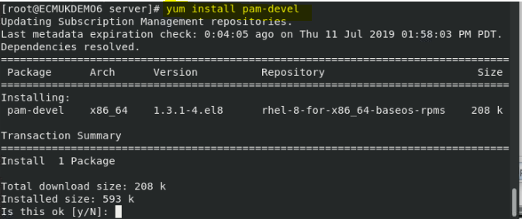

yum install pam-devel-1.3.1-4.el8.i686

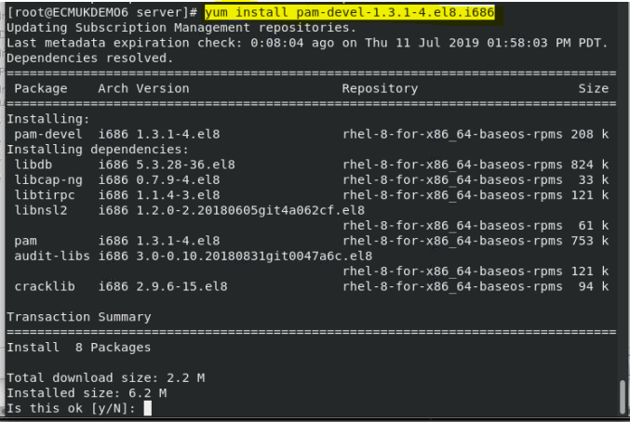

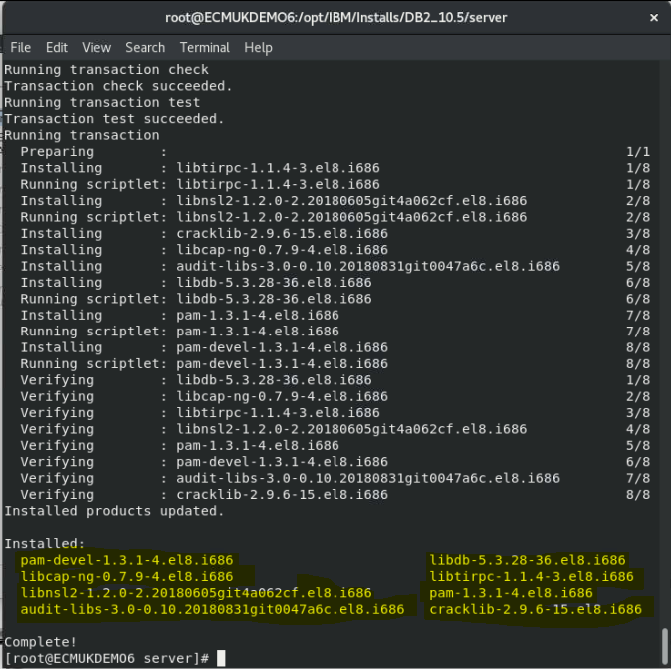

==========================================================================

Checking DB2 prerequisites for DB2 database version "10.5.0.3" on operating system "Linux"

Validating "kernel level " ...

Required minimum operating system kernel level: "2.6.16".

Actual operating system kernel level: "4.18.0".

Requirement matched.

Validating "SELinux status " ...

SELinux is "enabled ".

DBT3563E The db2prereqcheck utility determined that SELinux is enabled, which is not supported with GPFS.

ERROR : Requirement not matched.

**NB only needed if GPFS file system is required**

Validating "C++ Library version " ...

Required minimum C++ library: "libstdc++.so.6"

Standard C++ library is located in the following directory: "/usr/lib64/libstdc++.so.6.0.25".

Actual C++ library: "CXXABI\_1.3.1"

Requirement matched.

Validating "32 bit version of "libstdc++.so.6" " ...

Found the 32 bit "/lib/libstdc++.so.6" in the following directory "/lib".

Requirement matched.

Validating "libc.so version " ...

glibc library is located in the following directory "/usr/lib64/libc-2.28.so".

Required minimum glibc library version: "2.4.0"

Actual glibc library version: "2.28.0"

Requirement matched.

Validating "openibd" ...

DBT3564E The db2prereqcheck utility was unable to find the package "openibd" on host "ECMUKDEMO6".

ERROR : Requirement not matched.

**NB Only if DB2 Purescale is required**

Validating "modprobe.conf" ...

Requirement matched.

Validating "free space" ...

The directory "/tmp" has enough space on host "ECMUKDEMO6".

Requirement matched.

Validating "free space" ...

The directory "/var" has enough space on host "ECMUKDEMO6".

Requirement matched.

Validating "free space" ...

The directory "/home" has enough space on host "ECMUKDEMO6".

Requirement matched.

Validating "free space" ...

The directory "/opt" has enough space on host "ECMUKDEMO6".

Requirement matched.

Validating "free space" ...

The directory "/" has enough space on host "ECMUKDEMO6".

Requirement matched.

Validating "/lib/libpam.so\*" ...

DBT3514W The db2prereqcheck utility failed to find the following 32-bit library file: "/lib/libpam.so\*".

WARNING : Requirement not matched.

Requirement not matched for DB2 database "Server" with pureScale feature. Version: "10.5.0.3".

Summary of prerequisites that are not met on the current system:

DBT3514W The db2prereqcheck utility failed to find the following 32-bit library file: "/lib/libpam.so\*".

**NB fixed earlier**

DBT3564E The db2prereqcheck utility was unable to find the package "openibd" on host "ECMUKDEMO6".

DBT3563E The db2prereqcheck utility determined that SELinux is enabled, which is not supported with GPFS.

==========================================================================

Checking DB2 prerequisites for DB2 database version "10.5.0.2" on operating system "Linux"

Validating "kernel level " ...

Required minimum operating system kernel level: "2.6.16".

Actual operating system kernel level: "4.18.0".

Requirement matched.

Validating "C++ Library version " ...

Required minimum C++ library: "libstdc++.so.6"

Standard C++ library is located in the following directory: "/usr/lib64/libstdc++.so.6.0.25".

Actual C++ library: "CXXABI\_1.3.1"

Requirement matched.

Validating "32 bit version of "libstdc++.so.6" " ...

Found the 32 bit "/lib/libstdc++.so.6" in the following directory "/lib".

Requirement matched.

Validating "/lib/libpam.so\*" ...

DBT3514W The db2prereqcheck utility failed to find the following 32-bit library file: "/lib/libpam.so\*".

WARNING : Requirement not matched.

**Fixed earlier**

Requirement not matched for DB2 database "Server" . Version: "10.5.0.2".

Summary of prerequisites that are not met on the current system:

DBT3514W The db2prereqcheck utility failed to find the following 32-bit library file: "/lib/libpam.so\*".

==========================================================================

Checking DB2 prerequisites for DB2 database version "10.5.0.2" on operating system "Linux"

Validating "kernel level " ...

Required minimum operating system kernel level: "2.6.16".

Actual operating system kernel level: "4.18.0".

Requirement matched.

Validating "SELinux status " ...

SELinux is "enabled ".

DBT3563E The db2prereqcheck utility determined that SELinux is enabled, which is not supported with GPFS.

ERROR : Requirement not matched.

Validating "C++ Library version " ...

Required minimum C++ library: "libstdc++.so.6"

Standard C++ library is located in the following directory: "/usr/lib64/libstdc++.so.6.0.25".

Actual C++ library: "CXXABI\_1.3.1"

Requirement matched.

Validating "32 bit version of "libstdc++.so.6" " ...

Found the 32 bit "/lib/libstdc++.so.6" in the following directory "/lib".

Requirement matched.

Validating "libc.so version " ...

glibc library is located in the following directory "/usr/lib64/libc-2.28.so".

Required minimum glibc library version: "2.4.0"

Actual glibc library version: "2.28.0"

Requirement matched.

Validating "openibd" ...

DBT3564E The db2prereqcheck utility was unable to find the package "openibd" on host "ECMUKDEMO6".

ERROR : Requirement not matched.

Validating "modprobe.conf" ...

Requirement matched.

Validating "free space" ...

The directory "/tmp" has enough space on host "ECMUKDEMO6".

Requirement matched.

Validating "free space" ...

The directory "/var" has enough space on host "ECMUKDEMO6".

Requirement matched.

Validating "free space" ...

The directory "/home" has enough space on host "ECMUKDEMO6".

Requirement matched.

Validating "free space" ...

The directory "/opt" has enough space on host "ECMUKDEMO6".

Requirement matched.

Validating "free space" ...

The directory "/" has enough space on host "ECMUKDEMO6".

Requirement matched.

Validating "/lib/libpam.so\*" ...

DBT3514W The db2prereqcheck utility failed to find the following 32-bit library file: "/lib/libpam.so\*".

WARNING : Requirement not matched.

Requirement not matched for DB2 database "Server" with pureScale feature. Version: "10.5.0.2".

Summary of prerequisites that are not met on the current system:

DBT3514W The db2prereqcheck utility failed to find the following 32-bit library file: "/lib/libpam.so\*".

**Fixed Earlier**

DBT3564E The db2prereqcheck utility was unable to find the package "openibd" on host "ECMUKDEMO6".

DBT3563E The db2prereqcheck utility determined that SELinux is enabled, which is not supported with GPFS.

==========================================================================

Checking DB2 prerequisites for DB2 database version "10.5.0.1" on operating system "Linux"

Validating "kernel level " ...

Required minimum operating system kernel level: "2.6.16".

Actual operating system kernel level: "4.18.0".

Requirement matched.

Validating "C++ Library version " ...

Required minimum C++ library: "libstdc++.so.6"

Standard C++ library is located in the following directory: "/usr/lib64/libstdc++.so.6.0.25".

Actual C++ library: "CXXABI\_1.3.1"

Requirement matched.

Validating "32 bit version of "libstdc++.so.6" " ...

Found the 32 bit "/lib/libstdc++.so.6" in the following directory "/lib".

Requirement matched.

Validating "/lib/libpam.so\*" ...

DBT3514W The db2prereqcheck utility failed to find the following 32-bit library file: "/lib/libpam.so\*".

WARNING : Requirement not matched.

Requirement not matched for DB2 database "Server" . Version: "10.5.0.1".

Summary of prerequisites that are not met on the current system:

DBT3514W The db2prereqcheck utility failed to find the following 32-bit library file: "/lib/libpam.so\*".

==========================================================================

Checking DB2 prerequisites for DB2 database version "10.5.0.1" on operating system "Linux"

Validating "kernel level " ...

Required minimum operating system kernel level: "2.6.16".

Actual operating system kernel level: "4.18.0".

Requirement matched.

Validating "SELinux status " ...

SELinux is "enabled ".

DBT3563E The db2prereqcheck utility determined that SELinux is enabled, which is not supported with GPFS.

ERROR : Requirement not matched.

Validating "C++ Library version " ...

Required minimum C++ library: "libstdc++.so.6"

Standard C++ library is located in the following directory: "/usr/lib64/libstdc++.so.6.0.25".

Actual C++ library: "CXXABI\_1.3.1"

Requirement matched.

Validating "32 bit version of "libstdc++.so.6" " ...

Found the 32 bit "/lib/libstdc++.so.6" in the following directory "/lib".

Requirement matched.

Validating "libc.so version " ...

glibc library is located in the following directory "/usr/lib64/libc-2.28.so".

Required minimum glibc library version: "2.4.0"

Actual glibc library version: "2.28.0"

Requirement matched.

Validating "openibd" ...

DBT3564E The db2prereqcheck utility was unable to find the package "openibd" on host "ECMUKDEMO6".

ERROR : Requirement not matched.

Validating "modprobe.conf" ...

Requirement matched.

Validating "free space" ...

The directory "/tmp" has enough space on host "ECMUKDEMO6".

Requirement matched.

Validating "free space" ...

The directory "/var" has enough space on host "ECMUKDEMO6".

Requirement matched.

Validating "free space" ...

The directory "/home" has enough space on host "ECMUKDEMO6".

Requirement matched.

Validating "free space" ...

The directory "/opt" has enough space on host "ECMUKDEMO6".

Requirement matched.

Validating "free space" ...

The directory "/" has enough space on host "ECMUKDEMO6".

Requirement matched.

Validating "/lib/libpam.so\*" ...

DBT3514W The db2prereqcheck utility failed to find the following 32-bit library file: "/lib/libpam.so\*".

WARNING : Requirement not matched.

Requirement not matched for DB2 database "Server" with pureScale feature. Version: "10.5.0.1".

Summary of prerequisites that are not met on the current system:

DBT3514W The db2prereqcheck utility failed to find the following 32-bit library file: "/lib/libpam.so\*".

DBT3564E The db2prereqcheck utility was unable to find the package "openibd" on host "ECMUKDEMO6".

DBT3563E The db2prereqcheck utility determined that SELinux is enabled, which is not supported with GPFS.

==========================================================================

Checking DB2 prerequisites for DB2 database version "10.5.0.0" on operating system "Linux"

Validating "kernel level " ...

Required minimum operating system kernel level: "2.6.16".

Actual operating system kernel level: "4.18.0".

Requirement matched.

Validating "C++ Library version " ...

Required minimum C++ library: "libstdc++.so.6"

Standard C++ library is located in the following directory: "/usr/lib64/libstdc++.so.6.0.25".

Actual C++ library: "CXXABI\_1.3.1"

Requirement matched.

Validating "32 bit version of "libstdc++.so.6" " ...

Found the 32 bit "/lib/libstdc++.so.6" in the following directory "/lib".

Requirement matched.

Validating "/lib/libpam.so\*" ...

DBT3514W The db2prereqcheck utility failed to find the following 32-bit library file: "/lib/libpam.so\*".

WARNING : Requirement not matched.

Requirement not matched for DB2 database "Server" . Version: "10.5.0.0".

Summary of prerequisites that are not met on the current system:

DBT3514W The db2prereqcheck utility failed to find the following 32-bit library file: "/lib/libpam.so\*".

==========================================================================

Checking DB2 prerequisites for DB2 database version "10.5.0.0" on operating system "Linux"

Validating "kernel level " ...

Required minimum operating system kernel level: "2.6.16".

Actual operating system kernel level: "4.18.0".

Requirement matched.

Validating "SELinux status " ...

SELinux is "enabled ".

DBT3563E The db2prereqcheck utility determined that SELinux is enabled, which is not supported with GPFS.

ERROR : Requirement not matched.

Validating "C++ Library version " ...

Required minimum C++ library: "libstdc++.so.6"

Standard C++ library is located in the following directory: "/usr/lib64/libstdc++.so.6.0.25".

Actual C++ library: "CXXABI\_1.3.1"

Requirement matched.

Validating "32 bit version of "libstdc++.so.6" " ...

Found the 32 bit "/lib/libstdc++.so.6" in the following directory "/lib".

Requirement matched.

Validating "libc.so version " ...

glibc library is located in the following directory "/usr/lib64/libc-2.28.so".

Required minimum glibc library version: "2.4.0"

Actual glibc library version: "2.28.0"

Requirement matched.

Validating "openibd" ...

DBT3564E The db2prereqcheck utility was unable to find the package "openibd" on host "ECMUKDEMO6".

ERROR : Requirement not matched.

Validating "modprobe.conf" ...

Requirement matched.

Validating "free space" ...

The directory "/tmp" has enough space on host "ECMUKDEMO6".

Requirement matched.

Validating "free space" ...

The directory "/var" has enough space on host "ECMUKDEMO6".

Requirement matched.

Validating "free space" ...

The directory "/home" has enough space on host "ECMUKDEMO6".

Requirement matched.

Validating "free space" ...

The directory "/opt" has enough space on host "ECMUKDEMO6".

Requirement matched.

Validating "free space" ...

The directory "/" has enough space on host "ECMUKDEMO6".

Requirement matched.

Validating "/lib/libpam.so\*" ...

DBT3514W The db2prereqcheck utility failed to find the following 32-bit library file: "/lib/libpam.so\*".

WARNING : Requirement not matched.

Requirement not matched for DB2 database "Server" with pureScale feature. Version: "10.5.0.0".

Summary of prerequisites that are not met on the current system:

DBT3514W The db2prereqcheck utility failed to find the following 32-bit library file: "/lib/libpam.so\*".

DBT3564E The db2prereqcheck utility was unable to find the package "openibd" on host "ECMUKDEMO6".

DBT3563E The db2prereqcheck utility determined that SELinux is enabled, which is not supported with GPFS.

==========================================================================

Checking DB2 prerequisites for DB2 database version "10.1.0.2" on operating system "Linux"

Validating "kernel level " ...

Required minimum operating system kernel level: "2.6.16".

Actual operating system kernel level: "4.18.0".

Requirement matched.

Validating "C++ Library version " ...

Required minimum C++ library: "libstdc++.so.6"

Standard C++ library is located in the following directory: "/usr/lib64/libstdc++.so.6.0.25".

Actual C++ library: "CXXABI\_1.3.1"

Requirement matched.

Validating "32 bit version of "libstdc++.so.6" " ...

Found the 32 bit "/lib/libstdc++.so.6" in the following directory "/lib".

Requirement matched.

Validating "/lib/libpam.so\*" ...

DBT3514W The db2prereqcheck utility failed to find the following 32-bit library file: "/lib/libpam.so\*".

WARNING : Requirement not matched.

Requirement not matched for DB2 database "Server" . Version: "10.1.0.2".

Summary of prerequisites that are not met on the current system:

DBT3514W The db2prereqcheck utility failed to find the following 32-bit library file: "/lib/libpam.so\*".

==========================================================================

Checking DB2 prerequisites for DB2 database version "10.1.0.2" on operating system "Linux"

Validating "kernel level " ...

Required minimum operating system kernel level: "2.6.16".

Actual operating system kernel level: "4.18.0".

Requirement matched.

Validating "SELinux status " ...

SELinux is "enabled ".

DBT3563E The db2prereqcheck utility determined that SELinux is enabled, which is not supported with GPFS.

ERROR : Requirement not matched.

Validating "C++ Library version " ...

Required minimum C++ library: "libstdc++.so.6"

Standard C++ library is located in the following directory: "/usr/lib64/libstdc++.so.6.0.25".

Actual C++ library: "CXXABI\_1.3.1"

Requirement matched.

Validating "32 bit version of "libstdc++.so.6" " ...

Found the 32 bit "/lib/libstdc++.so.6" in the following directory "/lib".

Requirement matched.

Validating "libc.so version " ...

glibc library is located in the following directory "/usr/lib64/libc-2.28.so".

Required minimum glibc library version: "2.4.0"

Actual glibc library version: "2.28.0"

Requirement matched.

Validating "openibd" ...

DBT3564E The db2prereqcheck utility was unable to find the package "openibd" on host "ECMUKDEMO6".

ERROR : Requirement not matched.

Validating "modprobe.conf" ...

Requirement matched.

Validating "free space" ...

The directory "/tmp" has enough space on host "ECMUKDEMO6".

Requirement matched.

Validating "free space" ...

The directory "/var" has enough space on host "ECMUKDEMO6".

Requirement matched.

Validating "free space" ...

The directory "/home" has enough space on host "ECMUKDEMO6".

Requirement matched.

Validating "free space" ...

The directory "/opt" has enough space on host "ECMUKDEMO6".

Requirement matched.

Validating "free space" ...

The directory "/" has enough space on host "ECMUKDEMO6".

Requirement matched.

Validating "/lib/libpam.so\*" ...

DBT3514W The db2prereqcheck utility failed to find the following 32-bit library file: "/lib/libpam.so\*".

WARNING : Requirement not matched.

Requirement not matched for DB2 database "Server" with pureScale feature. Version: "10.1.0.2".

Summary of prerequisites that are not met on the current system:

DBT3514W The db2prereqcheck utility failed to find the following 32-bit library file: "/lib/libpam.so\*".

DBT3564E The db2prereqcheck utility was unable to find the package "openibd" on host "ECMUKDEMO6".

DBT3563E The db2prereqcheck utility determined that SELinux is enabled, which is not supported with GPFS.

==========================================================================

Checking DB2 prerequisites for DB2 database version "10.1.0.0" on operating system "Linux"

Validating "kernel level " ...

Required minimum operating system kernel level: "2.6.16".

Actual operating system kernel level: "4.18.0".

Requirement matched.

Validating "C++ Library version " ...

Required minimum C++ library: "libstdc++.so.6"

Standard C++ library is located in the following directory: "/usr/lib64/libstdc++.so.6.0.25".

Actual C++ library: "CXXABI\_1.3.1"

Requirement matched.

Validating "32 bit version of "libstdc++.so.6" " ...

Found the 32 bit "/lib/libstdc++.so.6" in the following directory "/lib".

Requirement matched.

Validating "/lib/libpam.so\*" ...

DBT3514W The db2prereqcheck utility failed to find the following 32-bit library file: "/lib/libpam.so\*".

WARNING : Requirement not matched.

Requirement not matched for DB2 database "Server" . Version: "10.1.0.0".

Summary of prerequisites that are not met on the current system:

DBT3514W The db2prereqcheck utility failed to find the following 32-bit library file: "/lib/libpam.so\*".

==========================================================================

Checking DB2 prerequisites for DB2 database version "10.1.0.0" on operating system "Linux"

Validating "kernel level " ...

Required minimum operating system kernel level: "2.6.16".

Actual operating system kernel level: "4.18.0".

Requirement matched.

Validating "SELinux status " ...

SELinux is "enabled ".

DBT3563E The db2prereqcheck utility determined that SELinux is enabled, which is not supported with GPFS.

ERROR : Requirement not matched.

Validating "C++ Library version " ...

Required minimum C++ library: "libstdc++.so.6"

Standard C++ library is located in the following directory: "/usr/lib64/libstdc++.so.6.0.25".

Actual C++ library: "CXXABI\_1.3.1"

Requirement matched.

Validating "32 bit version of "libstdc++.so.6" " ...

Found the 32 bit "/lib/libstdc++.so.6" in the following directory "/lib".

Requirement matched.

Validating "libc.so version " ...

glibc library is located in the following directory "/usr/lib64/libc-2.28.so".

Required minimum glibc library version: "2.4.0"

Actual glibc library version: "2.28.0"

Requirement matched.

Validating "openibd" ...

DBT3564E The db2prereqcheck utility was unable to find the package "openibd" on host "ECMUKDEMO6".

ERROR : Requirement not matched.

Validating "modprobe.conf" ...

Requirement matched.

Validating "free space" ...

The directory "/tmp" has enough space on host "ECMUKDEMO6".

Requirement matched.

Validating "free space" ...

The directory "/var" has enough space on host "ECMUKDEMO6".

Requirement matched.

Validating "free space" ...

The directory "/home" has enough space on host "ECMUKDEMO6".

Requirement matched.

Validating "free space" ...

The directory "/opt" has enough space on host "ECMUKDEMO6".

Requirement matched.

Validating "free space" ...

The directory "/" has enough space on host "ECMUKDEMO6".

Requirement matched.

Validating "/lib/libpam.so\*" ...

DBT3514W The db2prereqcheck utility failed to find the following 32-bit library file: "/lib/libpam.so\*".

WARNING : Requirement not matched.

Requirement not matched for DB2 database "Server" with pureScale feature. Version: "10.1.0.0".

Summary of prerequisites that are not met on the current system:

DBT3514W The db2prereqcheck utility failed to find the following 32-bit library file: "/lib/libpam.so\*".

DBT3564E The db2prereqcheck utility was unable to find the package "openibd" on host "ECMUKDEMO6".

DBT3563E The db2prereqcheck utility determined that SELinux is enabled, which is not supported with GPFS.

==========================================================================

Checking DB2 prerequisites for DB2 database version "9.8.0.4" on operating system "Linux"

Validating "kernel level " ...

Required minimum operating system kernel level: "2.6.16".

Actual operating system kernel level: "4.18.0".

Requirement matched.

Validating "C++ Library version " ...

Required minimum C++ library: "libstdc++.so.5"

DBT3510E The db2prereqcheck utility was unable to find the following required library file: "libstdc++.so.5".

ERROR : Requirement not matched.

Validating "/lib/libpam.so\*" ...

DBT3514W The db2prereqcheck utility failed to find the following 32-bit library file: "/lib/libpam.so\*".

WARNING : Requirement not matched.

Requirement not matched for DB2 database "Server" . Version: "9.8.0.4".

Summary of prerequisites that are not met on the current system:

DBT3514W The db2prereqcheck utility failed to find the following 32-bit library file: "/lib/libpam.so\*".

Required minimum C++ library: "libstdc++.so.5"

Actual version is undetermined

==========================================================================

Checking DB2 prerequisites for DB2 database version "9.8.0.4" on operating system "Linux"

Validating "kernel level " ...

Required minimum operating system kernel level: "2.6.16".

Actual operating system kernel level: "4.18.0".

Requirement matched.

Validating "SELinux status " ...

SELinux is "enabled ".

DBT3563E The db2prereqcheck utility determined that SELinux is enabled, which is not supported with GPFS.

ERROR : Requirement not matched.

Validating "C++ Library version " ...

Required minimum C++ library: "libstdc++.so.5"

DBT3510E The db2prereqcheck utility was unable to find the following required library file: "libstdc++.so.5".

ERROR : Requirement not matched.

Validating "libc.so version " ...

glibc library is located in the following directory "/usr/lib64/libc-2.28.so".

Required minimum glibc library version: "2.4.0"

Actual glibc library version: "2.28.0"

Requirement matched.

Validating "openibd" ...

DBT3564E The db2prereqcheck utility was unable to find the package "openibd" on host "ECMUKDEMO6".

ERROR : Requirement not matched.

Validating "modprobe.conf" ...

Requirement matched.

Validating "free space" ...

The directory "/tmp" has enough space on host "ECMUKDEMO6".

Requirement matched.

Validating "free space" ...

The directory "/var" has enough space on host "ECMUKDEMO6".

Requirement matched.

Validating "free space" ...

The directory "/home" has enough space on host "ECMUKDEMO6".

Requirement matched.

Validating "free space" ...

The directory "/opt" has enough space on host "ECMUKDEMO6".

Requirement matched.

Validating "free space" ...

The directory "/" has enough space on host "ECMUKDEMO6".

Requirement matched.

Validating "/lib/libpam.so\*" ...

DBT3514W The db2prereqcheck utility failed to find the following 32-bit library file: "/lib/libpam.so\*".

WARNING : Requirement not matched.

Requirement not matched for DB2 database "Server" with pureScale feature. Version: "9.8.0.4".

Summary of prerequisites that are not met on the current system:

DBT3514W The db2prereqcheck utility failed to find the following 32-bit library file: "/lib/libpam.so\*".

DBT3564E The db2prereqcheck utility was unable to find the package "openibd" on host "ECMUKDEMO6".

Required minimum C++ library: "libstdc++.so.5"

Actual version is undetermined

DBT3563E The db2prereqcheck utility determined that SELinux is enabled, which is not supported with GPFS.

==========================================================================

Checking DB2 prerequisites for DB2 database version "9.8.0.3" on operating system "Linux"

Validating "kernel level " ...

Required minimum operating system kernel level: "2.6.16".

Actual operating system kernel level: "4.18.0".

Requirement matched.

Validating "C++ Library version " ...

Required minimum C++ library: "libstdc++.so.5"

DBT3510E The db2prereqcheck utility was unable to find the following required library file: "libstdc++.so.5".

ERROR : Requirement not matched.

Validating "/lib/libpam.so\*" ...

DBT3514W The db2prereqcheck utility failed to find the following 32-bit library file: "/lib/libpam.so\*".

WARNING : Requirement not matched.

Requirement not matched for DB2 database "Server" . Version: "9.8.0.3".

Summary of prerequisites that are not met on the current system:

DBT3514W The db2prereqcheck utility failed to find the following 32-bit library file: "/lib/libpam.so\*".

Required minimum C++ library: "libstdc++.so.5"

Actual version is undetermined

==========================================================================

Checking DB2 prerequisites for DB2 database version "9.8.0.3" on operating system "Linux"

Validating "kernel level " ...

Required minimum operating system kernel level: "2.6.16".

Actual operating system kernel level: "4.18.0".

Requirement matched.

Validating "SELinux status " ...

SELinux is "enabled ".

DBT3563E The db2prereqcheck utility determined that SELinux is enabled, which is not supported with GPFS.

ERROR : Requirement not matched.

Validating "C++ Library version " ...

Required minimum C++ library: "libstdc++.so.5"

DBT3510E The db2prereqcheck utility was unable to find the following required library file: "libstdc++.so.5".

ERROR : Requirement not matched.

Validating "libc.so version " ...

glibc library is located in the following directory "/usr/lib64/libc-2.28.so".

Required minimum glibc library version: "2.4.0"

Actual glibc library version: "2.28.0"

Requirement matched.

Validating "openibd" ...

DBT3564E The db2prereqcheck utility was unable to find the package "openibd" on host "ECMUKDEMO6".

ERROR : Requirement not matched.

Validating "modprobe.conf" ...

Requirement matched.

Validating "free space" ...

The directory "/tmp" has enough space on host "ECMUKDEMO6".

Requirement matched.

Validating "free space" ...

The directory "/var" has enough space on host "ECMUKDEMO6".

Requirement matched.

Validating "free space" ...

The directory "/home" has enough space on host "ECMUKDEMO6".

Requirement matched.

Validating "free space" ...

The directory "/opt" has enough space on host "ECMUKDEMO6".

Requirement matched.

Validating "free space" ...

The directory "/" has enough space on host "ECMUKDEMO6".

Requirement matched.

Validating "/lib/libpam.so\*" ...

DBT3514W The db2prereqcheck utility failed to find the following 32-bit library file: "/lib/libpam.so\*".

WARNING : Requirement not matched.

Requirement not matched for DB2 database "Server" with pureScale feature. Version: "9.8.0.3".

Summary of prerequisites that are not met on the current system:

DBT3514W The db2prereqcheck utility failed to find the following 32-bit library file: "/lib/libpam.so\*".

DBT3564E The db2prereqcheck utility was unable to find the package "openibd" on host "ECMUKDEMO6".

Required minimum C++ library: "libstdc++.so.5"

Actual version is undetermined

DBT3563E The db2prereqcheck utility determined that SELinux is enabled, which is not supported with GPFS.

==========================================================================

Checking DB2 prerequisites for DB2 database version "9.8.0.2" on operating system "Linux"

Validating "kernel level " ...

Required minimum operating system kernel level: "2.6.16".

Actual operating system kernel level: "4.18.0".

Requirement matched.

Validating "C++ Library version " ...

Required minimum C++ library: "libstdc++.so.5"

DBT3510E The db2prereqcheck utility was unable to find the following required library file: "libstdc++.so.5".

ERROR : Requirement not matched.

Validating "/lib/libpam.so\*" ...

DBT3514W The db2prereqcheck utility failed to find the following 32-bit library file: "/lib/libpam.so\*".

WARNING : Requirement not matched.

Requirement not matched for DB2 database "Server" . Version: "9.8.0.2".

Summary of prerequisites that are not met on the current system:

DBT3514W The db2prereqcheck utility failed to find the following 32-bit library file: "/lib/libpam.so\*".

Required minimum C++ library: "libstdc++.so.5"

Actual version is undetermined

==========================================================================

Checking DB2 prerequisites for DB2 database version "9.8.0.2" on operating system "Linux"

Validating "kernel level " ...

Required minimum operating system kernel level: "2.6.16".

Actual operating system kernel level: "4.18.0".

Requirement matched.

Validating "SELinux status " ...

SELinux is "enabled ".

DBT3563E The db2prereqcheck utility determined that SELinux is enabled, which is not supported with GPFS.

ERROR : Requirement not matched.

Validating "C++ Library version " ...

Required minimum C++ library: "libstdc++.so.5"

DBT3510E The db2prereqcheck utility was unable to find the following required library file: "libstdc++.so.5".

ERROR : Requirement not matched.

Validating "libc.so version " ...

glibc library is located in the following directory "/usr/lib64/libc-2.28.so".

Required minimum glibc library version: "2.4.0"

Actual glibc library version: "2.28.0"

Requirement matched.

Validating "openibd" ...

DBT3564E The db2prereqcheck utility was unable to find the package "openibd" on host "ECMUKDEMO6".

ERROR : Requirement not matched.

Validating "modprobe.conf" ...

Requirement matched.

Validating "free space" ...

The directory "/tmp" has enough space on host "ECMUKDEMO6".

Requirement matched.

Validating "free space" ...

The directory "/var" has enough space on host "ECMUKDEMO6".

Requirement matched.

Validating "free space" ...

The directory "/home" has enough space on host "ECMUKDEMO6".

Requirement matched.

Validating "free space" ...

The directory "/opt" has enough space on host "ECMUKDEMO6".

Requirement matched.

Validating "free space" ...

The directory "/" has enough space on host "ECMUKDEMO6".

Requirement matched.

Validating "/lib/libpam.so\*" ...

DBT3514W The db2prereqcheck utility failed to find the following 32-bit library file: "/lib/libpam.so\*".

WARNING : Requirement not matched.

Requirement not matched for DB2 database "Server" with pureScale feature. Version: "9.8.0.2".

Summary of prerequisites that are not met on the current system:

DBT3514W The db2prereqcheck utility failed to find the following 32-bit library file: "/lib/libpam.so\*".

DBT3564E The db2prereqcheck utility was unable to find the package "openibd" on host "ECMUKDEMO6".

Required minimum C++ library: "libstdc++.so.5"

Actual version is undetermined

DBT3563E The db2prereqcheck utility determined that SELinux is enabled, which is not supported with GPFS.

[root@ECMUKDEMO6 server]#